Contents

2 Important Links 3

2.1 References 3

3 Design Documents 3

3.1 YTM Integration Testing and Demo Sites 4

4 Development Culture 4

5 Development Methodologies 5

5.1 GDAO – Generated Data Access Objects 5

5.2 Agile Software Development 5

6 Development Policies 6

6.1 Development Environment 6

6.1.1 Project Root Directory 6

6.1.2 Back End Source Code Location 7

6.1.3 Front End Source Code Location 7

7 Test Data 7

7.1 Database 8

7.2 Configuring Database Access 8

7.2.1 SQL*Plus 8

7.2.2 Configuring Oracle*Net 8

7.3 Access to Database Servers in Canada 9

7.3.1 Database ZORACLE 9

7.3.2 Database ZORACLE2 9

7.3.3 Database ZORACLE3 10

7.3.4 Database ZORACLE4 10

7.3.5 Sample from Aqua Data Studio 12

7.3.6 Utility database scripts 12

7.3.7 Creating new database user 13

7.3.8 Expired Database Password 13

7.3.9 Copying Database Schema 13

8 Database Analyzer 15

9 Eclipse 15

10 Database Model 16

10.1 Very Important – Data Dictionary 16

10.2 File Locations 16

11 Source Control System – Subversive SVN 17

11.1.1 Refreshing Working Directory 17

11.2 SVN Repositories 18

12 UTF-8 Character Encoding 19

13 WWW Development 19

13.1 Fonts 19

13.2 Using Microsoft Web Expression 4 19

14 Good Programming Practices 20

14.1 Automation 20

14.2 SQL Coding 20

14.2.1 Sample 1 20

14.2.2 Sample 2 21

14.2.3 SQL Formatting Utilities 23

14.2.4 WRONG SQL ALIGNMENT 25

14.2.5 CORRECT SQL ALIGNMENT 25

14.3 Java Code Formatting 26

15 Setting up Eclipse English Dictionary 27

16 User Interface design 28

17 FTP for Developers 28

18 Instructional Videos 29

19 Eclipse DBA Application Troubleshooting 30

20 Manual Application Build and Deploy 31

# Important Links

## References

|  |  |  |
| --- | --- | --- |
| **#** | **Link** | **Description** |
|  | <http://wiki.youtestme.com> | YouTestMe Wiki Site – useful information about the project |
|  | <http://it-ebooks.info> | Collection of IT Manuals |

# Design Documents

Every module has to have a design document in MS Word written using standard technical template.

Every document has to have the following sections:

1. Description what module is supposed to do
2. Description of the design
3. Technologies used
4. How are modules built, compiled and deployed
5. How can modules be tested
6. Location of the code, documentation and test data

Current (usually most recent) version of the design document has to be checked into SVN.

## YTM Integration Testing and Demo Sites

|  |  |  |
| --- | --- | --- |
| **#** | **Link** | **Description** |
|  | <http://206.248.172.39:55241/ytm/>  <http://test1.youtestme.com>  Links are equivalent however first one uses “HTTP redirect” while second one uses “Frame redirect”. | Primary development integration site  Should be used only by developers for system integration and testing  Uses database schema "YTM10"  Automated build times: 11 AM and then every 6 hours |
|  | <http://206.248.172.39:55242/ytm20/>  <http://test2.youtestme.com>  Links are equivalent however first one uses “HTTP redirect” while second one uses “Frame redirect”. | Site used for performance, load and stress testing  Uses database schema "YTM20"  Automated build times: 11 AM and then every 6 hours |
|  | <http://206.248.172.39:55243/ytm30/>  <http://test3.youtestme.com>  <http://demo.youtestme.com>  All three links are equivalent however latter two are using “Frame redirect” vs. “HTTP redirect”. | Site used for demos and presentations  Uses database schema "YTM30"  Automated build times: 12 AM daily |
|  | <http://206.248.172.39:56241/ytm/> | Primary development integration site  Should be used only by developers for system integration and testing  Uses database schema "YTM10"  Automated build times: 11 AM and then every 6 hours |
|  | <http://206.248.172.39:56242/ytm20/> | Site used for performance, load and stress testing  Uses database schema "YTM20"  Automated build times: 11 AM and then every 6 hours |
|  | <http://206.248.172.39:56243/ytm30/> | Site used for demos and presentations  Uses database schema "YTM30"  Automated build times: 12 AM daily |

# Development Culture

Company strategy is to establish highly efficient and productive culture by:

1. Automating all repetitive processes
2. Establishing and documenting procedures for all common tasks
3. Considering every task as a project and properly documenting it so anybody can take on that task at any given moment
4. Adhering to company standards and policies

# Development Methodologies

## GDAO – Generated Data Access Objects

<http://www.mallocinc.com>

## Agile Software Development

<http://en.wikipedia.org/wiki/Agile_software_development>

Agile is just a “common sense” approach to development. This is just a guideline but not the rule. The key point is to be adaptable to current situation and requirements.

Twelve principles underlie the Agile Manifesto:

1. Customer satisfaction by rapid delivery of useful software
2. Welcome changing requirements, even late in development
3. Working software is delivered frequently (weeks rather than months)
4. Working software is the principal measure of progress
5. Sustainable development, able to maintain a constant pace
6. Close, daily co-operation between business people and developers
7. Face-to-face conversation is the best form of communication (co-location)
8. Projects are built around motivated individuals, who should be trusted
9. Continuous attention to technical excellence and good design
10. Simplicity- The art of maximizing the amount of work not done - is essential
11. Self-organizing teams
12. Regular adaptation to changing circumstances

# Development Policies

## Development Environment

### Project Root Directory

Create a “Root Development” directory:  
C:\Zoran\Development

You should use your username as part of the root directory name because computer could be used by several individuals.

Check out all code in that directory.

Your directory structure will look something like this (depending on projects you checked out).

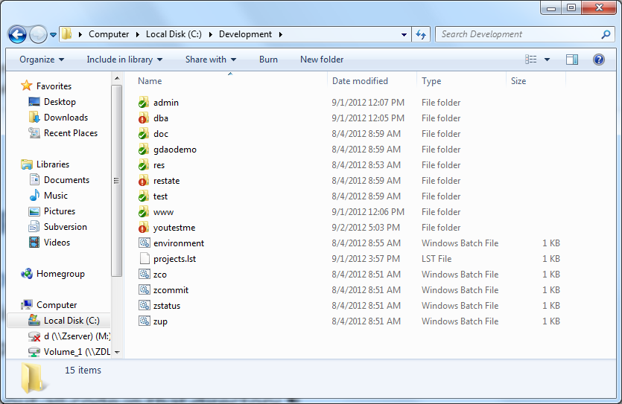

For remote desktop which is used by more than one person, create a directory with your name and copy paste the Development directory to the newly created directory. For example, instead of C:\Development, you should have C:\Zoran\Development. This policy is made so that conflicts are avoided while using SVN since more than one person is using the virtual machine. Personal computer can be set up in any way you like.

Files that start with “z” in “C:\Development” are utility DOS scripts that can help you checkout, update and commit files in multiple SVN Repositories. List of all affected repositories is in file “projects.lst”. You should edit this file and keep only list of repositories that you will be working on.

All “z” files and default “projects.lst” are in the archive below:



“z” scripts in SVN:

c:\Development\res\Scripts\SVN DOS Scripts\

### Back End Source Code Location

c:\Zoran\Development\youtestme\source\

### Front End Source Code Location

c:\Zoran\Development\youtestme\www_source\

# Test Data

1. All test data have to be created in spreadsheets located here:  
   \youtestme\batch_source\test_data\excel\
2. Test data is loaded by Java program:
3. com.youtestme.loaders.excel.testdata.LoadAllTestData
4. Test data should always be generated through re-runnable programs, scripts, files, spreadsheet. The process should be executable in one step.
5. Note that data created any other way (not through integrated process described below) will be lost every time database is refreshed.
6. There are great benefits of using standardized test data so please stick to the process. Be proactive and create or amend test data spreadsheets.

## Database

Each developer should use his/her own database schema for development. This way conflict are avoided and development is much more efficient.

Please do the following:

1. Create your own schema and implement data model and data in it by using shell scripts or Oracle database export file created from another schema.
2. If you are unfamiliar with database administration please ask somebody to do it for you.

## Configuring Database Access

The following software is needed to access Oracle database:

* Oracle Database Client Software – in order to user SQL*Plus and to run SQL*Plus scripts from command line. To download Windows version you can use this [link](http://www.oracle.com/technetwork/database/enterprise-edition/downloads/database12c-win64-download-2297732.html) and the scroll to “Oracle Database Client (12.1.0.2.0) for Microsoft Windows (x64)”
* JDBC driver in order to have Java programs access to the database. JDBC driver is the same on all operating systems and can be downloaded [here](http://www.oracle.com/technetwork/database/features/jdbc/jdbc-drivers-12c-download-1958347.html). You should download “ojdbc7.jar”

The following information is required to access oracle database:

1. IP address of the server where database is installed
2. Port number where Oracle listener is accepting connection requests (by default it is 1521)
3. Database name (default is “ORCL”)
4. Username
5. Password

### SQL*Plus

SQL*Plus is Oracle shell for executing SQL and PL/SQL statements and programs. It is universal tool for development and data administration. Unfortunately it is not very user friendly because it is exclusively command based so it is mostly used either when other tools are not available or when other tools cannot do operations that SQL*Plus can perform – a common example is changing expired Oracle password.

In order to run SQL*Plus and other programs that require Oracle native network interface you need to configure Oracle*Net.

### Configuring Oracle*Net

## Access to Database Servers in Canada

The following information is required to access oracle database:

1. IP address of the server where database is installed
2. Port number where Oracle listener is accepting connection requests (by default it is 1521)
3. Database name (default is “ORCL”)
4. Username
5. Password

Use “external” IP address and port to access databases from remote location.

Use “internal” IP address and port to access databases from within local network – for example when you log in to the one of the local machines using remote desktop. “Local” machine is one of the machines on the same local network as database servers, meaning they are all located in Canada at the same physical location.

### Database ZORACLE

|  |  |
| --- | --- |
| **External IP** | mallocinc.dnsalias.com  home.mallocinc.com |
| **External Port** | 56238 |
| **SID** | ZORACLE |
| **Username** | ytm1 |
| **Password** | ytm1 |
| **Version** | 11g |
| **Server** | zserver (Windows Server 2008 - physical) |
| **Internal IP** | 192.168.1.40 |

Users YTM2, 3, 4,....10 are also created so we will all have several database schemas for development and testing. Passwords are the same as username.

You can use DBA user: “ZDBA/ZDBA” if you want to create new users or to experiment.

Usernames and passwords are case sensitive.

### Database ZORACLE2

|  |  |
| --- | --- |
| **External IP** | mallocinc.dnsalias.com  home.mallocinc.com |
| **External Port** | 56238 |
| **SID** | ZORACLE2 |
| **Username** | ytm1 |
| **Password** | ytm1 |
| **Version** | 11g |
| **Server** | zlinux (Red Hat - virtual) |
| **Internal IP** | 192.168.1.? |

Users YTM2, 3, 4,....10 are also created so we will all have several database schemas for development and testing. Passwords are the same as username.

You can use DBA user: “ZDBA/ZDBA” if you want to create new users or to experiment.

Usernames and passwords are case sensitive.

### Database ZORACLE3

|  |  |
| --- | --- |
| **External IP** | mallocinc.dnsalias.com  home.mallocinc.com |
| **External Port** | 56238 |
| **SID** | orcl |
| **Username** | ytm1 |
| **Password** | ytm1 |
| **Version** | 12c |
| **Server** | zoracle3 (Oracle Linux 7.0 - virtual) |
| **Internal IP** | 192.168.1.35 |

Users YTM2, 3, 4,....10 are also created so we will all have several database schemas for development and testing. Passwords are the same as username.

You can use DBA user: “ZDBA/ZDBA” if you want to create new users or to experiment.

Usernames and passwords are case sensitive.

### Database ZORACLE4

|  |  |
| --- | --- |
| **External IP** | mallocinc.dnsalias.com  home.mallocinc.com |
| **External Port** | 56238 |
| **SID** | orcl |
| **Username** | ytm1 |
| **Password** | ytm1 |
| **Version** | 12c |
| **Server** | zoracle4 (Oracle Linux 7.0 - virtual) |
| **Internal IP** | 192.168.1.95 |
| **Internal Port** | 1521 |

Users YTM2, 3, 4,....10 are also created so we will all have several database schemas for development and testing. Passwords are the same as username.

You can use DBA user: “ZDBA/ZDBA” if you want to create new users or to experiment.

Usernames and passwords are case sensitive.

### Sample from Aqua Data Studio

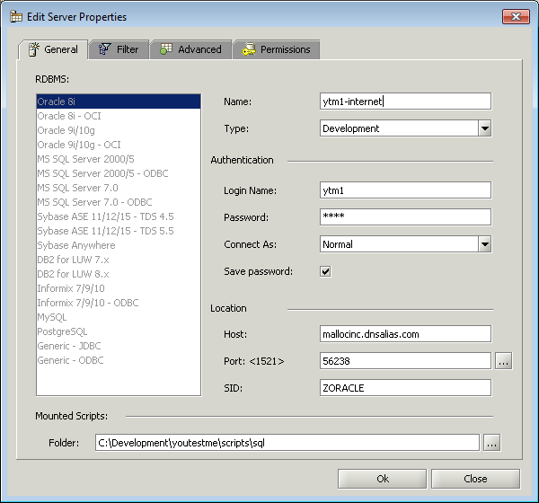

### Utility database scripts

\youtestme\db\dbmodel\scripts\

Check those scripts to see how to create database user(schema) and how to create database objects in that schema.

### Creating new database user

To create new database user, execute these commands in SQL:

CREATE USER user1 PROFILE "DEFAULT"

IDENTIFIED BY password1 DEFAULT TABLESPACE "USERS"

ACCOUNT UNLOCK;

GRANT "CONNECT" TO user1 WITH ADMIN OPTION;

GRANT "DBA" TO user1 WITH ADMIN OPTION;

GRANT "RESOURCE" TO user1 WITH ADMIN OPTION;

GRANT UNLIMITED TABLESPACE TO user1 WITH ADMIN OPTION;

Note the following:

* Statement terminator is “;” character so everything up to that character is one statement.
* User is granted role DBA which is very powerful role and practical for development however in the real production environment user will have more restrictions (no DBA role).

### Expired Database Password

Expired database password have to be changed in SQL*Plus:

Follow instructions from this document:

\youtestmedoc\Procedures\Database Password Change Procedure.docx

### Copying Database Schema

This is example procedure how to copy database schema YTM6 to schema YTM30 which is used by web site "/ytm30". This may be done because new data is prepared in YTM6 is now it is suitable to be used for demos in YTM30.

Steps:

1. Log in to remote desktop on one of the application servers using user "ytm3":  
   Primary application server IP: “home.mallocinc.com:55240”  
   Secondary application server IP: “home.mallocinc.com:56240
2. Stop tomcat server by executing: “c:\ytm3\Development\res\ProgramFiles\tomcat\scripts\zstop.bat”  
   Stopping Tomcat is required in order to close all database connections to database schema YTM30.  
   If there are any other database connections, say from SQL Developer or SQ*Plus – they should be closed. Database schema which has an active connection from cannot be dropped.
3. Copy schema ytm6 to ytm30 by executing:
   1. cd c:\ytm3\Development\youtestme\db\dbmodel\scripts\
   2. copy_schema.bat ytm6 ytm30
4. Start tomcat server by executing “c:\ytm3\Development\res\ProgramFiles\tomcat\scripts\zstartup_qa.bat”

# Database Analyzer

Install Database Analyzer 6.0 and use this configuration file to create analyze database and create a code:

“\youtestme\cfg\youtestme.dba”

Code will be generated in directory:

“\youtestme\source\generated\”

In the early stages of the project we will be generating and regenerating a lot of files and it will be unpractical to check them and update them all the time. This will change when code stabilizes.

If you are planning to use different database schema to analyze database and generate code then save this file under different name and change Database connection parameters since you will be using your own schema.

# Eclipse

Eclipse will be used as a Java development environment.

Project file is located here:

\youtestme\www_source\ytm.webview\.project

\youtestme\www_source\ytm.db\.project

\youtestme\www_source\ytm.model\.project

# Database Model

## Very Important – Data Dictionary

Whenever you make any change to database model such as adding new object ALWAYS add comment. Example is shown on the picture below.

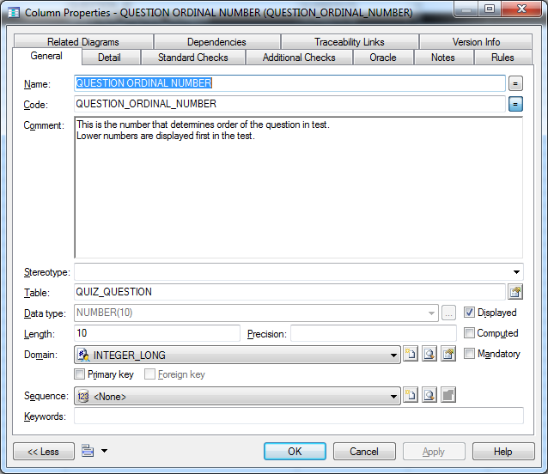

## File Locations

Power Designer Database Model:

\youtestme\db\dbmodel\YOUTESTME_ER_DIAGRAM.pdb

Utility database scripts:

\youtestme\db\dbmodel\scripts\

# Source Control System – Subversive SVN

Policies:

1. Never check in the code that does not compile!
2. Code in SVN has be complete – anybody should be able to check out entire project from SVN and be able to compile it without any fixing, adding libraries and similar.
3. Eclipse hidden files “.project” and “.classpath” have to be checked into SVN because project cannot be opened in Eclipse without them. Any other file required to open and build the project from scratch has to be checked into SVN.
4. Update and Commit your code frequently to avoid code conflicts.
5. Use SVN to Rename, Move or Remove files.
6. Communicate your development plans to other team members.
7. Do not check in things in SVN that do not belong there (for example: third party software or manuals). We keep those in designated directory.
8. Never put the Java source code in production. Always deploy application as “jar”, “war” or “ear”.
9. Occasionally test your code by checking it out (or exporting it) to empty directory and try to compile it. If there are errors then code is not properly checked into SVN or it is not complete. You should fix it as soon as possible. Please see prescribed procedure below.

### Refreshing Working Directory

This procedure is required in order to solve following problems:

1. Identify files that are required for the project but they are not checked into SVN
2. Resolve occasional issues with SVN

Procedure should be done every time you suspect that something is not right, files are missing or experiencing issues with SVN that cannot be easily resolved (say by SVN cleanup). It is recommended that it is executed at least once a week even if no problems are encountered.

#### Procedure

Assume that your working directory structure looks like this:

C:\Zoran\Development\youtestme

\youtestmedoc

\res

\doc

Refreshing procedure should be as follows:

1. Rename directory “C:\Zoran\Development” to “C:\Zoran\Development-Nov-16-2014”
2. Create new directory “C:\Zoran\Development”
3. Check out fresh copy of the code form SVN into “C:\Zoran\Development”  
   You can use SVN batch scripts from “\res\Scripts\SVN DOS Scripts\” to do this automatically.
4. Use “C:\Zoran\Development” for development
5. Use old directory “C:\Zoran\Development-Nov-16-2014” only for reference (do not use it for development anymore!). For example if you forgot to check in some files you can find them in this old directory.

## SVN Repositories

Note that with migration of SVN server to different platform you may need to add “/svn” in the path, for example:

http://mallocinc.dnsalias.com:59880/svn/youtestme

|  |  |  |
| --- | --- | --- |
| **#** | **Repository URL** | **Description** |
| 1. | <http://mallocinc.dnsalias.com:59880/dba> | Database Analyzer Development |
| 2. | <http://mallocinc.dnsalias.com:59880/res> | Resources |
| 3. | <http://mallocinc.dnsalias.com:59880/doc> | Documentation |
| 4. | [http://mallocinc.dnsalias.com:59880/www](http://zserver:9880/www) | Web development |
| 5. | <http://mallocinc.dnsalias.com:59880/restate> | Real Estate (demo project) |
| 6. | <http://mallocinc.dnsalias.com:59880/test> | Sandbox – testing repository |
| 7. | <http://mallocinc.dnsalias.com:59880/admin> | Administrator’s documents (restricted access to administrators only). |
| 8. | <http://mallocinc.dnsalias.com:59880/youtestme> | YouTestMe Application code |
| 9. | <http://mallocinc.dnsalias.com:59880/youtestmedoc> | YouTestMe Documentation |
| 10. | <http://mallocinc.dnsalias.com:59880/youtestme_sws> | YouTestMe Social Web Site Application code |
| 11. | <http://mallocinc.dnsalias.com:59880/youtestmedoc_sws> | YouTestMe Social Web Site Documentation |

NOTE: Use code from “trunk” for development.

# UTF-8 Character Encoding

Unicode UTF-8 character encoding will be used by default. Application has to support all languages and as many special characters as possible.

# WWW Development

Each developer should do development in your own instance of the application server. This way he/she is free to experiment and conflicts are avoided.

## Fonts

“Tahoma” or “Arial” family fonts are used as default fonts for:

* Text on the web site.
* Documentation

## Using Microsoft Web Expression 4

Set default font to “Tahoma” by following this procedure:

* Go to: Tools -> Page Editor Options
* Choose tab: “Default Fonts”
* For every “Language (character set)” change “Default Proprtional Font” to “Tahoma”. Please see picture below for reference.

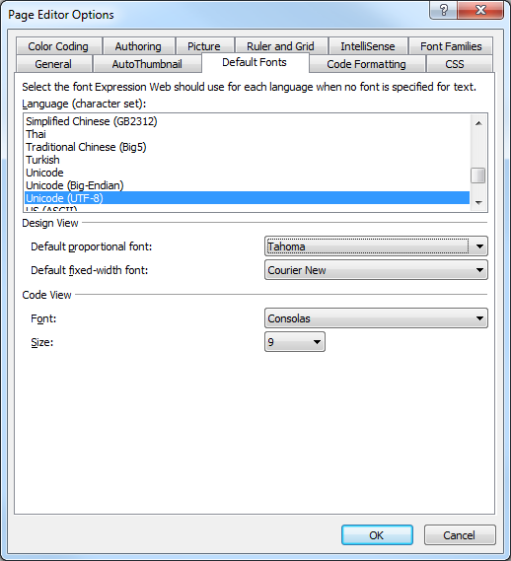

# Good Programming Practices

## Automation

Write a script for everything even if you are going to execute it only a few times. You may reuse it later and it may be used as reference what was done.

## SQL Coding

### Sample 1

Sample of the well formatted SQL Code (every condition on the new line):

CREATE OR REPLACE VIEW V_TABLESPACE_USED

(TABLESPACE_NAME

,TABLESPACE_SIZE_MB

,USED

,AVAIL

,USED_VISUAL

,PCT_USED)

AS

SELECT DF.TABLESPACE_NAME TSNAME

, SUM(DF.BYTES)/1024/1024 TBS_SIZE_MB

, ROUND(NVL(SUM(E.USED_BYTES)/1024/1024,0),2) USED

, ROUND(NVL(SUM(F.FREE_BYTES)/1024/1024,0),2) AVAIL

, RPAD(' '||RPAD('X',ROUND(SUM(E.USED_BYTES)

*10/SUM(DF.BYTES),0), 'X'),11,'-') USED_VISUAL

, ROUND(NVL((SUM(E.USED_BYTES)*100)/SUM(DF.BYTES),0), 2) PCT_USED

FROM DBA_DATA_FILES DF

, (SELECT FILE_ID

, SUM(NVL(BYTES,0)) USED_BYTES

FROM DBA_EXTENTS

GROUP BY FILE_ID) E

, (SELECT SUM(NVL(BYTES, 0)) FREE_BYTES

, FILE_ID

FROM DBA_FREE_SPACE

GROUP BY FILE_ID) F

WHERE E.FILE_ID(+) = DF.FILE_ID

AND DF.FILE_ID = F.FILE_ID(+)

GROUP BY DF.TABLESPACE_NAME

UNION

/*

Include Temporary tablespace

*/

SELECT DF.TABLESPACE_NAME TSNAME

, SUM(DF.BYTES)/1024/1024 TBS_SIZE_MB

, ROUND(NVL(SUM(E.USED_BYTES)/1024/1024,0),2) USED

, ROUND(NVL(SUM(F.FREE_BYTES)/1024/1024,0),2) AVAIL

, RPAD(' '||RPAD('X',ROUND(SUM(E.USED_BYTES)

*10/SUM(DF.BYTES),0), 'X'),11,'-') USED_VISUAL

, ROUND(NVL((SUM(E.USED_BYTES)*100)/SUM(DF.BYTES),0), 2) PCT_USED

FROM DBA_TEMP_FILES DF

, (SELECT FILE_ID

, SUM(NVL(BYTES,0)) USED_BYTES

FROM DBA_EXTENTS

GROUP BY FILE_ID) E

, (SELECT SUM(NVL(BYTES, 0)) FREE_BYTES

, FILE_ID

FROM DBA_FREE_SPACE

GROUP BY FILE_ID) F

WHERE E.FILE_ID(+) = DF.FILE_ID

AND DF.FILE_ID = F.FILE_ID(+)

GROUP BY DF.TABLESPACE_NAME

ORDER BY 6

Note comma (“,”) at the begging of the line – not at the end.

Also note alignment of the columns and aliases.

There should be NO **blank lines** and **trailing spaces** in SQL statements.

### Sample 2

/*==============================================================

View: V_ST_QUIZ

This view is used only to load data from staging tables to

permanent tables.

==============================================================*/

CREATE OR REPLACE VIEW V_ST_QUIZ AS

SELECT

ST_QUIZ.ST_QUIZ_ID

,ST_QUESTION.ST_QUESTION_ID

,ST_ANSWER.ST_ANSWER_ID

,ST_QUIZ.USERNAME

,ST_QUIZ.PASSWORD

,ST_QUIZ.USER_ID

,ST_QUIZ.QUIZ_NAME

,ST_QUIZ.DEFAULT_DURATION

,ST_QUIZ.USERS_COMMENT

,ST_QUIZ.DEFAULT_ENABLED_FROM

,ST_QUIZ.DEFAULT_ENABLED_TO

,ST_QUIZ.RESULT_TRANSPARENCY

,ST_QUIZ.DURATION_FACTOR

,ST_QUIZ.STATUS

,ST_QUIZ.CREATE_USER_ID

,ST_QUIZ.CREATE_DATETIME

,ST_QUESTION.ARTIFICIAL_QUESTION_ID QST_ARTIFICIAL_QUESTION_ID

,ST_QUESTION.QUESTION_TEXT

,ST_QUESTION.PICTURE

,ST_QUESTION.DURATION

,ST_QUESTION.DIFFICULTY

,ST_QUESTION.POINTS

,ST_QUESTION.ORDINAL_NUMBER QUESTION_ORDINAL_NUMBER

,ST_ANSWER.ARTIFICIAL_QUESTION_ID ANS_ARTIFICIAL_QUESTION_ID

,ST_ANSWER.ANSWER_TEXT

,ST_ANSWER.ORDINAL_NUMBER ANSWER_ORDINAL_NUMBER

,ST_ANSWER.CORRECT_ANSWER_IND

FROM ST_QUIZ,

ST_QUESTION,

ST_ANSWER

WHERE ST_QUIZ.ST_QUIZ_ID = ST_QUESTION.ST_QUIZ_ID

AND ST_QUIZ.ST_QUIZ_ID = ST_ANSWER.ST_QUIZ_ID

AND ST_QUESTION.ARTIFICIAL_QUESTION_ID = ST_ANSWER.ARTIFICIAL_QUESTION_ID

ORDER BY ST_QUIZ.ST_QUIZ_ID

,ST_QUESTION.ST_QUESTION_ID

,ST_ANSWER.ST_ANSWER_ID

;

comment on table V_ST_QUIZ is

'Used during load from staging tables into permanent tables in the database';

comment on column V_ST_QUIZ.ST_QUIZ_ID is

'Primary key';

comment on column V_ST_QUIZ.ST_QUESTION_ID is

'Primary key of table table ST_QUESTION_ID';

comment on column V_ST_QUIZ.ST_ANSWER_ID is

'Primary key of table table ST_ANSWER';

comment on column V_ST_QUIZ.USERNAME is

'Username has to be unique across the system.

Use of email adress is encouraged however it cannot be enforced because many

user will not have e-mail addresses or they will not provide it for various

reasons. ';

comment on column V_ST_QUIZ.QUIZ_NAME is

'Name (Title) of this test.';

comment on column V_ST_QUIZ.DEFAULT_DURATION is

'Test duration in seconds.

This is time available to complete the test once test instance started.';

comment on column V_ST_QUIZ.DURATION_FACTOR is

'Factor (in percents, for example: -40%, +120%, +300%) - how much the available

time for answering the questions should be shortened or prolonged.

Apply duration factor to the length of every question.

On this way duration of the questions can be parametrized.';

comment on column V_ST_QUIZ.STATUS is

'"S" - Loaded only in staging tables

"L" - Loaded into permanent tables, data from staging tables can be deleted';

comment on column V_ST_QUIZ.QST_ARTIFICIAL_QUESTION_ID is

'This is number assigned by user in order to link questions with answers in

excel.';

comment on column V_ST_QUIZ.PICTURE is

'This is picture that is displayed with question.';

comment on column V_ST_QUIZ.DURATION is

'Duration of the question in seconds.

This is optional value and it is intended to be used to limit time available to

answer this question.';

comment on column V_ST_QUIZ.DIFFICULTY is

'This is degree of difficulty.

Higher number represents higher difficulty of question.';

comment on column V_ST_QUIZ.POINTS is

'Number of points that person gets by answering this question correctly.

For example difficult questions can score more points than the others.

This is the "weight" of the question. ';

comment on column V_ST_QUIZ.QUESTION_ORDINAL_NUMBER is

'This number determines the order of this question as it appears on the test.

Lower numbers are displayed first. If this number is not present then questions

will be displayed in default order.';

comment on column V_ST_QUIZ.ANSWER_ORDINAL_NUMBER is

'This number determines the order of this answer as it appears on the test.

Lower numbers are displayed first. If this number is not present then answers

will be displayed in default order.';

comment on column V_ST_QUIZ.CORRECT_ANSWER_IND is

'Indicates if this is the correct answer.';

You can use configurable SQL code formatter from Aqua Data Studio to assist you with complex statements:

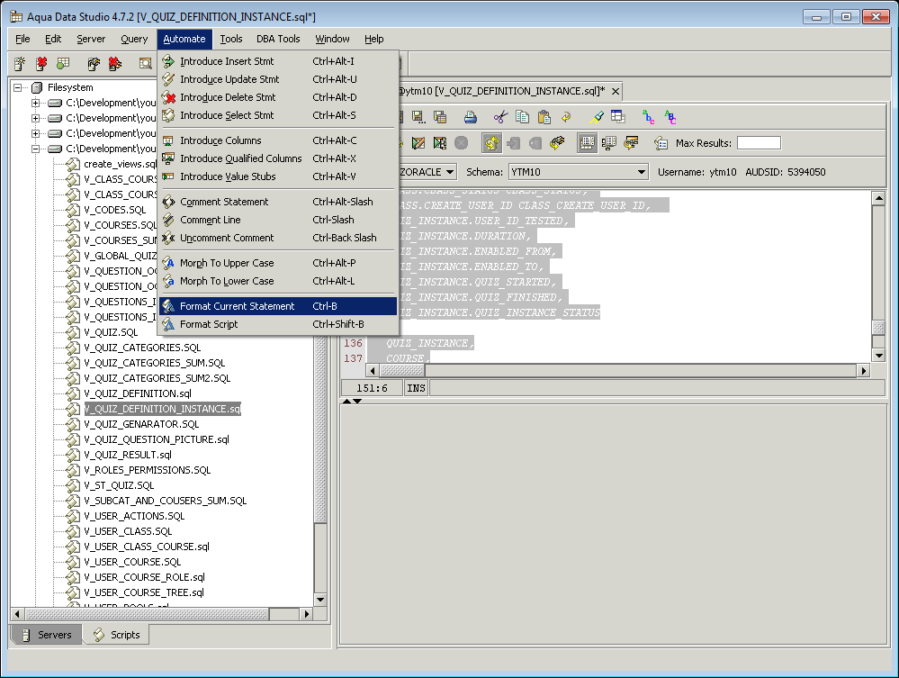

### SQL Formatting Utilities

#### Poor SQL

<http://poorsql.com/>

or command line tool:

\res\ProgramFiles\sqlformatter\SqlFormatter.exe

Sample usage:

DOS:> sqlformatter v_user_pools.sql

#### SQLinForms

<http://www.sqlinform.com/default.html>

Highly recommended by:

<http://www.dba-oracle.com/t_formatting_oracle_sql.htm>

**!!! Do not code like this !!!**

CREATE OR REPLACE VIEW V_QUIZ_DEFINITION_INSTANCE ("QUIZ_INSTANCE_ID", "QUIZ_DEFINITION_ID", "USER_ID", "QUIZ_CATEGORY_ID", "QUIZ_NAME", "DEFAULT_DURATION", "USERS_COMMENT", "DEFAULT_ENABLED_FROM", "DEFAULT_ENABLED_TO", "DISPLAY_ANSWER_IND", "DISPLAY_CORRECT_IND", "DURATION_FACTOR", "QUIZ_DEF_CREATE_USER_ID", "QUIZ_DEF_CREATE_DATETIME", "QUIZ_DEF_UPDATE_USER_ID", "QUIZ_DEF_UPDATE_DATETIME", "CATEGORY_NAME", "QUIZ_CATEGORY_DESCRIPTION", "COURSE_ID", "COURSE_NAME", "COURSE_CODE", "COURSE_STATUS", "COURSE_DESCRIPTION", "COURSE_CREDITS", "CLASS_ID", "CLASS_NAME", "CLASS_CODE", "CLASS_ACTIVE_FROM", "CLASS_ACTIVE_TO", "CLASS_STATUS", "CLASS_CREATE_USER_ID", "USER_ID_TESTED", "QUIZ_INST_DURATION", "QUIZ_INST_ENABLED_FROM", "QUIZ_INST_ENABLED_TO", "QUIZ_INST_STARTED", "QUIZ_INST_FINISHED", "QUIZ_INSTANCE_STATUS") AS....

### WRONG SQL ALIGNMENT

SELECT

QUIZ_INSTANCE.QUIZ_INSTANCE_ID QUIZ_INSTANCE_ID,

QUIZ_INSTANCE.QUIZ_DEFINITION_ID,

QUIZ_INSTANCE.USER_ID_TESTED USER_ID_TESTED,

QUIZ_RESULT.QUIZ_RESULT_ID QUIZ_RESULT_ID,

QUIZ_RESULT.QUESTION_ID QUESTION_ID,

QUIZ_RESULT.ANSWER_TEXT ANSWER_TEXT,

QUIZ_RESULT.NOT_SURE_FLAG NOT_SURE_FLAG,

QUIZ_RESULT.POINTS_ASSIGNED POINTS_ASSIGNED,

QUIZ_RESULT.CREATE_USER_ID Q_RESULT_CREATE_USER_ID,

WHERE UNIQUE_QUIZ.QUIZ_DEFINITION_ID = QUIZ_DEFINITION.QUIZ_DEFINITION_ID

AND UNIQUE_QUIZ.UNIQUE_QUIZ_ID = QUIZ_QUESTION.UNIQUE_QUIZ_ID

AND QUIZ_QUESTION.QUESTION_ID = QUESTION.QUESTION_ID

AND QUESTION.QUESTION_ID = ANSWER.QUESTION_ID (+)

### CORRECT SQL ALIGNMENT

SELECT

QUIZ_INSTANCE.QUIZ_INSTANCE_ID QUIZ_INSTANCE_ID

,QUIZ_INSTANCE.QUIZ_DEFINITION_ID

,QUIZ_INSTANCE.USER_ID_TESTED USER_ID_TESTED

,QUIZ_RESULT.QUIZ_RESULT_ID QUIZ_RESULT_ID

,QUIZ_RESULT.QUESTION_ID QUESTION_ID

,QUIZ_RESULT.ANSWER_TEXT ANSWER_TEXT

,QUIZ_RESULT.NOT_SURE_FLAG NOT_SURE_FLAG

,QUIZ_RESULT.POINTS_ASSIGNED POINTS_ASSIGNED

,QUIZ_RESULT.CREATE_USER_ID Q_RESULT_CREATE_USER_ID

WHERE UNIQUE_QUIZ.QUIZ_DEFINITION_ID = QUIZ_DEFINITION.QUIZ_DEFINITION_ID

AND UNIQUE_QUIZ.UNIQUE_QUIZ_ID = QUIZ_QUESTION.UNIQUE_QUIZ_ID

AND QUIZ_QUESTION.QUESTION_ID = QUESTION.QUESTION_ID

AND QUESTION.QUESTION_ID = ANSWER.QUESTION_ID (+)

## Java Code Formatting

We should all use same formatting style. Use this code formatting configuration file for Eclipse:

In Eclipse, go to “Window” -> “Preferences” and choose “Formatter as show on the picture below.

Then use button “Import” and choose this XML file:

\youtestme\cfg\Eclipse\ytm_eclipse_java_code_formatting.xml

Clisk “OK” to close the window.

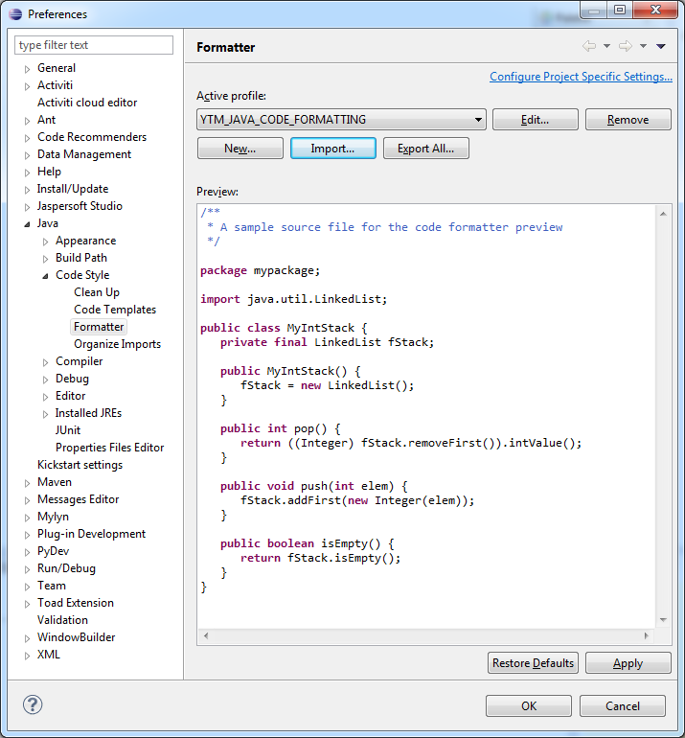

Java code formatter is executed when you place cursor anywhere in the Java code widow and press: “Ctrl”+”Shift”+”F”

All code should be uniform across the project.

# Setting up Eclipse English Dictionary

Team should be using the same English dictionary for the project.

The location of the file is:

**\youtestme\cfg\Eclipse\ytm_eclipse_dictionary.txt**

In eclipse it is set up as shown on the screen:

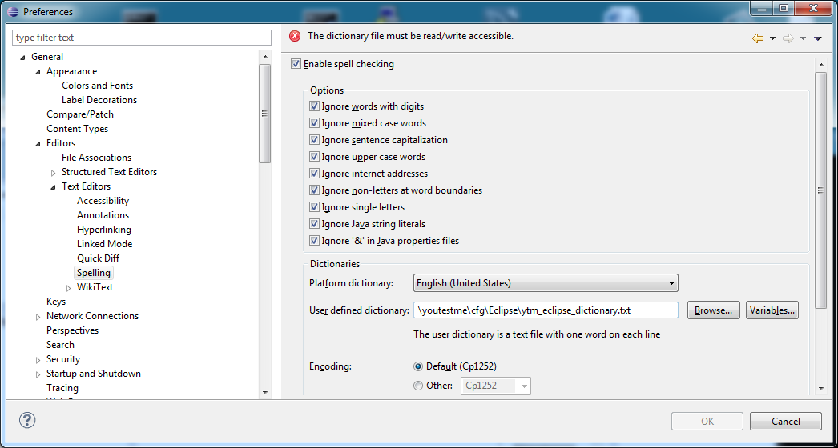

Team members should check in dictionary file into SVN.

This way, new words will be available to other team members.

# User Interface design

Gaps marked in red should be constant and independent of screen resizing.

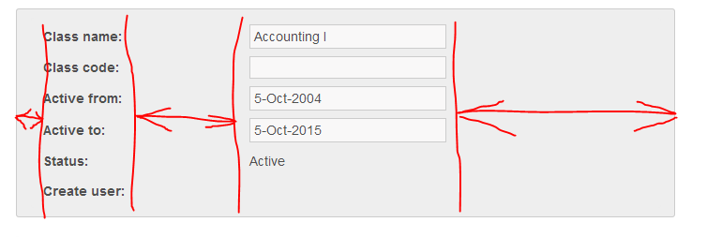

# FTP for Developers

Host name: “s117953983.onlinehome.us”

|  |  |  |
| --- | --- | --- |
| **#** | **Username** | **Password** |
|  | u37512132-ytmftp | 22ytm12! |

# Instructional Videos

|  |  |  |
| --- | --- | --- |
| **#** | **Link to the Presentation** | **Description** |
|  | <http://videos.youtestme.com/SVNPractice.mp4> | SVN Practice |
|  | <http://videos.youtestme.com/svncrashcourse.mp4> | SVN Crash Course |
|  | <http://videos.youtestme.com/GDAOUserRolesSample.mp4> | How to use GDAO on YouTestMe Project |
|  | <http://videos.youtestme.com/GDAOTransferObjects.mp4> | GDAO Transfer Objects (TO) |
|  | <http://videos.youtestme.com/RunDBAFromEclipse.mp4> | Running DBA from Eclipse |
|  | <http://videos.youtestme.com/YTMEnvironments.mp4> | Relevant information about Development and Integration testing environments |

# Eclipse DBA Application Troubleshooting

If you have problem running Database Analyzer from Eclipse try one or both of the following:

1. Start eclipse with “eclipse –clean”
2. In “dependencies” remove all invalid plug-ins (they will have invalid symbol in front) and then click on “Add Required Plug-Ins” (picture below). This is because you may have 32 bit platform and you are trying to run 64 bit plug ins (or vice versa)

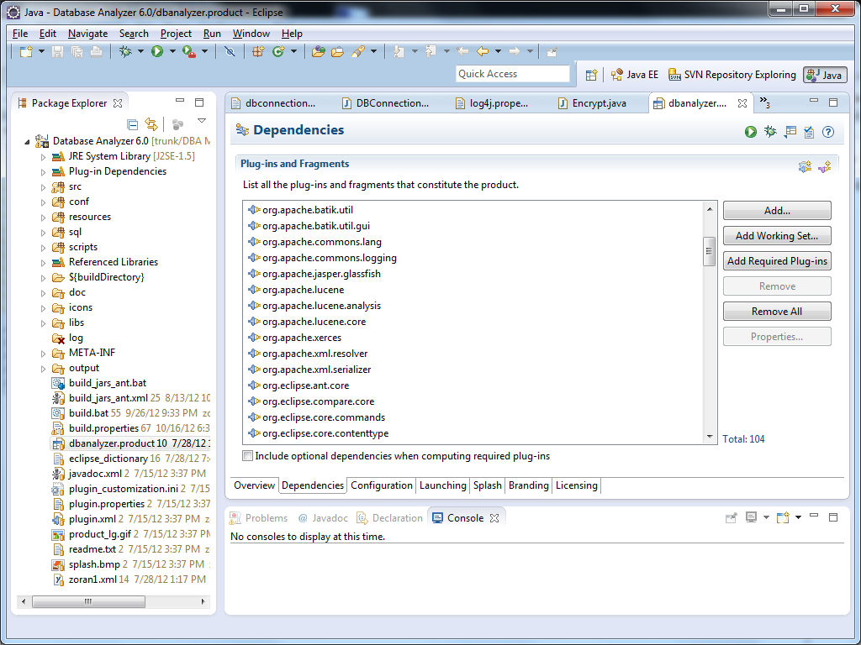

# Manual Application Build and Deploy

Use windows remote desktop to log in to application server:

IP: [home.mallocinc.com:55240](http://home.mallocinc.com:55240) (primary application server)

IP: [home.mallocinc.com:56240](http://home.mallocinc.com:56240) (secondary application server)

Note that if application is accessed on port “55…” then it runs on server with remote desktop on port “55240”. Similarly, if application is accessed on port “56…” then it runs on server with remote desktop on port “56240”.

Log in using one of three usernames:

* ytm
* ytm2
* ytm3

For example, if you would like to build and restart application “/you30” then you should log in as “ytm3”.

Go to directory:

\youtestme\www_source\redeploy.bat

Open DOS command window and run this script:

“redeploy.bat”

This script should do the following:

* Stop Tomcat
* Update code from SVN
* Compile and build the code
* Deploy the code
* Start Tomcat

You can see the log from the whole process in this directory:

\youtestme\www_source\log\

Log file will have name in format “redeploy_” + datetime, for example:

redeploy_Wed11-19-2014@12-03-23.41.log

Application can be accessed at links below:

Primary application server:

http://206.248.172.39:55241/ytm/

http://206.248.172.39:55242/ytm20/

http://206.248.172.39:55243/ytm30/

Secondary application server:

http://206.248.172.39:56241/ytm/

http://206.248.172.39:56242/ytm20/

http://206.248.172.39:56243/ytm30/

Demo web site:

http://demo.youtestme.com

or

http://206.248.172.39:56243/ytm30/

IP address 206.248.172.39 could be replaced by "home.mallocinc.com"