YouTestMe

Frequently Asked Questions
Installation and Support

File name | YTM Installation and Support - FAQ
Author | YouTestMe
Confidentiality | Internal
Last save date | Tuesday, April-07-2020 at 6:29:00 PM

Table of Contents
1 Application hosting 4
1.1 Hosting the application on YTM cloud server or on-premise 4
1.2 On-premise hosting installation 5
1.3 Cloud-based hosting installation 5
1.4 How is the product delivered? 5
1.5 Can we run the platform on the local network server of the company? 5
1.6 How do we perform AD synchronization if you are hosting our application? 5
1.7 Can GetCertified be used on our company's server and not via a 3rd party cloud account? I see that no internet connection is needed, does that mean it can be used on a private Wi-Fi network? 6
2 Application possibilities 7
2.1 Is it possible to get a fully functional demo? 7
2.2 What kind of integrations are supported? 7
2.3 Can the application be used in different locations? 7
2.4 Do you support the option of paper-based exams with an OMR tool: 7
2.5 Can YouTestMe products exchange data with other systems? 8
2.6 Does YouTestMe software support tests for Permits to Work (PTW) System Evaluation? 8
2.7 Could GetCertified be loaded/run through a laptop? Something like an interim solution while we migrate content and pilot test, but before we begin to receive actual test-taker data. Is that feasible? 8
3 Initial data load 9
3.1 What are the types of data load that you provide? 9
3.2 What metrics come standard with your software? 9
4 Opportunities for the Government 10
4.1 Can government bodies use YouTestMe GetCertified if there is a requirement for GSA Approval? 10
4.2 Can government bodies use YouTestMe GetCertified if there is a requirement for a FedRAMP Certificate? 10
4.3 How is the software application being delivered to government institutions? (Installation behind a firewall)? 10
5 Installation 11
5.1 How do I get and install the application? 11
5.2 Could the product be installed in a Windows environment, such as Windows 2016 Server, IIS, or Apache? 11
5.3 What are the minimum server capacity requirement for GetCertified and Classroom 2020? 11
5.4 What are the system hardware requirements? 12
5.5 Is the Load Balancer a requirement to run the software in the architectural footprint used to manage the number of users hitting the application server cluster? 13
5.6 Can you send software and version numbers for supported operating systems and databases? 13
5.7 The architecture is determined based on how many concurrent users will be accessing the system? 14
6 Support 15
6.1 Software maintenance plan 15
6.2 What kind of support is available? 15
6.3 Is your application in the public cloud option and multi-tenant with other customers? Would we have dedicated servers just for our data? 16
6.4 Does your organization have security accreditations for hosting your applications in the cloud and/or your business processes? 16
6.5 Does OVH have security accreditations for their hosting services? 16
6.6 Does the cloud-hosted option encrypt data in transit (TLS) and at rest (database)? 16
6.7 What happens in the case when a client does not want to extend the hosting & support of the application? 16
6.8 What is the method of database encryption? Is it using PostgreSQL-based encryption (e.g., TDE) or another mechanism? 17
6.9 Can the client preserve his domain on our cloud if he purchases the on-cloud YouTestMe GetCertified version? 17
6.10 In the Technical details on your website, it is listed that Oracle VirtualBox and VMWare are supported, but is Hyper-V supported as well? Would an instance using Hyper-V not function at all, or would it merely negate any assistance troubleshooting any issues? 17
6.11 Does YouTestMe have an API layer with which we could integrate? 17
6.12 Does GetCertified support single sign-on (Active Directory integration)? 18
6.13 If we wanted to manage the application server cluster on our own, could we do that? 19
6.14 What kind of software do you use to manage the application server cluster? 19
6.15 Does your application support data encryption at rest? 20
6.16 Is integration possible with Moodle, the LMS we use? 20
7 Security 21
7.1 If a change or modification is possible, is it possible for us to make our changes (i.e., Would we be able to access the source code once purchased)? 21
7.2 How often are the security patches released? 21
7.3 Do you use any standard security guidelines? 21
7.4 We have a general question about data protection compliance with GDPR. 21

Application hosting

Hosting the application on YTM cloud server or on-premise
The application can be hosted on YouTestMe cloud servers or your premises (the server of your choice).
- On-premise does not require connection to the Internet, and whole virtual infrastructure will be installed behind your firewall.
- It also means that you are responsible for the complete hosting process:
  - Servers
  - Hardware and software
  - Data backups
  - Storage
  - Disaster recovery.
If you choose to host YouTestMe GetCertified Standard Edition on YouTestMe cloud servers:
- All system components are always hosted exclusively using the infrastructure provided by our hosting provider - OVH - https://www.ovh.com/world/about-us
- You can have a dedicated server for your data
- OVH guarantees that your Private Cloud complies with:
  - ISO/IEC 27001:2013 certification
  - SOC 1 Type II (SSAE 16 and ISAE 3401)
  - SOC 2 Type II international certifications and PCI DSS level 1 certification https://www.ovh.com/world/private-cloud/documentation/certifications.xml
- At the point when you want to migrate the application on your premises, the migration is free of charge
The main difference between hosting the application on our cloud or your premises would be that our team does complete maintenance.

On-premise hosting installation
If you choose to host the application on our premises, we will provide you with our installation manual: https://wiki.youtestme.com/youtestme/youtestmedoc/Sales/Documentation%20for%20clients/YouTestMe%20-%20Installation%20and%20Support%20Manual%20-%20PostgreSQL.pdf
We can also arrange a WebEx call to help you with the process of installation.

Cloud-based hosting installation
If you choose to host the application on the cloud - the set-up process is performed by the YTM team.

How is the product delivered?
YouTestMe GetCertified can be delivered:
- Via a password-protected download link
- On a USB memory stick
The total size of YouTestMe GetCertified is around 25GB.

Can we run the platform on the local network server of the company?
Our software is distributed as a Virtual Appliance that can be installed on the client's premises or a cloud server, thus giving you full control over the applications and data.

How do we perform AD synchronization if you are hosting our application?
Synchronizing with the Active Directory stays the same whether the application is hosted on our cloud or your premises.:
- LDAP bind is used to validate user credentials
- When a user enters their credentials, they are sent via LDAP protocol to the Active Directory for validation.
- All you need to do to enable this functionality is to fill in the adequate information in the configuration panel:
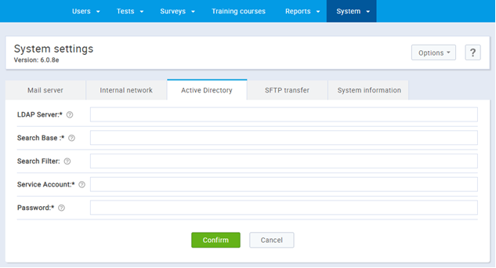
- Once you’ve filled in the appropriate values, you can synchronize users from the panel for managing users:
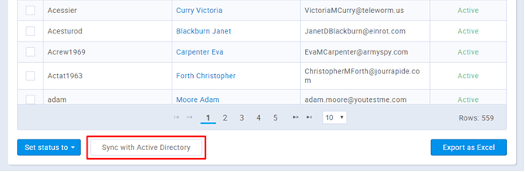

Can GetCertified be used on our company's server and not via a 3rd party cloud account? I see that no internet connection is needed, does that mean it can be used on a private Wi-Fi network?
YouTestMe GetCertified is distributed as a pre-configured Virtual Appliance that can be easily deployed on cloud or on-premises.
If it is hosted on-premises, the server can be behind the firewall, it does not require an Internet connection and can fully function within the institution's intranet.
This type of deployment has proved to be the best solution for government institutions that need full control of the system and have strict requirements regarding data security and privacy.
Other advantages of this type of deployment are:
- Easy installation and configuration - the entire system can be deployed within minutes
- Secure backup and restore of the whole system
- Smooth migration to other servers or other physical locations
- The ability to easily duplicate the entire system and deploy multiple instances

Application possibilities

Is it possible to get a fully functional demo?
We provide a cloud-based, fully functional 14-day personal demo that is hosted on our secure cloud servers.

What kind of integrations are supported?
YouTestMe applications can be integrated with a wide range of platforms and services using various protocols, such as :
- Active Directory
- FTP
- REST
- API
- Single Sign-On, etc
We can also enable other integrations if you need them:
- YouTestMe GetCertified is designed and opened to support a wide range of customizations and integrations with other systems
- Each integration with other systems can be designed and implemented based on the client-specific needs and available integration protocols
- YouTestMe specializes in building custom made services and endpoints which implement the client’s custom use-cases
- YouTestMe GetCertified has extendable standard REST-API endpoints, which can be used for integrations with other systems.
- Various integrations/synchronizations through the flat file interfaces are also supported and can be adapted to the specific use cases and protocols.

Can the application be used in different locations?
Each location would require one YouTestMe software copy and license if they are not on the same network.
It means that if all of your users can access the same web server, then you would need only one license.
If some of your users cannot access that web server, then you would need to install another server on their location/network, which requires another license.

Do you support the option of paper-based exams with an OMR tool:
YouTestMe GetCertified enables paper-based exams. Once you create tests inside the system, you can export them as PDF files.
The OMR support is in the final stages of the development, and it will be included in one of the next releases.

Can YouTestMe products exchange data with other systems?
YouTestMe offers the following options for data exchange:
- Export of data in CSV and Excel format (provided by default),
- Export of data as PostgreSQL dump files (supplied by default),
- Export of data in a custom format as per the client’s specification,
- Custom API as per the client’s specification,
- We offer assistance and custom development for data import into one or multiple target platforms

Does YouTestMe software support tests for Permits to Work (PTW) System Evaluation?
Yes. It can be adjusted to support all types of standards.

Could GetCertified be loaded/run through a laptop? Something like an interim solution while we migrate content and pilot test, but before we begin to receive actual test-taker data. Is that feasible?
GetCertified can be run on a laptop. Considering that YouTestMe GetCertified is distributed as a Virtual Appliance, installed on a workstation or small server, a physical machine (host) should have at least:
- 16GB RAM
- Minimum 350GB free space of HDD/SSD disk
- YouTestMe GetCertified will not start if you assign less than 8GB of RAM to YTM Virtual Machine.
Once you expand your server capacity, you can easily migrate YouTestMe GetCertified from a laptop to your server. We will help you during that process if any support is necessary.

Initial data load

What are the types of data load that you provide?
We provide service of loading data into the system before the delivery. Still, the system is user-friendly, and you can import data on your own - manually, or using our predefined Excel templates for bulk upload.

What metrics come standard with your software?
All the required data is stored in the database.
This data is combined and usually displayed in a tabular form. The “Reports” section that can be accessed via the main menu is specifically designed to provide information related to all segments of the application and user activity.
Many reports can be found across different screens of the application to display the most crucial information related to a specific module of the application. All of them can be exported in the form of an Excel table.
Many of the reports revolve around the data points you emphasized and provide the metrics you mentioned. In the subsequent paragraphs, we will highlight the location and function for most of these reports but also reports in general.

Opportunities for the Government

Can government bodies use YouTestMe GetCertified if there is a requirement for GSA Approval?
Yes, they can. Our partner company has GSA Approval; therefore, our application satisfies these requirements.

Can government bodies use YouTestMe GetCertified if there is a requirement for a FedRAMP Certificate?
YouTestMe GetCertified has the opportunity to provide a FedRAMP Certificate in about five months period from signing the agreement with a government body to match security to moderate risk.
To get the FedRAMP Certificate to match security to low and tailored – for Low-Impact SaaS risk, the process will take no more than a half of that period.
Our partner has a Red Hat® OpenStack-based cloud. In compliance with FedRAMP guidelines, he is managed by US citizens in the US-based Network Operations Center (NOC) and Security Operations Center (SOC) to maintain the security and performance of all associated data and applications.

How is the software application being delivered to government institutions? (Installation behind a firewall)?
YouTestMe application is distributed as a pre-configured Virtual Appliance that can be easily deployed on cloud or on-premise.
If it is hosted on-premises, the server can be behind the firewall, it does not require an Internet connection and can fully function within the institution's intranet.
This type of deployment has proved to be the best solution for government institutions that need full control of the system and have strict requirements regarding data security and privacy.
Some examples of this type of deployment are FBI, Serbia and Montenegro Air Traffic Services (SMATSA), and many others.
Other advantages of this type of deployment are:
- Easy installation and configuration - the entire system can be deployed within minutes
- Secure backup and restore of the whole system
- Smooth migration to other servers or other physical locations
- The ability to easily duplicate the entire system and use multiple instances.

Installation

How do I get and install the application?
There are two ways to install the application:
- The application comes as an archived virtual appliance package. To install it, you will need a hypervisor software installed, such as VMware Workstation, to deploy and run YTM Virtual Machine. Consult our implementation guide for a step-by-step procedure.
- Host the application in the YouTestMe Data Centre, in which case no installation is necessary. However, you would need to contact our Support team for hosting services.

Could the product be installed in a Windows environment, such as Windows 2016 Server, IIS, or Apache?
YouTestMe GetCertified is delivered in a plug-and-play pre-configured Virtual Appliance, and as such, requires to be deployed into a hypervisor software.
The host server can run any operating system, as long as it has suitable hypervisor software installed on it (e.g., Oracle VirtualBox, VMware Player, VMware ESXi).

What are the minimum server capacity requirement for GetCertified and Classroom 2020?
YouTestMe is a complex server-based system. It consists of:
- YouTestMe application
- Oracle Linux host operating system
- PostgreSQL Database, scripts, and utilities.
They are all packaged in one pre-configured Virtual Machine, also called the Virtual Appliance.
Virtualization is a powerful enterprise software concept that greatly simplifies the distribution, installation, configuration, and maintenance of complex computer systems.
HARDWARE | MINIMAL | RECOMMENDED
CPU | 2 Virtual CPU Cores | 4 Virtual CPU Cores
RAM | 8 GB | 16 GB
HDD | 120 GB | 320 GB
Network Connection | Yes | Yes

Note that the above requirements are for the YouTestMe virtual machine. To be installed on a workstation or small server, the physical device should have at least 4 GM RAM and 50 GB free disk space MORE than the above-stated requirements. If you are installing VM on a “bare metal” server with hypervisors such as ESXi, then the above conditions are equal to what you need to be available on the physical server.
YouTestMe Virtual Machine should have a minimum of 2 virtual CPU cores assigned. It is required by the Linux operating system within a virtual machine.

What are the system hardware requirements?
The required capacity of the system depends on the following parameters:
- The number of concurrent users on the system
- Average load that one user generates on the system
- Type and performance of hardware (CPU type, storage type, network capacity, etc.)
The table below represents a comparison of various activities and their load on the system.
# | Activity | Load on the system
1 | Taking the test | Light
2 | Registering user | Light
3 | Downloading large files | Medium
4 | Running simple reports | Medium
5 | Running complex reports | Heavy
6 | Batch operations like loading large amount of data from external files | Heavy

The overall performance of the system will depend on the load and infrastructure capacity. For more precise estimates, we recommend doing a proof of concept designed to produce accurate data in the specific environment.
Thanks to its scalability, the system can be easily upgraded by adding more hardware resources. Based on the conservative estimates in terms of the load that will be put in the system, a table below lists recommended and minimum system hardware requirements.
No. of concurrent users | Recommended | Minimum
<100 | Software: YouTestMe GetCertified Standard Edition One VM (2 CPU, 16 GB RAM) | Software: YouTestMe GetCertified Standard Edition One VM (1 CPU, 8 GB RAM)
100-1,000 | Software: YouTestMe GetCertified Enterprise Edition - High Performance One DB VM (4CPU, 32 GB RAM) Two Application Server VMs (2CPU, 24 GB RAM) One Load balancer VM (1CPU, 16 GB RAM) | Software: YouTestMe GetCertified Enterprise Edition - High Performance One DB VM (2CPU, 16 GB RAM) Two Application server VMs (2CPU, 16 GB RAM) One Load balancer VM (1CPU, 8 GB RAM)  1
1,000-2,000 | Software: YouTestMe GetCertified Enterprise Edition - High Performance and High Availability Two DB VM (4CPU, 32 GB RAM) Three Application Server VMs (2CPU, 24 GB RAM) One Load balancer VM (1CPU, 16 GB RAM) | Software: YouTestMe GetCertified Enterprise Edition - High Performance and High Availability One DB VM (4CPU, 32 GB RAM) Three Application Server VMs (2CPU, 16 GB RAM) One Load balancer VM (1CPU, 16 GB RAM)  2
2,000+ | Software: YouTestMe GetCertified Enterprise Edition - High Performance and High Availability Plus Add one Application Server VMs (2CPU, 24 GB RAM) per 1,000 users beyond initial 2,000 concurrent users. Add 16 GB RAM and 2 CPU to the database instance per 1,000 users beyond initial 2,000 concurrent users | Software: YouTestMe GetCertified Enterprise Edition - High Performance and High Availability Plus Add one Application Server VMs (2CPU, 16 GB RAM) per 1,000 users beyond initial 2,000 concurrent users.

Values in brackets in the table above are per one Virtual Machine. CPU is a physical socket. YouTestMe supplies all VMs. Above recommendations are determined in extensive simulations with an average load on the system performed on the following server configuration:
Component | Specification
Motherboard and chipset | Supermicro X9SRE
CPU | One Intel Xeon E5-1650 6 Core CPU @3.2GHz
RAM | 64 GB
HDD | Local ATA, Non-SSD, Soft RAID 1
Hypervisor Software | VMware vSphere 5
Network Adapter | 1 Gbps

Is the Load Balancer a requirement to run the software in the architectural footprint used to manage the number of users hitting the application server cluster?
Yes. The Load Balancer is a requirement in every Enterprise Edition of YouTestMe GetCertified.

Can you send software and version numbers for supported operating systems and databases?
YouTestMe GetCertified supports all versions of the PostgreSQL database but is primarily certified for versions 10 and 11.
YouTestMe GetCertified is distributed as a Virtual Appliance that can run on any platform that supports VMware or Oracle VirtualBox. It does not depend on the underlying OS.
The virtual appliance includes Oracle Linux OS v7 and has all the required software components, preinstalled, and preconfigured. Configuring the virtual appliance to work with another operating system is possible but would need significant customization.

The architecture is determined based on how many concurrent users will be accessing the system?
Yes, the number of concurrent users is the main factor. We have done benchmarks on various configurations where we determined the limits of the system, and we use this matrix to determine the adequate architecture.
Number of concurrent users | Recommended | Minimum
<100 | Software: YouTestMe GetCertified Standard Edition  One VM (2 CPU, 16 GB RAM) | Software: YouTestMe GetCertified Standard Edition  One VM (1 CPU, 8 GB RAM)
100-1,000 | Software: YouTestMe GetCertified Enterprise Edition - High Performance  One DB VM (4CPU, 32 GB RAM)  Two Application Server VMs (2CPU, 24 GB RAM)  One Load balancer VM (1CPU, 16 GB RAM) | Software: YouTestMe GetCertified Enterprise Edition - High Performance  One DB VM (2CPU, 16 GB RAM)  Two Application server VMs (2CPU, 16 GB RAM)  One Load balancer VM (1CPU, 8 GB RAM)
1,000-2,000 | Software: YouTestMe GetCertified Enterprise Edition - High Performance and High Availability  Two DB VM (4CPU, 32 GB RAM)  Three Application Server VMs (2CPU, 24 GB RAM)  One Load balancer VM (1CPU, 16 GB RAM) | Software: YouTestMe GetCertified Enterprise Edition - High Performance and High Availability  One DB VM (4CPU, 32 GB RAM)  Three Application Server VMs (2CPU, 16 GB RAM)  One Load balancer VM (1CPU, 16 GB RAM)
2,000+ | Software: YouTestMe GetCertified Enterprise Edition - High Performance and High Availability Plus  Add one Application Server VMs (2CPU, 24 GB RAM) per 1,000 users beyond the initial 2,000 concurrent users.  Add 16 GB RAM and 2 CPU to the database instance per 1,000 users beyond initial 2,000 concurrent users | Software: YouTestMe GetCertified Enterprise Edition - High Performance and High Availability Plus  Add one Application Server VMs (2CPU, 16 GB RAM) per 1,000 users beyond the initial 2,000 concurrent users.

Support

Software maintenance plan
All new releases of the application with new features are included in the free support during the first year. With every new major version, we provide a free demo so you can try new features and decide if you want the upgrade your application.
After the first year, support is optional for on-premise deployments and includes everything mentioned above.
The on-premise edition of YouTestMe GetCertified is delivered in a pre-configured Virtual Appliance and requires minimal maintenance and support. All updates are delivered via a secure download link with easy to follow installation instructions.

What kind of support is available?
We offer the following support plans:
- Standard Support
- Enterprise Support
- Custom
Support | Description | Standard | Enterprise
User Manual | Collection of PDF documents for Users | Yes | Yes
Technical Documentation | Collection of PDF documents for System Administrators | Yes | Yes
Online instructional videos | Video tutorials for Users and System Administrators | Yes | Yes
Dedicated Administrators | The dedicated person for Technical support via WebEx, email or phone | No | Yes
Email | Support over email with up to 6 hours response time | Yes | Yes
Phone | 1-800 number with a live attendant available in regular working hours (9:00 Am – 5:00 PM EST) | No | Yes
24/7 Phone Support | Support over the phone during the whole year or in specified time frames | No | Yes
WebEx Online Sessions | With Cisco WebEx, you can share the screen with our support team. We can guide through application leaving you in full control of your system. | No | Yes

Custom support plan may include any combination of support options plus options shown in the table below:
Custom Support | Description
Custom video tutorials | Custom video tutorials for specific use cases with your branding
Custom manuals | Custom manuals for specific functions with your branding
On-site maintenance | YouTestMe technician at your site
On-site training | YouTestMe Instructor at your site

A cost estimate for the Custom support option will be provided for specific requirements.

Is your application in the public cloud option and multi-tenant with other customers? Would we have dedicated servers just for our data?
You can have a dedicated server for your data.

Does your organization have security accreditations for hosting your applications in the cloud and/or your business processes?
YouTestMe does not have the accreditation mentioned above. However, no system components are ever hosted on the YouTestMe data center. All system components are always hosted exclusively using the infrastructure provided by OVH.

Does OVH have security accreditations for their hosting services?
OVH guarantees that your Private Cloud complies with:
- ISO/IEC 27001:2013 certification
- SOC 1 Type II (SSAE 16 and ISAE 3401)
- SOC 2 Type II international certifications and PCI DSS level 1 certification. https://www.ovh.com/world/private-cloud/documentation/certifications.xml

Does the cloud-hosted option encrypt data in transit (TLS) and at rest (database)?
Yes, the cloud-hosted option does encrypt data in transit (TLS) and at rest (database).

What happens in the case when a client does not want to extend the hosting & support of the application?
The client is the owner of the application and the VM.
If the client does not want to extend the hosting & support, YouTestMe is forced to stop hosting the application on its servers and deliver the VM with all existing data to the client.

What is the method of database encryption? Is it using PostgreSQL-based encryption (e.g., TDE) or another mechanism?
The fields in the database are encrypted using one-way MD5 encryption.
At this moment, we encrypt only password fields.
We can store any other data in an encrypted form; we need a list of data elements.
We think that TDE is an adequate solution; however, if you prefer another encryption mechanism, we can certainly evaluate it and confirm feasibility.

Can the client preserve his domain on our cloud if he purchases the on-cloud YouTestMe GetCertified version?
If the client is the owner of the URL address, the YouTestMe GetCertified platform can be hosted on the YouTestMe cloud server, and the client has to point his domain/subdomain (URL) - to our server. It will make the platform accessible through clients’ custom URL.

In the Technical details on your website, it is listed that Oracle VirtualBox and VMWare are supported, but is Hyper-V supported as well? Would an instance using Hyper-V not function at all, or would it merely negate any assistance troubleshooting any issues?
We haven't certified our product for Hyper-V software yet, but we have done the conversion successfully in the test environment, and we have confirmed that it works properly. However, we would have to do additional tests to certify it fully.

Does YouTestMe have an API layer with which we could integrate?
The API is continuously expanding as per specific requirements.
YTM API works using the REST technology while maintaining a high-security level by applying the web-tokenization technique and authentication of received data.
Tokenization revolves around using JWT Web Tokens that are encrypted and signed by the sender. They are a compact and self-contained way for securely transmitting information between parties via a JSON object.
Tokens can be signed using a secret (with the HMAC algorithm) or a public/private key pair using RSA or ECDSA algorithms.
Signed tokens can verify the integrity of the claims contained within it, while the encrypted tokens hide those claims from other parties.
When tokens are signed using public/private key pairs, the signature also certifies that only one of the parties holding the private key is the one that signed it.
It means that one can be sure that the senders are who they say they are.
Additionally, as the signature is calculated using the header and the payload, it verifies that the content hasn't been tampered with.
It means that the sender needs to implement his login by creating JWT tokens, signing them via a secret password provided by YouTestMe, or if one so chooses, by using private/public key pairs via RSA or ECDSA algorithms. Upon generating the token, it should be sent to YouTestMe's REST end-point, where it handles the request.
The basic workflow of the API is as the following:
- REST-end point works as an external communication channel by receiving a JSON Web token, which is generated and signed by the external application that is communicating with YouTestMe's API
- The authentication process is applied to the received token, and if it is successful, it is sent to processing
- By processing the authenticated token, necessary data is extracted from the token provided in it
- Back-end business logic handles the request from the data, the request is processed, and a notification is sent to the token-sender

Does GetCertified support single sign-on (Active Directory integration)?
GetCertified supports Microsoft Active Directory integration, which includes the following:
- Users synchronization:
- YouTestMe GetCertified user profiles are synchronized with corresponding Active Directory user accounts
- After the Active Directory configuration setup, YouTestMe GetCertified retrieves user accounts with all the necessary attributes and stores them in the YouTestMe GetCertified users' profiles
- It uses a pagination search to retrieve users, so there is no limitation to the number of user accounts that can be synchronized
- YouTestMe GetCertified supports both manual and automated periodical user-profiles synchronization.
- LDAP authentication:
- LDAP bind is used to validate user credentials.
- The moment a user enters his/her credentials upon login, the credentials are sent via the LDAP protocol to the Active Directory for validation.
- The benefit is that the user uses his/her Active Directory credentials to log in to GetCertified.
SAML Sign-On (SSO) is in the final stages of the development, and it will be included in one of the next releases. However, if you are interested in moving forward with the purchase of YouTestMe GetCertified, we can prioritize this feature and deliver it to you alongside the purchased application.
Upcoming features:
- Single Sign-On (SSO) with Kerberos or NTLM authentication.
- Multiple Roles and Groups synchronization.

If we wanted to manage the application server cluster on our own, could we do that?
Yes, when you receive the Virtual Machine, you will receive the root password, and theoretically, you can do whatever you want with those servers. You can change the amount of memory assigned to application servers, and you can change how servers communicate with each other. You can also change IP addresses.

What kind of software do you use to manage the application server cluster?
When you receive the Virtual Machine, all the settings for the cluster are predefined in the Virtual Machine. We use the JavaMelody software to monitor the application cluster. And we also use it to track all the sessions on the system, on a database, usage of memory, etc.
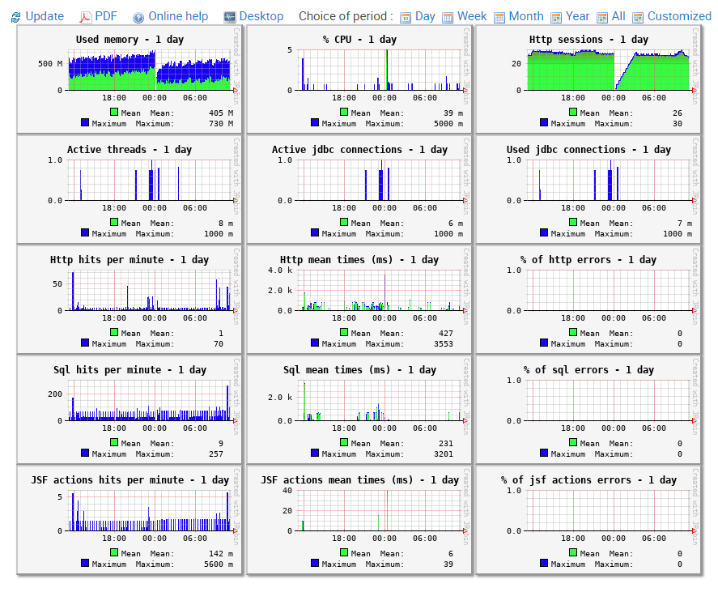

Does your application support data encryption at rest?
Yes. First, the network between the application server and the database is encrypted. PostgreSQL offers the possibility to encrypt any column in a database, and that column will be encrypted at rest. PostgreSQL goes a little bit further; it can encrypt an entire tablespace. What we usually do, we only encrypt data that needs to be encrypted.

Is integration possible with Moodle, the LMS we use?
The integration with Moodle is not currently supported. However, the service that we are using for automated proctoring can be integrated with Moodle, but that is something that we would have to propagate to our partners, who are the owners of the proctoring service.

Security

If a change or modification is possible, is it possible for us to make our changes (i.e., Would we be able to access the source code once purchased)?
The source code of YouTestMe GetCertified is the intellectual property of YouTestMe, and as such, it is not delivered to our clients.
Any modification of the application is possible only by the YouTestMe Development team.
At any time, you can contact us with your customization requirements, and we will send you an estimate of the necessary time and development to implement these functionalities into the system.
All customizations are delivered as part of official YouTestMe GetCertified upgrades.

How often are the security patches released?
They are released in three months. We upgrade the application, and if there are any new patches to the operating system or the database, they will also go in that cycle. The patch needs to be applied immediately to use the system, but only in urgent situations or if there are issues within the system. We have never had such a scenario.

Do you use any standard security guidelines?
Yes, we have a lengthy list of the things that we do to ensure that the system is secure, which include:
- How the users are created,
- How the users in the operating system and the database are authorized to do specific actions, and then
- How the ports are enabled or disabled,
- What kind of protocols are allowed,
- What kind of daemon processes are running.
FTP or any insecure protocol cannot run. We follow these procedures when creating virtual machines. Everything is documented, and we can send you this documentation if you need something like that.

We have a general question about data protection compliance with GDPR.
Any data you want to protect we can protect, and we can keep any personal information regarding our users encrypted in the database and encrypt it at rest point as well. So, there is the possibility to encrypt any information that you want hidden, and you can specify anything that you would want in the application protected, and we can make it so. Also, our system is delivered as a predefined virtual appliance with several security layers within the application and the system.
We follow a lengthy list of security measures that covers many things like the protocols we are using in the system, the roles and permissions, users that can access the database, users that can access the application, and similar. I can send you the list of our entire security check, so you can examine it and see if it meets the security criteria that you have.

I would like to know if the GetCertified has support for the Portuguese and Spanish languages ( in buttons, labels, etc. for the screen of the candidates).
GetCertified offers multilingual support, including Portuguese and Spanish languages

Is it possible to customize the UR?
GetCertified allows you to use your domain, which will host the application.

