Contents

2 Important Links 4

2.1 References 4

3 Design Documents 4

3.1 YTM Integration Testing and Demo Sites 5

4 Development Culture 5

5 Criteria for development completion of the project or module 6

6 Development Methodologies 6

6.1 GDAO – Generated Data Access Objects 6

6.2 Agile Software Development 6

7 Development Policies 8

7.1 Development Environment 8

7.1.1 Project Root Directory 8

7.1.2 Back End Source Code Location 9

7.1.3 Front End Source Code Location 9

8 Required Development Environment Variables 9

9 Test Data 9

9.1 QA testing tips 10

10 Database Development 11

10.1 Database development tools 11

10.1.1 SQL*PLUS 11

10.1.2 DB Visualizer 11

10.1.3 SQL Developer 12

10.2 Configuring Database Access 12

10.2.1 SQL*Plus 12

10.2.2 Configuring Oracle*Net 12

10.3 Access to Database Servers in Canada 12

10.3.1 Database ytm-6 – Oracle Linux 7.1 13

10.3.2 Database ytm-8 – Oracle Linux 7.1 13

10.3.3 Sample from Aqua Data Studio 16

10.3.4 Utility database scripts 17

10.3.5 Creating new database user 18

10.3.6 Expired Database Password 18

10.3.7 Copying Database Schema 18

11 Database Analyzer 19

12 Eclipse 19

13 Database Model 20

13.1 Very Important – Data Dictionary 20

13.2 File Locations 20

14 Source Control System – Subversive SVN 21

14.1.1 Refreshing Working Directory 21

14.2 SVN Repositories 22

14.3 Checking out code from branch - Example 22

14.4 Setting Executable property for UNIX Shell Scripts 23

14.4.1 Relocating SVN Repositories 23

15 UTF-8 Character Encoding 25

16 WWW Development 25

16.1 Fonts 25

16.2 Using Microsoft Web Expression 4 25

17 Good Programming Practices 26

17.1 Important! 26

17.2 Optimizing Performances 26

17.3 Automation 26

17.4 SQL Coding 26

17.4.1 Sample 1 26

17.4.2 Sample 2 27

17.4.3 SQL Formatting Utilities 30

17.4.4 WRONG SQL ALIGNMENT 32

17.4.5 CORRECT SQL ALIGNMENT 32

17.5 Java Code Formatting 33

17.6 Eclipse Source Clean Up 34

17.7 Eliminate Java Warnings 35

17.7.1 Clean Java Imports 35

18 Setting up Eclipse English Dictionary 35

19 User Interface design 37

20 FTP for Developers 37

21 Instructional Videos 38

22 Testing 38

22.1 Expected Response Time for User Interface 38

23 Eclipse DBA Application Troubleshooting 38

24 Manual Application Build and Deploy 39

25 Code Deployment Check Pint 41

26 Codes 41

27 Using Powerdesigner 42

28 Code Review from January 15th 2015 42

28.1 Database Connection Pool 42

28.2 Usage of loops and cursor in the database 42

28.3 Serialized Classes 43

28.4 Source Code Formatting 43

28.5 Source Code Warnings 43

29 Changing Oracle Password in Oracle 12c 43

30 SVN Code HTTP Download 43

30.1 Database Exports 44

31 Exporting database with SQL Developer 44

31.1 Create directory for data pump 44

31.2 Data Pump Export Wizard 45

31.3 Import Data Pump Wizard 47

32 Unix/Linux – Transfer Files From And To 48

33 Install SVN plugin in Eclipse Neon 49

34 Import Project from SVN 51

# Important Links

## References

|  |  |  |
| --- | --- | --- |
| **#** | **Link** | **Description** |
|  | <http://wiki.youtestme.com> | YouTestMe Wiki Site – useful information about the project |
|  | <http://it-ebooks.info> | Collection of IT Manuals |

# Design Documents

Every module has to have a design document in MS Word written using standard technical template.

Every document has to have the following sections:

1. Description what module is supposed to do
2. Description of the design
3. Technologies used
4. How are modules built, compiled and deployed
5. How can modules be tested
6. Location of the code, documentation and test data

Current (usually most recent) version of the design document has to be checked into SVN.

## YTM Integration Testing and Demo Sites

|  |  |  |
| --- | --- | --- |
| **#** | **Link** | **Description** |
|  | <http://206.248.172.39:55241/ytm/>  <http://test1.youtestme.com>  Links are equivalent however first one uses “HTTP redirect” while second one uses “Frame redirect”. | Primary development integration site  Should be used only by developers for system integration and testing  Uses database schema "YTM10"  Automated build times: 11 AM and then every 6 hours |
|  | <http://206.248.172.39:55242/ytm20/>  <http://test2.youtestme.com>  Links are equivalent however first one uses “HTTP redirect” while second one uses “Frame redirect”. | Site used for performance, load and stress testing  Uses database schema "YTM20"  Automated build times: 11 AM and then every 6 hours |
|  | <http://206.248.172.39:55243/ytm30/>  <http://test3.youtestme.com>  <http://demo.youtestme.com>  All three links are equivalent however latter two are using “Frame redirect” vs. “HTTP redirect”. | Site used for demos and presentations  Uses database schema "YTM30"  Automated build times: 12 AM daily |
|  | <http://206.248.172.39:56241/ytm/> | Primary development integration site  Should be used only by developers for system integration and testing  Uses database schema "YTM10"  Automated build times: 11 AM and then every 6 hours |
|  | <http://206.248.172.39:56242/ytm20/> | Site used for performance, load and stress testing  Uses database schema "YTM20"  Automated build times: 11 AM and then every 6 hours |
|  | <http://206.248.172.39:56243/ytm30/> | Site used for demos and presentations  Uses database schema "YTM30"  Automated build times: 12 AM daily |

# Development Culture

Company strategy is to establish highly efficient and productive culture by:

1. Automating all repetitive processes
2. Establishing and documenting procedures for all common tasks
3. Considering every task as a project and properly documenting it so anybody can take on that task at any given moment
4. Adhering to company standards and policies

# Criteria for development completion of the project or module

Worst case scenario for development is to end up with stalled projects - unusable for various reasons:

1. not tested – does not perform well or does not do what is supposed to do
2. not documented – nobody know how to use it
3. not integrated with the rest of the system
4. not maintainable because of the bad design or nobody understands it

Solution:

1. Code has to be written according to company standards and policies
2. Functional and performance test have to be executed and documented
3. Developer should be able to create and recreate test environment. Process for cereation test environment should be documented and all relevant test files should be checkd into SVN
4. Peer review – another team member should review code and documentation and do final confirmation that all criteria are fulfilled.

# Development Methodologies

## GDAO – Generated Data Access Objects

<http://www.mallocinc.com>

## Agile Software Development

<http://en.wikipedia.org/wiki/Agile_software_development>

Agile is just a “common sense” approach to development. This is just a guideline but not the rule. The key point is to be adaptable to current situation and requirements.

Twelve principles underlie the Agile Manifesto:

1. Customer satisfaction by rapid delivery of useful software
2. Welcome changing requirements, even late in development
3. Working software is delivered frequently (weeks rather than months)
4. Working software is the principal measure of progress
5. Sustainable development, able to maintain a constant pace
6. Close, daily co-operation between business people and developers
7. Face-to-face conversation is the best form of communication (co-location)
8. Projects are built around motivated individuals, who should be trusted
9. Continuous attention to technical excellence and good design
10. Simplicity- The art of maximizing the amount of work not done - is essential
11. Self-organizing teams
12. Regular adaptation to changing circumstances

# Development Policies

## Development Environment

### Project Root Directory

Create a “Root Development” directory:  
C:\Zoran\Development

You should use your username as part of the root directory name because computer could be used by several individuals.

Check out all code in that directory.

Your directory structure will look something like this (depending on projects you checked out).

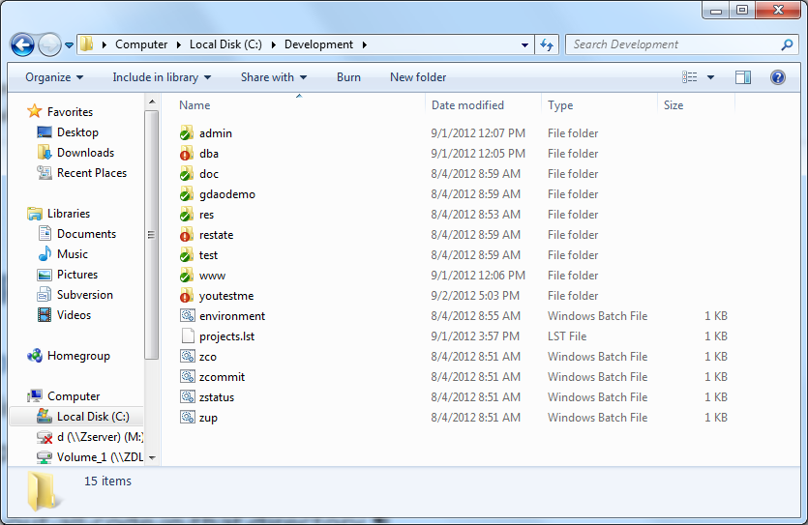

For remote desktop which is used by more than one person, create a directory with your name and copy paste the Development directory to the newly created directory. For example, instead of C:\Development, you should have C:\Zoran\Development. This policy is made so that conflicts are avoided while using SVN since more than one person is using the virtual machine. Personal computer can be set up in any way you like.

Files that start with “z” in “C:\Development” are utility DOS scripts that can help you checkout, update and commit files in multiple SVN Repositories. List of all affected repositories is in file “projects.lst”. You should edit this file and keep only list of repositories that you will be working on.

All “z” files and default “projects.lst” are in the archive below:



“z” scripts in SVN:

c:\Development\res\Scripts\SVN DOS Scripts\

### Back End Source Code Location

c:\Zoran\Development\youtestme\source\

### Front End Source Code Location

c:\Zoran\Development\youtestme\www_source\

# Required Development Environment Variables

Sample:

ZDEV_ENV=c:\Zoran\Development\res\Environment\environment_zoran_toshiba.bat

ZDEV_ROOT=c:\Zoran\Development\

ZYTM_ENV=c:\Zoran\Development\res\Environment\environment_zoran_toshiba.bat

ZYTM_ROOT=c:\Zoran\Development\youtestme\

# Test Data

Development and testing cannot be done without good quality data in the database. Testing programs without data is like test driving car without fuel - you can just sit and look at it, you may like what you see but this still does not mean that car can move at all.

1. All test data have to be created in spreadsheets located here:  
   \youtestme\batch_source\test_data\excel\
2. Test data is loaded by Java program:
3. com.youtestme.loaders.excel.testdata.LoadAllTestData
4. Test data should always be generated through re-runnable programs, scripts, files, spreadsheet. The process should be executable in one step.
5. Note that data created any other way (not through integrated process described below) will be lost every time database is refreshed.
6. There are great benefits of using standardized test data so please stick to the process. Be proactive and create or amend test data spreadsheets.

## QA testing tips

How you can quickly determine quality of your test environment?

You can use [Database Analyzer](https://www.mallocinc.com/) database reporting capabilities to determine many things about the state of the data in the database.

The most important thing is to have a sufficient data for complete coverage and the simplest way to quickly determine that is:

1. all tables have to have some data (more is generally better)
2. you have to have all codes, for example if you know that we have many question or user types and you see that there is only one in all records in the database you know that various scenarios cannot be tested (see picture below)
3. similar logic can be applied to all codes and many other data. For example timestamps, names, locations, etc.
4. empty tables also indicate that some functionalities cannot be tested. Traditionally the biggest problem are data missing in associative tables connect related tables with each other.
5. report also gives you number of records in each table which is very useful as a starting point and to determine if you have sufficient data for any type of testing
6. look at the "warnings" and "suggestions" in report. They usually indicate problem with data (but sometimes it may be ok).

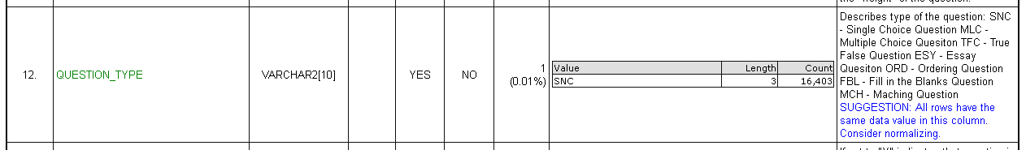

# Database Development

Each developer should use his/her own database schema for development. This way conflict are avoided and development is much more efficient.

Please do the following:

1. Create your own schema and implement data model and data in it by using shell scripts or Oracle database export file created from another schema.
2. If you are unfamiliar with database administration please ask somebody to do it for you.

## Database development tools

### SQL*PLUS

### DB Visualizer

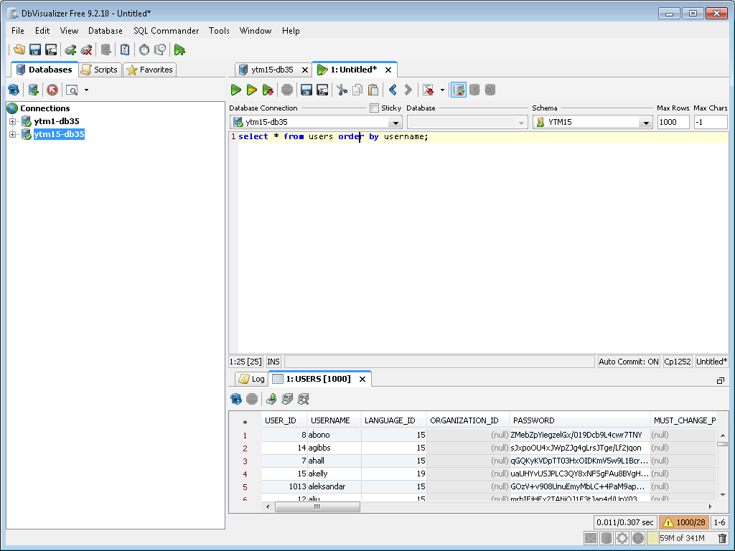

### SQL Developer

## Configuring Database Access

The following software is needed to access Oracle database:

* Oracle Database Client Software – in order to user SQL*Plus and to run SQL*Plus scripts from command line. To download Windows version you can use this [link](http://www.oracle.com/technetwork/database/enterprise-edition/downloads/database12c-win64-download-2297732.html) and the scroll to “Oracle Database Client (12.1.0.2.0) for Microsoft Windows (x64)”
* JDBC driver in order to have Java programs access to the database. JDBC driver is the same on all operating systems and can be downloaded [here](http://www.oracle.com/technetwork/database/features/jdbc/jdbc-drivers-12c-download-1958347.html). You should download “ojdbc7.jar”

The following information is required to access oracle database:

1. IP address of the server where database is installed
2. Port number where Oracle listener is accepting connection requests (by default it is 1521)
3. Database name (default is “ORCL”)
4. Username
5. Password

### SQL*Plus

SQL*Plus is Oracle shell for executing SQL and PL/SQL statements and programs. It is universal tool for development and data administration. Unfortunately it is not very user friendly because it is exclusively command based so it is mostly used either when other tools are not available or when other tools cannot do operations that SQL*Plus can perform – a common example is changing expired Oracle password.

In order to run SQL*Plus and other programs that require Oracle native network interface you need to configure Oracle*Net.

### Configuring Oracle*Net

## Access to Database Servers in Canada

The following information is required to access oracle database:

1. IP address of the server where database is installed
2. Port number where Oracle listener is accepting connection requests (by default it is 1521)
3. Database name (default is “ORCL”)
4. Username
5. Password

Use “external” IP address and port to access databases from remote location.

Use “internal” IP address and port to access databases from within local network – for example when you log in to the one of the local machines using remote desktop. “Local” machine is one of the machines on the same local network as database servers, meaning they are all located in Canada at the same physical location.

### Database ytm-6 – Oracle Linux 7.1

|  |  |
| --- | --- |
| **External IP** | mallocinc.dnsalias.com  home.mallocinc.com |
| **External Port** | 50106 |
| **Service Name** | Orcl |
| **Username** | ytm1 |
| **Password** | ytm1 |
| **Version** | 12c |
| **Server** | ytm-6 (Oracle Linux - virtual) |
| **Internal IP** | 192.168.1.106 |

Users YTM2, 3, 4,....10 are also created so we will all have several database schemas for development and testing. Passwords are the same as username.

You can use DBA user: “ZDBA/ZDBA” if you want to create new users or to experiment.

Usernames and passwords are case sensitive.

### Database ytm-8 – Oracle Linux 7.1

|  |  |
| --- | --- |
| **External IP** | mallocinc.dnsalias.com  home.mallocinc.com |
| **External Port** | 50108 |
| **Service Name** | Orcl |
| **Username** | ytm1 |
| **Password** | ytm1 |
| **Version** | 12c |
| **Server** | ytm-8 (Oracle Linux - virtual) |
| **Internal IP** | 192.168.1.108 |

Users YTM2, 3, 4,....10 are also created so we will all have several database schemas for development and testing. Passwords are the same as username.

You can use DBA user: “ZDBA/ZDBA” if you want to create new users or to experiment.

Usernames and passwords are case sensitive.

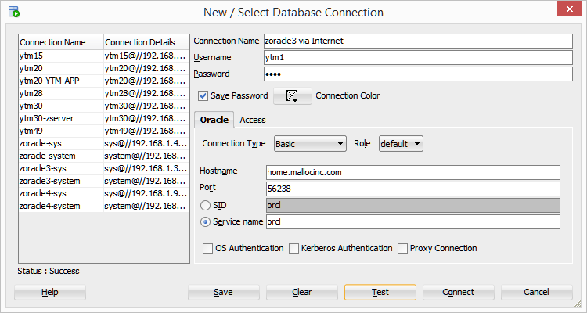

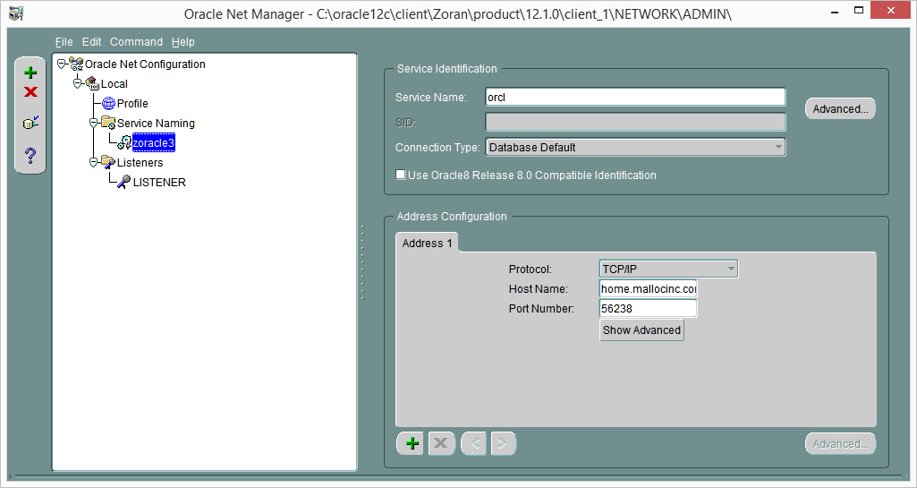

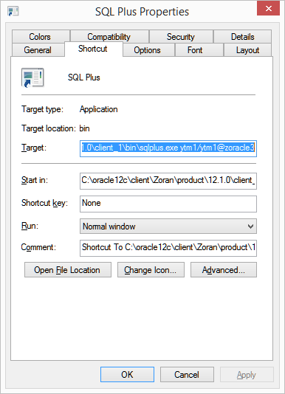

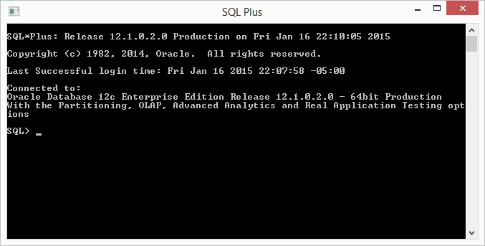

### Sample from Aqua Data Studio

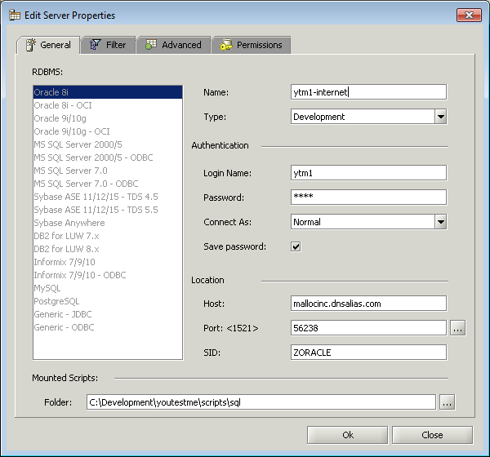

### Utility database scripts

\youtestme\db\dbmodel\scripts\

Check those scripts to see how to create database user(schema) and how to create database objects in that schema.

### Creating new database user

To create new database user, execute these commands in SQL:

CREATE USER user1 PROFILE "DEFAULT"

IDENTIFIED BY password1 DEFAULT TABLESPACE "USERS"

ACCOUNT UNLOCK;

GRANT "CONNECT" TO user1 WITH ADMIN OPTION;

GRANT "DBA" TO user1 WITH ADMIN OPTION;

GRANT "RESOURCE" TO user1 WITH ADMIN OPTION;

GRANT UNLIMITED TABLESPACE TO user1 WITH ADMIN OPTION;

GRANT SELECT ANY DICTIONARY TO user1;

Note the following:

* Statement terminator is “;” character so everything up to that character is one statement.
* User is granted role DBA which is very powerful role and practical for development however in the real production environment user will have more restrictions (no DBA role).

### Expired Database Password

Expired database password have to be changed in SQL*Plus:

Follow instructions from this document:

\youtestmedoc\Procedures\Database Password Change Procedure.docx

### Copying Database Schema

This is example procedure how to copy database schema YTM6 to schema YTM30 which is used by web site "/ytm30". This may be done because new data is prepared in YTM6 is now it is suitable to be used for demos in YTM30.

Steps:

1. Log in to remote desktop on one of the application servers using user "ytm3":  
   Primary application server IP: “home.mallocinc.com:55240”  
   Secondary application server IP: “home.mallocinc.com:56240
2. Stop tomcat server by executing: “c:\ytm3\Development\res\ProgramFiles\tomcat\scripts\zstop.bat”  
   Stopping Tomcat is required in order to close all database connections to database schema YTM30.  
   If there are any other database connections, say from SQL Developer or SQ*Plus – they should be closed. Database schema which has an active connection from cannot be dropped.
3. Copy schema ytm6 to ytm30 by executing:
   1. cd c:\ytm3\Development\youtestme\db\dbmodel\scripts\
   2. copy_schema.bat ytm6 ytm30
4. Start tomcat server by executing “c:\ytm3\Development\res\ProgramFiles\tomcat\scripts\zstartup_qa.bat”

# Database Analyzer

Install Database Analyzer 6.0 and use this configuration file to create analyze database and create a code:

“\youtestme\cfg\youtestme.dba”

Code will be generated in directory:

“\youtestme\source\generated\”

In the early stages of the project we will be generating and regenerating a lot of files and it will be unpractical to check them and update them all the time. This will change when code stabilizes.

If you are planning to use different database schema to analyze database and generate code then save this file under different name and change Database connection parameters since you will be using your own schema.

You can find the instructions on how to import DBA into Eclipse in the next document:

[http://svn.mallocinc.com/youtestmedoc1/trunk/Procedures/Development Procedures/Setting up DBA in Eclipse and generating code.docx](http://svn.mallocinc.com/youtestmedoc1/trunk/Procedures/Development%20Procedures/Setting%20up%20DBA%20in%20Eclipse%20and%20generating%20code.docx).

# Eclipse

Eclipse will be used as a Java development environment.

Project file is located here:

\youtestme\www_source\ytm.webview\.project

\youtestme\www_source\ytm.db\.project

\youtestme\www_source\ytm.model\.project

# Database Model

## Very Important – Data Dictionary

Whenever you make any change to database model such as adding new object ALWAYS add comment. Example is shown on the picture below.

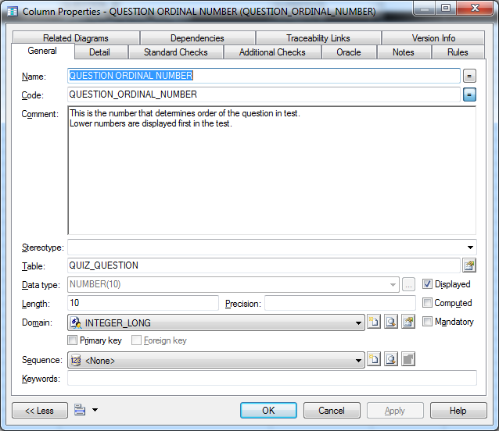

## File Locations

Power Designer Database Model:

\youtestme\db\dbmodel\YOUTESTME_ER_DIAGRAM.pdb

Utility database scripts:

\youtestme\db\dbmodel\scripts\

# Source Control System – Subversive SVN

Policies:

1. Never check in the code that does not compile!
2. Code in SVN has be complete – anybody should be able to check out entire project from SVN and be able to compile it without any fixing, adding libraries and similar.
3. Eclipse hidden files “.project” and “.classpath” have to be checked into SVN because project cannot be opened in Eclipse without them. Any other file required to open and build the project from scratch has to be checked into SVN.
4. Update and Commit your code frequently to avoid code conflicts.
5. Use SVN to Rename, Move or Remove files.
6. Communicate your development plans to other team members.
7. Do not check in things in SVN that do not belong there (for example: third party software or manuals). We keep those in designated directory.
8. Never put the Java source code in production. Always deploy application as “jar”, “war” or “ear”.
9. Occasionally test your code by checking it out (or exporting it) to empty directory and try to compile it. If there are errors then code is not properly checked into SVN or it is not complete. You should fix it as soon as possible. Please see prescribed procedure below.

### Refreshing Working Directory

This procedure is required in order to solve following problems:

1. Identify files that are required for the project but they are not checked into SVN
2. Resolve occasional issues with SVN

Procedure should be done every time you suspect that something is not right, files are missing or experiencing issues with SVN that cannot be easily resolved (say by SVN cleanup). It is recommended that it is executed at least once a week even if no problems are encountered.

#### Procedure

Assume that your working directory structure looks like this:

C:\Zoran\Development\youtestme

\youtestmedoc

\res

\doc

Refreshing procedure should be as follows:

1. Rename directory “C:\Zoran\Development” to “C:\Zoran\Development-Nov-16-2014”
2. Create new directory “C:\Zoran\Development”
3. Check out fresh copy of the code form SVN into “C:\Zoran\Development”  
   You can use SVN batch scripts from “\res\Scripts\SVN DOS Scripts\” to do this automatically.
4. Use “C:\Zoran\Development” for development
5. Use old directory “C:\Zoran\Development-Nov-16-2014” only for reference (do not use it for development anymore!). For example if you forgot to check in some files you can find them in this old directory.

## SVN Repositories

Example check out:

svn --username zoran.kukoljac co <http://svn.mallocinc.com/youtestme/trunk> youtestme

Make sure that you put your username in the line above.

|  |  |  |
| --- | --- | --- |
| **#** | **YTM Repository URL** | **Description** |
|  | <http://svn.mallocinc.com/res> | Resources |
|  | <http://svn.mallocinc.com/youtestme> | YouTestMe Application code |
|  | <http://svn.mallocinc.com/youtestmedoc> | YouTestMe Documentation |

|  |  |  |
| --- | --- | --- |
| **#** | **DBA Repository URL** | **Description** |
|  | <http://svn.mallocinc.com/dba> | Database Analyzer Development |
|  | <http://svn.mallocinc.com/doc> | Documentation |

|  |  |  |
| --- | --- | --- |
| **#** | **Utility Repository URL** | **Description** |
|  | <http://svn.mallocinc.com/www> | Web development |
|  | <http://svn.mallocinc.com/test> | Sandbox – testing repository |
|  | <http://svn.mallocinc.com/admin> | Administrator’s documents (restricted access to administrators only). |

NOTE: Use code from “trunk” for development.

## Checking out code from branch - Example

CALL environment

svn checkout %REPO%/youtestme/branches/Demo_Mega_v1.0 youtestme

## Setting Executable property for UNIX Shell Scripts

UNIX executable file have to have “executable” property set in SVN as shown on the picture below. Do not forget to commit after property is set. Unlike Windows which uses file extensions to determine if file is executable UNIX uses “executable” property of the file.

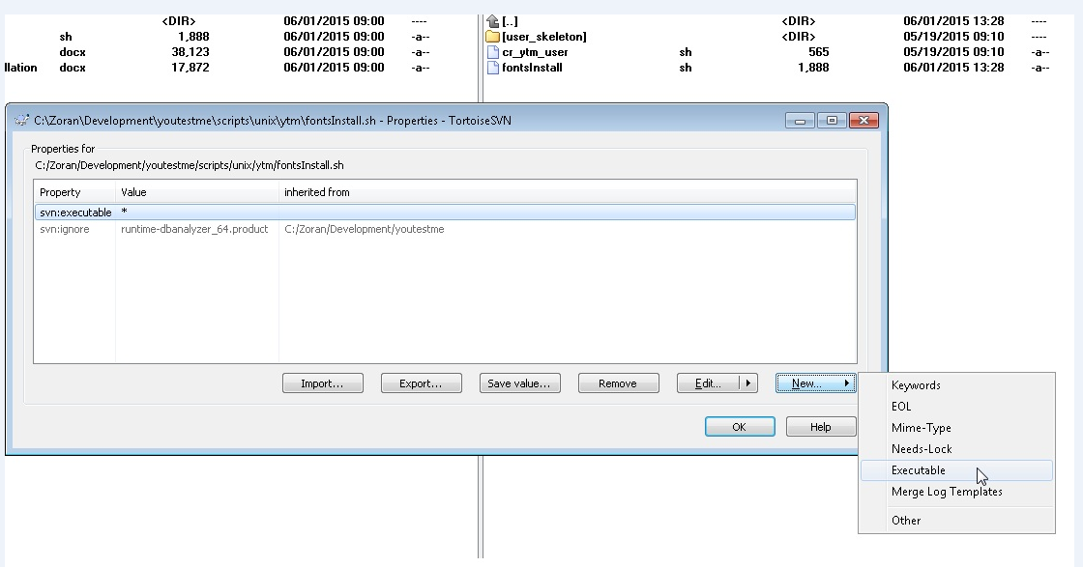

### Relocating SVN Repositories

If SVN repositories change URL (for example moved to another server or IP changes) then you need to do “SVN -> Relocate” in your local copy.

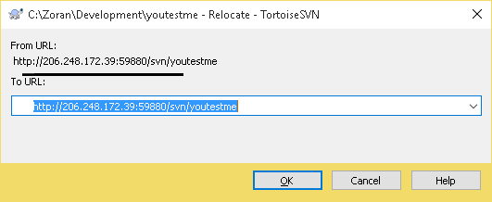

**Example from the command line:**

svn relocate http://home.mallocinc.com:59880/svn/res/trunk http://svn.mallocinc.com/res/trunk

Where:

Old URL: http://home.mallocinc.com:59880/svn/res/trunk

New URL: http://svn.mallocinc.com/res/trunk

Alternatively you can do new code checkout using new URL.

# UTF-8 Character Encoding

Unicode UTF-8 character encoding will be used by default. Application has to support all languages and as many special characters as possible.

# WWW Development

Each developer should do development in your own instance of the application server. This way he/she is free to experiment and conflicts are avoided.

## Fonts

“Tahoma” or “Arial” family fonts are used as default fonts for:

* Text on the web site.
* Documentation

## Using Microsoft Web Expression 4

Set default font to “Tahoma” by following this procedure:

* Go to: Tools -> Page Editor Options
* Choose tab: “Default Fonts”
* For every “Language (character set)” change “Default Proportional Font” to “Tahoma”. Please see picture below for reference.

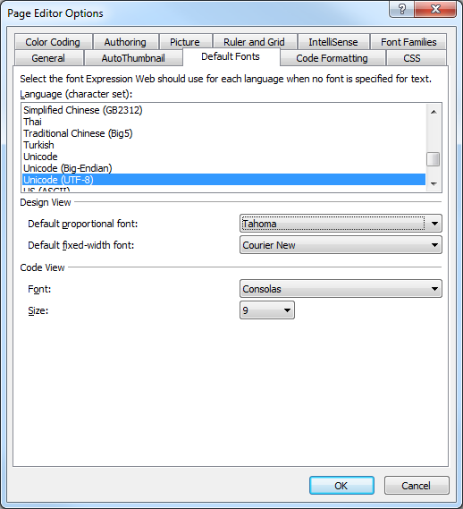

# Good Programming Practices

## Important!

* Do as much data processing in the database as possible. Consider processing outside of the database as necessity, not as a good option.
* Minimize number of database hits. Always stream to retrieve, update, delete or insert data in one query.
* It is always better to do data processing, calculation, counting, summing, and sorting in the database than in other language.
* If you need data from more than one table – create view.
* Avoid using cursors – try to do everything in one SQL statement if possible
* Check for errors after every SQL statement.

## Optimizing Performances

**Step by step procedure:**

1. Run the query with the same parameters in SQL*PLUS. If it runs fine go to next step:
2. Run same program outside of Application Server. If it runs fine go to next step:
3. Run the same program with the local database, to eliminate networking issues.
4. Run it in Application server with inserted debug lines to isolate lines that take most of the time.

## Automation

Write a script for everything even if you are going to execute it only a few times. You may reuse it later and it may be used as reference what was done.

## SQL Coding

### Sample 1

Sample of the well formatted SQL Code (every condition on the new line):

CREATE OR REPLACE VIEW V_TABLESPACE_USED

(TABLESPACE_NAME

,TABLESPACE_SIZE_MB

,USED

,AVAIL

,USED_VISUAL

,PCT_USED)

AS

SELECT DF.TABLESPACE_NAME TSNAME

, SUM(DF.BYTES)/1024/1024 TBS_SIZE_MB

, ROUND(NVL(SUM(E.USED_BYTES)/1024/1024,0),2) USED

, ROUND(NVL(SUM(F.FREE_BYTES)/1024/1024,0),2) AVAIL

, RPAD(' '||RPAD('X',ROUND(SUM(E.USED_BYTES)

*10/SUM(DF.BYTES),0), 'X'),11,'-') USED_VISUAL

, ROUND(NVL((SUM(E.USED_BYTES)*100)/SUM(DF.BYTES),0), 2) PCT_USED

FROM DBA_DATA_FILES DF

, (SELECT FILE_ID

, SUM(NVL(BYTES,0)) USED_BYTES

FROM DBA_EXTENTS

GROUP BY FILE_ID) E

, (SELECT SUM(NVL(BYTES, 0)) FREE_BYTES

, FILE_ID

FROM DBA_FREE_SPACE

GROUP BY FILE_ID) F

WHERE E.FILE_ID(+) = DF.FILE_ID

AND DF.FILE_ID = F.FILE_ID(+)

GROUP BY DF.TABLESPACE_NAME

UNION

/*

Include Temporary tablespace

*/

SELECT DF.TABLESPACE_NAME TSNAME

, SUM(DF.BYTES)/1024/1024 TBS_SIZE_MB

, ROUND(NVL(SUM(E.USED_BYTES)/1024/1024,0),2) USED

, ROUND(NVL(SUM(F.FREE_BYTES)/1024/1024,0),2) AVAIL

, RPAD(' '||RPAD('X',ROUND(SUM(E.USED_BYTES)

*10/SUM(DF.BYTES),0), 'X'),11,'-') USED_VISUAL

, ROUND(NVL((SUM(E.USED_BYTES)*100)/SUM(DF.BYTES),0), 2) PCT_USED

FROM DBA_TEMP_FILES DF

, (SELECT FILE_ID

, SUM(NVL(BYTES,0)) USED_BYTES

FROM DBA_EXTENTS

GROUP BY FILE_ID) E

, (SELECT SUM(NVL(BYTES, 0)) FREE_BYTES

, FILE_ID

FROM DBA_FREE_SPACE

GROUP BY FILE_ID) F

WHERE E.FILE_ID(+) = DF.FILE_ID

AND DF.FILE_ID = F.FILE_ID(+)

GROUP BY DF.TABLESPACE_NAME

ORDER BY 6

Note comma (“,”) at the begging of the line – not at the end.

Also note alignment of the columns and aliases.

There should be NO **blank lines** and **trailing spaces** in SQL statements.

### Sample 2

/*==============================================================

View: V_ST_QUIZ

This view is used only to load data from staging tables to

permanent tables.

==============================================================*/

CREATE OR REPLACE VIEW V_ST_QUIZ AS

SELECT

ST_QUIZ.ST_QUIZ_ID

,ST_QUESTION.ST_QUESTION_ID

,ST_ANSWER.ST_ANSWER_ID

,ST_QUIZ.USERNAME

,ST_QUIZ.PASSWORD

,ST_QUIZ.USER_ID

,ST_QUIZ.QUIZ_NAME

,ST_QUIZ.DEFAULT_DURATION

,ST_QUIZ.USERS_COMMENT

,ST_QUIZ.DEFAULT_ENABLED_FROM

,ST_QUIZ.DEFAULT_ENABLED_TO

,ST_QUIZ.RESULT_TRANSPARENCY

,ST_QUIZ.DURATION_FACTOR

,ST_QUIZ.STATUS

,ST_QUIZ.CREATE_USER_ID

,ST_QUIZ.CREATE_DATETIME

,ST_QUESTION.ARTIFICIAL_QUESTION_ID QST_ARTIFICIAL_QUESTION_ID

,ST_QUESTION.QUESTION_TEXT

,ST_QUESTION.PICTURE

,ST_QUESTION.DURATION

,ST_QUESTION.DIFFICULTY

,ST_QUESTION.POINTS

,ST_QUESTION.ORDINAL_NUMBER QUESTION_ORDINAL_NUMBER

,ST_ANSWER.ARTIFICIAL_QUESTION_ID ANS_ARTIFICIAL_QUESTION_ID

,ST_ANSWER.ANSWER_TEXT

,ST_ANSWER.ORDINAL_NUMBER ANSWER_ORDINAL_NUMBER

,ST_ANSWER.CORRECT_ANSWER_IND

FROM ST_QUIZ,

ST_QUESTION,

ST_ANSWER

WHERE ST_QUIZ.ST_QUIZ_ID = ST_QUESTION.ST_QUIZ_ID

AND ST_QUIZ.ST_QUIZ_ID = ST_ANSWER.ST_QUIZ_ID

AND ST_QUESTION.ARTIFICIAL_QUESTION_ID = ST_ANSWER.ARTIFICIAL_QUESTION_ID

ORDER BY ST_QUIZ.ST_QUIZ_ID

,ST_QUESTION.ST_QUESTION_ID

,ST_ANSWER.ST_ANSWER_ID

;

comment on table V_ST_QUIZ is

'Used during load from staging tables into permanent tables in the database';

comment on column V_ST_QUIZ.ST_QUIZ_ID is

'Primary key';

comment on column V_ST_QUIZ.ST_QUESTION_ID is

'Primary key of table table ST_QUESTION_ID';

comment on column V_ST_QUIZ.ST_ANSWER_ID is

'Primary key of table table ST_ANSWER';

comment on column V_ST_QUIZ.USERNAME is

'Username has to be unique across the system.

Use of email adress is encouraged however it cannot be enforced because many

user will not have e-mail addresses or they will not provide it for various

reasons. ';

comment on column V_ST_QUIZ.QUIZ_NAME is

'Name (Title) of this test.';

comment on column V_ST_QUIZ.DEFAULT_DURATION is

'Test duration in seconds.

This is time available to complete the test once test instance started.';

comment on column V_ST_QUIZ.DURATION_FACTOR is

'Factor (in percents, for example: -40%, +120%, +300%) - how much the available

time for answering the questions should be shortened or prolonged.

Apply duration factor to the length of every question.

On this way duration of the questions can be parametrized.';

comment on column V_ST_QUIZ.STATUS is

'"S" - Loaded only in staging tables

"L" - Loaded into permanent tables, data from staging tables can be deleted';

comment on column V_ST_QUIZ.QST_ARTIFICIAL_QUESTION_ID is

'This is number assigned by user in order to link questions with answers in

excel.';

comment on column V_ST_QUIZ.PICTURE is

'This is picture that is displayed with question.';

comment on column V_ST_QUIZ.DURATION is

'Duration of the question in seconds.

This is optional value and it is intended to be used to limit time available to

answer this question.';

comment on column V_ST_QUIZ.DIFFICULTY is

'This is degree of difficulty.

Higher number represents higher difficulty of question.';

comment on column V_ST_QUIZ.POINTS is

'Number of points that person gets by answering this question correctly.

For example difficult questions can score more points than the others.

This is the "weight" of the question. ';

comment on column V_ST_QUIZ.QUESTION_ORDINAL_NUMBER is

'This number determines the order of this question as it appears on the test.

Lower numbers are displayed first. If this number is not present then questions

will be displayed in default order.';

comment on column V_ST_QUIZ.ANSWER_ORDINAL_NUMBER is

'This number determines the order of this answer as it appears on the test.

Lower numbers are displayed first. If this number is not present then answers

will be displayed in default order.';

comment on column V_ST_QUIZ.CORRECT_ANSWER_IND is

'Indicates if this is the correct answer.';

You can use configurable SQL code formatter from Aqua Data Studio to assist you with complex statements:

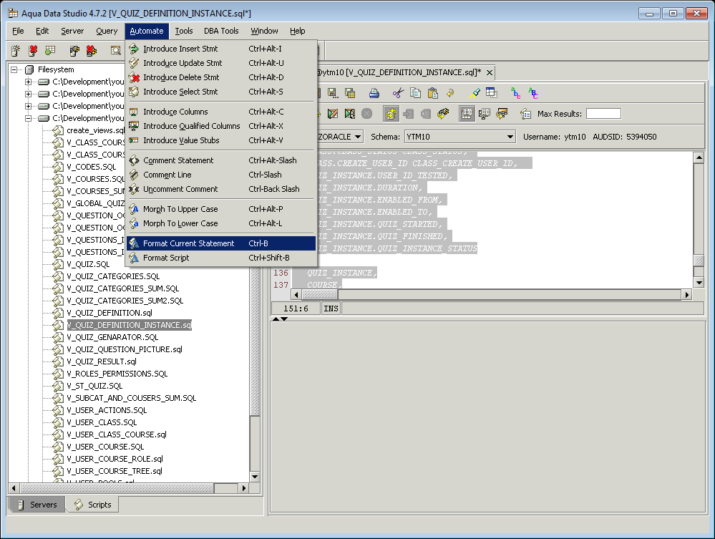

### SQL Formatting Utilities

#### Poor SQL

<http://poorsql.com/>

or command line tool:

\res\ProgramFiles\sqlformatter\SqlFormatter.exe

Sample usage:

DOS:> sqlformatter v_user_pools.sql

#### SQLinForms

<http://www.sqlinform.com/default.html>

Highly recommended by:

<http://www.dba-oracle.com/t_formatting_oracle_sql.htm>

**!!! Do not code like this !!!**

CREATE OR REPLACE VIEW V_QUIZ_DEFINITION_INSTANCE ("QUIZ_INSTANCE_ID", "QUIZ_DEFINITION_ID", "USER_ID", "QUIZ_CATEGORY_ID", "QUIZ_NAME", "DEFAULT_DURATION", "USERS_COMMENT", "DEFAULT_ENABLED_FROM", "DEFAULT_ENABLED_TO", "DISPLAY_ANSWER_IND", "DISPLAY_CORRECT_IND", "DURATION_FACTOR", "QUIZ_DEF_CREATE_USER_ID", "QUIZ_DEF_CREATE_DATETIME", "QUIZ_DEF_UPDATE_USER_ID", "QUIZ_DEF_UPDATE_DATETIME", "CATEGORY_NAME", "QUIZ_CATEGORY_DESCRIPTION", "COURSE_ID", "COURSE_NAME", "COURSE_CODE", "COURSE_STATUS", "COURSE_DESCRIPTION", "COURSE_CREDITS", "CLASS_ID", "CLASS_NAME", "CLASS_CODE", "CLASS_ACTIVE_FROM", "CLASS_ACTIVE_TO", "CLASS_STATUS", "CLASS_CREATE_USER_ID", "USER_ID_TESTED", "QUIZ_INST_DURATION", "QUIZ_INST_ENABLED_FROM", "QUIZ_INST_ENABLED_TO", "QUIZ_INST_STARTED", "QUIZ_INST_FINISHED", "QUIZ_INSTANCE_STATUS") AS....

### WRONG SQL ALIGNMENT

SELECT

QUIZ_INSTANCE.QUIZ_INSTANCE_ID QUIZ_INSTANCE_ID,

QUIZ_INSTANCE.QUIZ_DEFINITION_ID,

QUIZ_INSTANCE.USER_ID_TESTED USER_ID_TESTED,

QUIZ_RESULT.QUIZ_RESULT_ID QUIZ_RESULT_ID,

QUIZ_RESULT.QUESTION_ID QUESTION_ID,

QUIZ_RESULT.ANSWER_TEXT ANSWER_TEXT,

QUIZ_RESULT.NOT_SURE_FLAG NOT_SURE_FLAG,

QUIZ_RESULT.POINTS_ASSIGNED POINTS_ASSIGNED,

QUIZ_RESULT.CREATE_USER_ID Q_RESULT_CREATE_USER_ID,

WHERE UNIQUE_QUIZ.QUIZ_DEFINITION_ID = QUIZ_DEFINITION.QUIZ_DEFINITION_ID

AND UNIQUE_QUIZ.UNIQUE_QUIZ_ID = QUIZ_QUESTION.UNIQUE_QUIZ_ID

AND QUIZ_QUESTION.QUESTION_ID = QUESTION.QUESTION_ID

AND QUESTION.QUESTION_ID = ANSWER.QUESTION_ID (+)

### CORRECT SQL ALIGNMENT

SELECT

QUIZ_INSTANCE.QUIZ_INSTANCE_ID QUIZ_INSTANCE_ID

,QUIZ_INSTANCE.QUIZ_DEFINITION_ID

,QUIZ_INSTANCE.USER_ID_TESTED USER_ID_TESTED

,QUIZ_RESULT.QUIZ_RESULT_ID QUIZ_RESULT_ID

,QUIZ_RESULT.QUESTION_ID QUESTION_ID

,QUIZ_RESULT.ANSWER_TEXT ANSWER_TEXT

,QUIZ_RESULT.NOT_SURE_FLAG NOT_SURE_FLAG

,QUIZ_RESULT.POINTS_ASSIGNED POINTS_ASSIGNED

,QUIZ_RESULT.CREATE_USER_ID Q_RESULT_CREATE_USER_ID

WHERE UNIQUE_QUIZ.QUIZ_DEFINITION_ID = QUIZ_DEFINITION.QUIZ_DEFINITION_ID

AND UNIQUE_QUIZ.UNIQUE_QUIZ_ID = QUIZ_QUESTION.UNIQUE_QUIZ_ID

AND QUIZ_QUESTION.QUESTION_ID = QUESTION.QUESTION_ID

AND QUESTION.QUESTION_ID = ANSWER.QUESTION_ID (+)

## Java Code Formatting

We should all use same formatting style. Use this code formatting configuration file for Eclipse:

In Eclipse, go to “Window” -> “Preferences” and choose “Formatter as show on the picture below.

Then use button “Import” and choose this XML file:

\youtestme\cfg\Eclipse\ytm_eclipse_java_code_formatting.xml

Clisk “OK” to close the window.

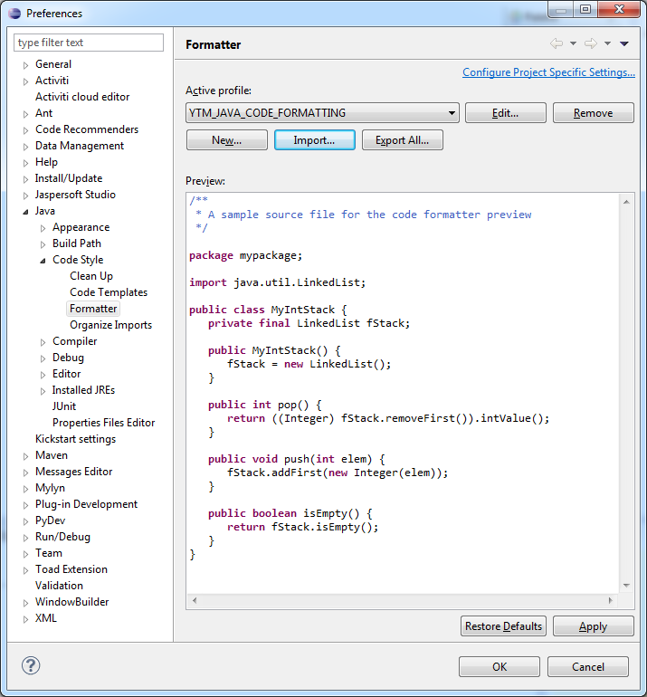

Java code formatter is executed when you place cursor anywhere in the Java code widow and press: “Ctrl”+”Shift”+”F”

You can format all code in certain directory with this procedure:

1. Right-click on directory
2. Choose “Source”
3. Click “Format”

All code should be uniform across the project.

## Eclipse Source Clean Up

By configuring and using Eclipse Source “Clean Up” you can accomplish many different things at one on all source code selected:

* organizing imports
* cleaning redundant variables
* removing extra spaces at the end of the lines
* various other code cleanups and amendments

In Eclipse Package Explorer right click on the packages that you want to clean up. Then choose “Source” -> “Clean Up”

**Important:**

When you install eclipse or change workspace you need to import (see screen below) standard YTM profile which is located in SVN here:

\youtestme\cfg\Eclipse\ytm_code_cleanup_profile.xml

Also, don’t forget to set up YTM standard formatting profile as explained in Java Code Formatting before doing source clean up.

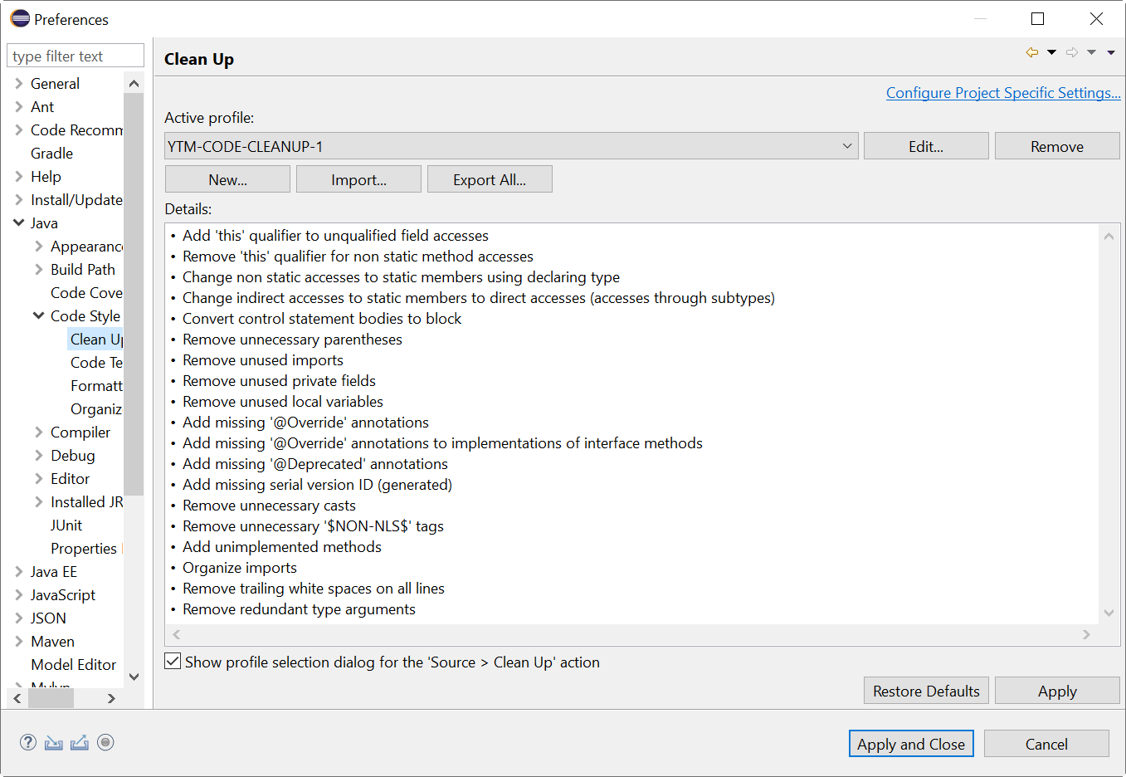

## Eliminate Java Warnings

Java warnings in eclipse should be eliminated as much as possible.

This can be accomplished to great extent by performing a source clean up procedure in Eclipse which is explained above.

Also, a lot of warnings come from unused imports and those can be easily cleaned up automatically in Eclipse by selecting Java packages and pressing “Ctrl+Shift+O”

### Clean Java Imports

Java code should not have unused imports. They can be quickly cleaned by pressing “Ctrl+O” in Eclipse.

# Setting up Eclipse English Dictionary

Team should be using the same English dictionary for the project.

The location of the file is:

**\youtestme\cfg\Eclipse\ytm_eclipse_dictionary.txt**

In eclipse it is set up as shown on the screen:

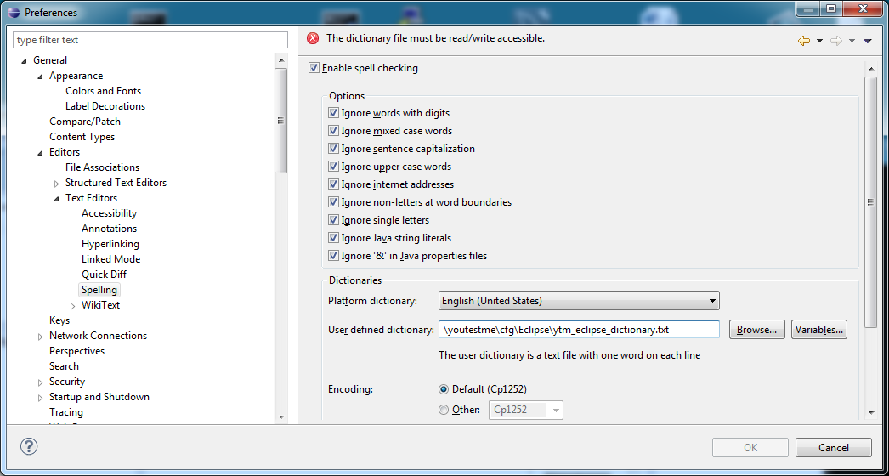

Team members should check in dictionary file into SVN.

This way, new words will be available to other team members.

# User Interface design

Gaps marked in red should be constant and independent of screen resizing.

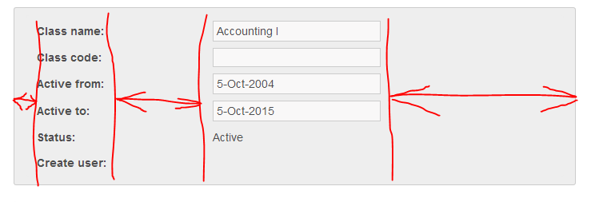

# FTP for Developers

|  |  |  |  |
| --- | --- | --- | --- |
| Hostname | Username | Password | Remote directory |
| ftp://home.mallocinc.com | ytm | 22ytmftp33 | /My_Passport/FTP_malloc |
| ftp://s117953983.onlinehome.us | u37512132-ytmftp | 22ytm12! |  |

# Instructional Videos

|  |  |  |
| --- | --- | --- |
| **#** | **Link to the Presentation** | **Description** |
|  | <http://videos.youtestme.com/SVNPractice.mp4> | SVN Practice |
|  | <http://videos.youtestme.com/svncrashcourse.mp4> | SVN Crash Course |
|  | <http://videos.youtestme.com/GDAOUserRolesSample.mp4> | How to use GDAO on YouTestMe Project |
|  | <http://videos.youtestme.com/GDAOTransferObjects.mp4> | GDAO Transfer Objects (TO) |
|  | <http://videos.youtestme.com/RunDBAFromEclipse.mp4> | Running DBA from Eclipse |
|  | <http://videos.youtestme.com/YTMEnvironments.mp4> | Relevant information about Development and Integration testing environments |

# Testing

## Expected Response Time for User Interface

Response time in table below is given for complex operations. It is assumed that response time for simple operations is instant.

|  |  |  |
| --- | --- | --- |
| **#** | **Response Time** | **Severity and Action Required** |
|  | < 3 seconds | Normal |
|  | Between 3 and 6 seconds | Acceptable but optimization is desired |
|  | Between 6 and 15 seconds | Slow – optimization is required |
|  | Between 15 and 25 seconds | Function too slow, optimization or redesign is required in next release |
|  | > 25 seconds | Function is practically unusable, optimization or redesign is required as soon as possible |

# Eclipse DBA Application Troubleshooting

If you have problem running Database Analyzer from Eclipse try one or both of the following:

1. Start eclipse with “eclipse –clean”
2. In “dependencies” remove all invalid plug-ins (they will have invalid symbol in front) and then click on “Add Required Plug-Ins” (picture below). This is because you may have 32 bit platform and you are trying to run 64 bit plug ins (or vice versa)

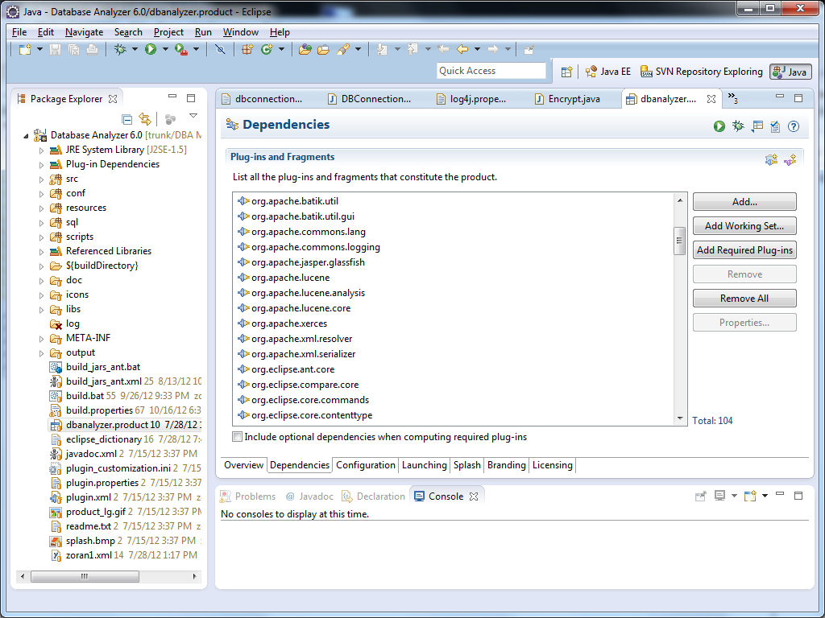

# Manual Application Build and Deploy

Use windows remote desktop to log in to application server:

IP: [home.mallocinc.com:55240](http://home.mallocinc.com:55240) (primary application server)

IP: [home.mallocinc.com:56240](http://home.mallocinc.com:56240) (secondary application server)

Note that if application is accessed on port “55…” then it runs on server with remote desktop on port “55240”. Similarly, if application is accessed on port “56…” then it runs on server with remote desktop on port “56240”.

Log in using one of three usernames:

* ytm
* ytm2
* ytm3

For example, if you would like to build and restart application “/you30” then you should log in as “ytm3”.

Go to directory:

\youtestme\www_source\redeploy.bat

Open DOS command window and run this script:

“redeploy.bat”

This script should do the following:

* Stop Tomcat
* Update code from SVN
* Compile and build the code
* Deploy the code
* Start Tomcat

You can see the log from the whole process in this directory:

\youtestme\www_source\log\

Log file will have name in format “redeploy_” + datetime, for example:

redeploy_Wed11-19-2014@12-03-23.41.log

Application can be accessed at links below:

Primary application server:

http://206.248.172.39:55241/ytm/

http://206.248.172.39:55242/ytm20/

http://206.248.172.39:55243/ytm30/

Secondary application server:

http://206.248.172.39:56241/ytm/

http://206.248.172.39:56242/ytm20/

http://206.248.172.39:56243/ytm30/

Demo web site:

http://demo.youtestme.com

or

http://206.248.172.39:56243/ytm30/

IP address 206.248.172.39 could be replaced by "home.mallocinc.com"

# Code Deployment Check Pint

Code Deployment Check Point ensures that system components are in sync and should be done at least once a month.

1. Generate Database from PowerDesigner Model
2. Generate new GDAO code form the newly created database
3. Load demo data in new database
4. Build application and make sure there are no error and warnings
5. Start application an perform sanity check to make sure that all or functionalities are working

# Codes

There are various codes required in programs. There are all stored in the database in these two tables:



Values from the codes are created and maintained in these two spreadsheets and they are loaded in the database as soon as database is created:

\youtestme\batch_source\data\initial_data\System\Code.xls

\youtestme\batch_source\data\initial_data\System\Code_Type.xls

CODE_ID column represents a code itself and it is a Primary Key in table CODES, meaning it has to be unique. This is intentional because this way all codes are unique across the system and there is no possibility for confusion (for example: "what code type is this code?")

From February 15th, 2015 naming convention for CODE_ID changed. Codes created prior to this date can stay unchanged. New convention is as follows:

CODE_ID = CODE_TYPE_ID + unique_character_sequence

CODE_ID_TYPE should be exactly 5 characters long

For example, user statuses:

CODE_TYPE_ID="USRST"

CODE_ID="USRSTACTVE" - user is active

CODE_ID="USESTASUSPE" - user is suspended

CODE_ID="USESTADELETE" - user is deleted

This new convention should make code more readable.

Also it will be easier to come up the unique CODE_IDs.

# Using Powerdesigner

If you want to connect to the database using SAP Powerdesigner 16.5 you would need to have Oracle Client 11 32 bit version. Note that 64 bit version is not supported by Powerdesigner 16.5.

Connection from to the database is useful if you want to do reverse engineering of the database or comparison between the model and the database.

Currently Oracle 32bit Client is installed on Windows virtual machine: “ZWin7Ult64-Dev4”

# Code Review from January 15th 2015

## Database Connection Pool

## Usage of loops and cursor in the database

## Serialized Classes

## Source Code Formatting

## Source Code Warnings

# Changing Oracle Password in Oracle 12c

SQL> show user

USER is "SYS"

SQL> alter user system identified by oracle;

alter user system identified by oracle

*

ERROR at line 1:

ORA-65066: The specified changes must apply to all containers

SQL> alter user system identified by oracle containers=all;

alter user system identified by oracle containers=all

*

ERROR at line 1:

ORA-00922: missing or invalid option

SQL> alter user system identified by oracle container=all;

alter user system identified by oracle container=all

*

ERROR at line 1:

ORA-65050: Common DDLs only allowed in CDB$ROOT

SQL> alter session set container=CDB$ROOT;

Session altered.

SQL> alter user system identified by oracle container=all;

User altered.

# SVN Code HTTP Download

Every night the newest code is uploaded on server from where they could be downloaded using HTTP protocol. This is convenient when the code could not be obtained through SVN.

<http://downloads.mallocinc.com/svn/res_nosvn.zip>

<http://downloads.mallocinc.com/svn/youtestme_nosvn.zip>

<http://downloads.mallocinc.com/svn/youtestmedoc_nosvn.zip>

<http://downloads.mallocinc.com/svn/doc_nosvn.zip>

<http://downloads.mallocinc.com/svn/dba_nosvn.zip>

## Database Exports

<http://downloads.mallocinc.com/svn/ytm1.zip>

<http://downloads.mallocinc.com/svn/ytm2.zip>

<http://downloads.mallocinc.com/svn/ytm3.zip>

<http://downloads.mallocinc.com/svn/ytm10.zip>

<http://downloads.mallocinc.com/svn/ytm11.zip>

<http://downloads.mallocinc.com/svn/ytm20.zip>

<http://downloads.mallocinc.com/svn/ytm30.zip>

<http://downloads.mallocinc.com/svn/ytm40.zip>

<http://downloads.mallocinc.com/svn/ytm50.zip>

# Exporting database with SQL Developer

Oracle Data Pump is the replacement for the original Export and Import utilities. Oracle Data Pump enables very high-speed movement of data and metadata from one database to another.

The Data Pump Export and Import utilities have a similar look and feel to the original utilities, but they are much more efficient and give you greater control and management of your import and export jobs.

## Create directory for data pump

In the following example, SQL statement creates a directory object named test_dir that is mapped to a directory located at D:\dumpfolder.

**SQL> CREATE DIRECTORY test_dir AS ‘D:\dumpfolder’;**

After a directory is created, you need to grant READ and WRITE permission on the directory to other users.

**SQL> GRANT READ,WRITE ON DIRECTORY test_dir TO ytm5;**

## Data Pump Export Wizard

To access the export wizard go to “View”, then “DBA”

You will need to have DB privileges to use the data pump feature.

Choose what kind of export you need.

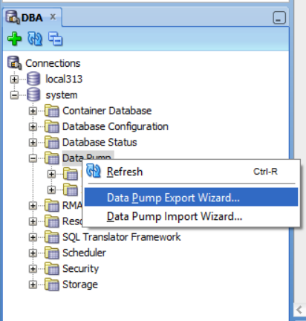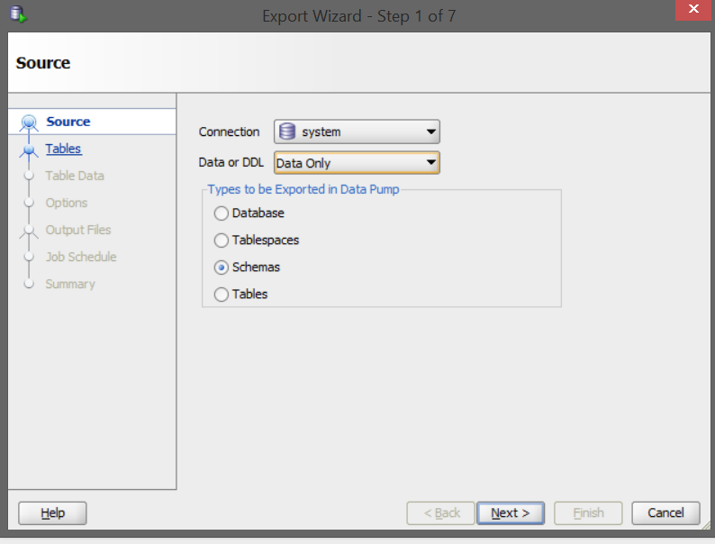

Choose your directory that you created and name your log file.

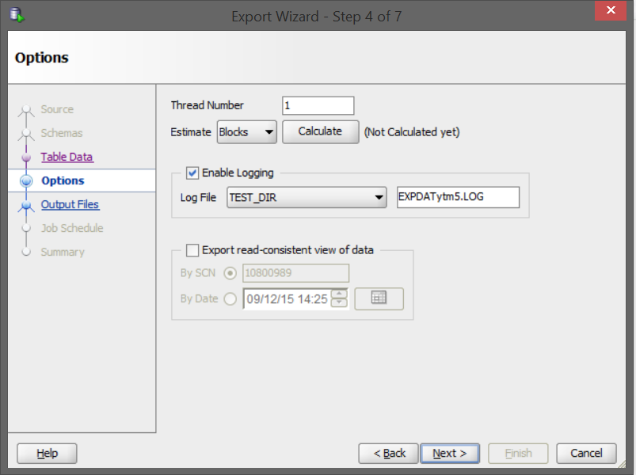

Also choose where you want to export your dump files and how to name them, there is default limit for dump files 100MB, so there will be a few files, “%U” means that if it is a bigger file it will create EXPDATytm501, EXPDATytm502, etc.

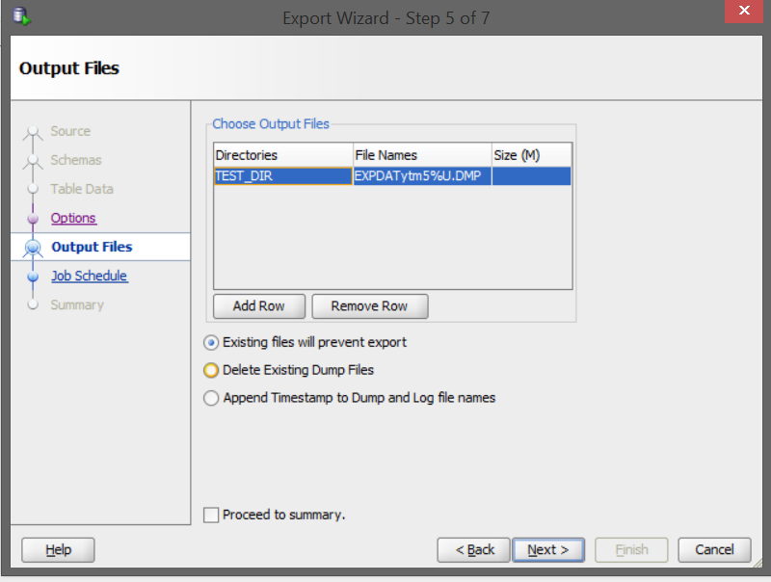

Details are in the summary right before export and after exporting in log file in your directory.

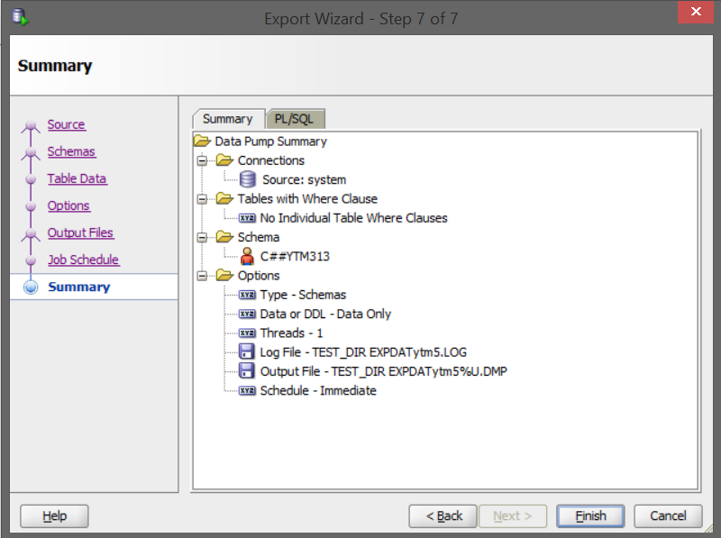 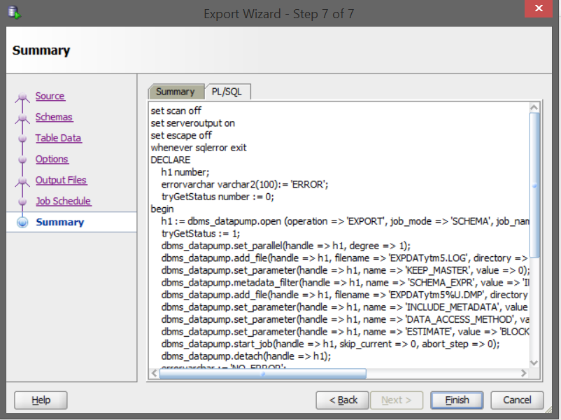

## Import Data Pump Wizard

Select in what directory is your dump file, and file name.

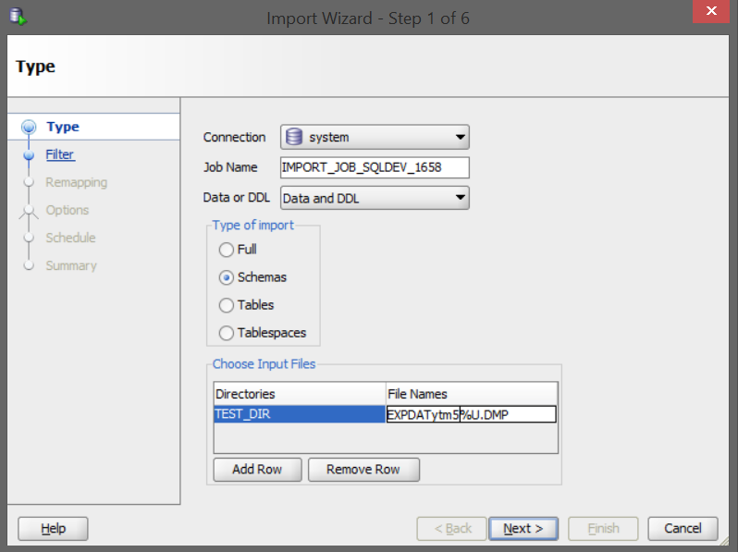

Specify to what user you want to transfer data, then create log file and import the data.

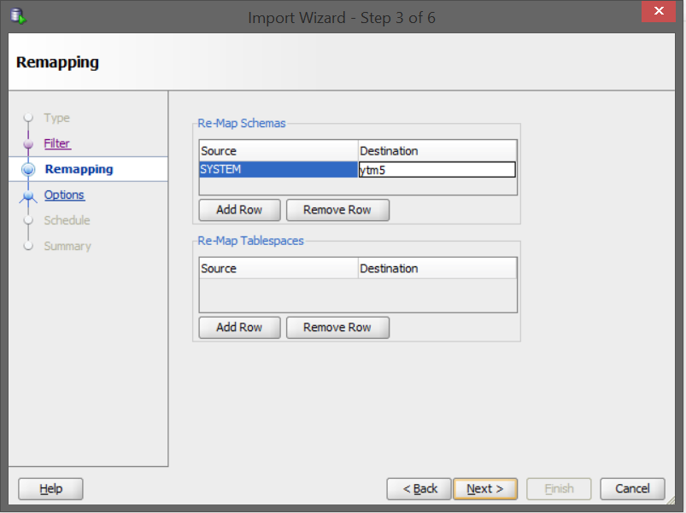

# Unix/Linux – Transfer Files From And To

Use GUI Utility WinSCP

<https://winscp.net/eng/download.php>

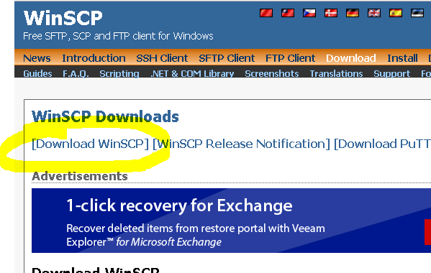

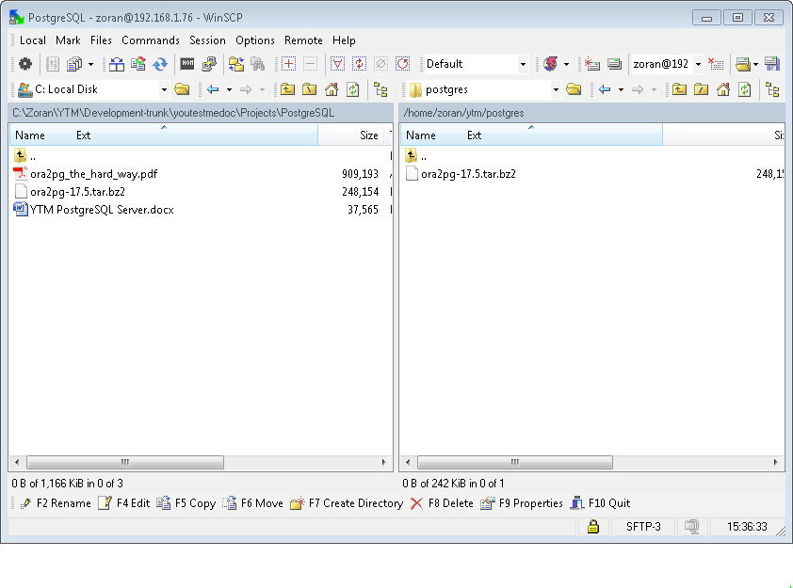

# Install SVN plugin in Eclipse Neon

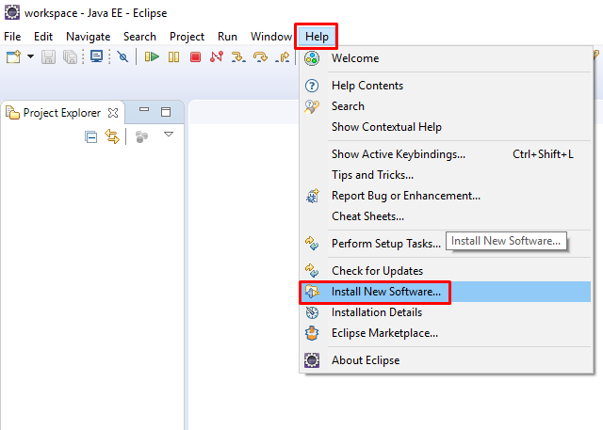

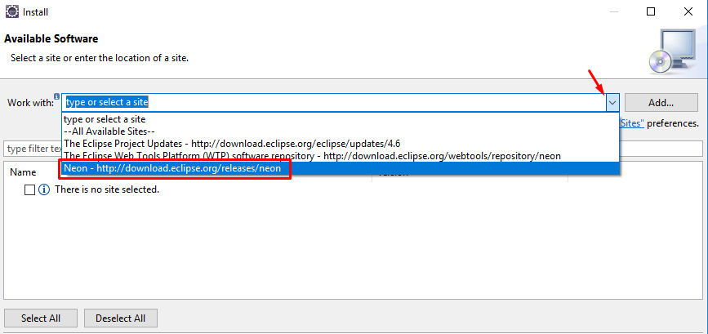

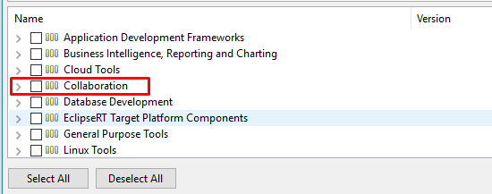

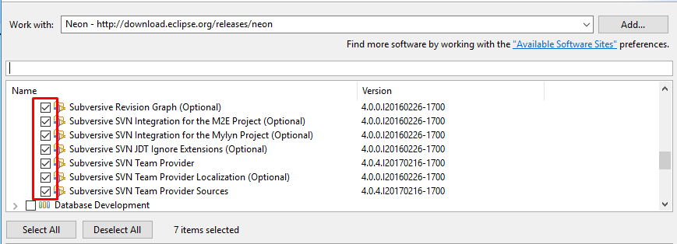

# Import Project from SVN

Right click on Project Explorer window and then click on Import -> Import… On new screen you need to find SVN document and click on Project from SVN function:

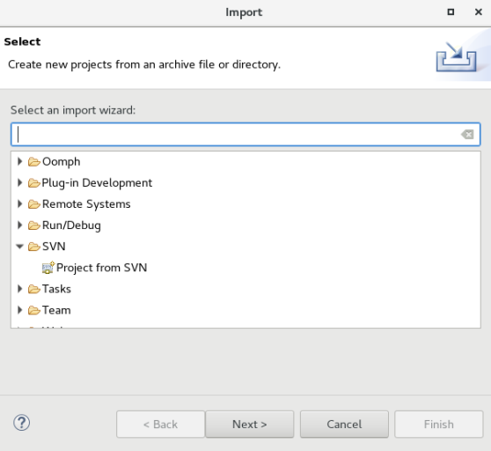

Before you run checkout, make sure that you set up the following things:

* Repository URL
* Username
* Password

Then click Next

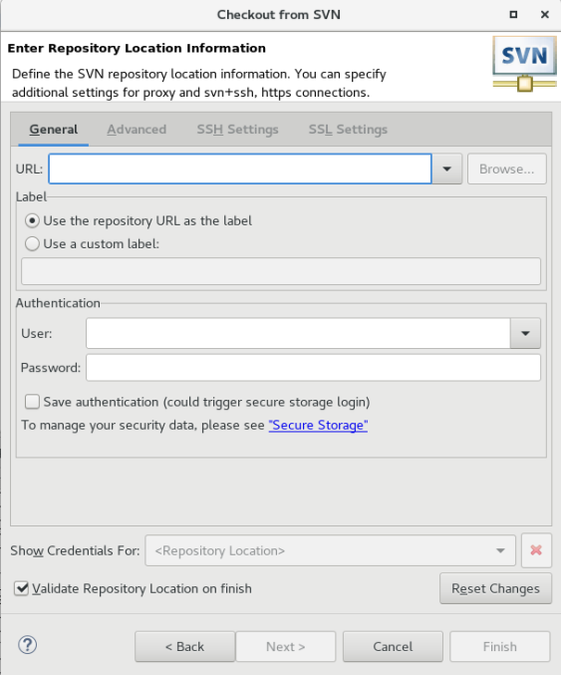

On next screen you need to confirm that you want to checkout head revision of branch:

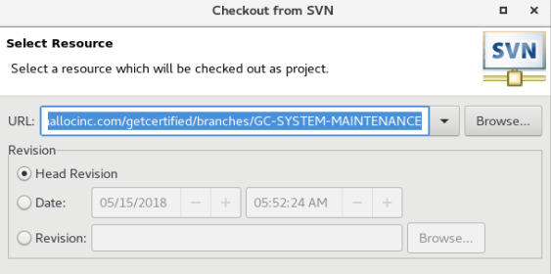

Finally, chose how you want to check out folder:

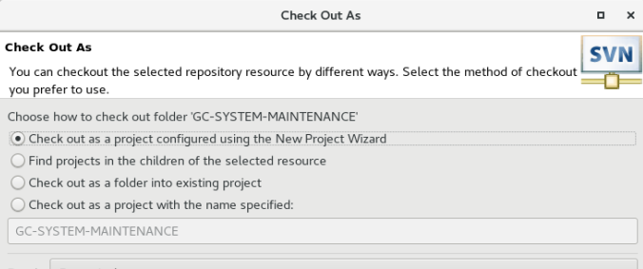

After all this steps your checkout wiil start.

If you want to commit some changes, just following up next steps:

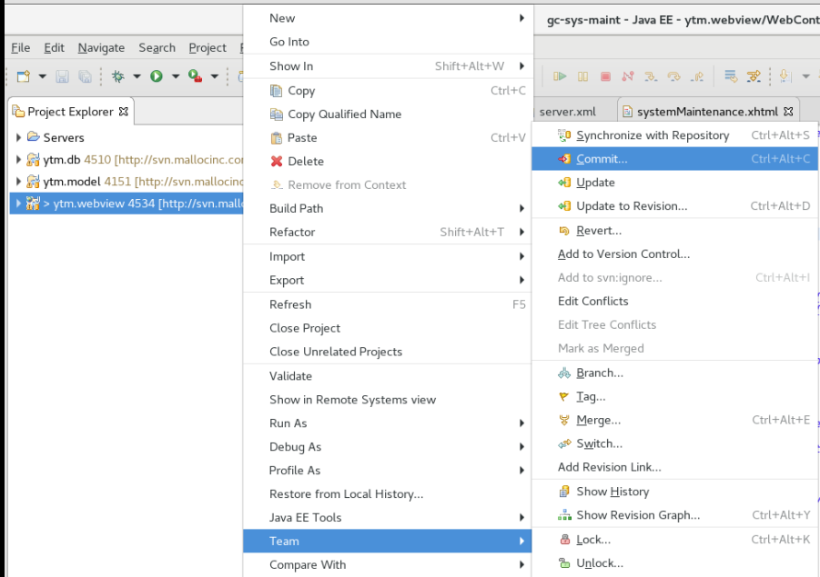

You can choose what files you want to commit like on Windows SVN:

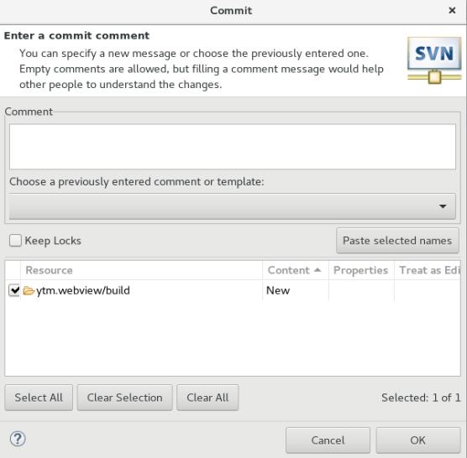

More information on following link: <https://www.youtube.com/watch?v=4jSkppB54qM>