File name | Procedures for New Team Members
Author | Irena Petrovic
Confidentiality | Internal
Last save date | Friday, February-07-2020 at 9:35:00 AM

Table of Contents
1 Introduction 3
2 List of the Tasks for the HR Manager 3
3 List of Tasks for the System Administration 4
4 Steps of the Inclusion a New Member in YTM Team 5
4.1 Introducing the Company Policy Rules Document 5
4.2 Introducing the Company Culture and Procedures – Wiki2 5
4.3 Sending the Email with the Accounts 5
5 Documentation and Application 6
6 SVN 7
6.1 About SVN 7
6.2 Download SVN Client Software 8
6.3 Document Location 8
7 YouTestMe Email System 8
7.1 Setting up Email Client via Microsoft Outlook 9
8 Slack 9
9 Mandatory Reading Material 10
10 New Employees Should Sign 10
11 "Must read" documents and instructions 10
12 Typical first tasks for new employees 10
13 Create NAS (Network Attached Storage) Account 11
14 Create Unix (proxy server) account 11
15 Mandatory Security Policies 12
16 Useful Videos 12
16.1 Instructions for developers 12
17 Phone numbers 13

Introduction
This document provides all necessary information so that new intern and employee can get acquainted with the procedures and get the necessary tools to operate within the company.

You can find the list and the download links to all procedures from this document on our Wiki.

The check list with all documents and tasks for managers and mentors required is on the following link -
https://svn.youtestme.com/youtestmedoc1/trunk/Procedures/HR Procedures/YTM Team Member On-boarding Procedure.docx

List of the Tasks for the HR Manager

# | Account | Tasks
 | Company email | Create email address.  Add new email to the appropriate email groups.
 | SVN | Create SVN account.  Add user to the appropriate SVN team.
 | Bugzilla | Create Bugzilla account.
 | Folder in the Human Resource repository | Create folder named on the member name and surname.  Folder should contain the following docs:  - ID card  - CV  - Non-confidential agreement, and  If member is on unpaid internship  - No Compensation - Agreement
 | Wiki editing, and/or reading privileges | Enable user to edit Wiki or Wiki2 if it is one of his/her tasks.
 | YouTube channel administration | Enable user to edit YouTube.
 | Facebook page contributions and administrations | Send username and password.
 | Word press (web sites) | Create username and password.
 | SLACK | Activate member’s account
 | Google Groups | Add a member to the google mailing lists.
 | Human-Recourses repository | Transfer folder with a employee’s name from Active Employees (C:\SVN\Human-Resources\trunk\Recruitment\Employees\Employees\Active Employees or Active Remote Internship) to C:\SVN\Human-Resources\trunk\Recruitment\Employees\Employees\Former Employees or Former Internships
 | Google Sheets | Add permission.
 | Responsibility matrix | Add tasks to the responsibility matrix if it is appropriate:  \youtestmedoc\Management\Responsibilities Matrix and Recurring Tasks.xlsx
 | Team Directory | https://svn.youtestme.com/youtestmedoc1/trunk/Management/Team/Team Directory.xlsx  Add Contact info for employee from Team directory sheet in Team Directory document to Archive sheet in the same document.
 | Facebook page contributions and administrations | Create username and password.

List of Tasks for the System Administration
# | Access to | Comment
 | SVN Administration console
 | Guacamole (from all servers – as of October 24, 2016 we have two)
 | Guacamole administration
 | Remote access
 | Guacamole
 | VPN
 | VNC
 | Unix accounts
 | Administration consoles at OVH hosting service
 | Windows accounts
 | Databases accounts
 | Critical system like: OVH, client's virtual machines | If he/she needs to have access to it.
 | NAS

Steps of the Inclusion a New Member in YTM Team

Introducing the Company Policy Rules Document
Before a new team member gets email with all accounts, he should be introduced to the following document -
\youtestmedoc\trunk\Procedures\HR Procedures\Malloc Inc. – Company Procedure & Policies.docx

Introducing the Company Culture and Procedures – Wiki2
A new team member then should read documents on the following page.
https://wiki2.youtestme.com/index.php/Getting_to_Know_YouTestMe

Sending the Email with the Accounts
A new team member should proceed as directed by the email with the account’s information. Template email is on the following link - https://svn.youtestme.com/youtestmedoc1/trunk/Document Templates/E-mail templates/Recruitment/English/Email Templates/001 YTM Sending Accounts.msg

Email text
Pozdrav IME,

U nastavku su Vam kreirani nalozi. Pratite predefinisane korake ispod.

1. Instrukcije:
https://wiki2.youtestme.com/index.php/Getting_to_Know_YouTestMe - Nakon otvorenog linka pogledajte tacku 6.

2. YTM Mail:
Korisničko ime: CREATED YTM EMAIL
Šifra: PASSWORD – najmanje 8 znakova, minimalno 1 veliko slovo, 1 malo slovo, 1 znak (#, %, ?...) i 1 broj
Webmal: webmail.1and1.com

3. YTM Slack:
https://youtestme.slack.com/ - ukoliko ne budete dobili od Slack-a na mail password, kliknite opciju forgot password i ulogujte se na Vaš iznad već kreirani youtestme e-mail.
Potrebno je, takodje, da na profil na Slack-u dodate svoju fotografiju, broj telefona I Skype – nalog (ako ga posedujete).

4. YTM Bugzilla:
Korisničko ime: CREATED YTM EMAIL
Šifra: PASSWORD
http://bugzilla.youtestme.com
5. YTM SVN:
Korisničko ime: IME.PREZIME (sve malim slovima)
Šifra: PASSWORD

6. YTM Wiki2:
Korisničko ime: Ytmdev
Šifra: 1Dev#@!
https://wiki2.youtestme.com/
VAŽNO: Šifru za Wiki2 nemojte menjati jer ona nije personalizovana.
7. Outlook Express
Prijavite se sa novim imejlom na Outlook Express, pošto je to praksa u YTM kompaniji za pisanu komunikaciju sa kako eksternu, tako I formalnu - internu.

8. YTM Wiki1:
https://wiki.youtestme.com/index.php/Welcome_to_YouTestMe_Wiki - Getting to know YouTestMe.

9. Dokumentacija:
https://goo.gl/Ew98nW - YouTestMe GetCertified Main Features.
https://employees-training.youtestme.com – na ovoj sajtu možete uraditi kurs u kojem ćete proći kroz osnovne stvari. Kreirajete svoj nalog kao i prošli put, ovo je drugačiji sajt iako izgleda isto (ista je aplikacija).

Savetujem da promenite lozinke nakon otvorenih naloga – osim kod Wiki2 gde šifra treba da ostane ista.
Ukoliko budete imali bilo kakvih problema prilikom otvaranja ovih naloga, molim Vas pošaljite mi e-mail.

Srdačan pozdrav,

Documentation and Application
Upon joining, every team member needs to get acquainted with the application by:
- Creating an account on a designated YouTestMe application and testing its version, writing down all observations in the standard YTM Word Document Template
- Reading the standard document package (for introduction)
- Watching the YouTube tutorials:
  - Get Certified - https://www.youtube.com/watch?v=d9lRDuDMiBQ&list=PLNr69myqMnd_mgmn-Jt9cSh4WKbreudif
  - Classroom 2020 - https://www.youtube.com/watch?v=TVGTBHp1ShA&list=PLNr69myqMnd-RGFIdt59kvWVWfpzVSGb7

SVN

About SVN
Subversion is a free/open source version control system (VCS). That is, Subversion manages files and directories, and the changes made to them, over time. This allows you to recover older versions of your data or examine the history of how your data changed. In this regard, many people think of a version control system as a sort of “time machine.”
Subversion can operate across networks, which allows it to be used by people on different computers. At some level, the ability for various people to modify and manage the same set of data from their respective locations fosters collaboration

Download SVN Client Software
Go to http://tortoisesvn.net/downloads.html and choose the appropriate version for your PC (32 bit or 64 bit). Once it is downloaded, go to one of your local hard drives and create a folder called SVN. In it, create a new folder with name corresponding to the repository you want to checkout (youtestme, youtestmedoc, etc.)

Document Location
To see detailed info about using SVN, read the document found here: https://svn.youtestme.com/youtestmedoc1/trunk/Procedures/Development Procedures/SVN/YTM Using SVN.pdf

YouTestMe Email System
Every new team member will receive a mail in the format of name.surname@youtestme.com . This email must be used for communications within the company and with clients/partners. You will receive the password to this email account in the inbox of your personal account.

NOTE While creating an email for new employee, please make sure to turn on the Anti-Spam and Virus protection. This will protect our computers from getting emails that contain spam, virus or phishing scams.

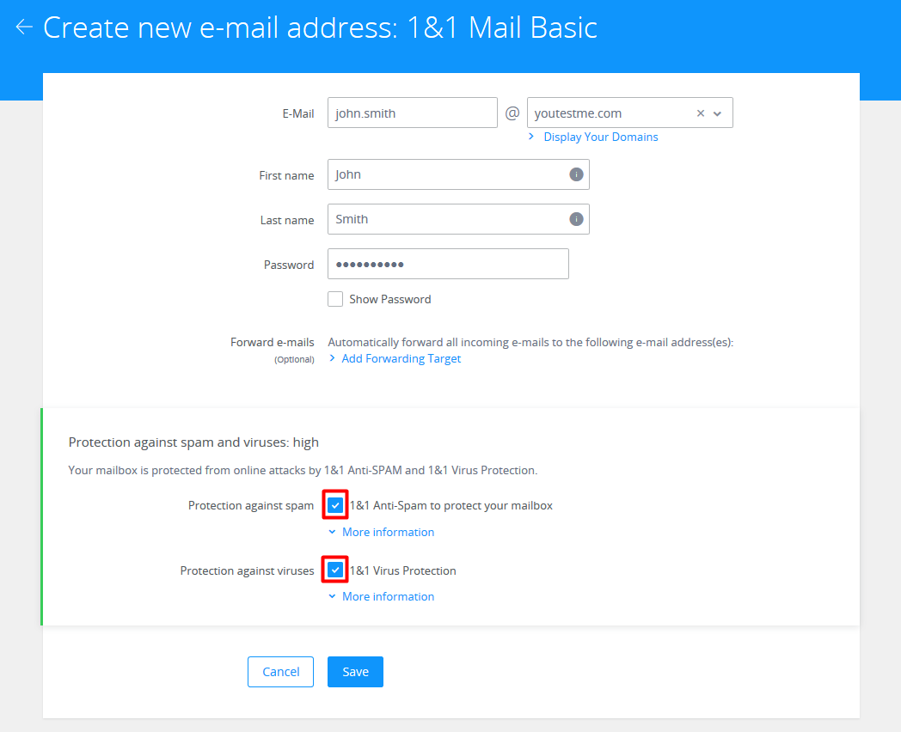

Setting up Email Client via Microsoft Outlook
Before you begin, you will need to have Outlook already installed on your computer.

To find help with the procedure of setting your email account via MS Outlook check the document found in:
youtestmedoc\trunk\Procedures\Technical Procedures\General Office\Setting email for Outlook.pdf

Every member should create their own signature. To find help with the procedure of setting your email signature:
youtestmedoc\trunk\Procedures\Technical Procedures\General Office\Setting email for Outlook.pdf

Slack
Slack is the main tool used for chat, quick document transfers (in case the SVN is unavailable) and discussion. In order to join Slack, a valid @youtestme mail account is necessary.
We have sent you the invite to our @youtestme.slack on your YTM email that was created for you. Please Log In to your email and find an Email from Slack that says JOIN. When you confirm, you only need to write in your account information, which we have sent you to your personal email.
Please make sure, that you write in all the necessary information regarding your profile
your phone number is mandatory:
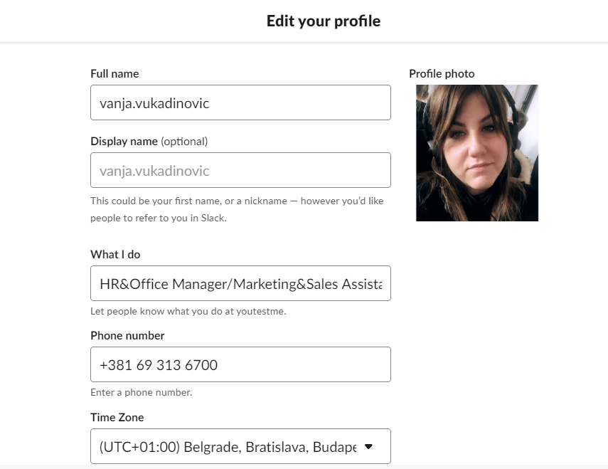

Mandatory Reading Material
- \youtestmedoc\Procedures\HR Procedures\YTM General Rules.docx
- https://svn.youtestme.com/youtestmedoc1/trunk/Procedures/HR Procedures/Malloc Inc - Company Procedures & Policies.docx

New Employees Should Sign
- Non-confidential agreement which you will receive by email, and
- Unpaid Internship Statement.

"Must read" documents and instructions
Please get familiar with these documents:
- YTM MS Word Best Practices located in youtestmedoc\trunk\Procedures\Technical Procedures\General Office
- Procedure for creating procedures located in youtestmedoc\trunk\Procedures
- YTM Grammarly located in youtestmedoc\trunk\Procedures\Technical Procedures\General Office
- Suggestions Procedure located in youtestmedoc\trunk\Procedures\HR Procedures

For Developers:
- YouTestMe Developer Manual located in youtestmedoc\trunk\Procedures\Development Procedures
- YTM Web Development Manual located in youtestmedoc\trunk\Procedures\Development Procedures
note: Please download Lightshot https://prnt.sc/ .

Typical first tasks for new employees
- Test both applications and website and give feedback about possible problems and improvements
  - Link - https://recruitment.youtestme.com
YTM GetCertified – document with login account and tasks for easy use of the app
- Test at least two procedures, if possible relevant to the tasks that he/she will be doing and give feedback.
- Feedback should be stored in SVN and email sent to team leader and ALL management
youtestmedoc\trunk\Projects\YTM Get Certified\Feedbacks – GetCertified Feedbacks
youtestmedoc\trunk\Projects\YTM Classroom 2020\Feedbacks – CL2020 Feedbacks

Create NAS (Network Attached Storage) Account
NOTICE: Ask your mentor do you need this before creating

Login to NAS Web Console and enter administrator credentials and click “Configuration” button. The credentials can be found in: http://svn.mallocinc.com/admin/trunk/Important Accounts.xlsx

Continue with “Advanced->Users/Groups” and create new user. Username should consist of the name of the new member and the first letter of the surname. For example: “miloss” for Milos Sekulovic.

The second step would be to add the username to the appropriate group.
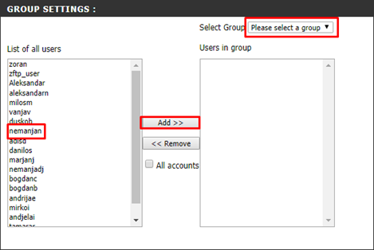

Create Unix (proxy server) account
NOTICE: Ask your mentor do you need this

Geo location | IP address | SSH port
France | 79.137.2.228 | 1769
Montreal | 167.114.198.81 | 1759
Belgrade | homebg.mallocinc.com | 45721
Toronto | home.mallocinc.com | 54678

Every new developer and member of QA team should have Unix account created on every Proxy server from the table above except in Montreal. The username consists of the first letter of the name and its surname. For example, “msekulovic” for Milos Sekulovic.

- ssh -p [port] [your_proxy_username]@[ip_address]
- su - admin (password can be found in: /admin/trunk/ImportantAccounts.xlsx)
- cd manage_users
- sudo ./create_user.sh [username](for example: sudo ./create_user.sh msekulovic)

Mandatory Security Policies
Please strictly adhere to these security policies:

- Never open suspicious email from unknown sources
- If you open email from unknown source never click on any link (possible phishing attack)
- Never open attachment sent from unknown or suspicious source (possible virus attack)
- Do not go on blacklisted (http sites, gambling, gaming, XXX, etc.) web sites since most of them are designed to inject malicious software into your browser and computer
- Do not install suspicious or harmful software on your computer
- Have Windows Defender turned on all the time
- Scan your computer with antivirus software at least once a week

Useful Videos
SVN Crash Course:
https://www.youtube.com/watch?v=zGzSuRQMWBk&list=PLNr69myqMnd9wSQmItRYfFsM1R1BsIu--

Managing Emails for 1and1:
https://www.youtube.com/watch?v=XyjOpMM_Y94

Bugzilla Usage:
https://www.youtube.com/watch?v=voNbHkKawyM

Instructions for developers
List of instructional videos for developers:
\youtestmedoc\Training\YouTube Video Links.xlsx

YTM Development Tools and Environment: https://www.youtube.com/watch?v=zGzSuRQMWBk&list=PLNr69myqMnd9bM8mpjI3rdVpEPbLXDK6N

Virtual Machine Tutorials:
https://www.youtube.com/watch?v=DUFmoNpobMs&list=PLNr69myqMnd_u11MpR6ZFWbRUgF4EetaG

JMeter Tutorial:
https://www.youtube.com/watch?v=eIIZp_Gi3a8

Oracle Database: https://www.youtube.com/watch?v=HiPNDQQtgOo&list=PLNr69myqMnd-zpG0BOvF9nkzxTwvK7Zfv

Selenium Project: https://www.youtube.com/watch?v=0rx1DeZAXtQ&list=PLNr69myqMnd9fQ6Fi_8FTfTGSISO8K4-v

Phone numbers
It is very important to exchange numbers. Please make sure you have the number of your mentor, Dusko and Danilo so you can notify them (you can notify only one of them) in case of an emergency or you got sick or have exam that you need to go, etc.
Phone numbers of all team members - http://svn.mallocinc.com/youtestmedoc1/trunk/Management/Team/Team Directory.xlsx

