Online Proctor Exam Guide

Contents
- Introduction 3
- Support Contact Information 3
- Requirements for test-taking 4
- Important notice 5
- Important information about navigation in the exam 6
- Exam Taking Process 7
  - Starting the Exam/Equipment Validation 7
  - Checking equipment & student validation 8
  - Attempting the Exam 12
  - Completing the exam 14
  - Some Frequently Asked Questions 15

Introduction
This document represents a guide to the test-taking process on the CRBOH Exam platform. Please follow these instructions carefully to avoid your test attempt being nullified.

Support Contact Information

If you are having any issue with accessing your exam during Exam Session Time, please contact the Exam Support Team at +1 888 418-1718

Requirements for test-taking

To start a successful testing session with proctoring, you must have the following:

A working camera

A working microphone (or headphones with a microphone)

A stable and fast Internet connection

Chrome or Firefox browser

Note: Google Chrome is recommended.

Laptop or Desktop computer (Please do not use tablets or mobile phones)

Outside interruptions may compromise your test-taking session. Keep in mind the following:

- The noise in the room where the test is to be taken should be reduced to the minimum. In the case of noise, Proctor will be notified of it and take appropriate actions.
- You should be the only person present in the room and in front of your camera.
- You may not use other tabs during the exam.

Important notice
Before taking the exam, you MUST take the Equipment Check Test to test your equipment.

If you don’t take the Equipment Validation Test, you may not be able to take the official Exam (due to non- functioning or non-compatible equipment).

Important information about navigation in the exam
ATTENTION – During the exam on our Exam platform:

Do not click the “Back” button on your browser

Do not click the “X” button on your browser; to finish the test, use the “Finish test” button

Do not click the “Finish test” button unless you are sure you have completed everything

Do not log out from the proctoring system during the test-taking
If your exam is disconnected due to any of the above action, you may not be able to regain access to your exam

Exam Taking Process

Checking equipment & student validation
    - Allow the camera, microphone, and Screen sharing (Entire screen) usage when prompted. Wait until everything has been set up.
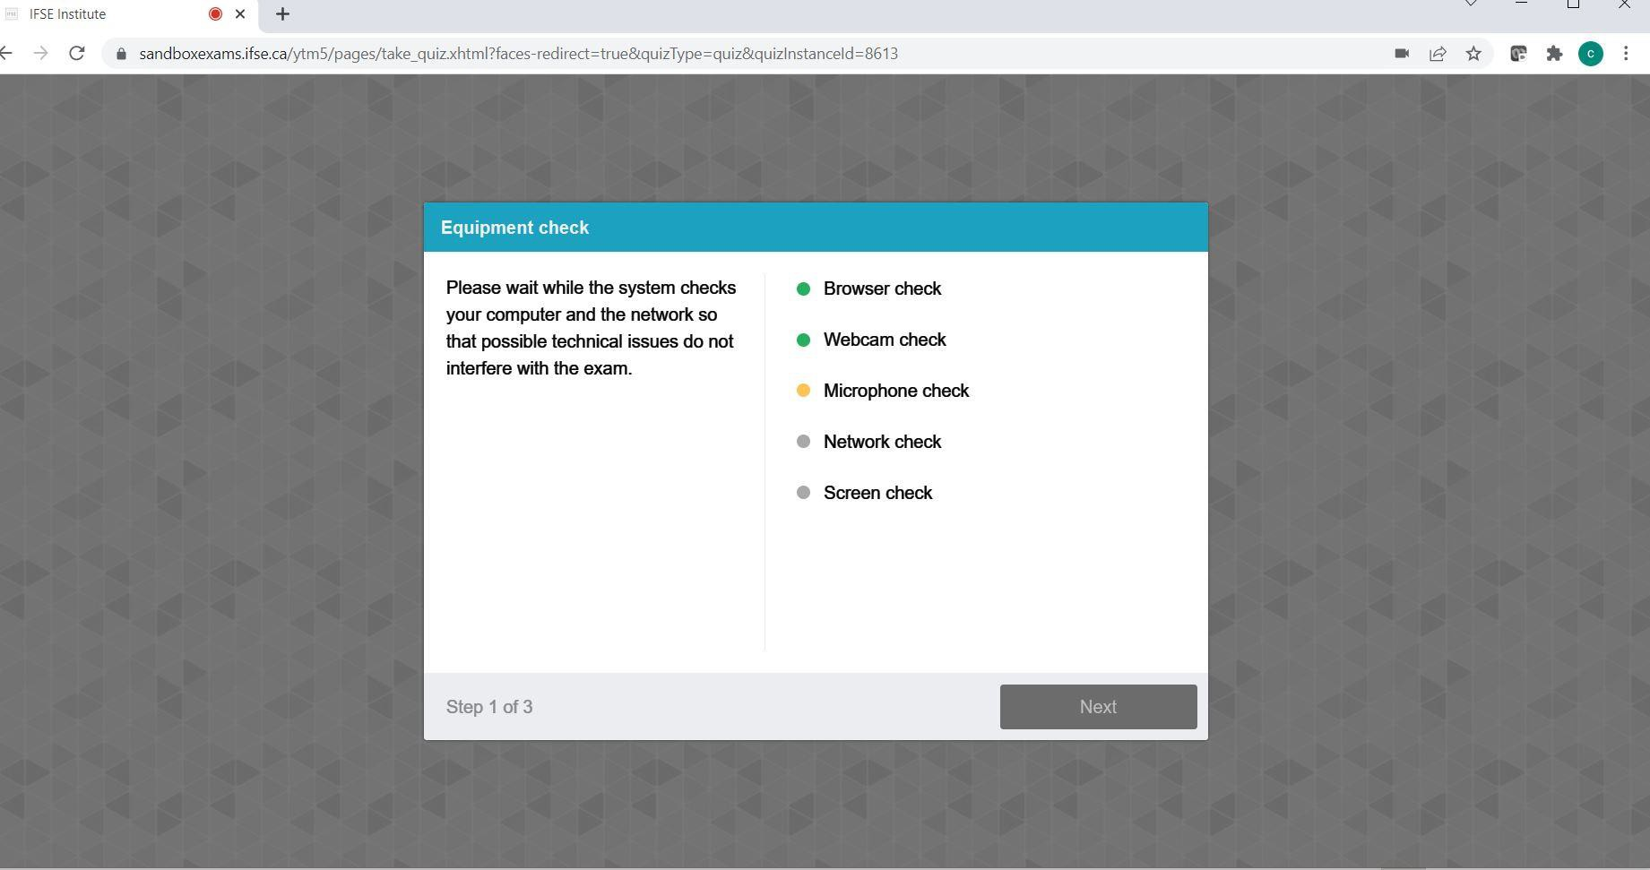

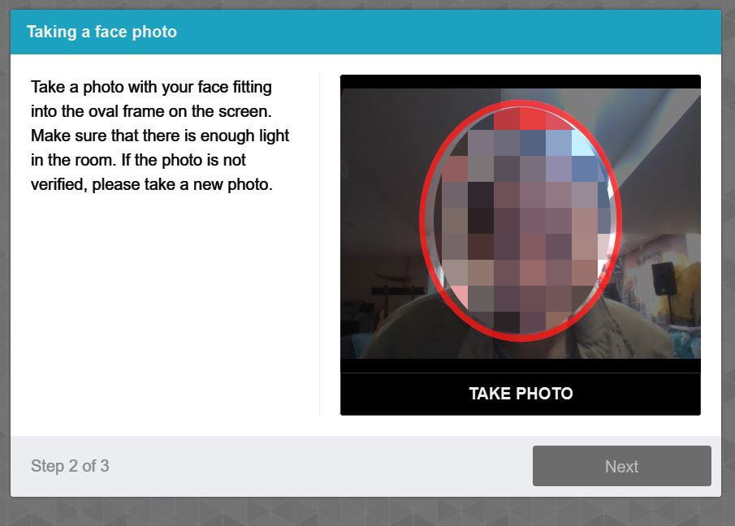
    - Take a photo of yourself when asked by the system

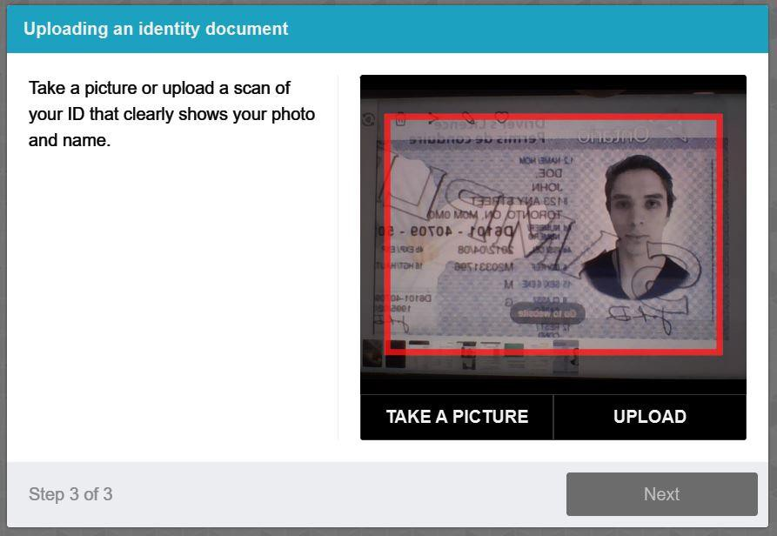
    - Provide a photo ID to be captured when asked by the system

    - You will need to confirm the entire screen sharing once again. When prompted with permission to share your entire screen, press the button “Share.” If you cancel sharing, you will not be proctored, which will mean your Exam will not be valid. Proctoring is required for all Exam takers.
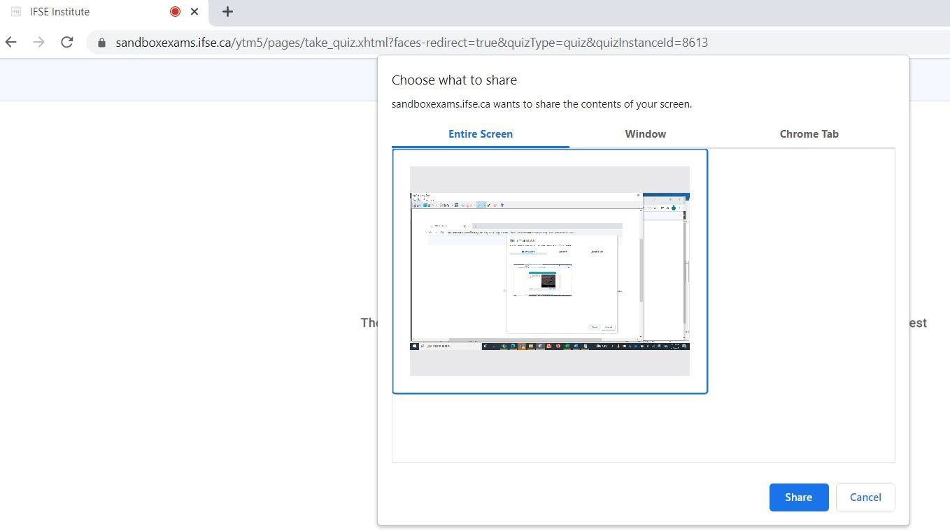

    - QR Code for environment scan. When a QR code is presented, open the Camera app on your smart phone to point to the QR code on screen, as soon as the camera can capture the code, a URL will be popped up on your phone to click to access the environment scan application, follow the instructions to scan your complete working area and submit when done.
    - After all required checks have been completed, the Proctor will start the exam.
    - You may need to confirm Sharing your screen again with the Proctor, do NOT click “Stop sharing” as it will result in your Exam being terminated.

    - You can move your picture by clicking and dragging. Place the mouse cursor over it, press and hold down the left mouse button, then move the mouse while still holding down the left mouse button. By clicking on your picture, the chat that you can use to contact the proctor will open.
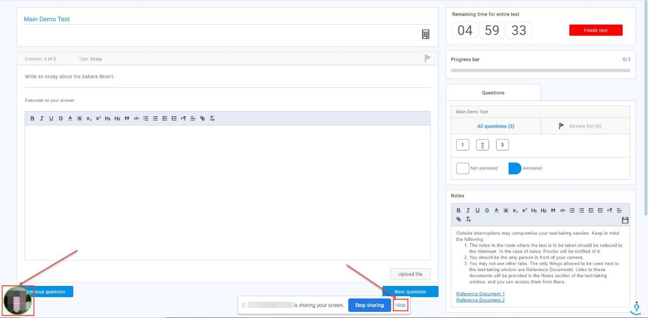

Attempting the Exam

Do not click the Back and X button in the web browser.

The only buttons you are allowed to click in the platform during the test-taking are:
- Next question – to go to the next question
- Previous question – to go back and re-do a question
- Use the scroll bar – you can also use the scroll bar to see the Notes.
- Mark for review – if you want to mark a question for a review and later go back to it, use this button (it is optional). The question will appear in the Review list (marked with number 5in the screenshot below)
- Review list – use it to go back to the questions you have marked for a review previously

Calculator
- Notes – Here, you can see a set of instructions or rules and links that you can use to access the Reference Documents. Besides reading the instructions, you can add your notes.

Select your answer
- Finish test – when you make sure you are done with the test, click this button.
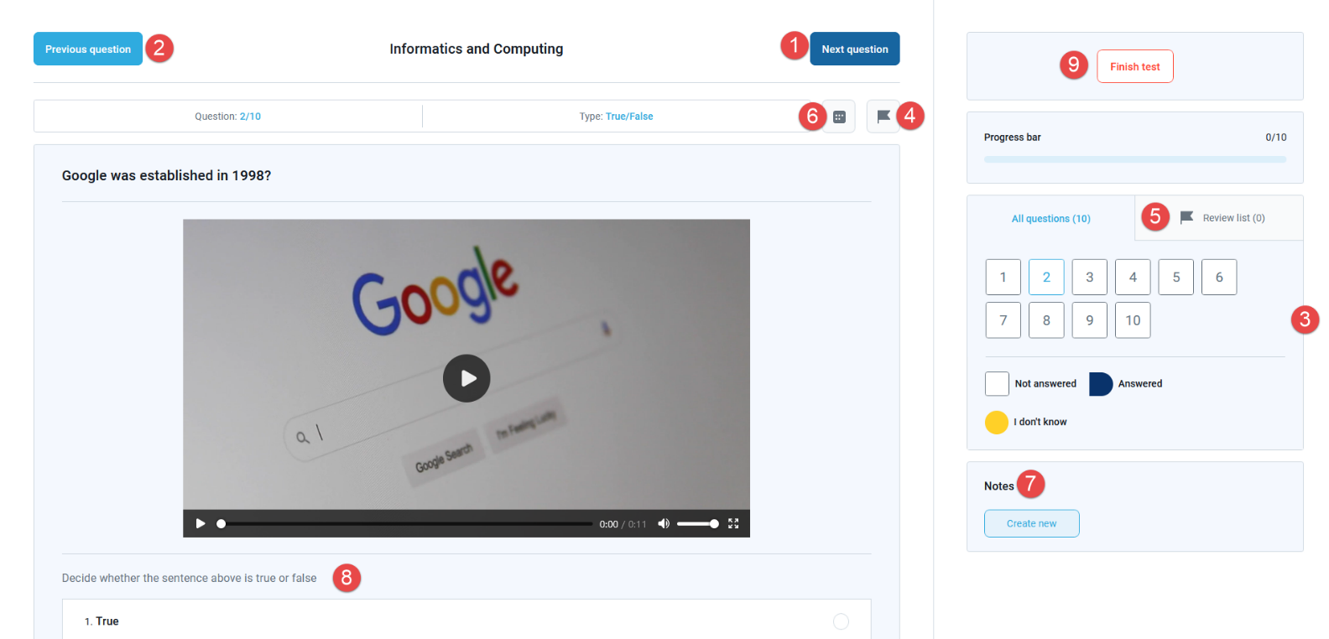

If you marked a question for a review, once you are done reviewing it, make sure to go to the Review list (number 5 in the screenshot above) and uncheck it by clicking on the “x” button, or you won’t be able to finish the test. This is shown in the screenshot below:
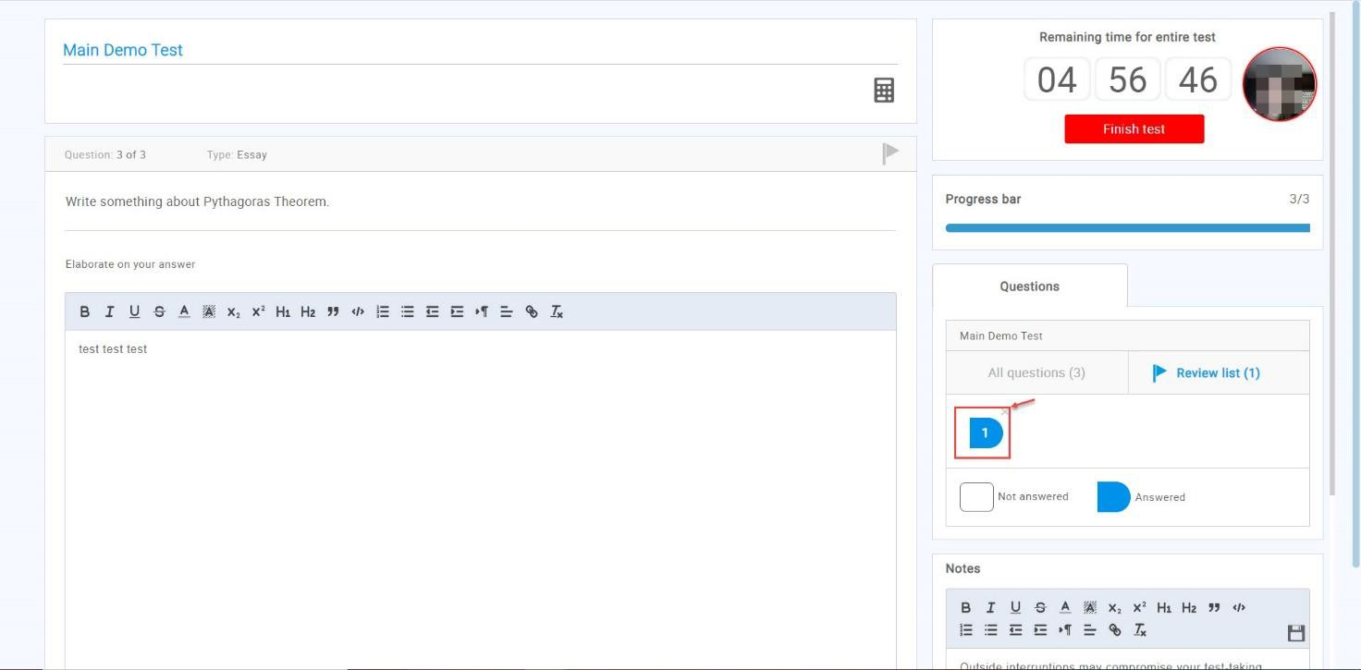

Completing the exam
Once you have finished answering all questions on your exam and Confirmed that you want to finish the test, you can simply click close the browser window by clicking the X at the top right corner of the browser.

Some Frequently Asked Questions
- I’m having issue with taking a picture
Please make sure that your face fits into the frame on the screen and that there is sufficient amount of light in the room. The glasses' reflection may also be a problem, you may try to take a photo without glasses if you are wearing them

- I cannot scan the QR code
You can use any QR code scan app on your smart phone, or simply open up the Camera app and try to focus on the QR code but do not take a picture, once the app recognizes the QR code it will display the URL on your phone screen to click to access the app for scanning your environment.

- I cannot share my screen
Once you are on the screen sharing screen, you will have to:
  - Choose the entire screen.
  - Click on the screen box
  - Click on the button “share”
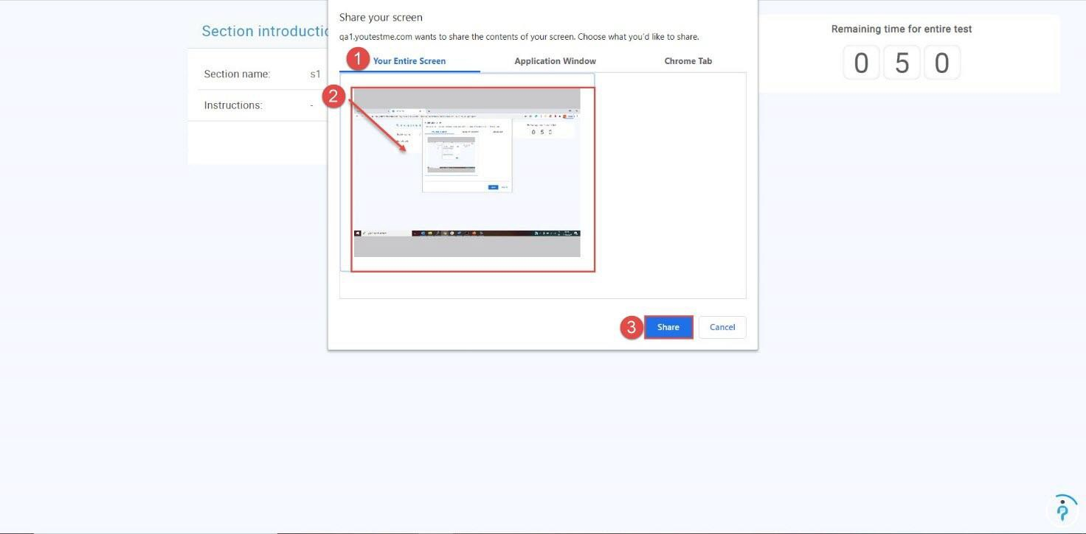
Once the equipment check is done, you will be prompted with the screen sharing option once again, and you will have to follow the same steps as above.
Please note that you are not allowed to use multiple monitors during the exam. If you have more than 1 monitor, you must plug in only 1 monitor during the exam to be able to choose the entire screen option.

- During the exam, sometimes I see a notification showing “Two faces in front of a camera”
Sometimes, due to light or shadows, the system may incorrectly determine that there are 2 faces. You do not need to be concerned with this message, the proctors are watching all candidates and will contact the candidates if they suspect of any suspicious behaviors

