Contents
1 About 2
2 Location of this document 2
3 Bugzilla rules for YouTestMe team members 2
4 Updating Bugzilla items Assigned to You 2
5 Searches and Reports 4
5.1 Creating reports 5
6 Additional Bugzilla Manuals 9
7 For Administrators 9
8 Listing all users 9
8.1 Regular users permissions 11
8.2 Administrator’s permissions 12
9 Bug Reporting 13
9.1 Viewing a bug list 13
9.2 Searching bugs 14
9.3 Bugzilla – Bug List 16
9.4 Bugzilla Bug List Column Customization 16
9.5 Exporting Bugzilla Bug List 18
9.6 Importing the Bug List into Excel 18
9.7 Opening Bug List .csv File 18
9.8 Importing a Bug List as Query 20
9.9 Updating CC List 22
9.9.1 Adding to CC List inside the Bug 22
9.9.2 Adding to CC List Several Bugs at Once 22
10 Extending Deadline 24

About
Bugzilla will be used as an issue tracking system on YouTestMe project.
All team members should regularly check items assigned to them and update them accordingly as per instructions provided below.
Bugzilla also send email reminders about outstanding tasks assigned to you. If you are receiving reminders about tasks that you completed you should change status of that task to “RESOLVED” or “CLOSED”.

Location of this document

http://svn.mallocinc.com/youtestmedoc1/trunk/Procedures/Technical%20Procedures/Bugzilla/YTM%20Using%20Bugzilla.docx

Bugzilla rules for YouTestMe team members

- The Development team should assign all tasks they have completed to the QA team for the QA team to check.
- After this, the QA team member needs to check whether the bug is fixed.
- If it is, QA team member can close the bug. If not, QA should briefly explain in a comment what happens with the functionality and what doesn’t work. The developer should be assigned back to the task in that case.

Updating Bugzilla items Assigned to You

Update items assigned to you by:

- Reassigning it to other team member if task is not for you
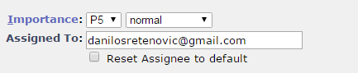
In case of reassigning the bug, it is mandatory to put as a comment from who is bug reassigned and to whom. For example – Transferring bug from Danilo Sretenovic to Aleksandar Nikolic

The person who is receiving the bug needs to changed bug for ‘’New’’ to ‘’Assigned
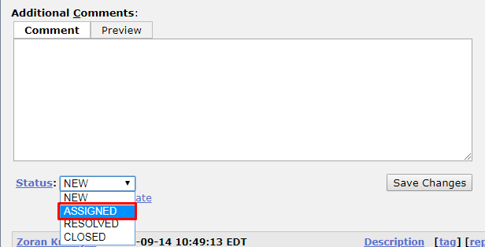

Also, the person in charge needs to add comment with suggested solution or plan of progress.
- Add “deadline” – an estimate when you think the task will be completed.
If task is complex you can add “Hours Left” so we can plan workload if item becomes critical.
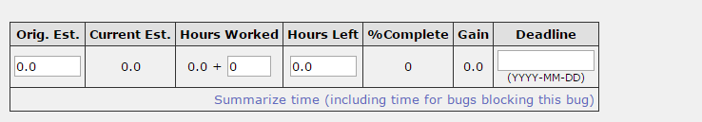
- Close Items that are completed and always put the comment with resolution:
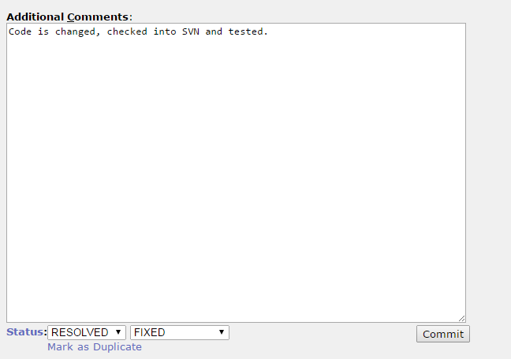

Searches and Reports

In Bugzilla you can predefine reports and always execute them on one click.
Example:
Reports you predefine are listed at the bottom of the screen:

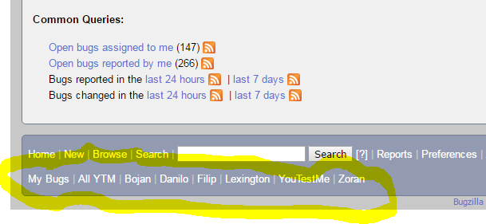
To run any of them just click on it (example for “All YTM” is below):
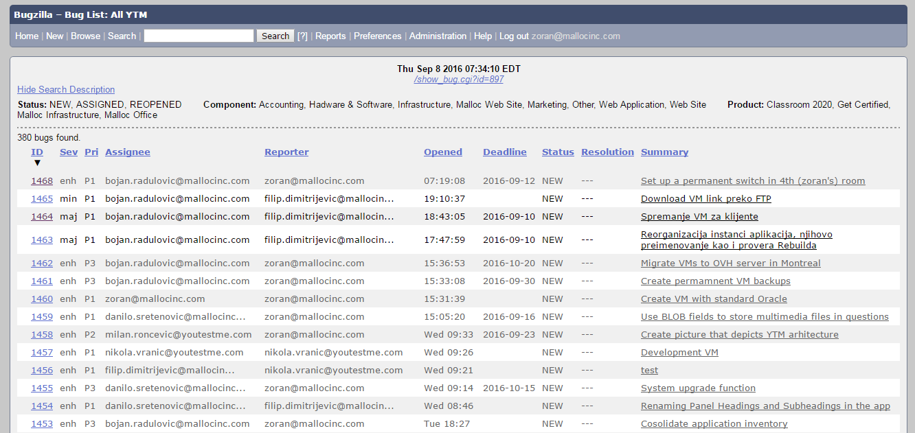

Creating reports

Go to http://bugzilla.mallocinc.com
Insert your username and password
Click “Search” on the top left side
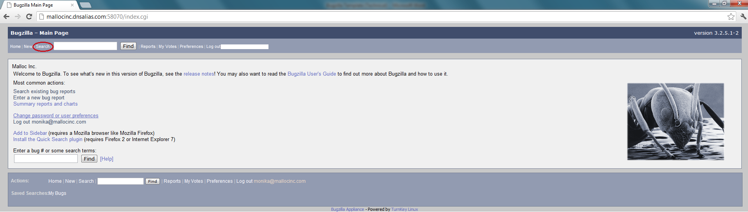

Click “Advanced Search” on the right side
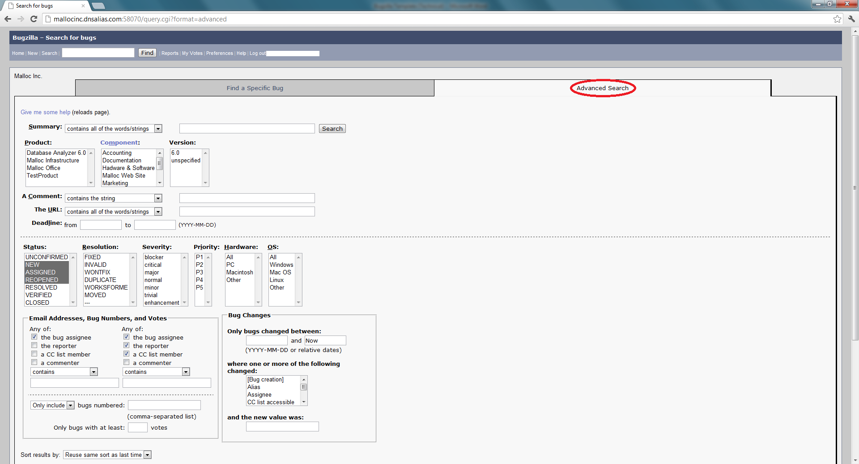
A. Select a “Product” you are assigned to work on, select other options if necessary, and click “Search” at the bottom.
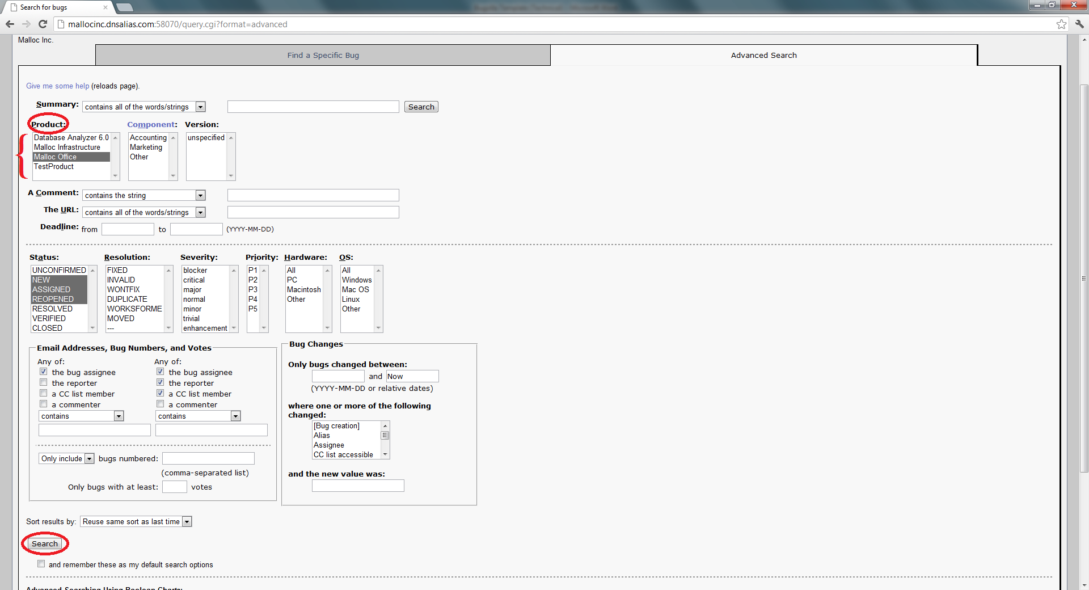

B. Select the priority level and enter assignee’s name to search the tasks
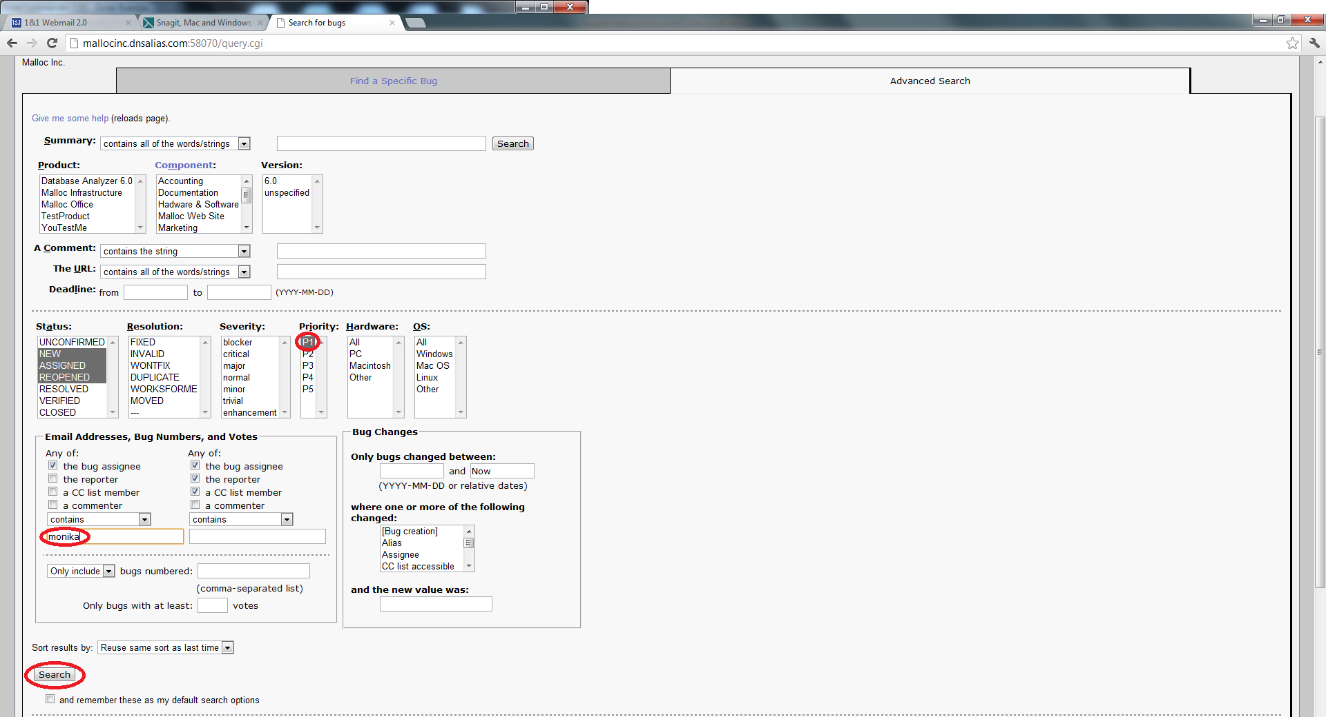

Click on the task that has highest priority (P1).
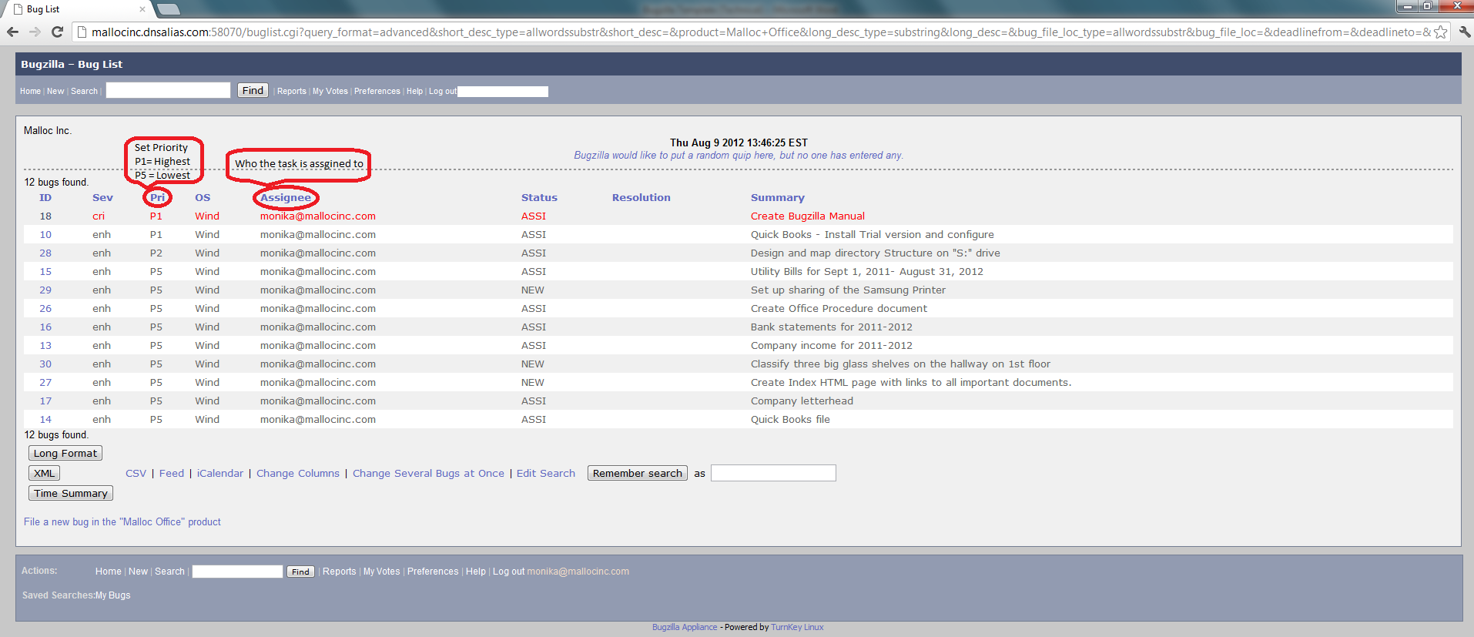

Under this task, some useful features will appear such as hours spent on it, hours remaining to finish it, deadline, add attachment and comment to communicate the progress of the task, etc. Update them as needed.
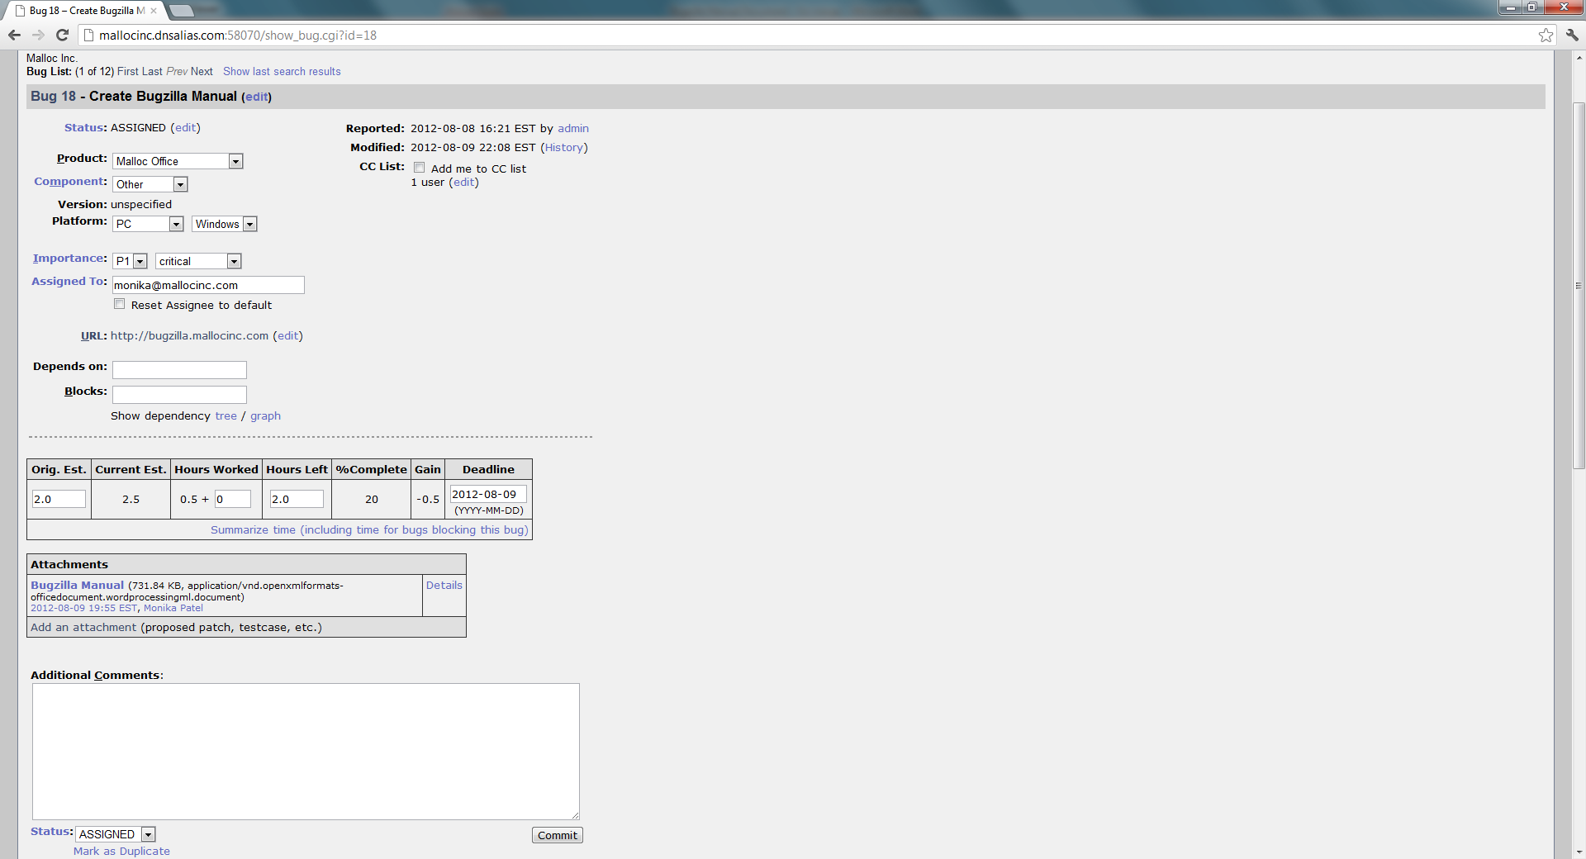

Once you complete the task, change “Assigned To” option to zoran@mallocinc.com and click “Commit” on the bottom right side.
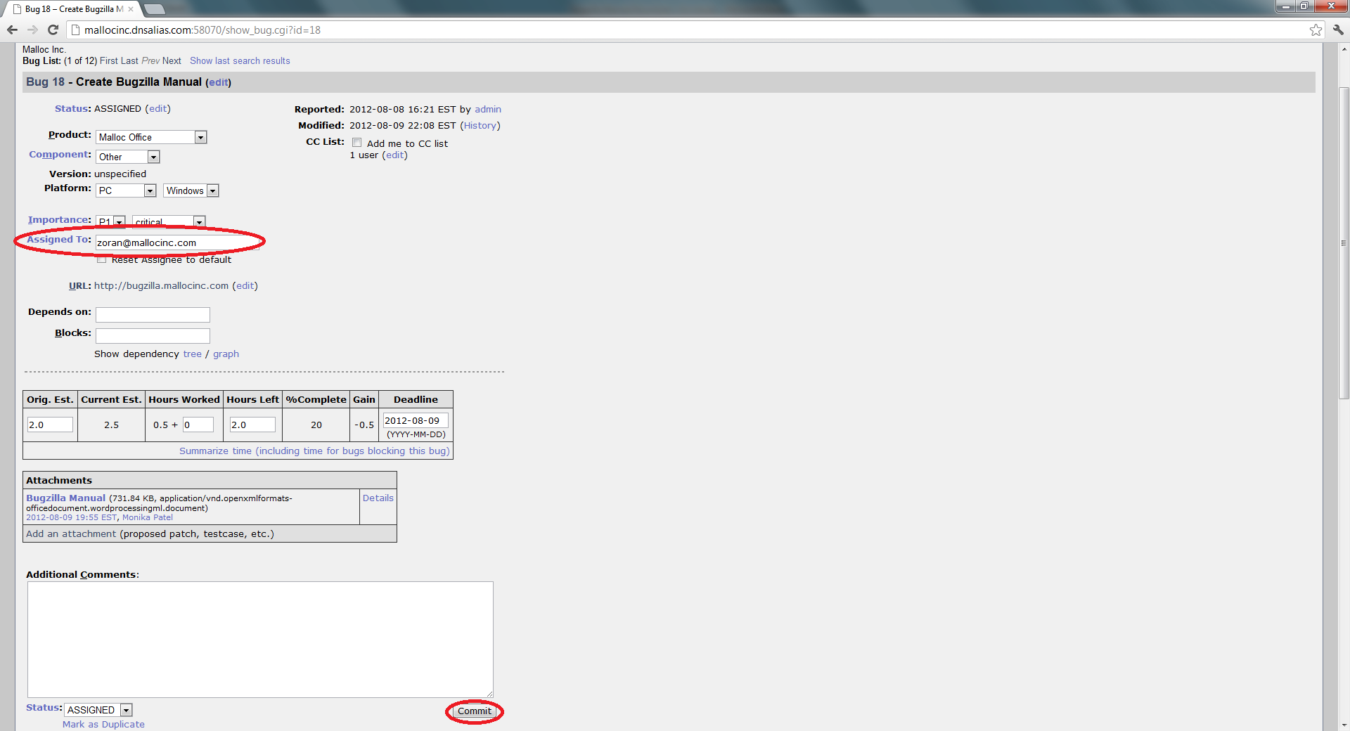

For more information, please visit
http://mallocinc.dnsalias.com:58070/doc/bugzilla3-doc/en/html/index.html

Additional Bugzilla Manuals

There are many tutorials available on the internet. Probably most convenient are videos on YouTube:
Search: "bugzilla tutorial for beginners"

For Administrators
See the following procedure - https://svn.youtestme.com/youtestmedoc1/trunk/Procedures/Technical Procedures/Bugzilla/Bugzilla Administration - Management.docx.

Listing all users

Go to “Administration”
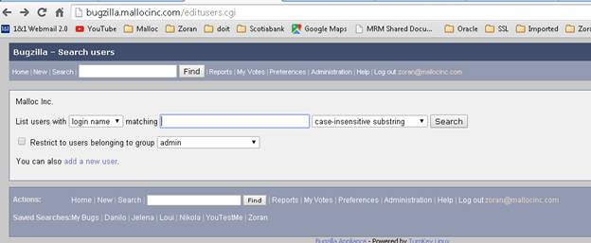

Just click “search” and you will get list of all users:
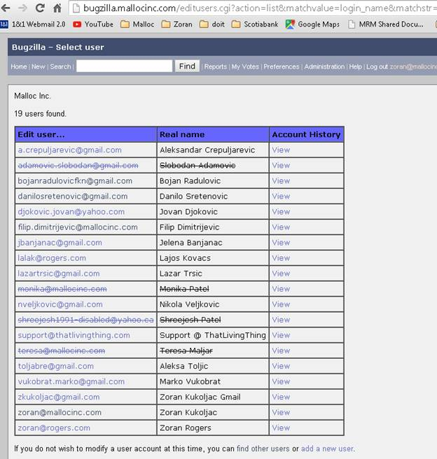

Regular users permissions

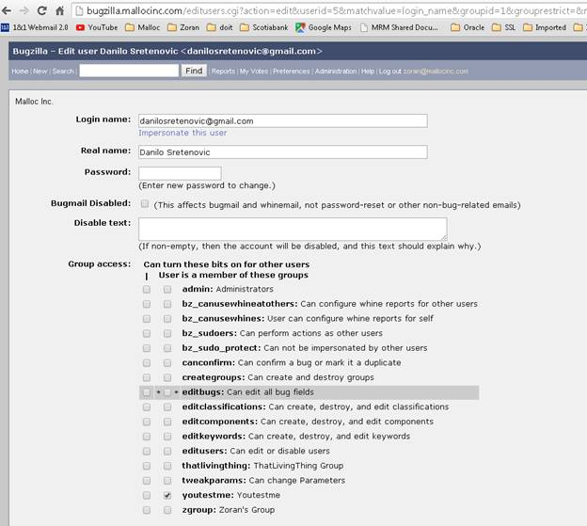

Administrator’s permissions

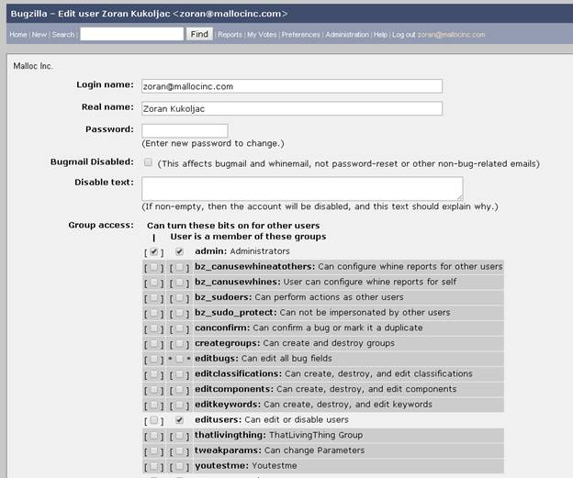

Bug Reporting
Step-by-step procedure for exporting a bug list from Bugzilla and importing it in Excel (2016).

Viewing a bug list
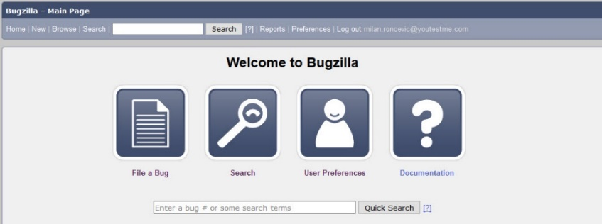
To view a bug list, first you need to open Bugzilla homepage at bugzilla.mallocinc.com. when you open Bugzilla homepage click on Search link (Picture 1).
Picture 1 - Bugzilla Homepage

Searching bugs
To find and to list all bugs on Bugzilla, you need to create a search query defined as in the Picture 2. These search parameters are located on ‘Advanced Search’ tab on Bugzilla Search page. When you define all parameters click on the search button.

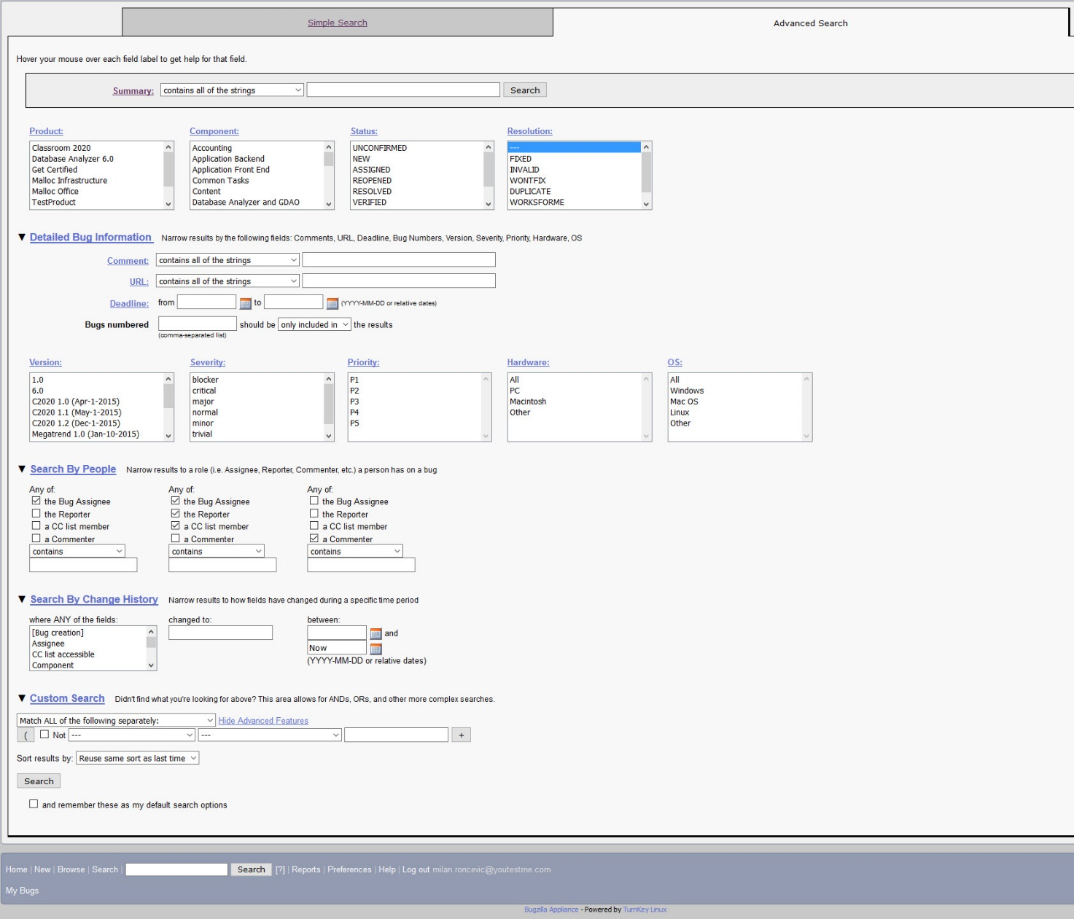
Picture 2 - Bugzilla Search Page

If you want to include all products and components in your search the best thing to deselect all options in those boxes. You can deselect item in the box by clicking “Ctrl” + Left Mouse button. Example below:

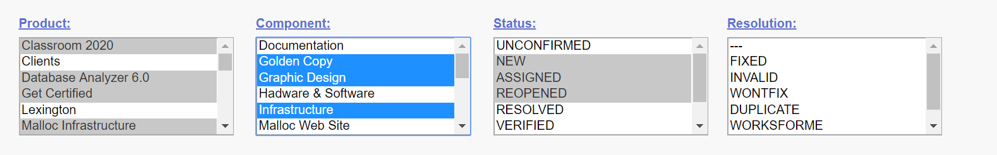

Instead of selection above you should have selection like one below and that will include all Products and Components:

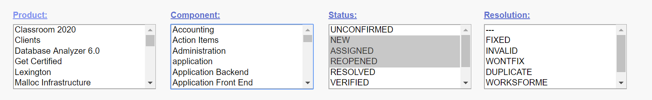

Bugzilla – Bug List
Once you click on search button you will see a list of all bugs (Picture 3).

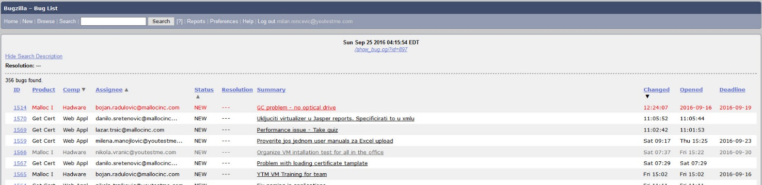
Picture 3 - Bugzilla Bug List

Bugzilla Bug List Column Customization
For different purposes you will need different data related to Bug List. To define the columns that you need, go to the end of Bugzilla Bug List page and click on the ‘Change Columns’ button (Picture 4).

Picture 4 - The End of Bugzilla Bug List Page

Once you click on the ‘Change Columns’ button, you will see the list of available columns and selected columns (Picture 5). Go through both lists and check which columns you need and which ones you don’t need. When you define the columns, click on the ‘Change Columns’ button.

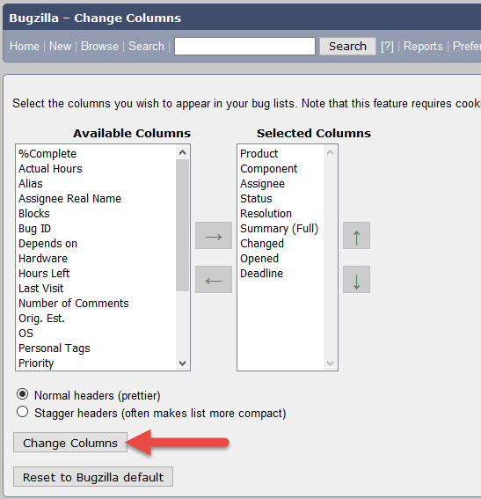
Picture 5 – Bugzilla Bug List Column Selection

Exporting Bugzilla Bug List
After defining the columns, you will see a Bug List with columns which you defined.

Now when you have customized the Bug List you can proceed to exporting the Bug List. To do that, scroll down to the end of Bug List and click the ‘CSV’ button (Picture 6). That way you will export the Bug List as an Excel Table.

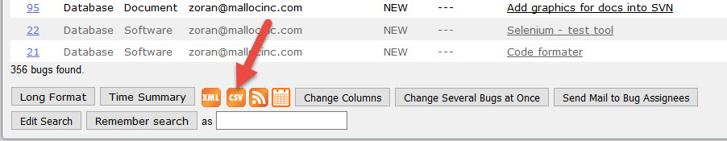
Picture 6 - Bugzilla Bug List Export

Importing the Bug List into Excel
Depending on the version of MS Excel on your computer, you can import the Bug List in two ways.

First way is just to open the Bug List .csv file in Excel and format the table manually.

Second way is to import the table as a new Query. This way the bug list will be automatically formatted and ordering filters will be applied on the first row of the table. In the following of this document you will see the both ways of importing bug list in Excel. The Excel I am using for demonstration is Excel 2016.

Opening Bug List .csv File
Find the .csv Bug List file on your computer and double click on it. You will see unformatted table, with some data unreadable (Picture 7).

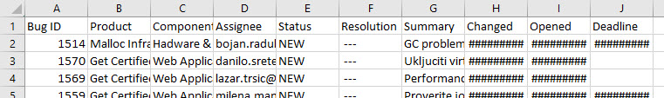
Picture 7 - Unformatted Bug List Table

To format this table, spread the columns and all data will become readable (Picture 8).

Picture 8 - Readable Bug List Table
As you can see on Picture 8, the data is now readable and columns can be sorted. For example, you can sort the Bug List by Bug ID, or by date when bug was created (from newest to oldest and vise-versa). To do the sorting, you need to create a filter (Picture 9). It is located at Home tab of Excel, on the top right side of the screen. After that you will have table formatted as on Picture 8.

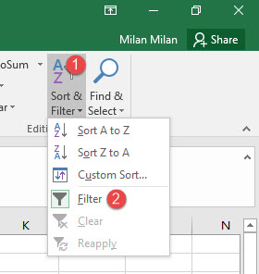
Picture 9 - Creating a Filter for Data Sorting
After sorting the table, go to File > Save As > Excel Workbook (.xlsx)

Importing a Bug List as Query
This process is faster because in a couple of clicks you will import a formatted Bug List table without any needs for further adjustments.
Take the following steps to import the table (Picture 10):
- Go to ‘Data’ tab in Excel
- Click on ‘New Query’
- Hover on ‘From File’
- Click on ‘From CSV’

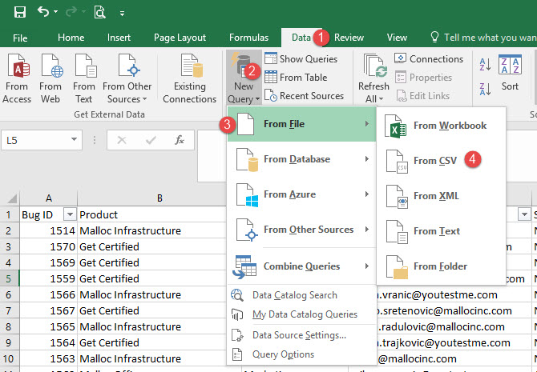
Picture 10 - Importing a .csv Bug List

Next you will see a new window where you will need to locate the Bug List .csv file on your computer. When you find it select it and click Open (or do double click on the file).

When you do that, another window will be shown to you (Picture 11). Just click on the ‘Load’ button.

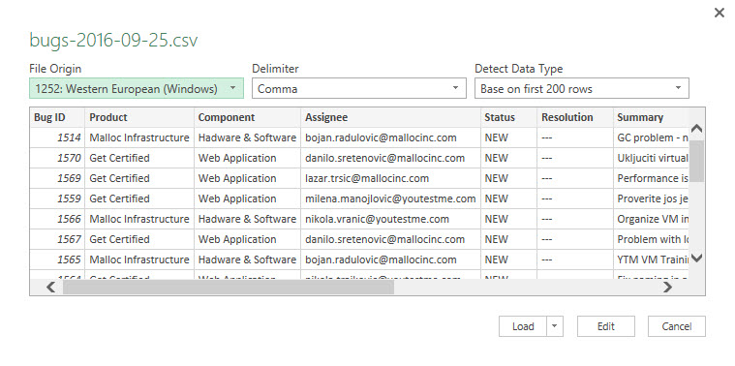
in the window on Picture 11, Excel has recognized the column names and once you click on the ‘Load’ button you will get a formatted Bug List table (Picture 12).
Picture 11 - Bug List Load

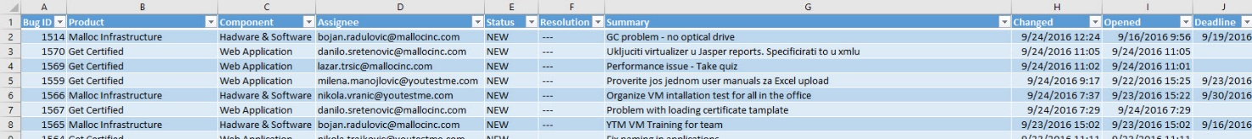
Picture 12 - Formated bug List Table

Updating CC List
CC list is used to inform all people that should be informed on the status of bug(s). You can add people to CC list when creating/editing bug(s) or you can add people to multiple number of bugs at once.

Adding to CC List inside the Bug
To add someone to a CC list of a certain bug, create/open the bug, and on the right, you will see a CC list option. In the field “Add” type in email address/es, separated with comma, of people who you wish to add to a CC list.
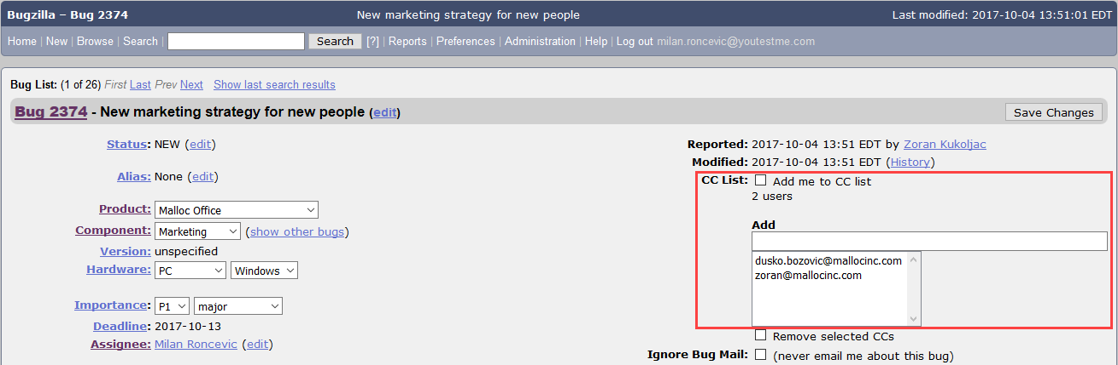

Adding to CC List Several Bugs at Once
In some cases, you might want to assign someone or yourself to a several number of bugs, or all bugs. I.e. if you are a new team member and you need to get notified of all changes within the existing bugs for GetCertified. In order to do that, search for all bugs related to a GetCertified. Once the list of bugs is generated, scroll down to the end of bug list and click “Change Several Bugs at Once”.
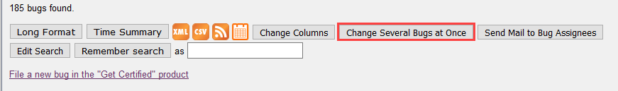
Your search will reload and you will see a checkboxes next to bugs. Find and thick checkboxes next to the bugs that you wish to change or scroll down to the end of bug list and click “Check All” button to select all bugs at once.
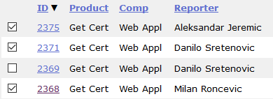

Follow the steps from the screenshot below in order to see how to add someone to CC list in several or all bugs at once.
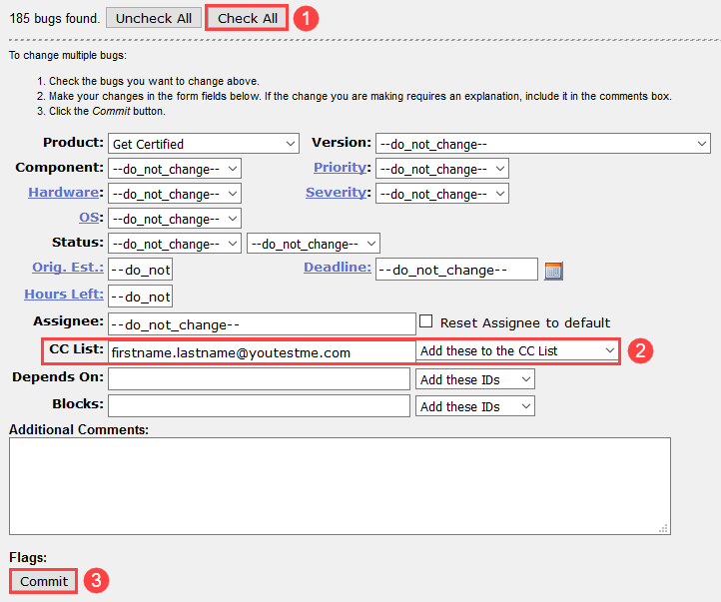

Extending Deadline
It is important to extend expired bug deadlines. To do so extend deadline to some meaningful date in the future that is appropriate to complete the task following with the comment about the reason why the deadline was extended.
- Click on the “Calendar” icon to open calendar and chose date.
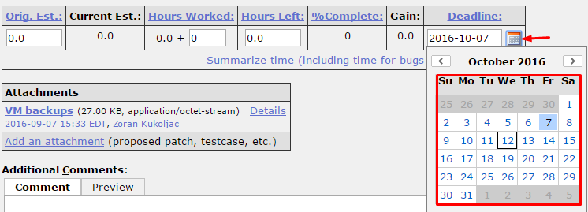
- Write comment about the reason why the deadline is extended and choose “Save Changes”.
