Step 1
On your computer, click the Start Menu and select Control Panel.

Step 2
If using Windows XP, double-click the Mail icon.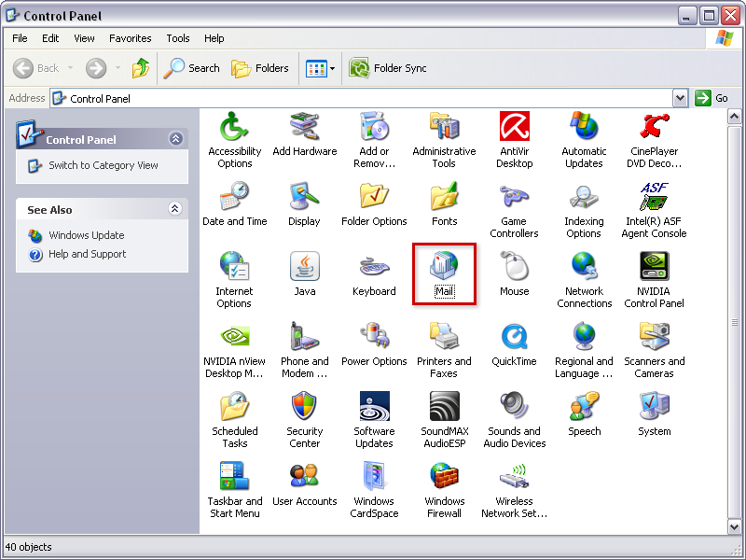
Open the Control Panel

If using Windows Vista, Windows 7, or above, type Mail into the search box at the top-right of the Control Panel window to quickly find the Mail icon. Then, double-click it.

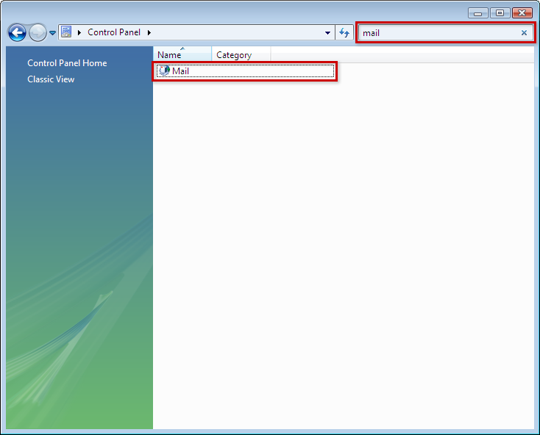
Click Mail

Step 3
Click the Email Accounts button.
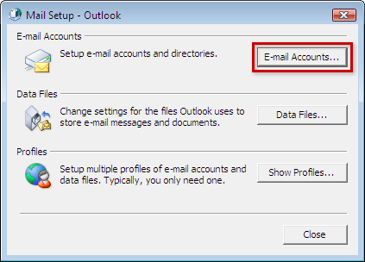
Click Email Accounts

Step 4
Under the Email tab, click the New button to add your 1&1 email account. 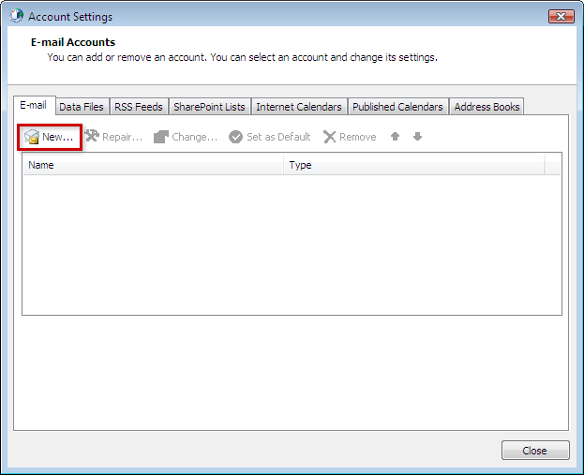
Click New

Step 5
Select Manually configure server settings or additional server types and then click the Next button.

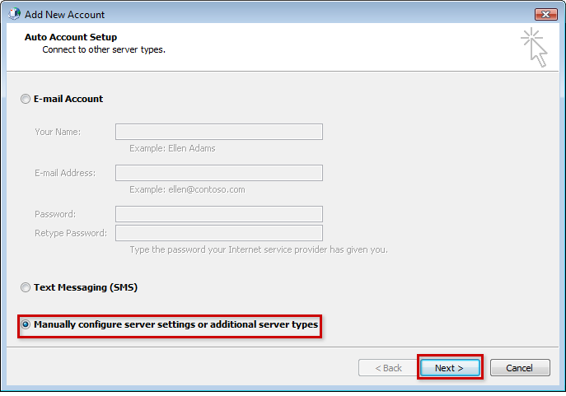
Select Manually configure

Step 6
Select the POP or IMAP type of account and then click the Next button.

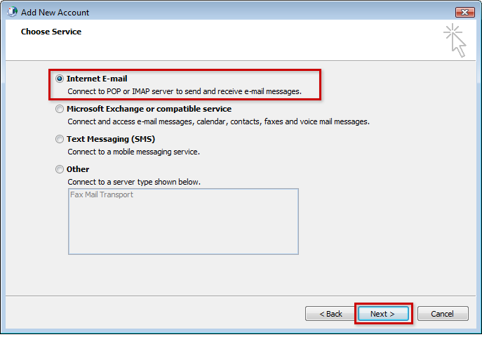
Select Internet Email

Step 7
- Enter Your Name. This is the name that will appear when others receive your email.
- Enter your 1&1 ( IONOS) email address.
- Make sure that IMAP is selected from the Account Type drop-down box.
- Enter imap.ionos.com as the Incoming mail server.
- Enter smtp.ionos.com as the Outgoing mail server (SMTP)
- Enter your full 1&1(IONOS) email address as the User Name
- Enter the email account's password.
- Check the box for Remember password if you do not want to enter your password every time you check or send mail from this account.
- Click the More Settings button.

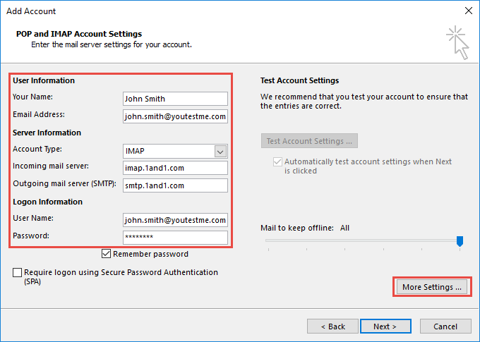
Enter the appropriate information and click More Settings

Step 8
Select the Outgoing Server tab from the top of the new window that opens.
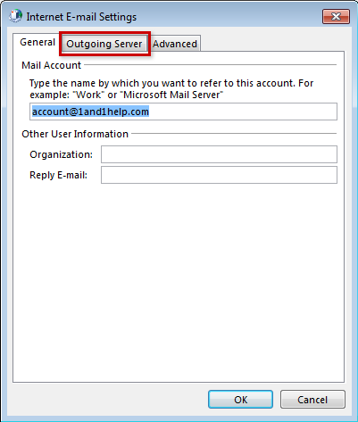
Select Outgoing Server

Step 9
Check the box for My outgoing server (SMTP) requires authentication and ensure that Use same settings as my incoming mail server is selected.
Next, click the Advanced tab at the top of the window.

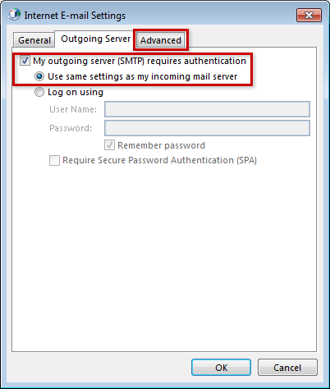
Click Advanced

Step 10
Enter port 993 as the Incoming server (IMAP) port and ensure that SSL is chosen from the following type of encrypted connection drop-down box.
Enter port 587 as the Outgoing server (SMTP) port and choose TLS from the drop-down box next to Use the following type of encrypted connection.
Click the OK button to save your settings.
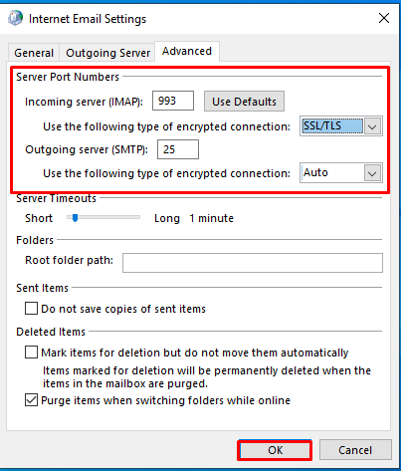
Enter the information and click OK

Step 11
Click the Next button.

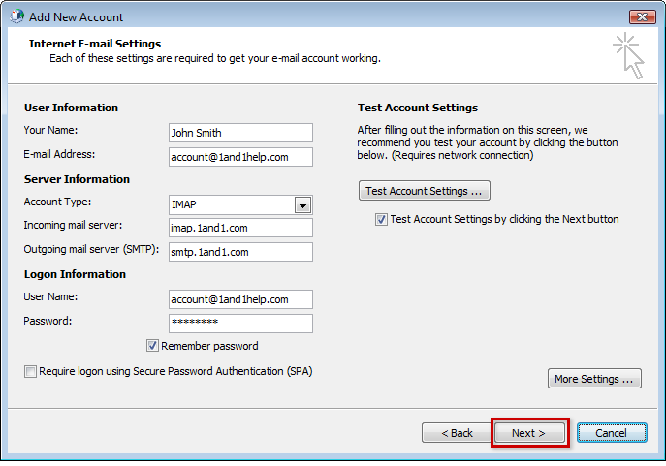
Click Next

Step 12
If the test fails, go through the previous steps and double-check all of your settings in Outlook. If the test is successful, click the Close button.

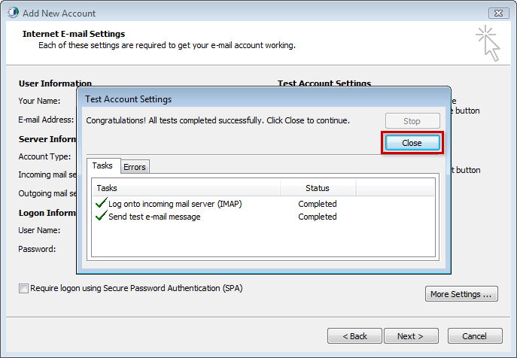
Click Close

Step 13
Click the Finish button.

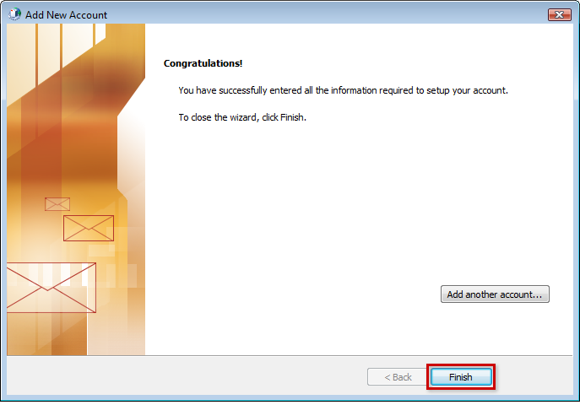
Click Finish

Step 14
Click the Close button to close the Account Settings window.

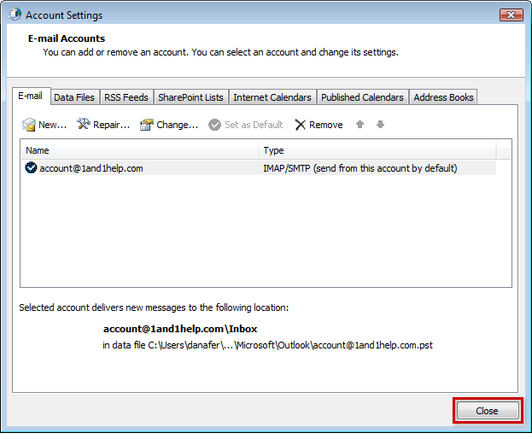
Click Close

Step 15
Click the Close button to close the Mail Setup window.

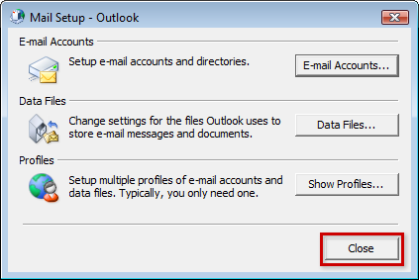
Click Close

You may now launch Outlook from the Start menu and begin writing and checking your mail!

Step 16
Once you have added the company email, you need to add the company signature to it.
- Go to File/Options…
- Inside the options window, click on the "Mail" tab and then click Signatures…

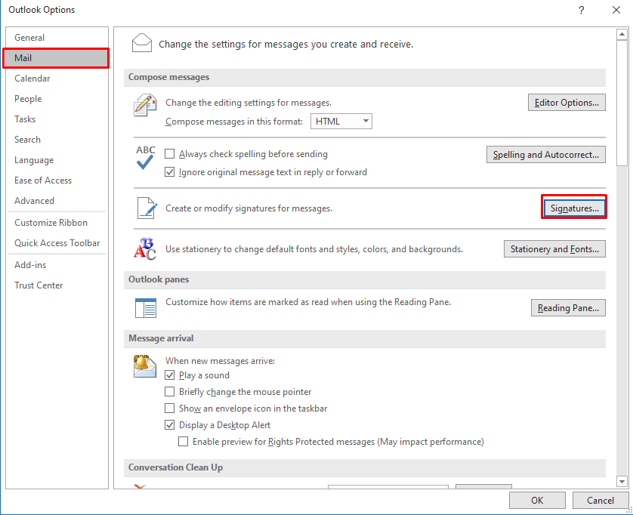

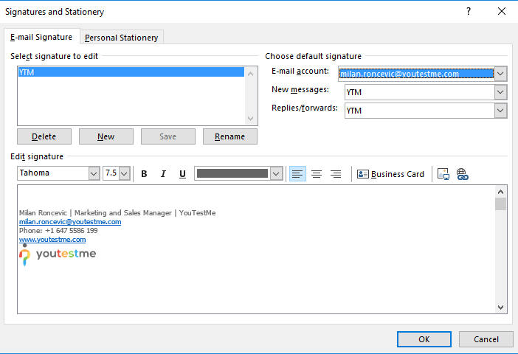
- Click on New and define the name of your company signature
- In the Edit signature box, copy YouTestMe or Malloc Inc official email signatures

John Doe | Job Title | YouTestMe
john.doe@youtestme.com
Phone:+1 647 5586 199
https://www.youtestme.com/
John Doe | Job Title | Malloc Inc.
john.doe@mallocinc.com
Phone:+1 647 5586 199
www.mallocinc.com

SetingUp AutoArchive in Outlook
The necessary instructions on how to set up auto archiving can be seen in this video:
https://owncloud.youtestme.com/owncloud/s/6xgEERIMH9po3Cg

Troubleshooting

Outlook won't connect to my YouTestMe email account
If the settings in the steps above didn't help you connect Outlook to your YouTestMe email account, try with the settings in the table below.
First, try to set up Outlook using IMAP.

# | Setting | IMAP | POP3
 | Incoming Server | imap.ionos.com | pop.1and1.co.uk
 | Port with SSL enabled | 993 | 995
 | Outgoing Server (SMTP) | smtp.ionos.com | auth.smtp.1and1.co.uk
 | Outgoing port with TLS enabled | 587 | 587
 | Outgoing server requires authentication  (user name and password)? | Yes | Yes

Outlook stopped receiving new emails
Sometimes Outlook stops receiving new emails even though there are no errors in send/receive. If this occurs, go to Task Manager and in Processes tab end Outlook.exe process. When this process is gone, start the Outlook again and it should start receiving emails again.

