| **File name** | MS Word Best Practices |
| --- | --- |
| **Author** | Malloc Inc |
| **Confidentiality** | Internal |
| **Last save date** | Tuesday, November-30-2021 at 4:39:00 PM |

Table of Contents

1 Introduction 1

2 Requirements 2

3 Most Important Rules 2

4 First Steps 2

5 MS Word Best Practices 4

5.1 Adding code samples in the document 5

5.2 Represent data using bullets format rather than in list 6

5.3 Examples 7

6 When to use a “list” and when a “table” 12

7 Use “Page Break” instead of infinitely clicking “Enter” 12

8 Alignments of data in Tables 13

9 Other "shiny" examples 13

9.1 Using TAB to do alignment in table header 13

9.2 Create Meaningful Tables 14

10 Writing Style 14

11 Checking documents in SVN 15

12 Useful Links 16

# Introduction

Well organized and formatted documents are of extreme importance since they greatly improve readability, productivity and our image with clients and partners. If you are going to create or edit YTM document you need to be familiar and use recommended MS Word best practices.

Always remember that by writing badly formatted, difficult to read and understand documents you are creating unnecessary work for others.

# Requirements

In order to write or edit company documents it is absolutely necessary that you learn basic functions and formatting in MS Word as described in this document. There are no positions in the company that do not require writing or editing documents. Do yourself a favor – try to understand this early ☺.

# Most Important Rules

1. Always have English Spell checker and Grammar checker turned ON
2. Always do additional spelling and grammar checking with Grammarly
3. Always start new document from document template. If you use some old document as starting point the chances are that styles are corrupted or template is simply obsolete.
4. Use predefined "styles" and don't change them! Styles are preconfigured and ready for you to use them. You need to use only four styles:   
   "Normal" - for text and tables  
   "Heading 1", "Heading 2", "Heading 3" for titles (picture below)  
   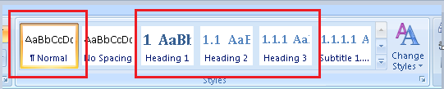
5. Just type text and when you need to format it click on one of the styles above.
6. If you need table - cut-paste prepared table from template document and then edit it.
7. For the best practices please see remaining of the document below
8. Please remember - there is no need to create new styles, change existing styles or use any style other than four styles mentioned above.

# First Steps

**Step #1:**

Take a copy of the "document template" document:

\youtestmedoc\Document Templates\YTM Document Template.docx

(note there are many templates - chose one that best suit your needs)

**Step #2:**

Put in directory where you want to create new document and give it a new name.

**Step #3:**

Edit the header and table at the beginning of the document

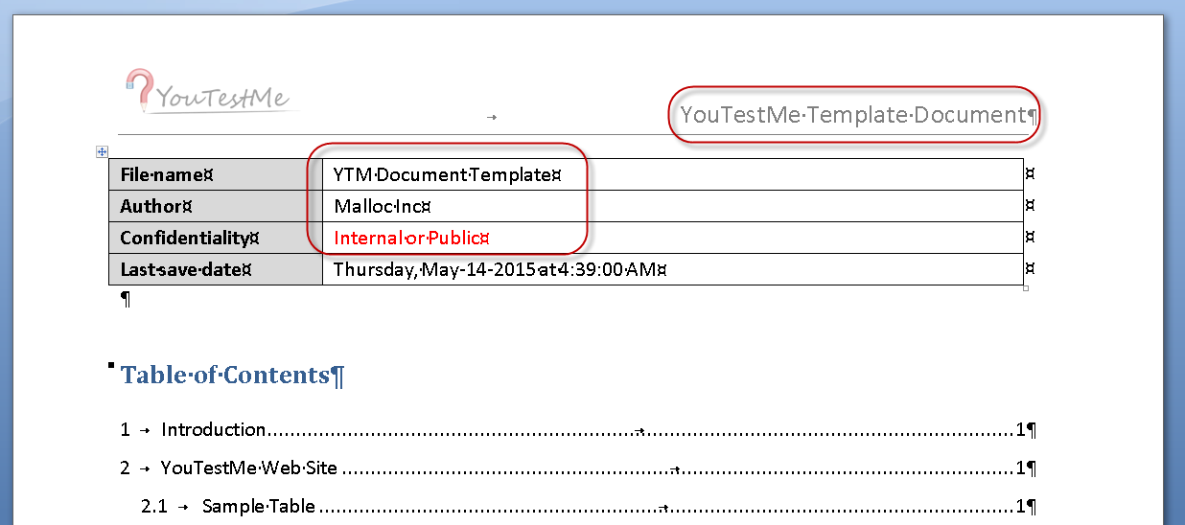

Example:

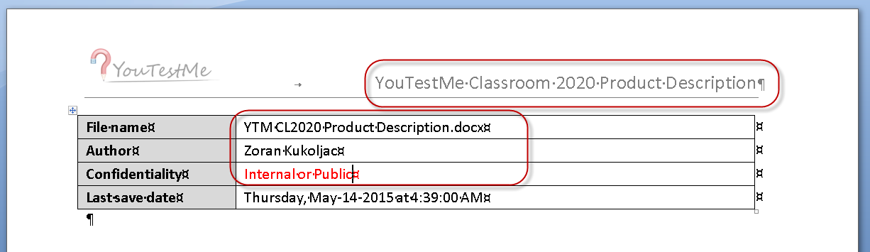

**Step #4:**

Remove sample text in the document and add your text and tables. Reuse same formatting already in the document. If you need to create a new table then cut-paste existing table and add/remove columns.

**DO NOT CHANGE:**

* Fonts
* Alignment
* Paragraphs
* Headings

# MS Word Best Practices

1. Whenever you write any instructions, manual, design, procedure, etc always consider using standard document template. Generally the rule should be that it has to be an explanation why standard document template is not used.
2. Consider that any document you write may end up with the customer for various reasons. It is important for all documents to be standardized and in proper format.
3. Do not use MS Word as a typewriter. It does many things for you automatically (numbering, alignments, spacing, formatting) – learn them ☺. This is something that you will need to the rest of your career.
4. Try not to have entire document as continuous text – use paragraphs to organize text by topics.
5. Never use “space” characters to align text! There are functions in MS Word for that.
6. Never use "Enter" (new line character) to create "page break". There is actually a "page break" function in MS Word.
7. Never use “Shift + Enter” paragraph separator to split paragraphs. They are used to split lines in the same paragraph. See the example in the table below.
8. Never enter number of paragraphs or bullets manually. This is automatic operation in Word. Let it worry about numbering and ordering.
9. Never use empty lines to accomplish page break. Use Page break .
10. Do not create documents from scratch. Always use standard, predefined document templates in:  
    \youtestmedoc\Document Templates\. Also do not start from the document where any style is changed.
11. Use tables for complex lists. If your list is complex (requires significant text in addition to one sentence per items) and if you have ANY problem formatting is properly – use tables.
12. Do not change styles (font, alignments, headings, headers, footers, spacing, tables) in standard, predefined document templates unless you are creating a new template.
13. Use spell and grammar checker.
14. Use table from the document template to create new tables if you need them. Just cut-paste template table and add rows and columns. Table in template has spacing and other properties set up to most optimal formats.
15. Influence others and keep updating this document ☺
16. Use pictures, graphs and diagrams when it helps understand the context.
17. Use the styles Heading 1, Heading 2, etc. to organize reports and other longish documents. This not only helps the reader understand how your document is organized, but it also lets you easily view the document's overall structure in outlining mode or using the Navigation pane. Moreover, it lets you easily reorganize if/when you need to.
18. Use Word's caption and cross-referencing features for tables, figures and other numbered items. Not only does the built-in captioning feature automatically number your tables and figures, but it lets you move, delete, and insert items without having to manually renumber everything. And, when you're done, it lets you automatically create a list of tables/figures for front matter.
19. Use “Landscape” page orientation for wide tables. Only page(s) that require extra width should be landscape. You can accomplish that by inserting section breaks. You can see table below as an example.
20. Update table of context before saving the document if you added new paragraphs
21. Do not check in into SVN MS Word files that start with “~”, for example “~$M Marketing Strategy.docx”. Those are temporary files that usually ret removed once main document is closed.

## Adding code samples in the document

If you need to add sample code in the document use proportional font such as “Currier New” for the code sample. Note that proportional font takes more space than proportional so lines can be significantly longer with the font of the same size. The good practice is to use smaller size when using proportional font. For example, using “Courier New 8”:

SET LOG_FILE=./log/%THIS_SCRIPT_NAME%-%FILE_SAVESTAMP%.log

java -cp %LOADER_CLASS_LOCATION% %LOADER_CLASS% %PROP_FILE% %DATA_LOCATION_SECTION% > %LOG_FILE% 2>&1

SQL code:

/*==============================================================

VIEW: AVG TIME TO ANSWER PER QUESTION DIFFICULTY IN CERTAIN

QUIZ IN SECONDS

================================================================*/

CREATE

OR REPLACE VIEW V_AVG_QUIZ_QUESTION_TYPE_TIME AS

SELECT

V_QUESTION_STAT.QUIZ_DEFINITION_ID

,V_QUESTION_STAT.DIFFICULTY_CODE

,AVG(V_QUESTION_STAT.AVG_TIME) AVG_TIME

FROM V_QUESTION_STAT

GROUP BY

V_QUESTION_STAT.QUIZ_DEFINITION_ID

,V_QUESTION_STAT.DIFFICULTY_CODE;

## Represent data using bullets format rather than in list

Instead of:

*Required software is Oracle’s VirtualBox, VMWare workstation, VMWare vSpehere client, Putty.*

Use bullets:

*Required software is:*

1. *Oracle’s VirtualBox*
2. *VMWare workstation*
3. *VMWare vSpehere client*
4. *Putty*

Do not put unnecessary characters at the end of the line, for example (character “;” highlighted in yellow):

1. *Oracle’s VirtualBox;*
2. *VMWare workstation;*
3. *VMWare vSpehere client;*
4. *Putty;*

Character “;” is redundant and may cause confusion in some cases when somebody may think that it is part of the data.

## Examples

| **Wrong** | **Right** | **Comment** |
| --- | --- | --- |
| * Types:   + Second try   + Learning feedback (Hint)   + Additional time   + Minus one wrong answer * Ordinal number – defines the order that question assistance will appear in (Student clicks on the assistance button, and the next assistance is applied) * Penalty – defines how many points are deducted if this assistance is chosen. | 1. Types:    1. Second try    2. Learning feedback (Hint)    3. Additional time    4. Minus one wrong answer 2. Ordinal number – defines the order that question assistance will appear in (Student clicks on the assistance button, and the next assistance is applied) 3. Penalty – defines how many points are deducted if this assistance is chosen. | When discussing the document, especially in remote conferencing, it is easier to say “point 3” or “point 1-c”. |
|  |  | Never use “Shift + Enter” paragraph separator for regular paragraphs.  They are only used only to separate lines in the same paragraph. |
| Example: Enter 3 medieval Serbian kings:  Student A entered Dragutin, Milutin, Stefan Prvovencani.  Student B entered Milutin, Stefan Prvovencani, Dragutin.  Student C entered Stefan Prvovencani, Dragutin, Milutin. | Example: Enter 3 medieval European kings:  Student A entered: “Henry I”, “Edward II”, “Arthur”  Student B entered: “Edward II”, “Isabella I”, “William the Conqueror”  Student C entered: “Elizabeth I”, “Henry VII”, “Henry I”. | Do not use examples and terms from the local culture. Remember that we are building a global product that has to be understandable to most people in the World. Always try to put yourself in their shoes and imagine what kind of example would be easiest to understand. |
| Example: Enter 3 medieval Serbian kings:  Student A entered Dragutin, Milutin, Stefan Prvovencani.  Student B entered Milutin, Stefan Prvovencani, Dragutin.  Student C entered Stefan Prvovencani, Dragutin, Milutin. | ***Enter 3 medieval Serbian kings:***   1. Student A entered:    1. Dragutin    2. Milutin    3. Stefan Prvovencani 2. Student B entered:    1. Milutin    2. Stefan Prvovencani    3. Dragutin 3. Student C entered:    1. Stefan Prvovencani    2. Dragutin    3. Milutin | Format text for easier reading and understanding. |
|  |  | Heading paragraphs has to be used to titles of the paragraph. IN the standard template they have numbering which greatly helps with navigation. Numbering should not be lost under any circumstances (this means that either standard heading is not used or it is changed). This problem is frequent in YTM documentation. |
| 1. Use Android Studio  Eclipse ADT is not actively updated by Google anymore. Android Studio provides better support for different build flavors and customizations (multiple servers, different environments)  2. Use Gradle build system  Allows high degree of freedom, but is not easy to learn. Takes care of library dependencies, APK signing, etc. Start from an existing simple Gradle build and learn as you go. It will only pay off in the long run.  3. Use active, well known open-source libraries  These are well documented and have a big user pool. There is probably no feature that we need that is not covered by these. Never try to implement something before you check if it is already available (for free). | 1. Use Android Studio  Eclipse ADT is not actively updated by Google anymore. Android Studio provides better support for different build flavors and customizations (multiple servers, different environments) 2. Use Gradle build system Allows high degree of freedom, but is not easy to learn. Takes care of library dependencies, APK signing, etc. Start from an existing simple Gradle build and learn as you go. It will only pay off in the long run. 3. Use active, well known open-source libraries These are well documented and have a big user pool. There is probably no feature that we need that is not covered by these. Never try to implement something before you check if it is already available (for free). | If you want to have several paragraphs under one bullet  you have to use “Shift + Enter”. |
| Using space character to do alignment | NEVER do that! Use formatting options. |  |
| 1. first option  2. second option  3.....third option | 1. first option 2. second option 3. third option | Use formatting features such as bullets to create lists! |
| To list directories on Linux use command ls –ld */. | To list directories on Linux use command:  **ls –ld */** | When giving example of the command you need to clearly distinguish it from other text by using different typeface, bold font, different color, etc. |
| All *.doc files are Word documents. | All “*.doc” files are Word documents. |  |
| Dockerfile is the root of the problem. | “Dockerfile” is a root of the problem. | You need to put names in quotes because somebody may think that proper sentence is:  *Docker file is the root of the problem.* |

**Person who uses MS Word as a typewriter should not be allowed near company computers.**

# When to use a “list” and when a “table”

Whenever you have a more than one data element – use table.

For example if you need to list of features then you can use list but if you have to list features and their descriptions – use table. Another example is FAQ – it has two data elements: question and answer so it has to be table.

# Use “Page Break” instead of infinitely clicking “Enter”

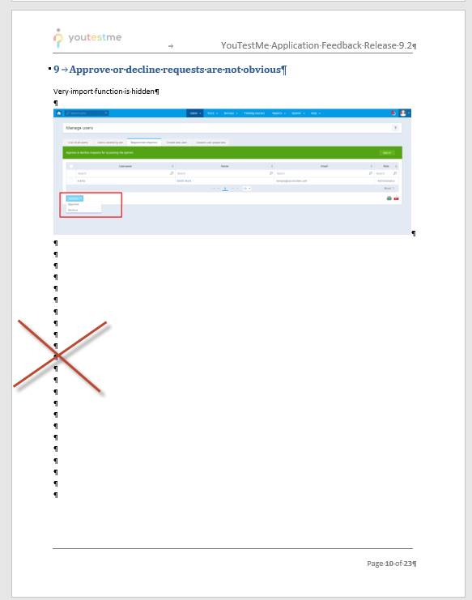     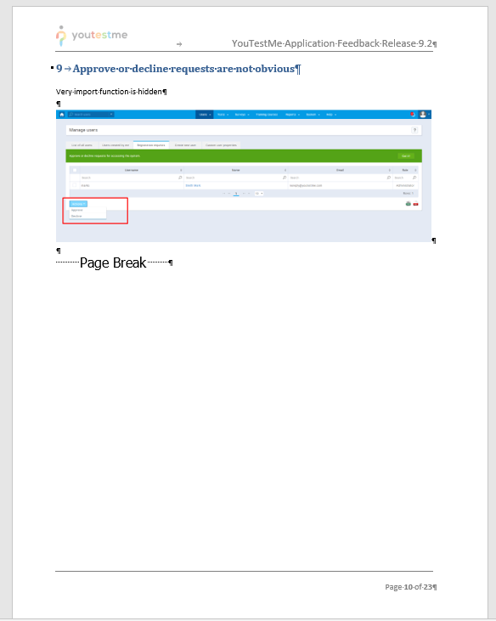

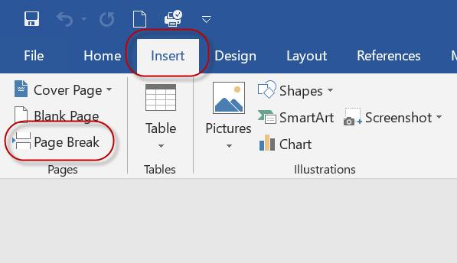

# Alignments of data in Tables

* Numerical data is always right aligned
* Textual data is usually Left aligned unless strings are made of one word like “Yes”, “No”
* Dollar values, proper format is shown in list below:
  + $2,340.45
  + $300.10
  + $0.90

# Other "shiny" examples

## Using TAB to do alignment in table header

**Never use "Tab" character to center text:**

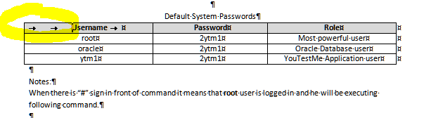

**Use this:**

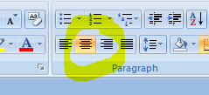

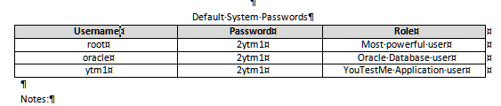

## Create Meaningful Tables

**Wrong! (It is unclear what needs to be done)**

| **Description** | **Link** |
| --- | --- |
| Zoran’s feedback rfom March 13, 2022  Video explains some issues with design | <https://owncloud.youtestme.com/owncloud/s/Df4ZvoEkpJIuF0V> |
| *UI testing* | <https://docs.google.com/spreadsheets/d/1X2h4pF4ZInF_lDwIIzL3xK8AgtqLcMAY5Kdlwmk2_KI/edit#gid=0> |

Also, long meaningless links that make text difficult to read should be replaced by meaningful text that leads to the link as shown in the table below.

**Correct: (it is clear what needs to be done)**

| **Description** | **Taks** | **Status** |
| --- | --- | --- |
| Zoran’s [feedback](https://owncloud.youtestme.com/owncloud/s/Df4ZvoEkpJIuF0V) from March 13, 2022  Video explains some issues with the design | Analyze feedback and implement solutions |  |
| *UI* [*testing plan*](https://docs.google.com/spreadsheets/d/1X2h4pF4ZInF_lDwIIzL3xK8AgtqLcMAY5Kdlwmk2_KI/edit#gid=0) *and status* | Use this spreadsheet to track development and testing statuses |  |

# Writing Style

Text must be simple, concise and understandable. Below is an example of very confusing text (in red font) and example how it should be rewritten (in blue font).

Questions

*The objects that contain questions are called Question Pools. They can hold a theoretically infinite number of questions. Pool access can be entirely personal, but the creator(s) can also make them available to other users. Pool access is restricted only to pool members. It is also possible to import questions into pools by using the application’s Excel template. The questions in the application are sorted by difficulty: Easy, Medium and Hard. Besides this, questions can be differentiated according to their type:...*

*...*

What is a question pool?

*Question pools represent entities that hold the questions and there is no limit to the number of questions a pool can have. Users can only see those pools they are member of, unless they have the permission to view...*

Above text should be rewritten as shown below:

**Questions**

*Questions have various properties:*

1. *Type:* 
   1. *Single choice – Test participants can choose one of the offered answers and only one is correct.*
   2. *Multiple choices – More than one of the offered answers may be correct.*
   3. *Ordering – Place offered answers into correct order.*
   4. *....*
2. *Difficulty:* 
   1. *Easy*
   2. *Medium*
   3. *Hard*

Question Pools

*Questions can be grouped into Question pools. Creator of the Question pool can restrict access to his/her poll to certain users. Questions can be prepared offline in Excel files and loaded directly into Question pools.*

# Checking documents in SVN

Please don't check **“~$*.docx**” and “**~$*.xls**” files in SVN.

Those are temporary MS WORD and Excel files that exist only while documents are open.

Close documents before checking them into SVN. That will make “**~$\***” files disappear.

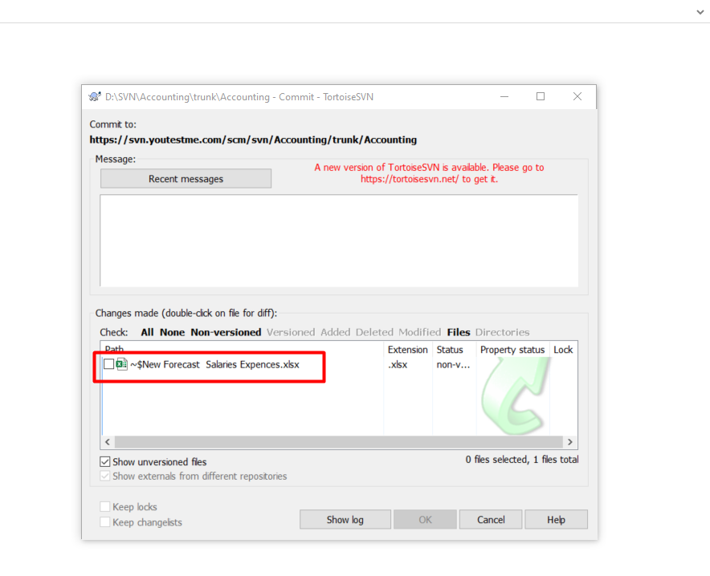

# Useful Links

There is a useful MS WORD tutorial on the following link - <https://www.youtube.com/watch?v=ME_F9yypzsw&list=PLWPirh4EWFpHyWP7u5HOrr4s2-bycPpO6>

| **Document or link** | **Description** |
| --- | --- |
| <https://www.youtube.com/watch?v=B54cm8TWTjI&list=PLWPirh4EWFpHyWP7u5HOrr4s2-bycPpO6&index=2> | Formatting Text |
| <https://www.youtube.com/watch?v=mf3pKJmnWJ0&list=PLWPirh4EWFpHyWP7u5HOrr4s2-bycPpO6&index=3> | Editing Text |
| <https://www.youtube.com/watch?v=TVe7XkvGu2I&list=PLWPirh4EWFpHyWP7u5HOrr4s2-bycPpO6&index=4> | Paragraphs |
| <https://www.youtube.com/watch?v=5w0uaxJkAN0&list=PLWPirh4EWFpHyWP7u5HOrr4s2-bycPpO6&index=5> | Spelling and grammar |
| <https://www.youtube.com/watch?v=3v3J1bBKn8c&list=PLWPirh4EWFpHyWP7u5HOrr4s2-bycPpO6&index=9>  <https://www.youtube.com/watch?v=F-TiTbKDr5s&list=PLWPirh4EWFpHyWP7u5HOrr4s2-bycPpO6&index=10>  <https://www.youtube.com/watch?v=ZfkTx8RjuRE&list=PLWPirh4EWFpHyWP7u5HOrr4s2-bycPpO6&index=11>  <https://www.youtube.com/watch?v=hn77WOHBPLI&list=PLWPirh4EWFpHyWP7u5HOrr4s2-bycPpO6&index=12> | Creating and managing tables |
| <https://www.youtube.com/watch?v=X8e5WCdxbx0&list=PLWPirh4EWFpHyWP7u5HOrr4s2-bycPpO6&index=14> | Insert pictures |
| <https://www.youtube.com/watch?v=uZ_bYDXasjA&list=PLWPirh4EWFpHyWP7u5HOrr4s2-bycPpO6&index=17> | Insert Charts |
| <https://www.youtube.com/watch?v=LQvS_dT8tV8&list=PLWPirh4EWFpHyWP7u5HOrr4s2-bycPpO6&index=18> | Convert pdf to Word |
| <https://www.youtube.com/watch?v=CCeRlrWOPUU&list=PLWPirh4EWFpHyWP7u5HOrr4s2-bycPpO6&index=23>  <https://www.youtube.com/watch?v=-i-TdD3mCVo&list=PLWPirh4EWFpHyWP7u5HOrr4s2-bycPpO6&index=24> | Page setup |
| <https://www.youtube.com/watch?v=k9k9olMHjqg&list=PLWPirh4EWFpHyWP7u5HOrr4s2-bycPpO6&index=29> | Export document |
| <https://www.youtube.com/watch?v=-sL80KzB5cQ&list=PLWPirh4EWFpHyWP7u5HOrr4s2-bycPpO6&index=30> | Styles and outline |
| <https://www.youtube.com/watch?v=fWdWdasRriU&list=PLWPirh4EWFpHyWP7u5HOrr4s2-bycPpO6&index=27> | Restrict editing |
| <https://www.youtube.com/watch?v=54ugHfkXfvU&list=PLWPirh4EWFpHyWP7u5HOrr4s2-bycPpO6&index=25>  <https://www.youtube.com/watch?v=IXTQBbtEq_4&list=PLWPirh4EWFpHyWP7u5HOrr4s2-bycPpO6&index=26> | Header and footer; page numbers |