Filename | YTM Connecting to VPN
Author | Sean Huseini
Confidentiality | Internal
Last save date | Tuesday, February-22-2022 at 2:32:00 PM

Table of Contents
1 Introduction 1
2 Connecting via OpenVPN 1
2.1 What is OpenVPN 1
2.2 How to connect to OpenVPN on Windows 10 OS 1
3 Office VPN 3
3.1 Troubleshooting 5
3.2 Introduction 5
4 Open Issues 6

Introduction
The purpose of this document is to describe how to connect to YTM VPN. In this document there are two way on how to connect to VPN. It’s preferable and recommend to use the Connecting via OpenVPN method. Only use the Office VPN if the OpenVPN is not working

Connecting via OpenVPN

What is OpenVPN
OpenVPN is a virtual private network (VPN) system that implements techniques to create secure point-to-point or site-to-site connections in routed or bridged configurations and remote access facilities. It implements both client and server applications.

How to connect to OpenVPN on Windows 10 OS

- First, you will need to download and install OpenVPN onto your machine. Go to this link to download OpenVPN: https://openvpn.net/community-downloads/ and chose which OS you are using. In this example I will use Windows 64-bit MSI installer
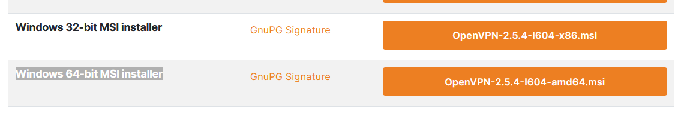
- Install the “*.msi” file on your machine, leaving everything as default. There might be a need to install a TAP network driver, do that If you get asked.
- After the installation is complete on the right side on the bottom of the screen a small monitor icon will appear

- The next step is to download the file that was provided to you by the system administrator. The downloaded file will look like this.

- Go to the small monitor icon which is located on the right side on the bottom of the screen and right-click on that, then go to import file and select the file that you’ve downloaded in step 4.

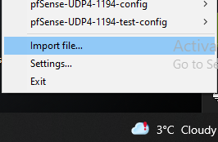

- The last step is to go to the small monitor icon and right-click it, right above “Import file” you should see the file you’ve just imported, it will look like on the above example. Find your file, click on the > and click “connect”
- It will ask you to enter your username and password
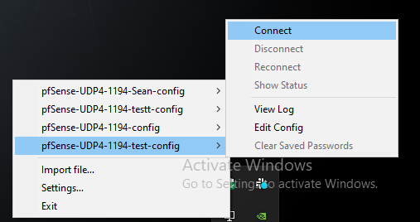
- If everything is working properly you should see the small monitor light up green

Office VPN
- In the start menu, type VPN
- In the start menu click on VPN settings
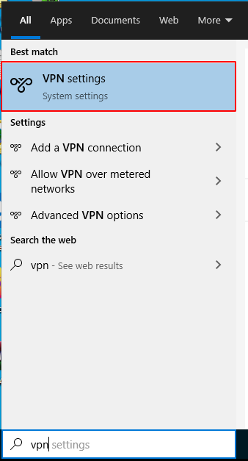
- Click on the button ‘New’
- Type data in fields. Personal username and password will be provided by Passbolt. Pass-phrase can be found in the password description on Passbolt.
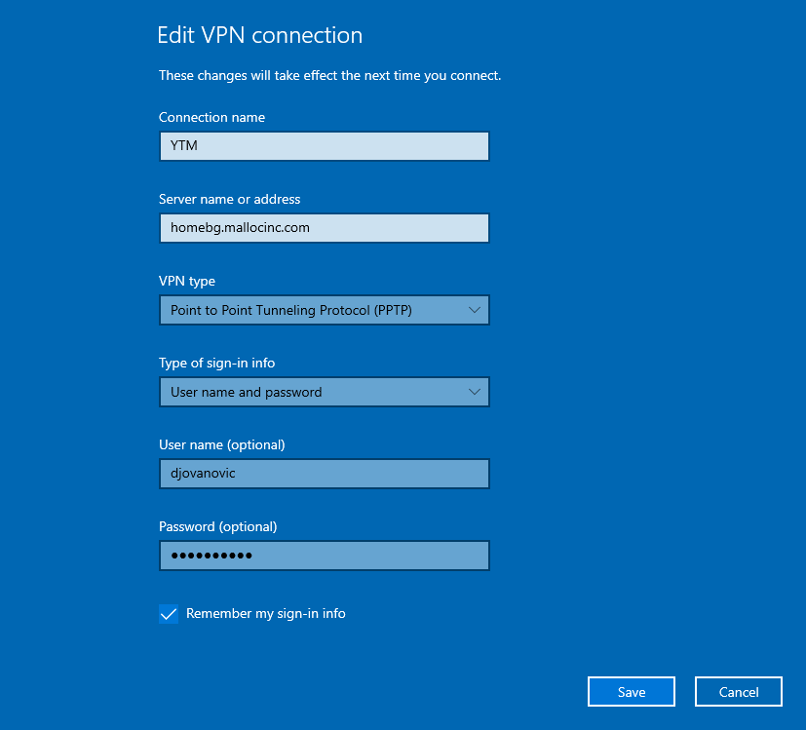
- Click on Save
- Select newly created connection and click “Connect”
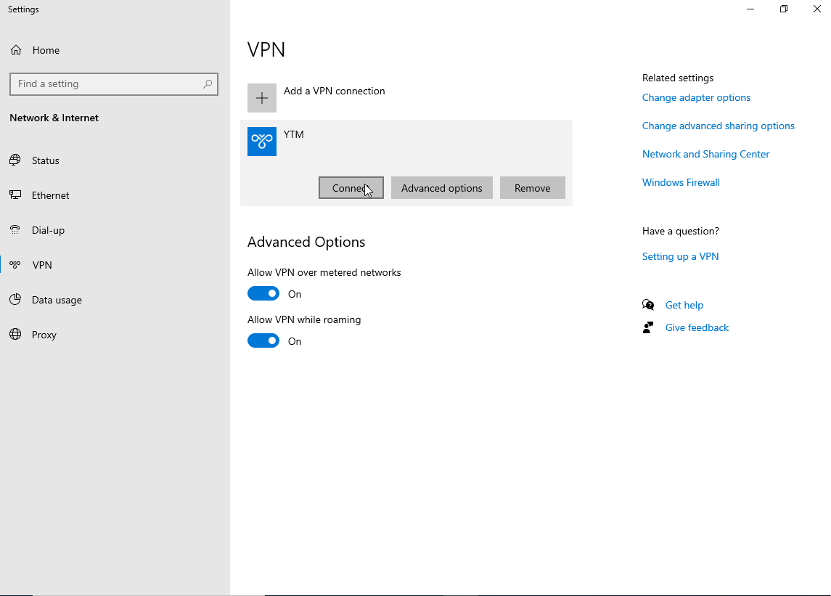

Troubleshooting

Introduction
Use this solution only when you’ve check that you have entered all the necessary credentials right and you’ve tried all the steps from Office VPN and OpenVPN

- Start “Run” from the start menu
- Run “devmgmt.msc”
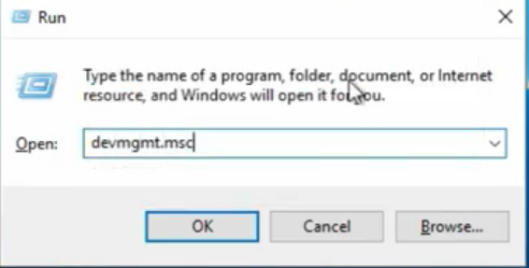
- Delete WAN miniports using right-click > Uninstall device :
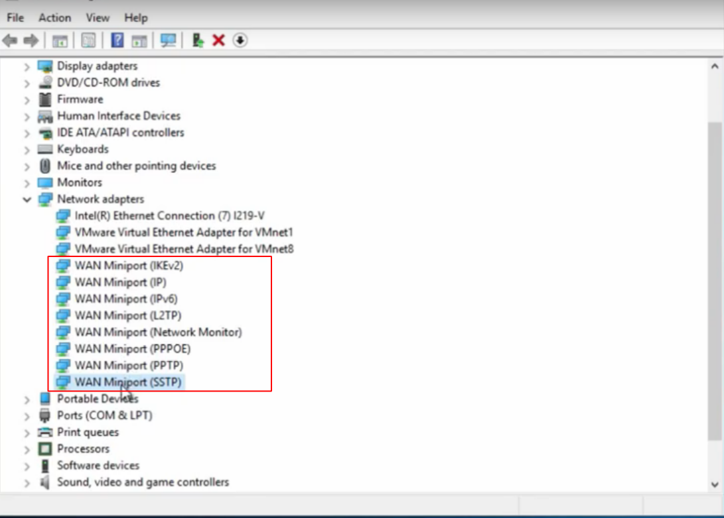
- Click on the “Scan for hardware changes” button in the toolbar or the Action dropdown menu:
- Try to connect again

Open Issues
What to do when you get this message

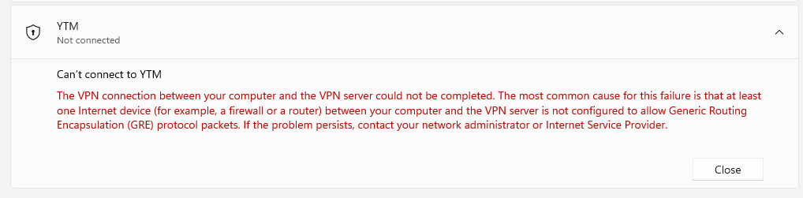

- To fix this go to your router settings. You can access your router by typing 192.168.0.1 or 192.168.1.1
- Next you will be asked for password in most cases leave those blank and hit enter . If it ask for password and user name you will need to contact your internet provider
- Once you are into your router navigate to Home Network and next go to Advanced Settings
- And Enable IPSec Passthrough PPTP Passthrough

