File name | YTM Bookmarks
Author | Malloc Inc.
Confidentiality | Internal
Last save date | Sunday, November-20-2016 at 5:51:00 PM

Table of Contents
1 Introduction 1
2 Add bookmark on Chrome 2
3 Add bookmark on Mozzila 3

Introduction
How to add important YTM bookmarks to Chrome and Mozilla.

Add bookmark on Chrome
Enter Chrome and press (ctrl+left shift+o) to open the bookmark manager . Right-click on organize and go to “Import bookmarks from HTML file” 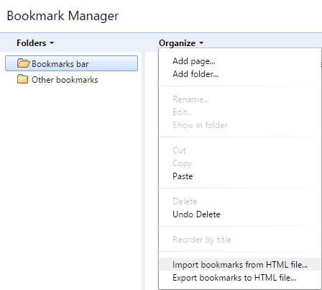

Then select the file from this directory: youtestmedoc\trunk\Procedures\bookmarks.html , and chrome will create an inported folder and in that folder you will find YTM bookmarks .
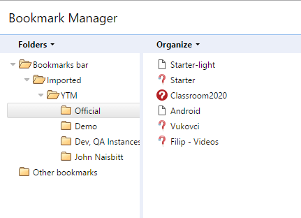

Add bookmark on Mozzila
Enter Mozilla and press (ctrl+left shift+b) to open bookmark manager.
Right-click on “import and archiving” and go to “Import bookmarks from HTML file”

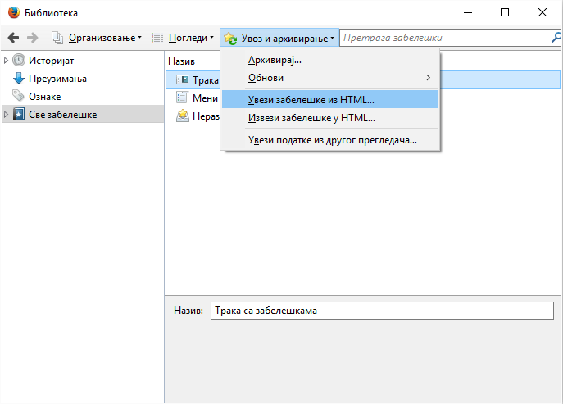

and select the file from this directory: youtestmedoc\trunk\Procedures\bookmarks.html .

