File name | YTM System Troubleshooting
Author | Malloc Inc
Confidentiality | Internal or Public
Last save date | Sunday, November-20-2016 at 6:03:00 PM

Table of Contents
1 Introduction 1
2 Rebuilt from admin dashboard – code wasn’t there 2
2.1 Checking Tomcat Log 3
3 Tomcat could not be stopped 3
4 Automated build does not work 4
5 Oracle account is locked 4
6 Dropping public synonyms from the database 4
7 VM Clipboard does not work 5
8 Troubleshooting procedures 5
9 Create new database 5
10 Load data 5
11 Implementation 6
12 Rebuilding application 6

Introduction
This document describes troubleshooting procedures.

Rebuilt from admin dashboard – code wasn’t there
- check if package exists in the database at all
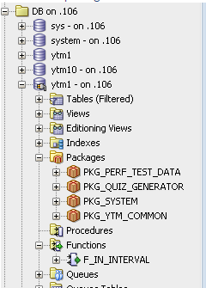
2. From the picture in SQL developer above you can see that it is not created in the database – most likely this is old version of database
3. Find the code for package and implement it in the database:
\youtestme\db\dbmodel\packages\pkg_system_requests.sql
4. 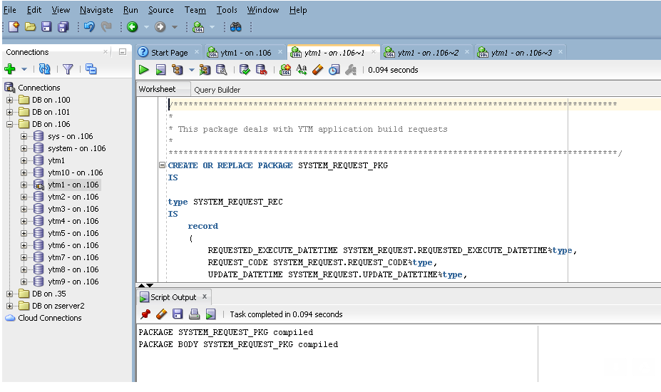
5. Test the function again.

Checking Tomcat Log
In most cases there will be a problem with YTM application. There are two aliases set up to make checking of Tomcat log easier and faster:
- tlog
- tlogt

Aliases are defined as:
alias tlog='vi /home/ytm1/ytm/res/ProgramFiles/tomcat/apache-tomcat-7.0.34-64bit/logs/catalina.out'
alias tlogt='tail -f /home/ytm1/ytm/res/ProgramFiles/tomcat/apache-tomcat-7.0.34-64bit/logs/catalina.out'

Tomcat could not be stopped
Use command “istomcat” to see if tomcat is running.
Sample output:

ytm1 23221 0 Jun09 ? 00:18:49 java -Djava.util.logging.config.file=/home/ytm1/ytm/res/ProgramFiles/tomcat/apache-tomcat-7.0.34-64bit/conf/logging.properties -Djava.util.logging.manager=org.apache.juli.ClassLoaderLogManager -Djava.endorsed.dirs=/home/ytm1/ytm/res/ProgramFiles/tomcat/apache-tomcat-7.0.34-64bit/endorsed -classpath /home/ytm1/ytm/res/ProgramFiles/tomcat/apache-tomcat-7.0.34-64bit/bin/bootstrap.jar:/home/ytm1/ytm/res/ProgramFiles/tomcat/apache-tomcat-7.0.34-64bit/bin/tomcat-juli.jar -Dcatalina.base=/home/ytm1/ytm/res/ProgramFiles/tomcat/apache-tomcat-7.0.34-64bit -Dcatalina.home=/home/ytm1/ytm/res/ProgramFiles/tomcat/apache-tomcat-7.0.34-64bit -Djava.io.tmpdir=/home/ytm1/ytm/res/ProgramFiles/tomcat/apache-tomcat-7.0.34-64bit/temp org.apache.catalina.startup.Bootstrap -config /home/ytm1/ytm/res/ProgramFiles/tomcat/config/deployment/server_ytm1.xml start

Use command “tstop” to stop the Tomcat server.

After issueing “tstop”, chack if tomcat is still running. If it is still running after several minuted the use “kill” command to kill the process.

For example:
Use "kill -9 2322"

Note that “2322” is a Unix process id that could be seen in output od the command “istomcat”.

Automated build does not work
Use "crontab -e"

Oracle account is locked

To unlock user “ytm1” log in to Oracle database as “system” or “sys as sysdba” and execute command:

ALTER USER ytm1 ACCOUNT UNLOCK;

Dropping public synonyms from the database
There should not be any public synonyms in the database. If there are any it is leftover from obsolete db implementation.

Generate drop statements with this SQL:

SELECT 'DROP PUBLIC SYNONYM ' || SYNONYM_NAME || ';' FROM ALL_SYNONYMS WHERE TABLE_OWNER LIKE 'YTM%';

Execute generated SQL statements to drop synonyms.

VM Clipboard does not work
When “copy-paste” between host and VM don’t work go to VM command line and execute:

/usr/bin/VBoxClient–clipboard

Troubleshooting procedures
1. check minimal required system resources (RAM, Disk, CPU)
command “free -m -h”
command “cat /proc/meminfo”

2. check free disk space on all file systems
use command “df -h”

Create new database
Important:
Shutdown tomcat
From windows cmd call script with parameters:
youtestme\trunk\db\dbmodel\scripts\create_database_wrapper_scriptytm ytm3 ytm3
These parameters are just example, 3rd one is password witch is not needed because password is automatically set to be same as username (ytm3/ytm3)
Now redeploy application with:
youtestme/trunk/www_source/build.dep.applnc.sh

Load data
Files:
Load script:
youtestme\trunk\batch_source\scripts\data_load\LoadClassroom2020Data
Data base connections:
youtestme\trunk\batch_source\conf\dbconnections
ytm.properties:
youtestme\trunk\batch_source\conf\ytm.properties
Error log:
youtestme\trunk\batch_source\scripts\data_load\log\LoadClassroom202Data

To load data, configure dbconnections file and at the bottom of the file add a line like this :
YTM1-BOJAN, YTM15 Database - Oracle 12c on .35, jdbc:oracle:thin:@192.168.1.35:1521/orcl, ytm15, ytm15, oracle.jdbc.driver.OracleDriver
Yellow – this is the name of connection you can put anything you want
Red – username and password specified in db creation

Copy ytm.properties and name lets say ytm.bojan.properties, in that file change section:
db_connection_id=YTM1-BOJAN

Edit LoadClassroom2020Data, change section:
SET PROP_FILE=%ZYTM_ROOT%\batch_source\conf\ytm.bojan.properties
Open cmd and execute LoadClassroom202Data.
Check error log file if there is any.

Implementation
There are various ways to implement virtual machine depending on software client is using. We have to be prepared for everything. It is good practice to have both export and regular files (not exported just copied). Exported files *.ova *.ovf etc.
To Import virtual machine on remote ESXi server, using workstation first import virtual machine ( toyoucomputer,client) > upload to remote server.
There can be problem with using vmwarevSphere client for import because it can’t support virtualization above 9, and we are using 11 at the moment.

Rebuilding application
There are 3 ways to rebuild application.
1. Requesting system rebuild from application administrative control panel
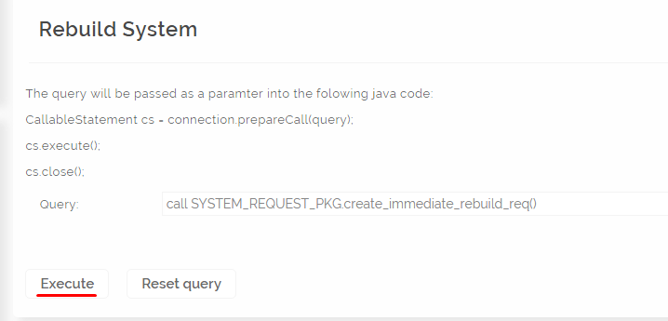

2. Rebuild from SQL Developer.
If above fails, and you don't have access to rebuild script ( step 3. ) you can rebuild system by SQL Developer. Log in to matching database you want to rebuild and execute:
call SYSTEM_REQUEST_PKG.create_immediate_rebuild_req()

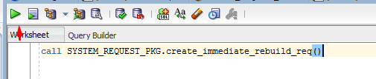

3. Rebuild with build.dep.applnc.sh script
Path to the script is underlined with red line.

