File name | YTM Enterprise Deployment Appliance
Author | Malloc Inc
Confidentiality | Internal
Last save date | Tuesday, December-01-2020 at 3:23:00 PM

Table of Contents
1 Introduction 2
2 Enterprise Configurations 2
2.1 High Performance Solution 2
2.2 High Performance and High Availability Solution 3
3 Apache HTTP Server 4
3.1 Step by Step Configuration Guide 4
3.2 Apache HTTPD and MOD_JK Installation 4
3.3 MOD_JK Configuration 5
3.4 Tomcat Setup 6
3.5 Open Issues 6
4 Useful links 6
5 PostgreSQL Hot Standby Configuration 6
6 Limitations and Concerns 8

Introduction
This document describes the configuration of the YTM Enterprise Deployment Appliance.

Enterprise Configurations

High Performance Solution

# | Layer | Min Number of VMs  Required | Description
 | Apache HTTP Server  https://httpd.apache.org/docs/2.4/ | 1 | v2.4
 | A number of Tomcat Servers (default 2) | 2+ | Apache tomcat 7.0.34-64bit
 | PostgreSQL database server | 1 | v10

High Performance and High Availability Solution

# | Layer | Min Number of VMs  Required | Description
 | Apache HTTP Server | 1 | v2.4
 | A number of Tomcat Servers (default 2) | 2+ | Apache tomcat 7.0.34-64bit
 | A number of PostgreSQL servers (default 2) | 2 | Primary and Hot Standby database - v10

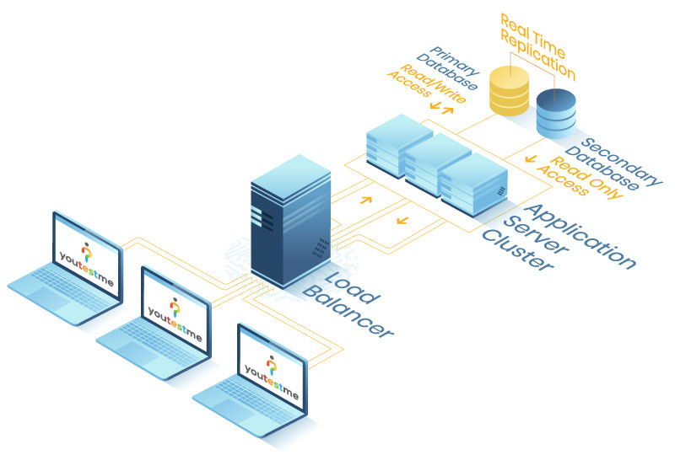

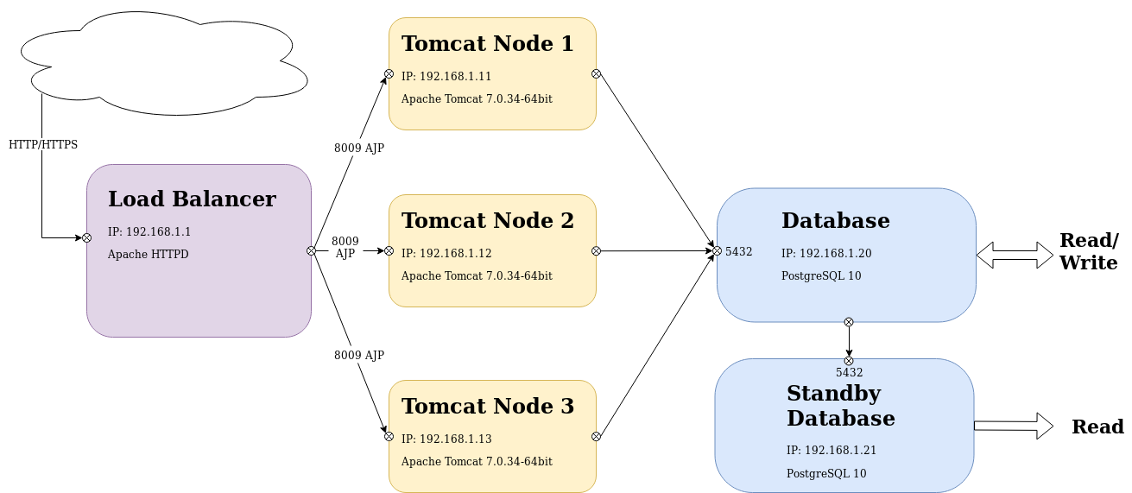

Apache HTTP Server

Step by Step Configuration Guide
https://www.mulesoft.com/tcat/tomcat-clustering

Apache HTTPD and MOD_JK Installation
Install HTTPD package with other useful packages by running the following command:

# yum install httpd-devel apr apr-devel apr-util apr-util-devel gcc gcc-c++ make autoconf libtool

Download and install Tomcat connector “mod_jk” from the official site:
http://tomcat.apache.org/download-connectors.cgi.

# mkdir -p /opt/mod_jk/
# cd /opt/mod_jk
# wget http://www.eu.apache.org/dist/tomcat/tomcat-connectors/jk/tomcat-connectors-1.2.41-src.tar.gz
# tar -xvzf tomcat-connectors-1.2.41-src.tar.gz
# cd tomcat-connectors-1.2.41-src/native

# ./configure --with-apxs=/usr/sbin/apxs --enable-api-compatibility
# make
# libtool --finish /usr/lib64/httpd/modules
# make install

MOD_JK Configuration
Open the file “/etc/httpd/conf/httpd.conf” and add the following:
LoadModule jk_module "/etc/httpd/modules/mod_jk.so"

JkWorkersFile /etc/httpd/conf/workers.properties
# Where to put jk shared memory
JkShmFile /var/run/httpd/mod_jk.shm
# Where to put jk logs
JkLogFile /var/log/httpd/mod_jk.log
# Set the jk log level [debug/error/info]
JkLogLevel info
# Select the timestamp log format
JkLogStampFormat "[%a %b %d %H:%M:%S %Y] "

<Location /status>
JkMount jkstatus
Require ip [Allowed_IP]
</Location>

<IfModule mod_jk.c>
JkMount /* LoadBalancer
</IfModule>

Create new directory to store shared memory of the module:

# mkdir -p /var/run/httpd/mod_jk
# chown apache:apache /var/run/httpd/mod_jk

Next step will be to create “worker.properties” file with the following content:

# vim /etc/httpd/conf/workers.properties

worker.list=jkstatus, LoadBalancer
worker.jkstatus.type=status
worker.LoadBalancer.type=lb

worker.jvm1.type=ajp13
worker.jvm1.host=[TOMCAT1_IP]
worker.jvm1.port=[TOMCAT1_AJP_PORT]
worker.jvm1.lbfactor=1

worker.jvm2.type=ajp13
worker.jvm2.host=[TOMCAT2_IP]
worker.jvm2.port=[TOMCAT2_AJP_PORT]
worker.jvm2.lbfactor=1

worker.LoadBalancer.balance_workers=jvm1,jvm2
worker.LoadBalancer.sticky_session=true

Tomcat Setup
The “jvmRoute” attribute of the Engine element allows the load balancer to match requests to the JVM currently responsible for updating the relevant session. It does this by appending the name of the JVM to the JSESSIONID of the request, and matching this against the worker name provided in “workers.properties”.

In order to configure jvmRoute, make sure that the value of “jvmRoute” for all your Engines is paired with an identically named Worker name entry in mod_jk’s worker.properties configuration file.

We should set “jvmRoute” to support load-balancing via AJP by modifying Engine element:

<Engine name=”Catalina” defaultHost=”localhost” jvmRoute=”jvm1”>

At the end of the configuration process it is necessary to restart Tomcat server and Apache HTTPD.

Open Issues
- LB keep sending connections to worker marked as disabled
The issue occurs on testing in the company. After testing in LoadBalancing mode (both applications active), status for one worker is configured as disabled, and apache HTTPD is restarted using command graceful. After that, all new connections should be sent to one worker, but they are still sent to the disabled one.

Useful links
- Configuring tomcat cluster with load balancer - https://www.mulesoft.com/tcat/tomcat-clustering
- Official tomcat workers document - http://tomcat.apache.org/connectors-doc/common_howto/loadbalancers.html
- Official tomcat cluster document - https://tomcat.apache.org/tomcat-8.5-doc/cluster-howto.html
- Example with session replication in Java - https://examples.javacodegeeks.com/enterprise-java/tomcat/tomcat-clustering-session-replication-tutorial/
- Tomcat Clustering configuration tutorial:
http://www.datadisk.co.uk/html_docs/java_app/tomcat6/tomcat6_clustering.htm
- https://geekflare.com/tomcat-load-balancer-using-mod-proxy-and-session-sticky/
- https://access.redhat.com/documentation/mod_jk

PostgreSQL Hot Standby Configuration
All relevant information can be found in the following document:

https://svn.youtestme.com/admin/trunk/System Administration/PostgreSQL/YTM PostgreSQL Replication and Hot Standby.docx

Limitations and Concerns
Report Location | Summary
https://svn.youtestme.com/scm/svn/qa/trunk/YTM Group Tests/Group Tests Reports/YTM Limitations and Concerns of EE Configuration 01.12.2020..docx | System configuring does not apply to all applications on EE.  1. Proctoring service is set up on the application with VM 192.168.1.114  the user who is not logged in to the same application will not be able to start the proctored test.  2. Pause the session only works for users at the same VM IP address as the admin.

