Restore procedure from snapshot
YouTestMe
This document describes how to restore your GetCertified application to the last saved version.

Table of Contents
1 Introduction 3
2 VMware client 3
2.1 Shutdown the YouTestMe Virtual Machine 3
2.2 Perform restore operation 4
2.3 Power on YouTestMe Virtual Machine 6
3 VirtualBox 7
4 VMware vSphere client 8
5 Contact 10

Introduction
This document explains the details of the restore procedure of YouTestMe application from a snapshot. Snapshot is a convenient way of creating a light backup of the Virtual Machine, so we can easily roll back to a specific point in time.

Important note: We strongly suggest that you perform a snapshot of YouTestMe Virtual Machine before applying any changes.

VMware client

Shutdown the YouTestMe Virtual Machine

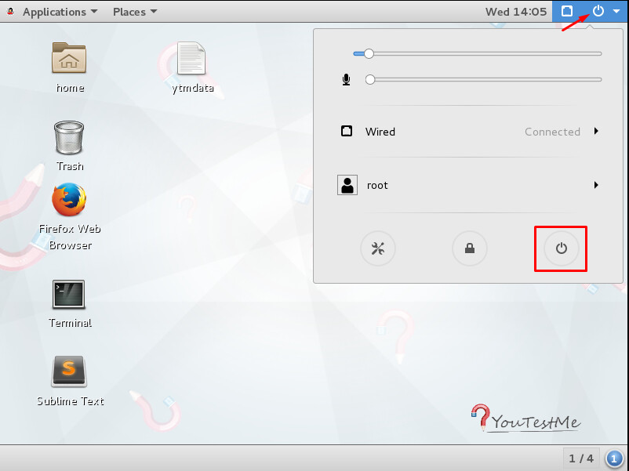

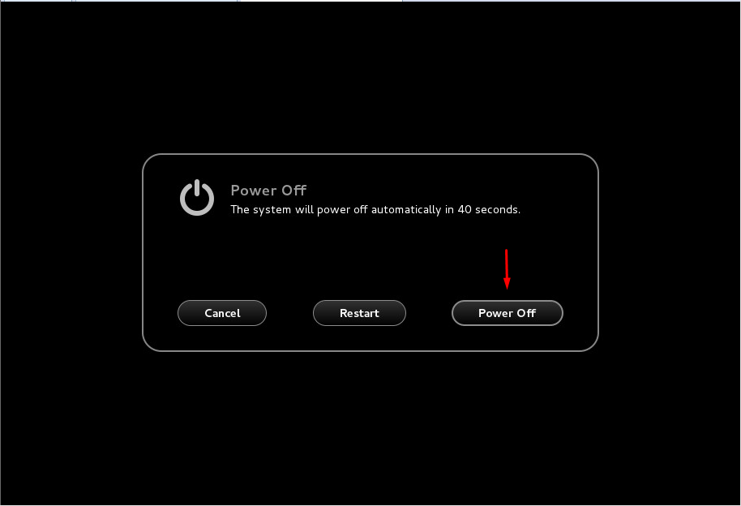

Perform restore operation

Select YouTestMe Virtual Machine from the list on the left side of the virtualization software and select this option:
VM -> Snapshot -> Revert to Snapshot: SNAPSHOT-NAME where SNAPSHOT-NAME is the name of your last snapshot (see the picture below)

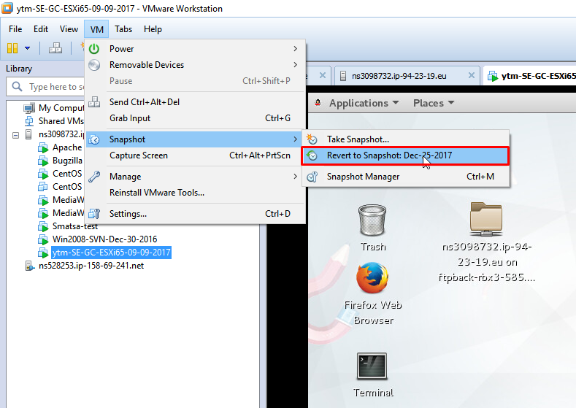

Power on YouTestMe Virtual Machine

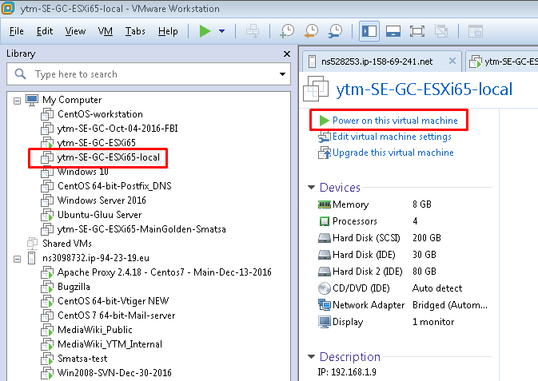

VirtualBox

1. Power off YouTestMe Virtual Machine
2. Select specific snapshot and click “Restore” button (see the picture below)
3. Power on YouTestMe Virtual Machine

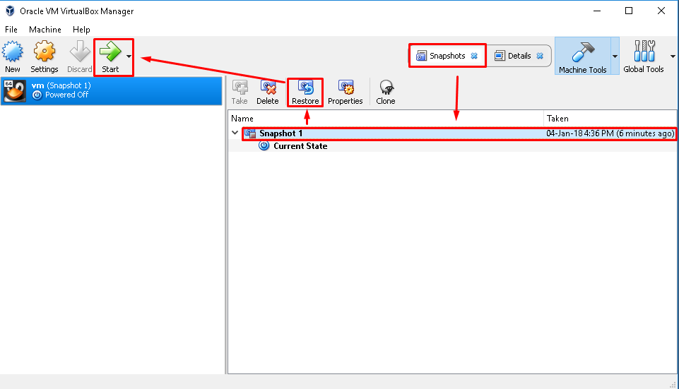

VMware vSphere client

1. Power off YouTestMe Virtual Machine
2. Select specific snapshot and click “Go to” button (see the pictures below)
3. Power on YouTestMe Virtual Machine

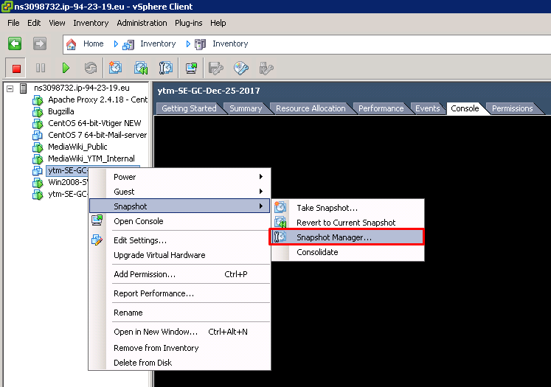

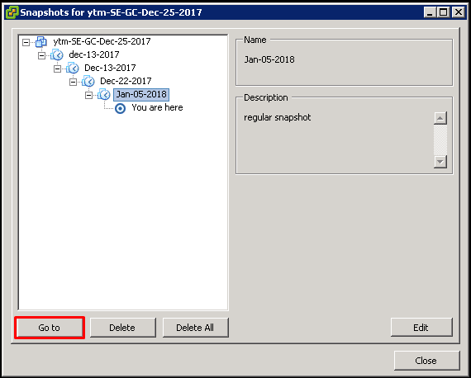

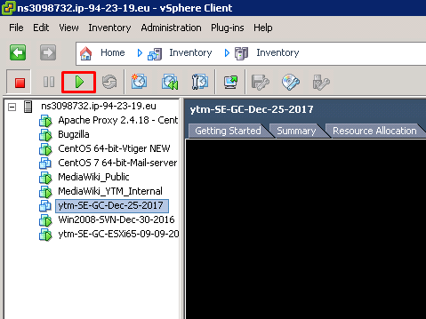

Contact
In case you have any difficulties, contact us at support@youtestme.com and our Team can help you with any issue you encounter.

