Linux Upgrade Procedure
Full Virus Scan
VMware Software Upgrade
YouTestMe
GetCertified

Table of Contents
1 Introduction 3
2 Transfer scripts to Virtual Machine 3
2.1 Connecting to the Virtual Machine 3
2.2 Transfer the scripts to YTM virtual machine 4
2.3 Set up executable file properties 5
2.4 Logging into the Virtual Machine 6
3 Scripts execution 7
3.1 Opening the Terminal 7
3.2 OS upgrade procedure 8
3.3 Performing the virus scan of YTM virtual machine 9
3.4 Log files 11
4 Install latest patch for VMware software 11
5 Contact 13

Introduction
This document provides the instructions for the following tasks:

1. Linux OS upgrade to the latest version of YTM virtual machine
2. Performing full virus scan after install the latest patch to antivirus software
3. Install the latest patch for VMware software

IMPORTANT: We strongly suggest that you perform a snapshot and an export of YouTestMe virtual machine before applying any changes and verify that the virtual machine can be restored from newly created export.

Transfer scripts to Virtual Machine

Connecting to the Virtual Machine

Transfer downloaded files “ytm_os_upgrade.sh” and “ytm_virus_scan.sh” attached to the email received from YTM company to the YTM Virtual Machine. The most convenient way to do this is to use FTP client software such as WinSCP for Windows and FileZilla for Macintosh.

The scenario will be presented by using WinSCP software. This application can be downloaded from the internet for free: https://winscp.net/download/WinSCP-5.9.4-Setup.exe

All necessary data required for connection to the YTM Virtual Machine are as following (you can also see them in the picture):

File protocol: SFTP
Host name: 192.168.1.100 (this is the default virtual machine IP4 address)
Port number: 22
Username: root
Password: 2ytm1

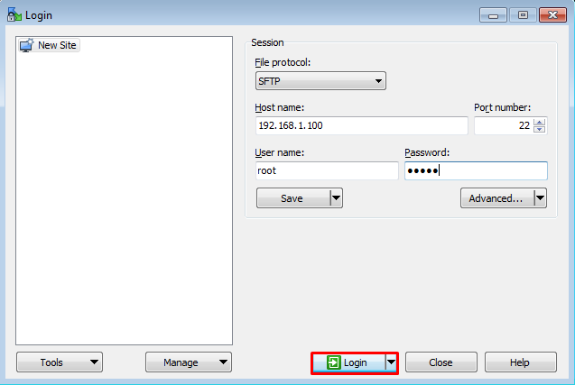

Transfer the scripts to YTM virtual machine

On the left side of the application you will need to open the download folder where you downloaded the scripts. This is usually located in the “Downloads” folder on your host machine.

On the right side, open the following location: /tmp (see the picture below)

Once you have selected these two folders, drag and drop the scripts from left to the right side of the screen for them to be transferred.

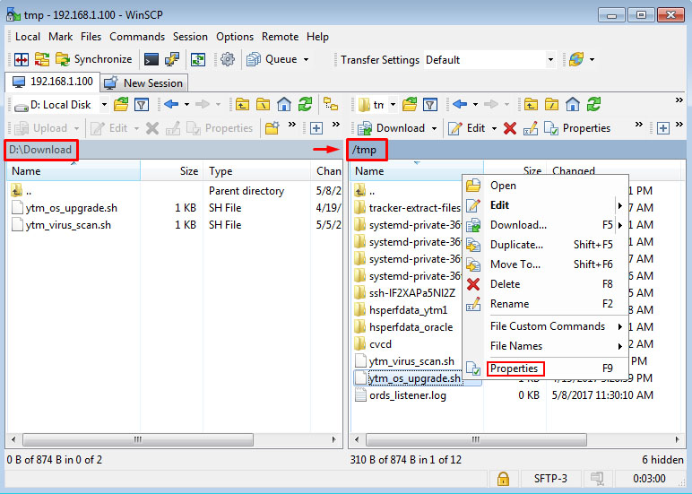

Set up executable file properties
This can be done by right-clicking on copied file, choosing “Properties” and then checking all checkboxes by the symbol “X” as shown in pictures below. This operation should be performed on both scripts.

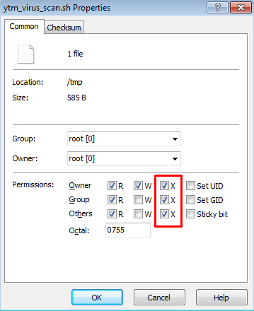

Logging into the Virtual Machine

Log into the YTM virtual machine as the following user:

Username: root
Password: 2ytm1

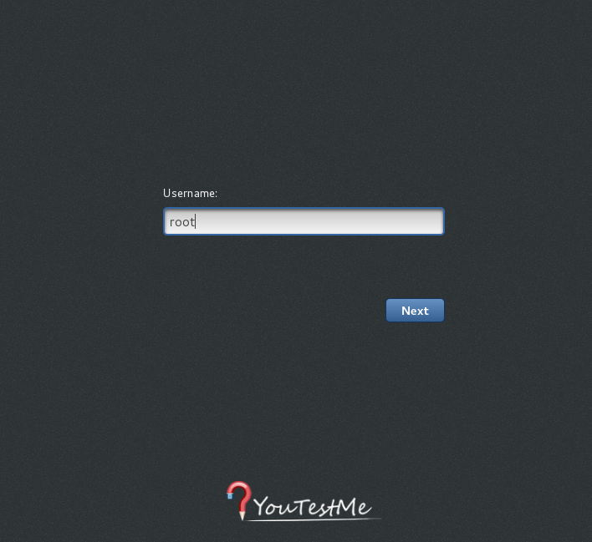

Scripts execution

Opening the Terminal

Open the Terminal on the YTM Virtual Machine:

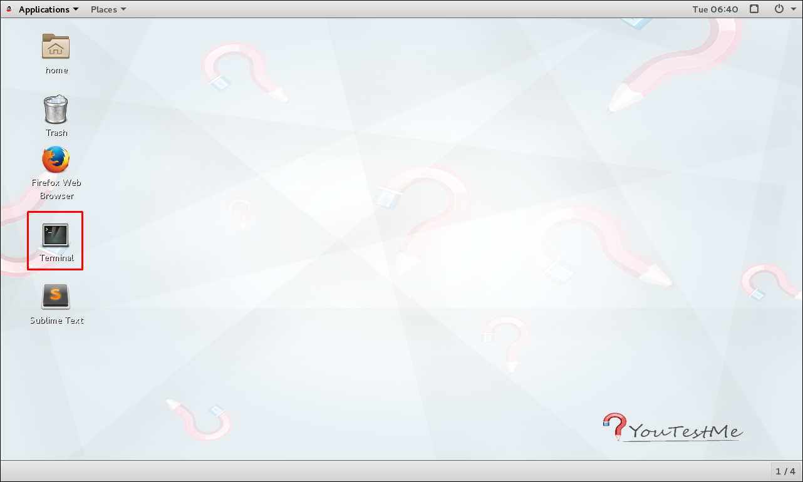

OS upgrade procedure
Snapshot of the YTM virtual machine is highly recommended before Linux upgrade to the latest version. The following process can be interrupted for many reasons and the snapshot will be the only way to restore your virtual machine to the previous state.

Type in the following commands, followed by {ENTER} key after each command.
The commands are written in italic font. (see the screenshot of the terminal below)

- Change the directory to “/tmp” where the scripts are located:
cd /tmp
- Remove all existing log files:
rm -f *log*
- Execute “ytm_os_upgrade.sh” script:
./ytm_os_upgrade.sh

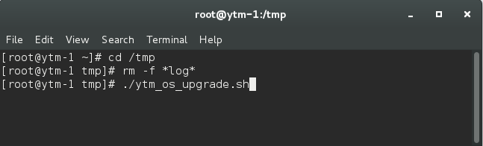

The estimated time for “ytm_os_upgrade.sh” script execution is about 30 minutes. If the Linux upgrade is completed successfully (see the picture below), restart the YTM virtual machine and proceed to the next chapter 3.3 Performing the virus scan of YTM virtual machine.

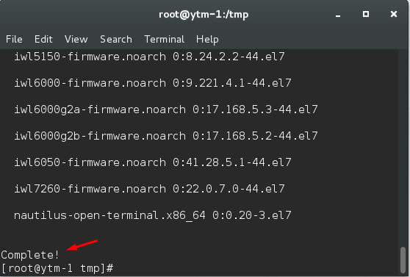

If something goes wrong, like internet disconnection during the upgrade process, restore the virtual machine from the latest snapshot and proceed to chapter Log files.

Performing the virus scan of YTM virtual machine

After the restart of YTM virtual machine and logging to it, open the terminal located on Desktop and execute following commands to start full system virus scan:

- Change the directory to “/tmp” where the scripts are located:
cd /tmp
- Execute “ytm_virus_scan.sh” script:
./ytm_virus_scan.sh

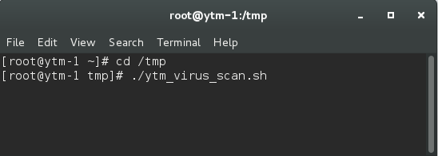

The estimated time for “ytm_virus_scan.sh” script execution tested on clone machine of virtual machine delivered to a client can vary from 59 minutes to 75 minutes. At the end of the scanning process it is important to verify status information presented as SCAN SUMMARY.

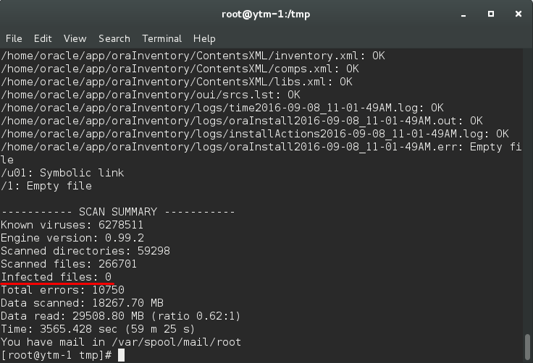

Log files
Each script will produce separate log file: “ytm_os_upgrade + run timestamp” and “ytm_virus_scan + run timestamp” in “/temp” directory, for example:
ytm_os_upgrade_20170416-085555.log

Please copy produced log files to your workstation and send us by email to examine.

Install latest patch for VMware software

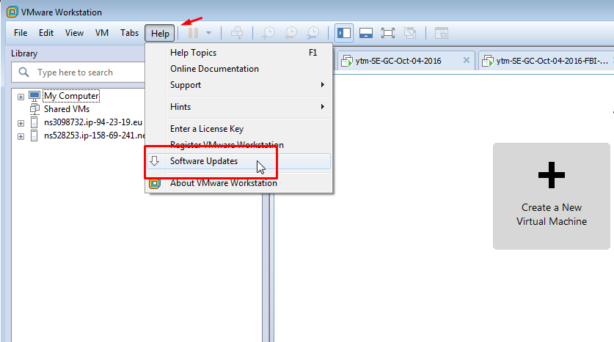

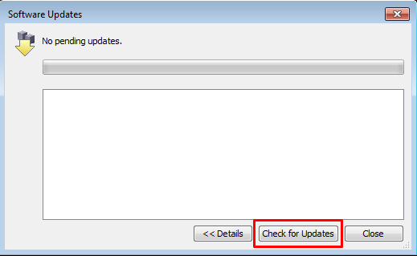

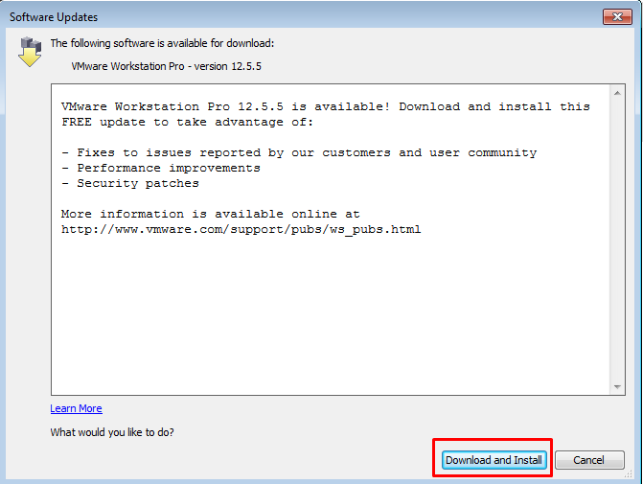

Contact
In case you have any difficulties, contact us at support@youtestme.com and our Team can help you with any issue you encounter.

