

YouTestMe

GetCertified

A guide on how to import questions via Excel template

Pool Questions Excel Upload

IFSE

Table of Contents

1 Basic Information 3

1.1 Sheet 1: Questions 4

1.2 Sheet 2: Answers 5

2 Filled Template and Test-taking preview 6

2.1 Single choice (Question type = SNC) 6

2.1.1 Sheet 1: Questions 6

2.1.2 Sheet 2: Answers 6

2.1.3 Test-taking 6

2.2 Multiple choice (Question type = MLC) 7

2.2.1 Sheet 1: Questions 7

2.2.2 Sheet 2: Answers 7

2.2.3 Test-taking 7

2.3 True or false (Question type = TFC) 8

2.3.1 Sheet 1: Questions 8

2.3.2 Sheet 2: Answers 8

2.3.3 Test-taking 8

2.4 Matching (Question type = MHC) 9

2.4.1 Sheet 1: Question 9

2.4.2 Sheet 2: Answers 9

2.4.3 Test-taking 9

2.5 Ordering (Question type = ORD) 10

2.5.1 Sheet 1: Questions 10

2.5.2 Sheet 2: Answers 10

2.5.3 Test-taking 10

2.6 Fill in the blank (Question type = FBL) 11

2.6.1 Sheet 1: Questions 11

2.6.2 Sheet 2: Answers 11

2.6.3 Test-taking 11

2.7 Essay (Question type = ESY) 12

2.7.1 Sheet 1: Questions 12

2.7.2 Sheet 2: Answers 12

2.7.3 Test-taking 12

2.8 Open (Question type = OPQ) 13

2.8.1 Sheet 1: Questions 13

2.8.2 Sheet 2: Answers 13

2.8.3 Test-taking 13

# Basic Information

YouTestMe Get Certified allows users to import questions into the desired question pool quickly and efficiently using a predefined YTM Excel format.

Excel template consists of three sheets:

**Sheet 1: Questions** – On this sheet, it is necessary to enter all data for the questions being imported into the selected pool.

**Note: Hotspot, Matrix, and Branching questions are not supported.**

**Sheet 2: Answers** – On this sheet, it is necessary to enter all possible answers offered for the questions in sheet 1.

**Sheet 3: A legend** with predetermined codes explained.

## Sheet 1: Questions

The data that needs to be entered to import questions are shown and explained below.

|  |  |  |  |
| --- | --- | --- | --- |
| **Name** | **Description** | **The type of input** | **The default value for empty optional fields** |
| **Question ID\*** | A unique number that identifies the question and is used to link the answers to the questions. \***IFSE question ID should be entered in this column.** | Type a numeric value | / |
| **Question text\*** | Question text | Type the text | / |
| **Question type\*** | Use the predetermined code to select the question type | Select from a list | / |
| **Duration** | Express the time in seconds to time limit the question answering. This time limit is used only if the test duration option is set to “Time per question.” | Type a numeric value | 00:00:00 |
| **Difficulty code** | Use the predetermined code to set the question difficulty that can later be used when generating different versions of the test. | Select from a list | Medium |
| **Points** | Set the number of points each question carries - must be greater than zero. | Type a numeric value | 1 |
| **Frequency factor** | Define how likely it is for the question to appear in a generated test. | Select from a list | Normal |
| **Penalty** | Set the number of negative points for incorrect answers. | Type a numeric value | 0 |
| **External ID** | External ID is an optional unique identifier of the question. Typically it is used to reference questions from external systems in the integrations. Since the YouTestMe assigns internal IDs to questions, this field is useful when the questions are migrated from an external system to preserve IDs already assigned in that system.\***IFSE question ID should be entered in this column.** | Type the text | / |
| **Data Source** | Name of the source external system of the question. *Recommended value for the IFSE questions is **IFSE.** | Type the text | / |
| **Tags** | Insert certain question tags that you will be able to use later to make them easier to find. | Type the text (separate with a comma) | / |

**\*NOTE: For the IFSE use-case scenario, since questions have IDs already and YouTestMe generated IDs will not be used, the IFSE question ID should be entered in both the Question ID and External ID column. For the Data Source recommended value is IFSE.**

## Sheet 2: Answers

The data that needs to be entered to import answers are shown and explained below.

|  |  |  |
| --- | --- | --- |
| **Name** | **Description** | **The type of input** |
| **Question ID\*** | Enter an ID that links answers to the question. If the question has multiple answers offered, you should enter the same ID in more fields. | Type a numeric value |
| **Answer text\*** | Answer text | Type the text |
| **Answer ordinal number\*** | Determine the order of the answer | Type a numeric value |
| **Correct Answer\*** | Set whether the answer is correct or incorrect. The field’s value could vary depending on the question type. | Select from a list |
| **Answer Feedback** | Answer feedback is configurable only for single choice, multiple choice and true/false question types. | Type the text |

# Filled Template and Test-taking preview

## Single choice (Question type = SNC)

Multiple answers are displayed, but users can select only one.

### Sheet 1: Questions

### Sheet 2: Answers

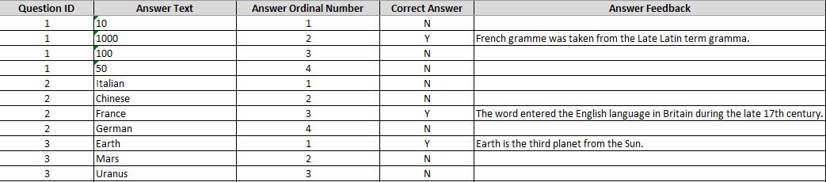

**Correct Answer**: This question type can have only one answer with Y value, while all others have N value.

### Test-taking

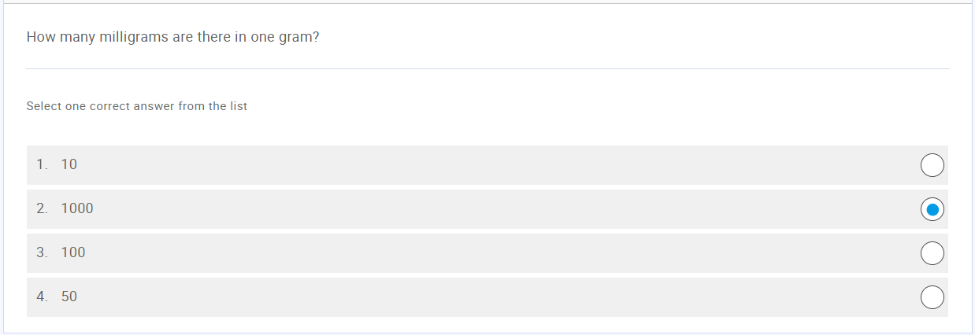

## Multiple choice (Question type = MLC)

Users can mark one or multiple answers as correct.

### Sheet 1: Questions

### Sheet 2: Answers

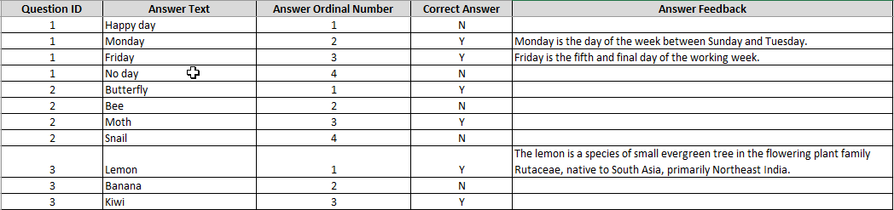

**Correct Answer**: This question type can have multiple answers with both Y and N values.

### Test-taking

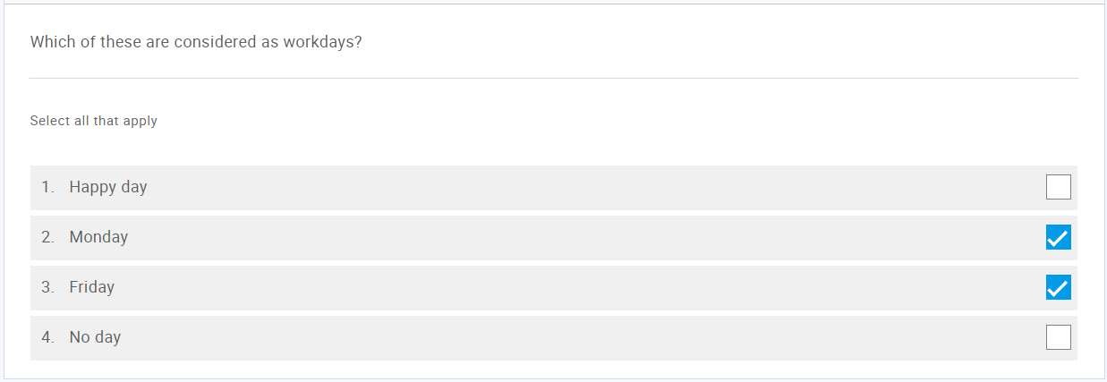

## True or false (Question type = TFC)

Users have to mark the sentence as "true" or "false."

### Sheet 1: Questions

### Sheet 2: Answers

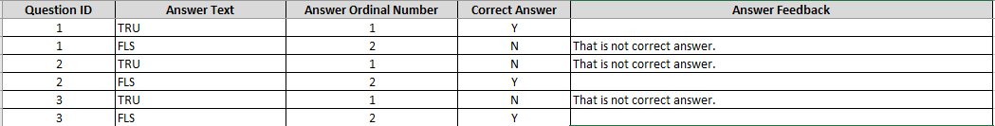

**Correct Answer**: This question type can have only one answer with Y value, and one with N value.

### Test-taking

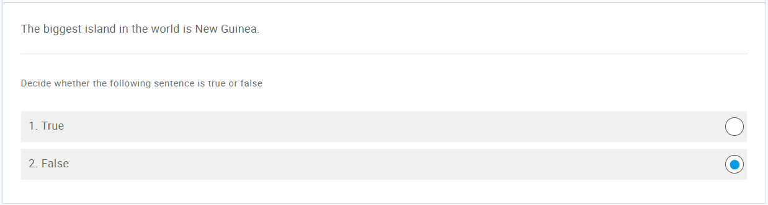

## Matching (Question type = MHC)

Users pair objects/text on the left with the objects/text on the right side.

### Sheet 1: Question

### Sheet 2: Answers

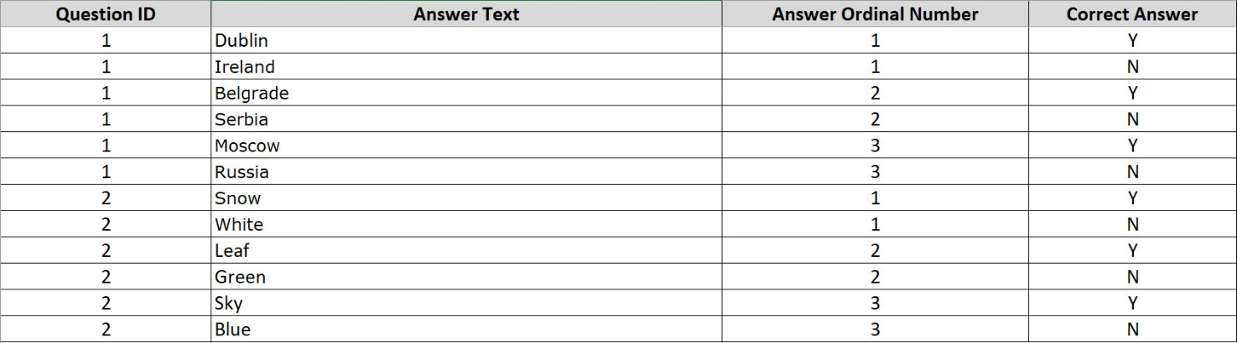

**Answer Ordinal Number:** Answer ordinal number is used to connect the statements on the left with the statements on the right that form the correct combination.

**Correct answer**: To form two sets of answers that should be matched, statements on the left side should have N value and those on the right side Y value.

### Test-taking

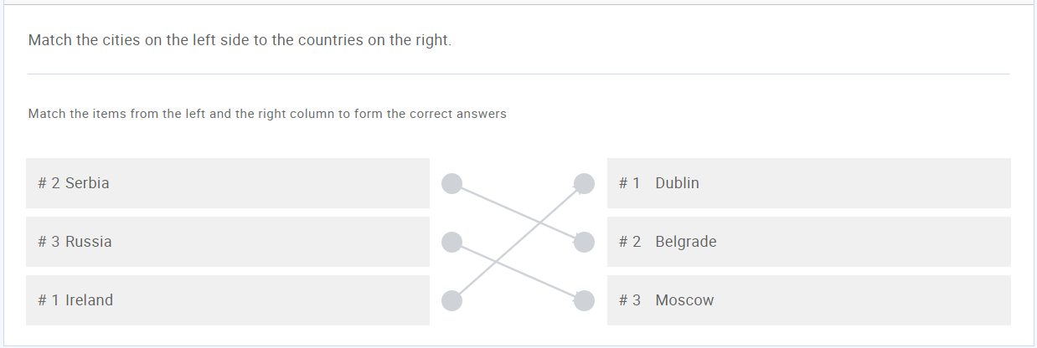

## Ordering (Question type = ORD)

Users need to rearrange answers into the correct order.

### Sheet 1: Questions

### Sheet 2: Answers

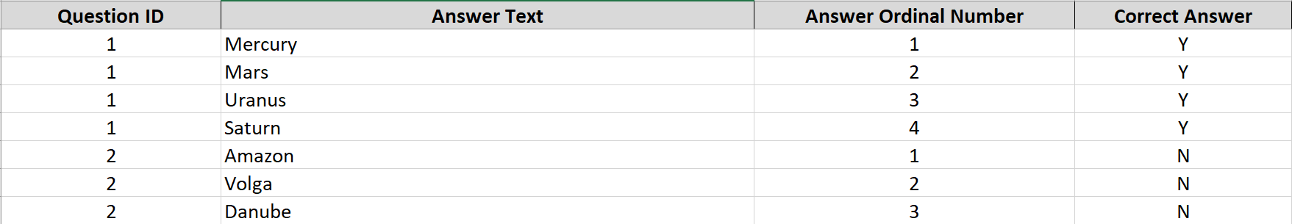

**Correct answer**: Although this question type does not have correct or incorrect answers, each statement must have a Y or N value in this field for the system to process it successfully.

### Test-taking

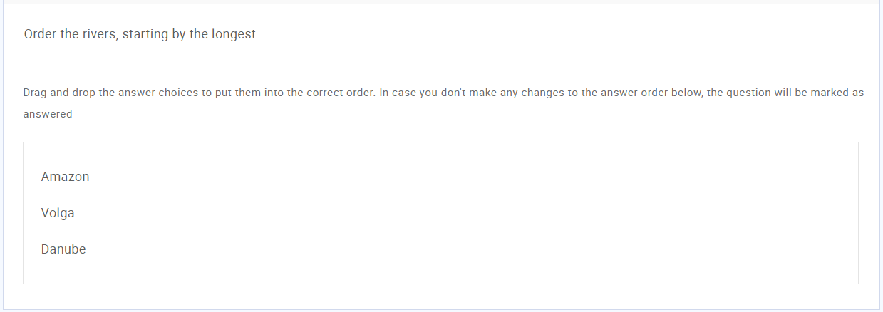

## Fill in the blank (Question type = FBL)

Users need to fill in the missing parts of sentences.

### Sheet 1: Questions

### Sheet 2: Answers

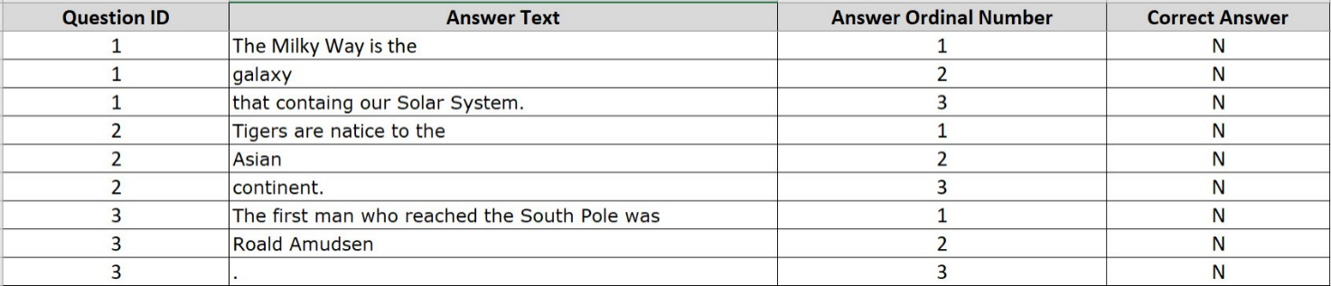

**Correct Answer:** Although this question type does not have correct or incorrect answers, each statement must have a Y or N value in this field for the system to process it successfully.

### Test-taking

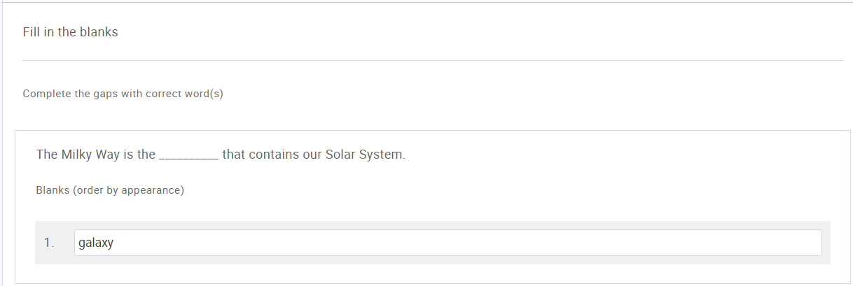

## Essay (Question type = ESY)

Users have to type an essay answer in a text box.

### Sheet 1: Questions

### Sheet 2: Answers

No data should be entered in this table for this question type since the answer is open-ended.

### Test-taking

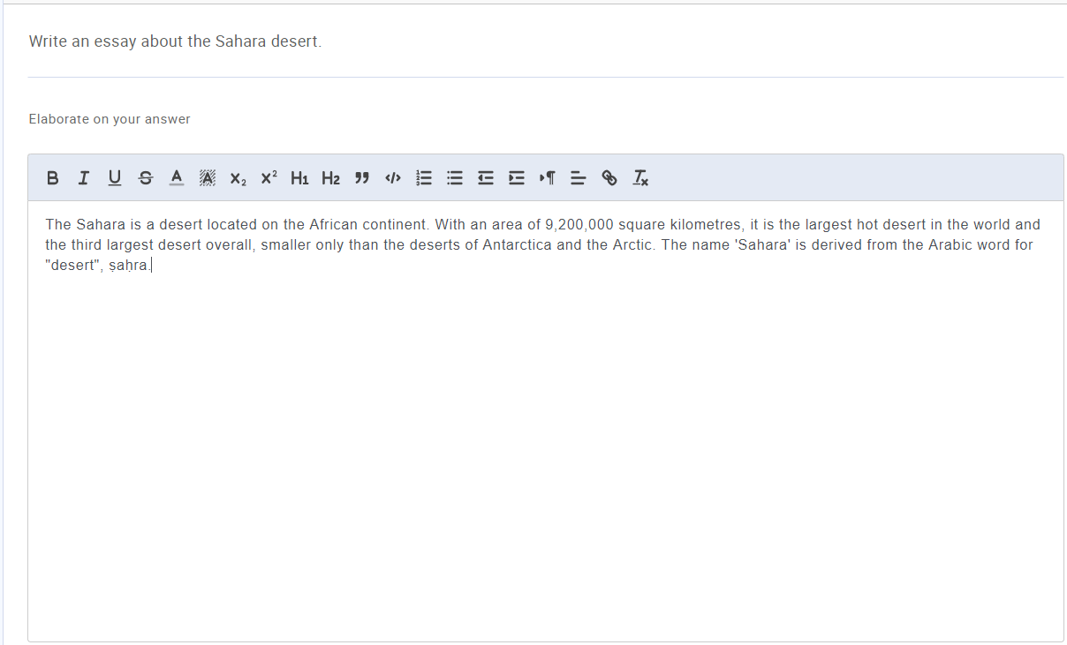

## Open (Question type = OPQ)

Blank spaces need to be filled in with the correct answer.

### Sheet 1: Questions

### Sheet 2: Answers



**Correct Answer:** There is only one answer per question, and it should have a value Y.

### Test-taking

