| **File name** | How to import multiple question pools from an Excel file |
| --- | --- |
| **Author** | YouTestMe |
| **Confidentiality** | Public |
| **Last save date** | Tuesday, October-19-2021 at 8:08:00 PM |

Table of Contents

1 Introduction 1

2 Question pools import 2

2.1 Creating Auswendig field in the question pool 4

2.2 Excel file layout 6

3 Questions preview 7

# Introduction

This article explains how to import multiple question pools from an Excel file into the YouTestMe GetCertified.

# Question pools import

To import question pools:

1. Hover over the “**Tests**” tab in the main menu, then select “Question pools”.  
     
   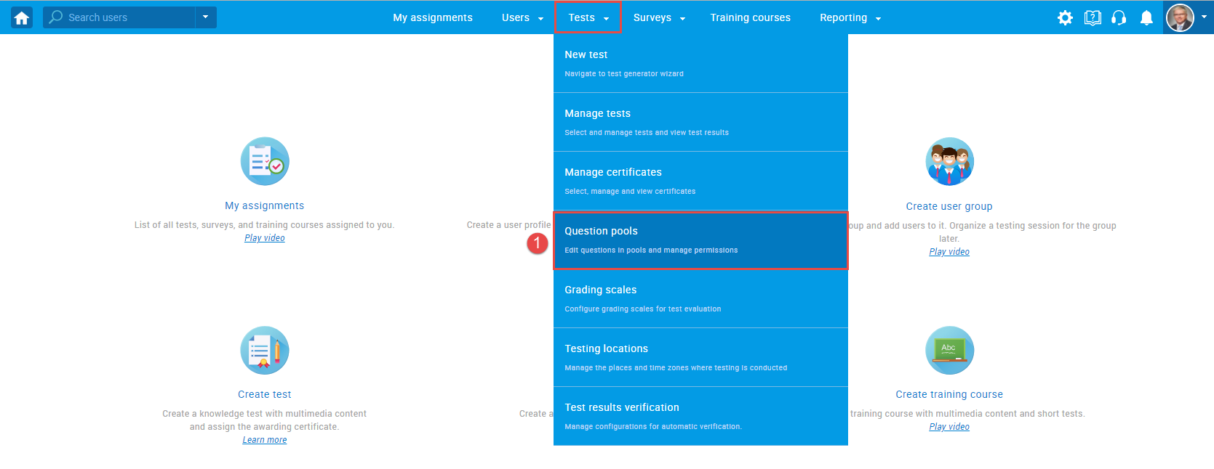
2. Click the “**Import from Excel**” button that will appear in the menu on the left side.  
     
   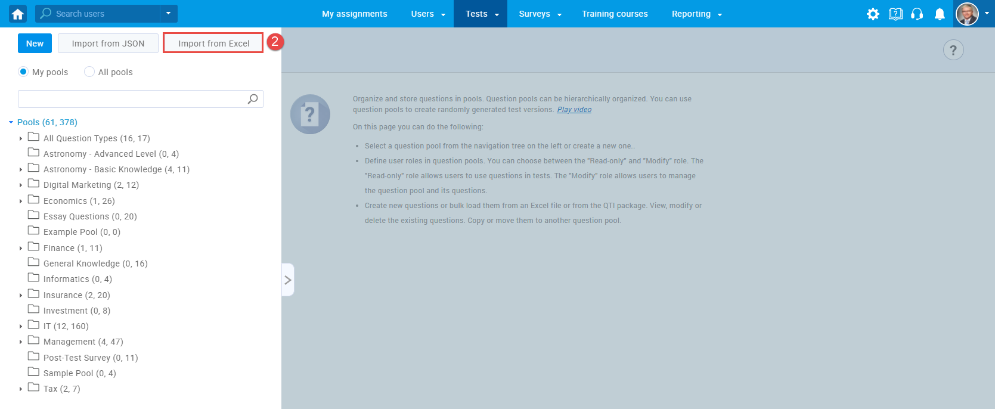
3. To import previously inserted values in the Auswendig column in the Excel file, tick the checkbox next to the Auswendig option. For more information on how to allow uploading this custom property (Auswendig), please check chapter 2.1.
4. Click the “**Select file**” button, then choose the .zip archive that will be uploaded.
5. Click the “**Upload**” button.  
     
   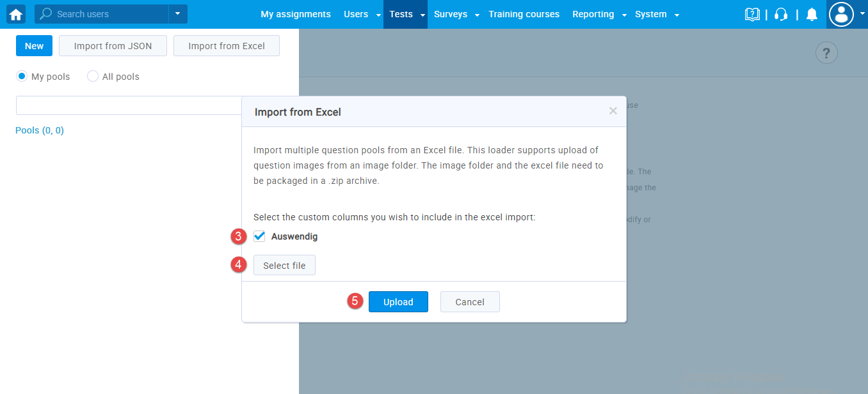

.Zip archive should contain an Excel file with question pools, their questions and answers, and a folder with images.



**Note**: It is possible to upload only single-choice questions.

## Creating Auswendig field in the question pool

It is possible to create the Auwendig field in three ways:

1. **Yes/No type of question property** – for more information on creating a Yes/No type of question property, please check this [link](https://wiki.youtestme.com/youtestme/youtestmedoc/YTM%20Customer%20Support/Client%20onboarding%20documentation%20(best%20practices%20for%20common%20scenarios,%20how-to)/Lufthansa/PDF/2021-08-10%20How%20to%20create%20custom%20question%20properties.pdf).   
   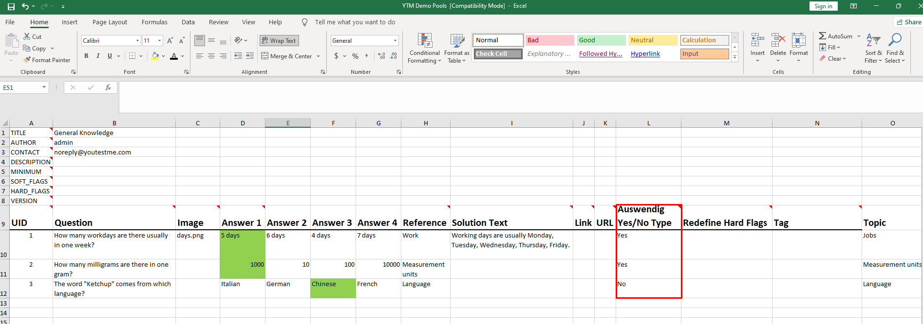
2. **Text type of question property** – for more information on how to create text type custom property, please check this [link](https://wiki.youtestme.com/youtestme/youtestmedoc/YTM%20Customer%20Support/Client%20onboarding%20documentation%20(best%20practices%20for%20common%20scenarios,%20how-to)/Lufthansa/PDF/2021-08-10%20How%20to%20create%20custom%20question%20properties.pdf).

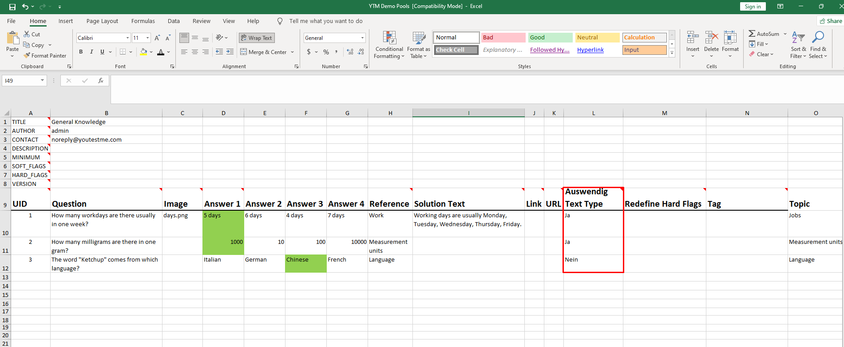

1. **Dropdown type of question property** – for more information on creating a dropdown type of question property, please check this [link](https://wiki.youtestme.com/youtestme/youtestmedoc/YTM%20Customer%20Support/Client%20onboarding%20documentation%20(best%20practices%20for%20common%20scenarios,%20how-to)/Lufthansa/PDF/2021-13-10%20How%20to%20create%20dropdown%20type%20of%20custom%20question%20property.pdf).

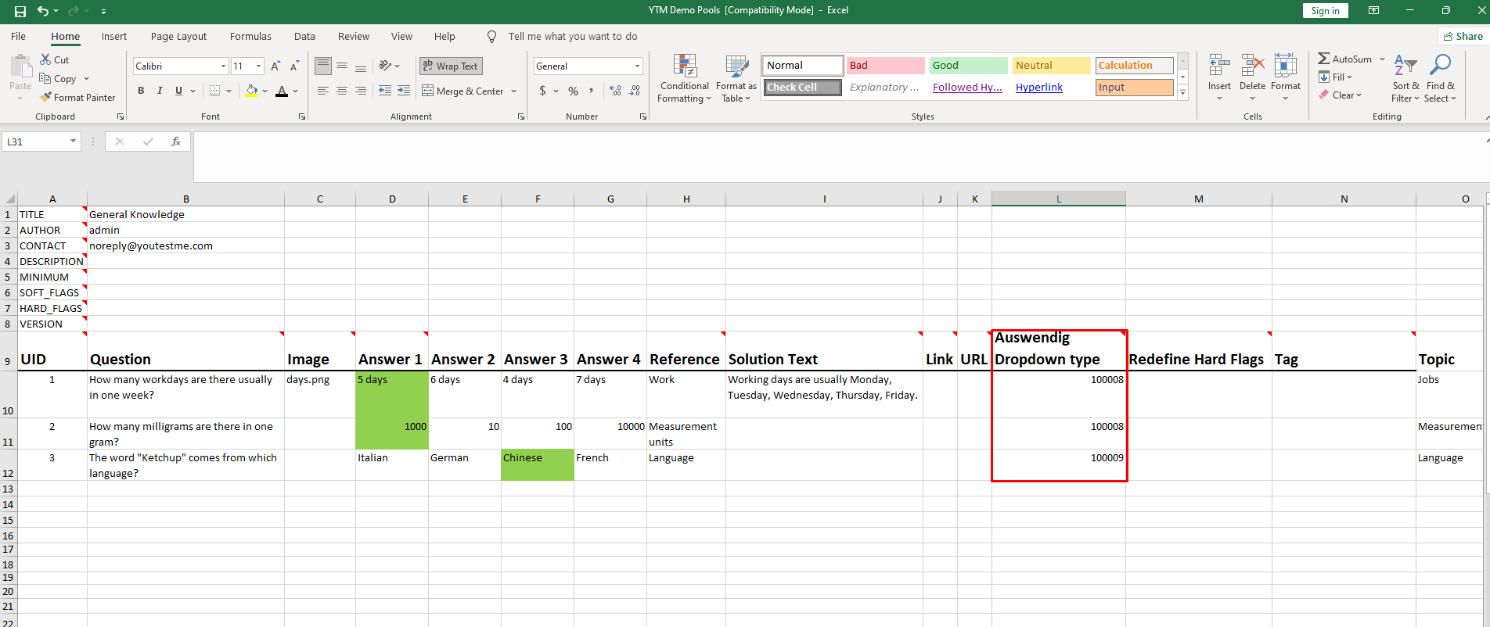

**Note**: In the Excel file in the Auswendig column, it is necessary to insert ID’s of previously created custom data types.

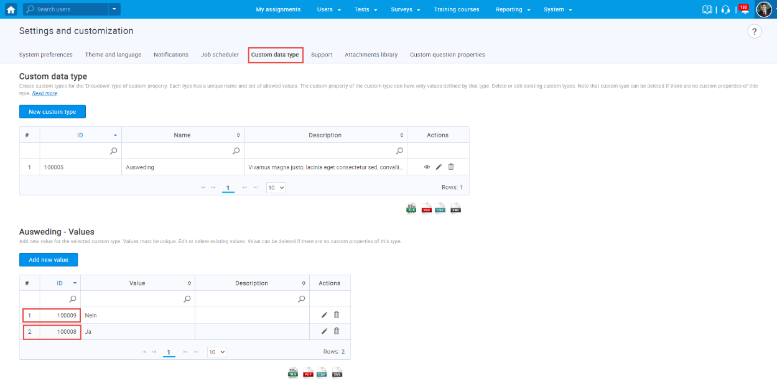

## Excel file layout

The Excel file should be filled out in the following way:

1. Create one sheet for each question pool you want to add to the system.
2. Enter a pool title.
3. Enter a question text.
4. Enter a picture name that you want to add in the question text (optionally).
5. Enter the question answers. The correct answer should be painted in a different color.
6. In the Reference field, enter tags you want to assign to the question (optionally).
7. In the Solution text field, enter the text that will be shown to the candidate as question feedback (optionally).
8. In the Auswending field, enter Yes or No, depending you want candidates to know the question by heart.  
   **Note:** Created custom column (Auswendig) must be named the same as the column you inserted in the Excel file.

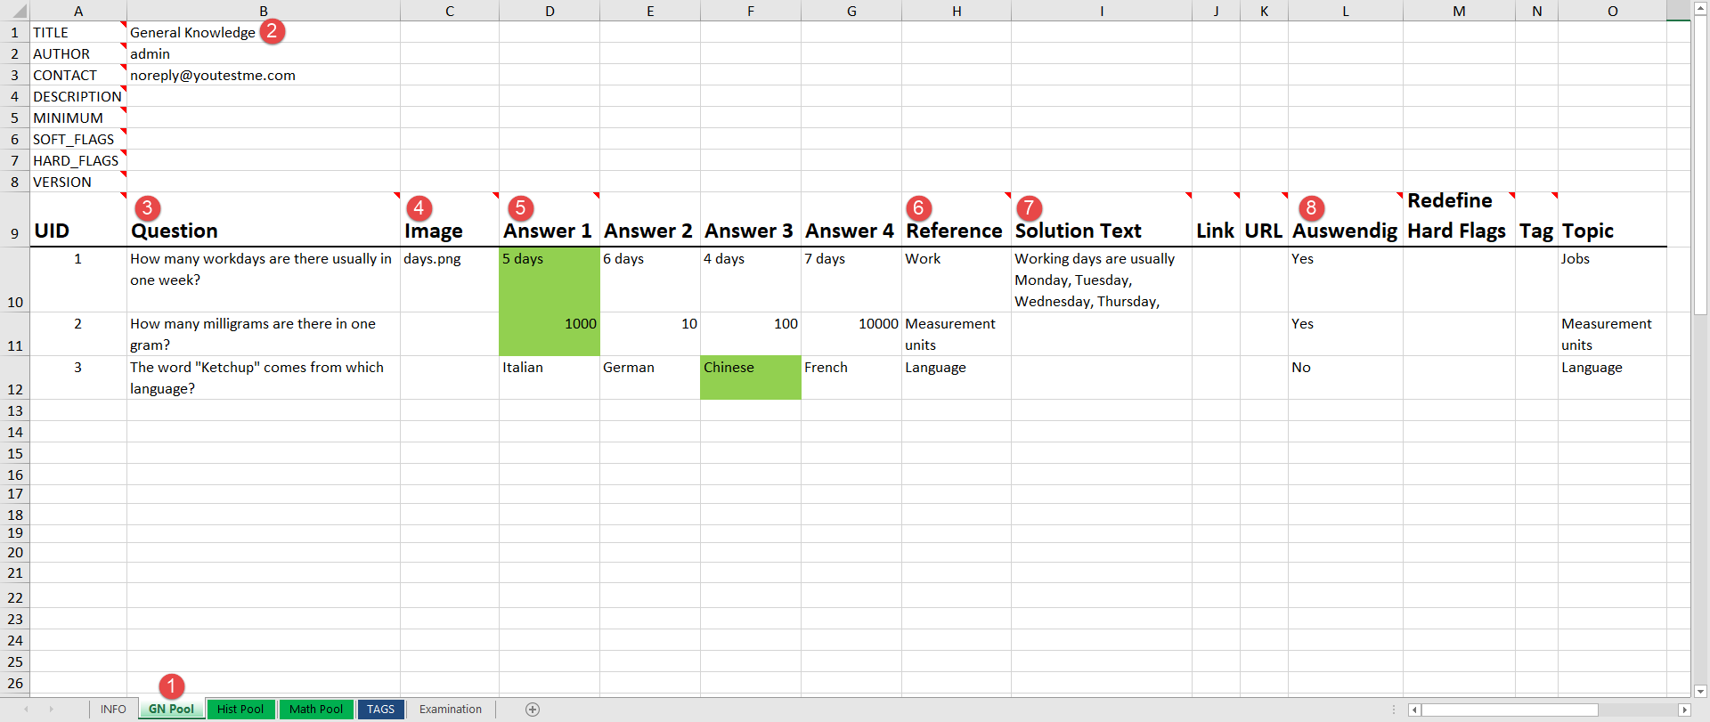

# Questions preview

Once you import question pools, you will be able to see them in the left-side menu.

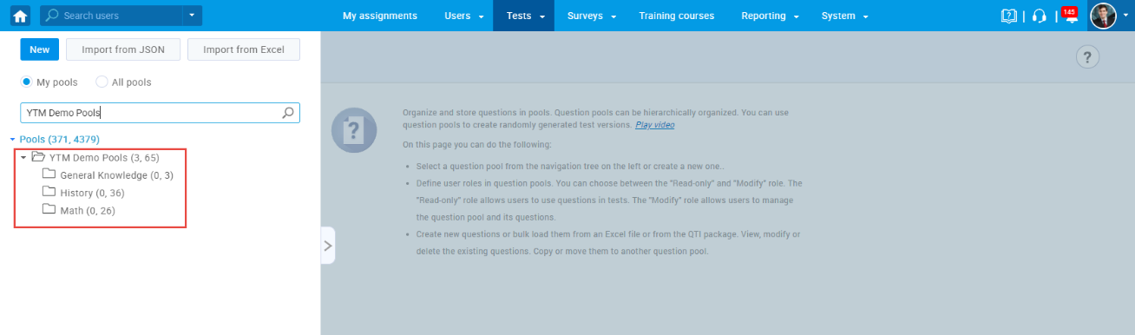

To see the list of questions for the desired question pool, open the pool and navigate the “**Questions**” tab.

Also, in the table, you can see imported Auswending values for each question and filter them.

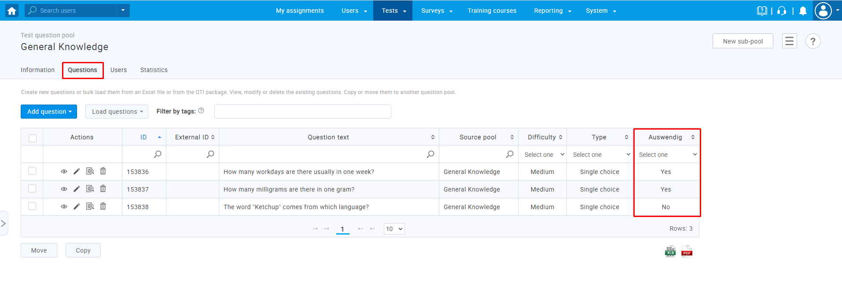

For more details about each question, click the marked icon.

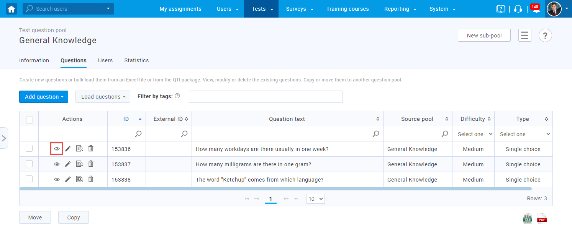

When you open the desired question, in the “**Tags**” field, you can see the text previously inserted in the “**Reference**” column in the Excel file.

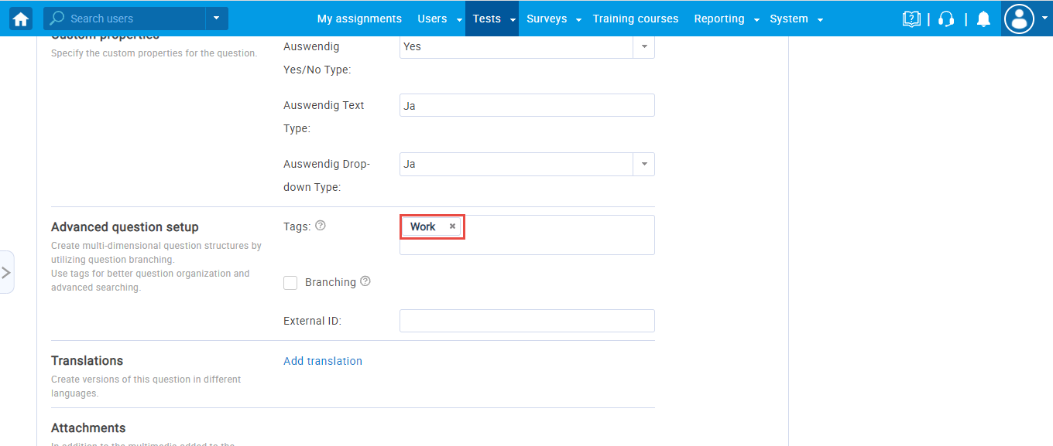

*In the application*

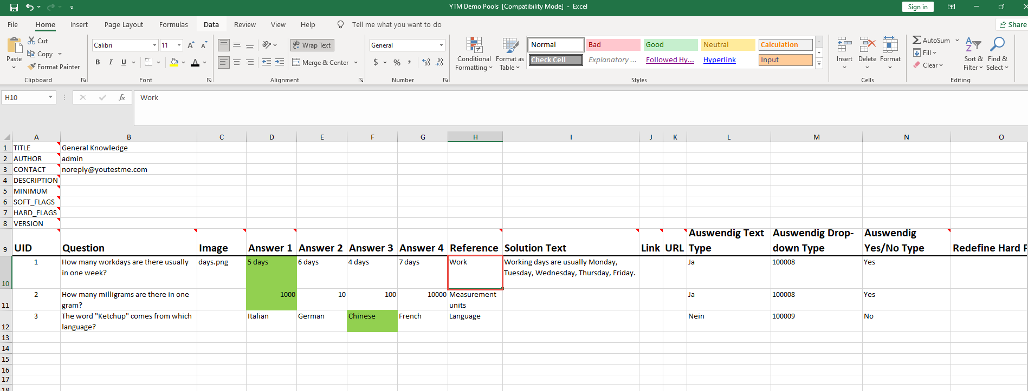

*In the Excel file*

When you click on the “**Edit question feedback**” button, you can see inserted question feedback that is written in the “**Solution text**” column in the Excel file.

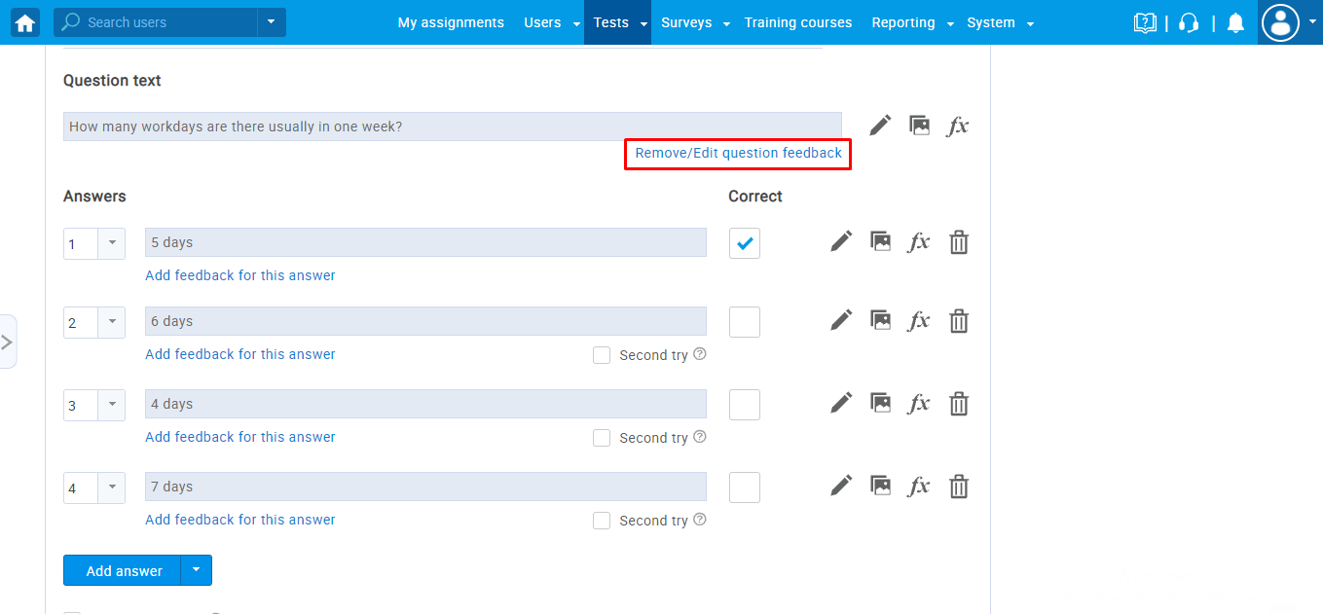

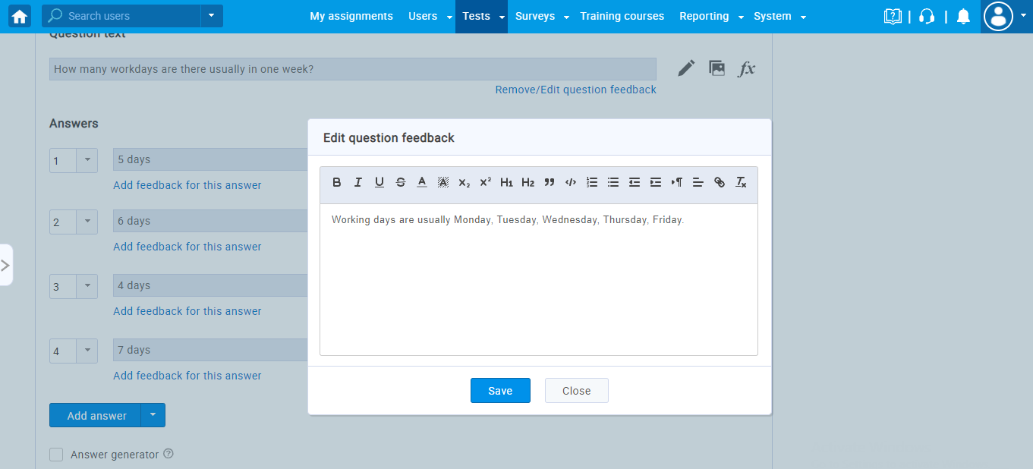

*In the application*

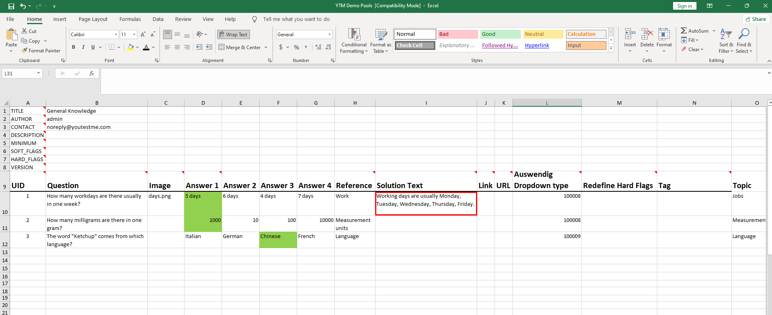

*In the Excel file*