YouTestMe

Paper Exam Venues Migration Guide
Contents
1 Introduction 2
2 Steps 2
2.1 How to access the production instance 2
2.2 Accessing testing location page 3
2.3 Process of creation a new testing location 4
2.4 Process of importing location through the Excel template 5
2.5. Process of asignig proctors to the loaded location 6

Introduction
This document represents a guide on how to load testing locations with addresses and additional information using an excel spreadsheet in the YouTestMe GetCertified platform.

Note: Before you start the migration process, make sure that the version of the production environment is appropriate!

Steps

How to access the production instance
To access the production instance, please go to ifse.youtestme.com and enter:
- Username.
- Password. (Once you receive the credentials, please make sure that you do not copy the blank space along with the password as you will not be able to log in.)
- Click the “Sign in” button to enter the platform.
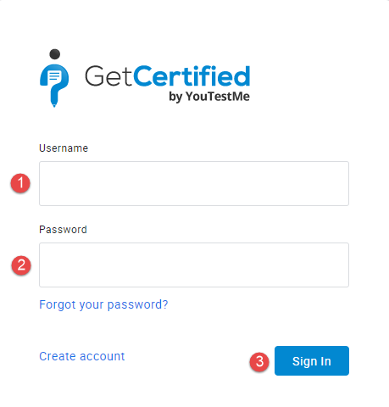

Note: To load testing locations, you need to log in with an account with the appropriate permissions.

Accessing testing location page
To load new testing locations, navigate to “Tests” in the main menu, and select “Testing locations”.
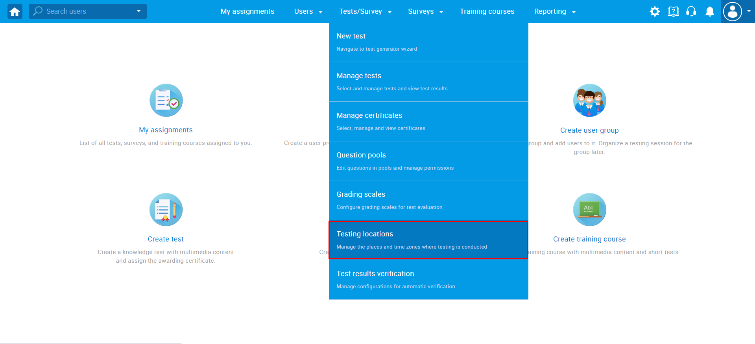

Process of creation a new testing location
To create a new testing location follow the next steps:
- Click the arrow next to the “Create new” button and from the drop down menu choose the “Load location” option.
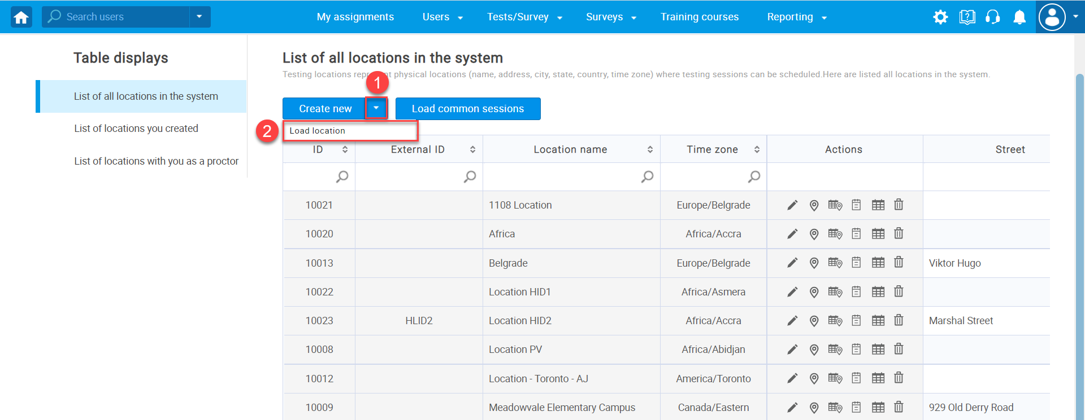
- The pop-up window "Load location" will appear, after which you need to follow the steps below:
  - Download and then read detailed instructions on how to fill in the template by clicking on the hyperlinked word "here".
  - Click the “Excel template” link to download an Excel file you should fill in.
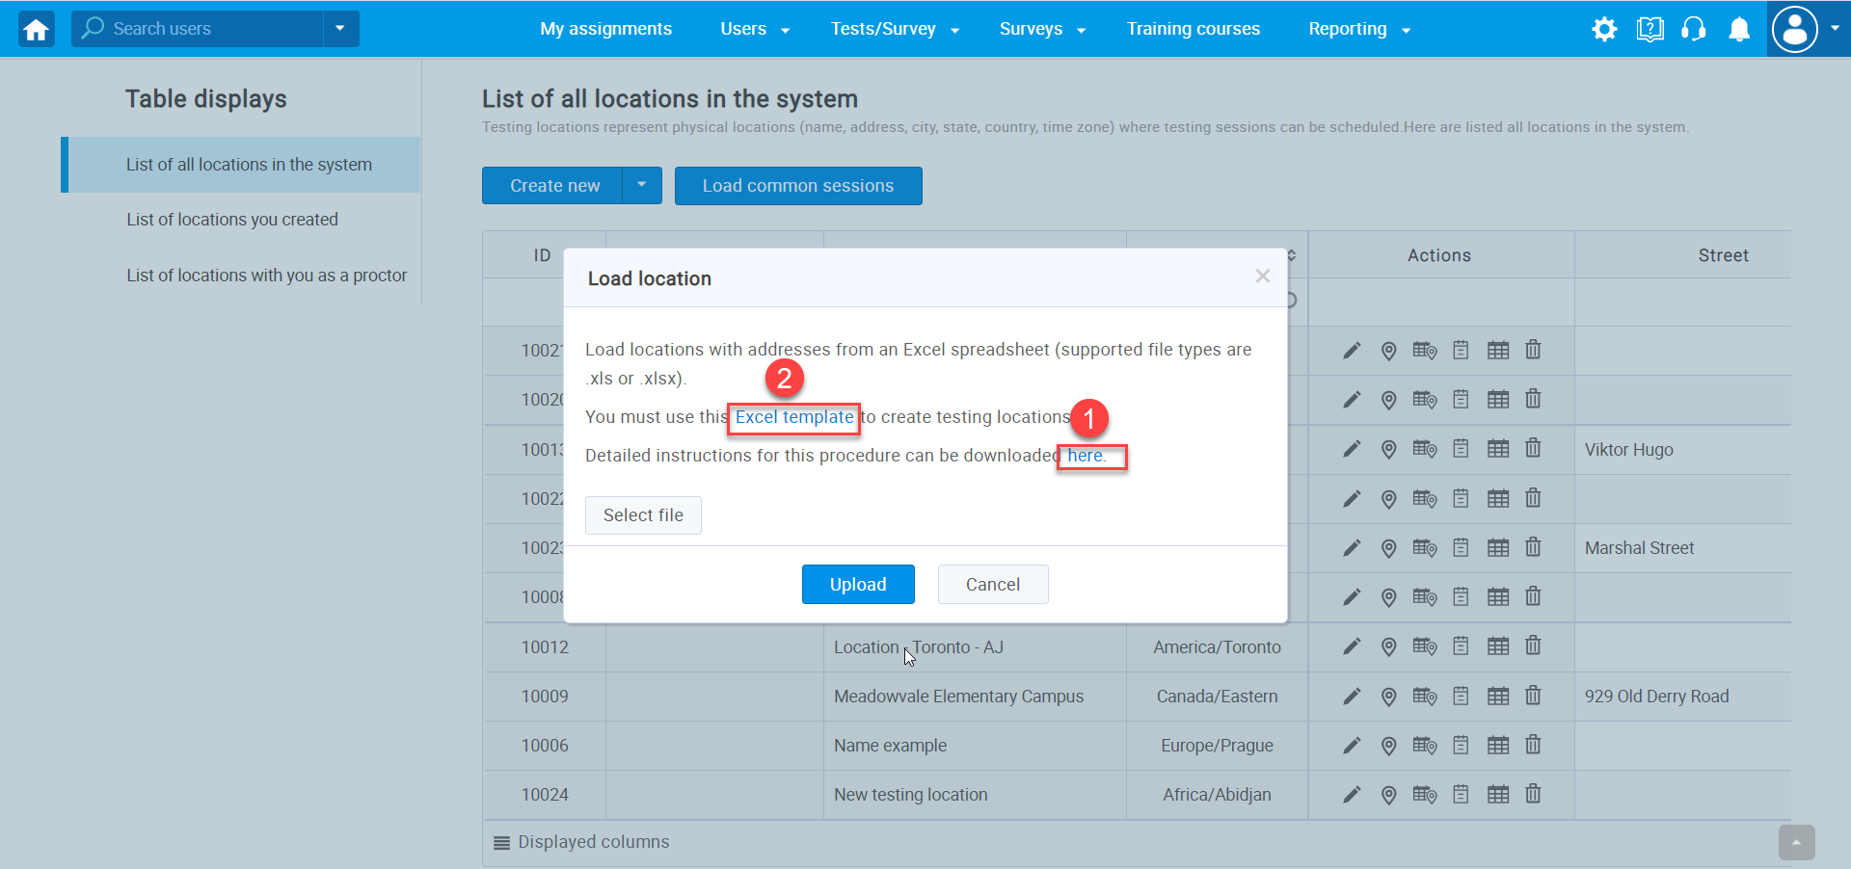

Process of importing location through the Excel template
To fulfill and save Excel template follow next steps:
1. Fill the template - only two fields are obligatory: Location name and Time zone.
2. Save the file.
3. Click on the “Select file” button and choose the file.
4. Click the “Upload” button.
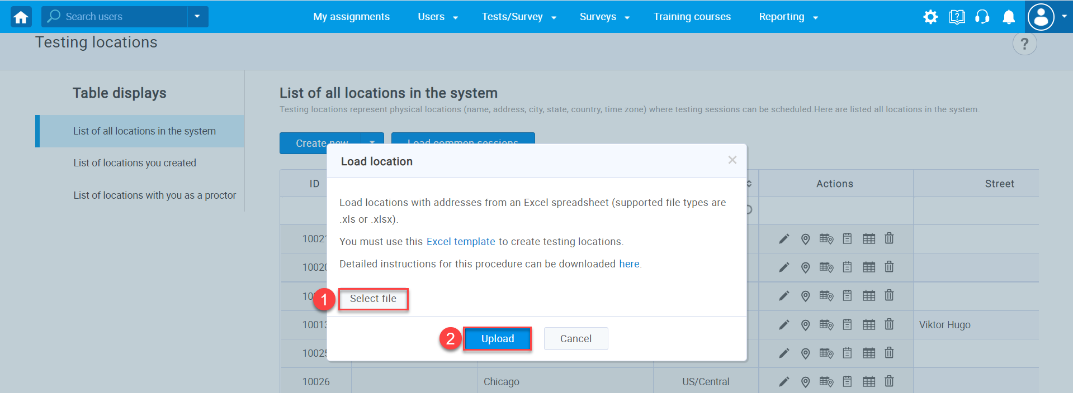
After the completion of the steps described above, all defined locations which are inserted and created in the YTM will be displayed in the list of all locations.
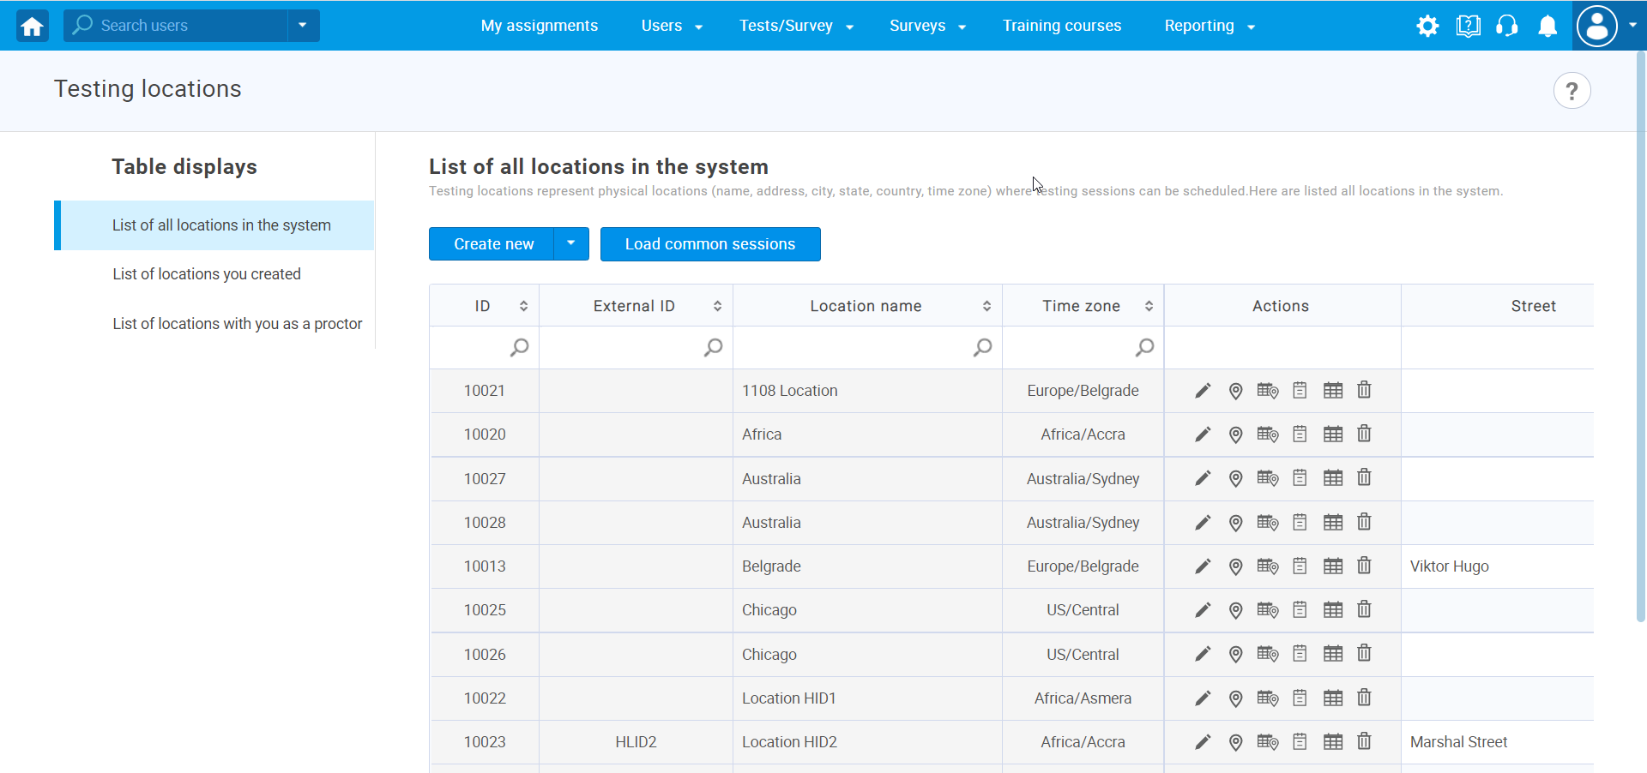

Process of assigning proctors to the loaded location
To assign proctor to the loaded location:
- Choose desired testing location
- Click on the first icon in the actions column
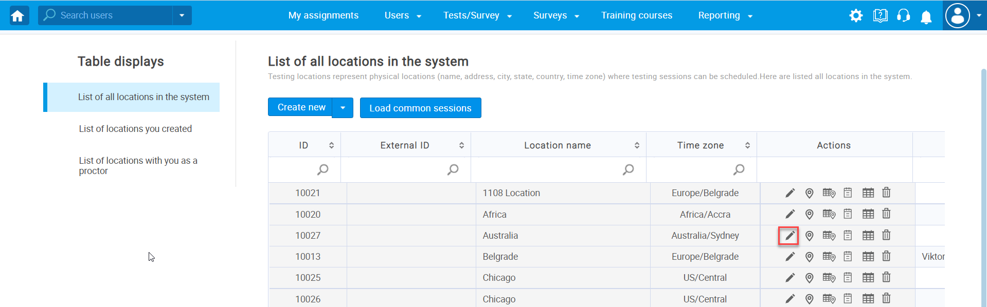
- The pop-up window “Edit test location” will appear after which you need the follow the steps below:
  - Enter the name of testing location
  - Enter the time zone of testin location
  - Enter the capcacity number
  - Click “Assign proctors” button
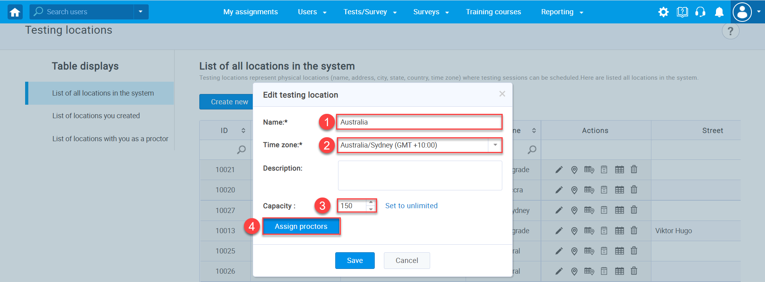
A list of all users will appear, and you should:
- Select the users you want to assigin as proctors
- Clic the “Confirm” and then then the “Save” button
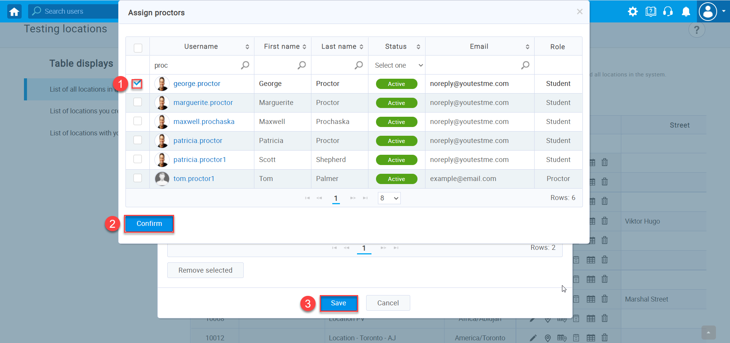
After you follow the steps from the "Paper Exam Venues Migration Guide" document, you will successfully complete the venues migration process via the excel template.

