YouTestMe

Guide on How to Create and Test Exams
Contents
1 Introduction 2
2 Steps 2
2.1 How to access the production instance 2
2.2 How to create exams 3
2.3 How to test exams 5
2.3.1 Method 5
2.3.2 Scenario 7
3 Important links 7

Introduction
This document represents a guide on how to create Pearson VUE, Online, and Paper exams and then how to perform testing on them.

Note: Before you start the migration process, make sure that the version of the production environment is appropriate!

Steps

How to access the production instance
To access the production instance, please go to ifse.youtestme.com and enter:
- Username.
- Password. (Once you receive the credentials, please make sure that you do not copy the blank space along with the password as you will not be able to log in.)
- Click the “Sign in” button to enter the platform.
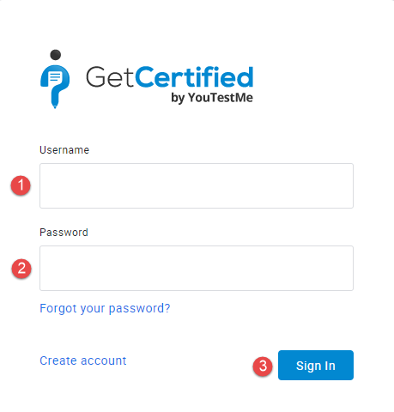
Note: To create exams, you need to log in with an account with the appropriate permissions.

How to create exams
- Create question pools. For detailed information, please follow the How to create, import and export question pools guide.
- Create exam. Hover over the “Tests” in the main menu, and select “New test”.
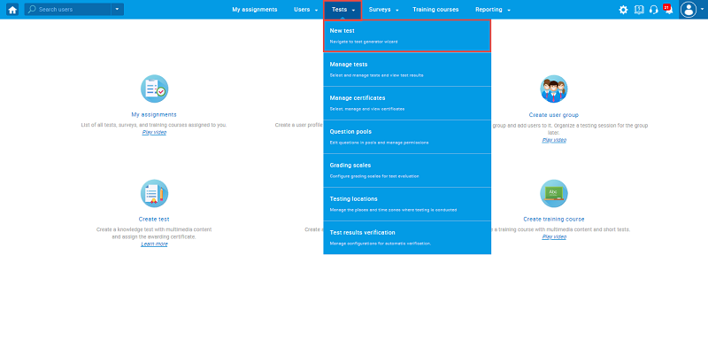

  - Set delivery preference to be “Paper-based” | “PearsonVue” | “Online” | “Proctoring”

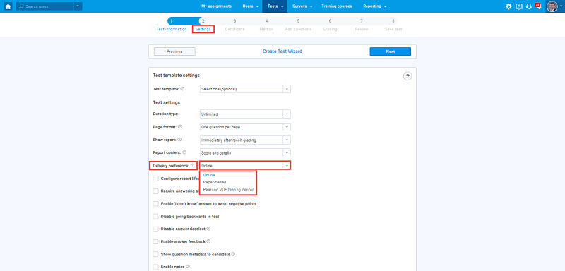

  - Include questions from question pools
    - “Paper-based” - Decide on the test creation methods:
      - For pre-printed exams: manually defined exam versions. For more information, please watch this video.
      - For newly created exams: static test generator (generate versions in advance). For more information, please watch this video.
      - Define unique names for each of your exam versions
    - PearsonVue
      - Create a blueprint – ad hoc generated method, specify the number of questions per question pool. For more information, please watch this video.
    - Online exam / Proctoring exam
      - Any creation method is possible – but probably will be “Ad hoc generated”
  - Define exam code (external ID). Navigate the “Tests“/”Manage Test“. Select the test for which you want to add an External ID. Navigate the “Settings” tab. Click on “External attributes” from the left-side menu. Enter External ID and click on the “Save” button.

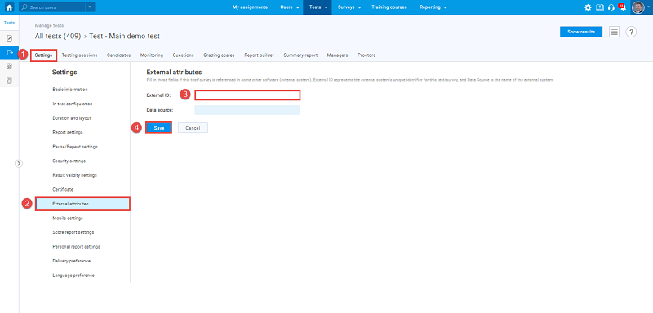

How to test exams

Method
Decide which method to use:
- Migrate from production to sandbox using the export test to JSON option. To export test using JSON option, for the desired exam, from the drop-down menu in the right upper corner, select the"Export to JSON" option.
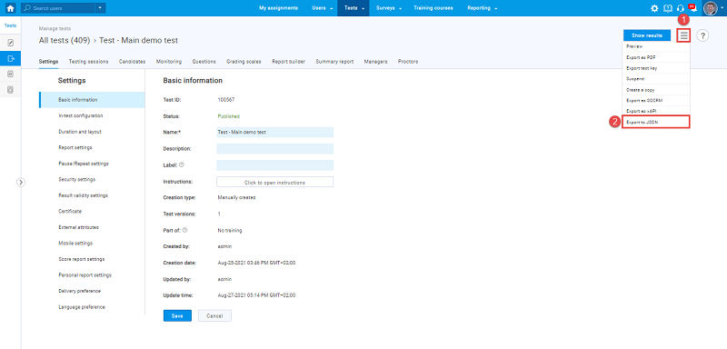
    - Must know:
      - Question pool references will be lost
      - An end-to-end test with Lambda is possible
      - Not supported for Ad-hoc generated blueprints (PearsonVue, Online with ad-hoc)
- Create an exam on sandbox and test it there.
    - Must know:
      - Cannot be moved to production (question pool references will be lost, and the possibility of moving corrupted data is too big)
      - An end-to-end test with Lambda is possible
      - Have to manually re-create the same exam on production (no automated validation possibility)
- Create an exam on production and test it there.
    - Must know:
      - Production usage before the go-live date and accidental changes
      - YTM can swipe all testing data (user results, for example, from production)
      - Cannot perform End-to-End testing with Lambda (if Lambda don’t create another environment)
      - Use preview test option – It allows a test manager to take the dummy attempt and check the exam settings.
- Test on the production copy
    - Must know:
      - Production copy environment currently does not exists
      - Cannot perform End-to-End testing with Lambda (if Lambda don’t create another environment)
    - Process of DB copying:
      - Create exam on production
      - Notify YTM that the exam is created
      - YTM can copy the entire DB to a new URL
      - Certify that test is ok on the new URL

Scenario
- Test exams - minimal scenario:
- Paper-based
- Assign sample users to take the exam
- Create common session
- Export common session
- Find this user on a signing sheet and other CSR packages
- Find exam PDF – make sure the questions are in the same order on paper and application in the respective exam versions
- Fill in the bubble sheet
- Produce file from Remark
- Import single report file
- Check if the user report is populated
- PearsonVue
    - How to create an exam for PearsonVue integration
    - How to import PearsonVue test results
    - How to export the PearsonVue files with simulated test results and import PearsonVue test results with exported files
- Online Exam
- Proctored Exam
- Test exam – end-to-end
  - Organize exam booking in Lambda
  - Test exam – minimal scenario
  - Import results
    - Online – no need for importing
    - PearsonVue – import via SFTP
    - Paper-Based – shared folder for picking up reports
- Notify YTM:
  - The exam is good – swipe up unnecessary test data from production (if tested on production), do a backup
  - The exam is not good – ytm CSR can help with advice on how to fix it
  - The exam is not good, and data is corrupted – revert to the previous backup state

Important links
Additional instructional materials can be found at the IFSE Help Center in the following tables:
- Tests
- Pearson VUE exams
- Hold and release grades for Pearson VUE

