

YouTestMe

IFSE – Exam Code Mappings

Contents

1 Introduction 2

2 Migration 2

2.1 Task list 2

2.2 Import of paper exam bookings in YouTestMe 3

2.2.1 Solution 1 – YTM finds the exam session and creates the attempt 4

2.2.2 Solution 2 – Lambda finds the exam session and creates the attempt 4

2.3 Migration process 4

2.4 Open issues/questions 5

# Glossary

|  |  |  |  |  |
| --- | --- | --- | --- | --- |
|  | IFSE Term | YTM Term | Screenshot |  |
|  | Exam code | **Test.external_id** |  |  |
|  | ? | Test.**test_version.version_name** |  |  |
|  | / | Test.auto_generated_id |  |  |
|  | / | Test.test_version.auto_generated_id |  |  |
|  |  |  |  |  |

## YTM Structure

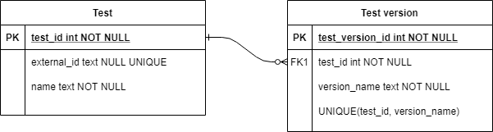

# Export package samples

<https://owncloud.youtestme.com/owncloud/s/eZYPSrT4p4Dezbv>

# Examples

## Example 1

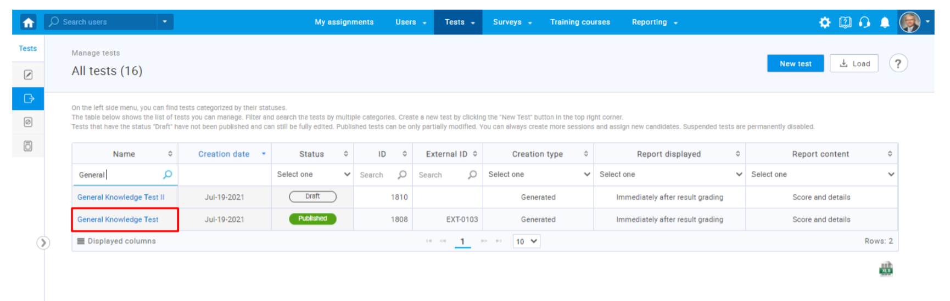

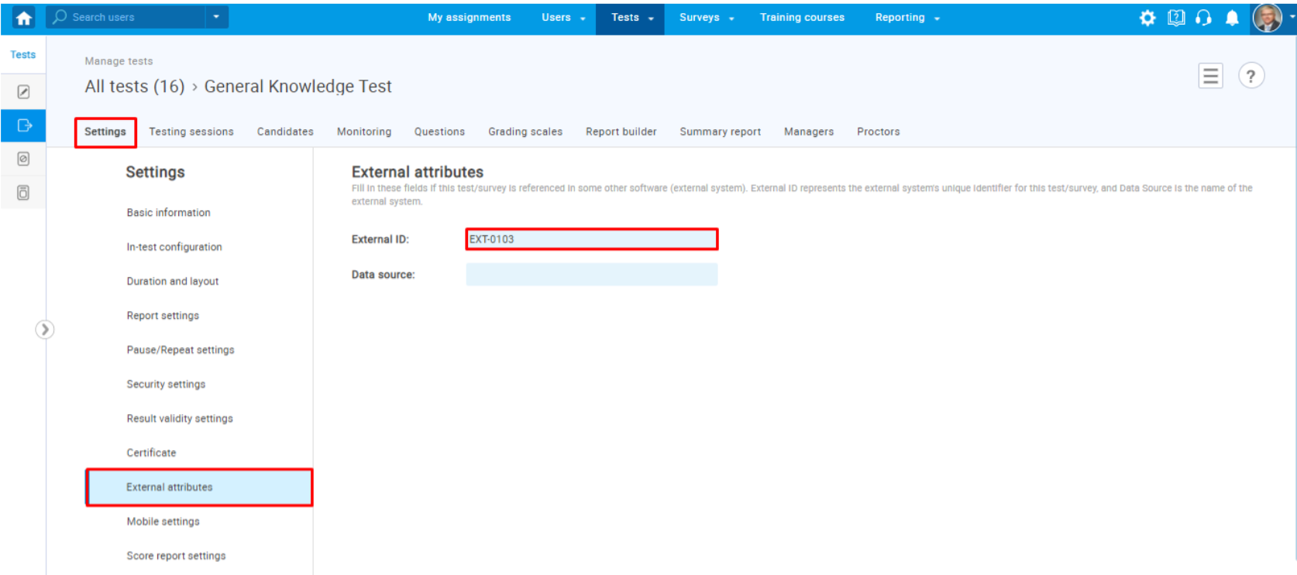

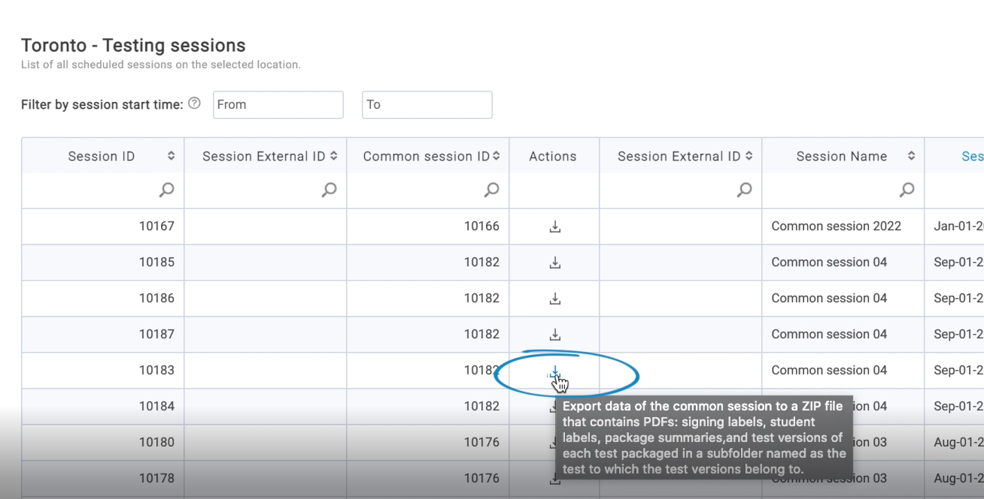

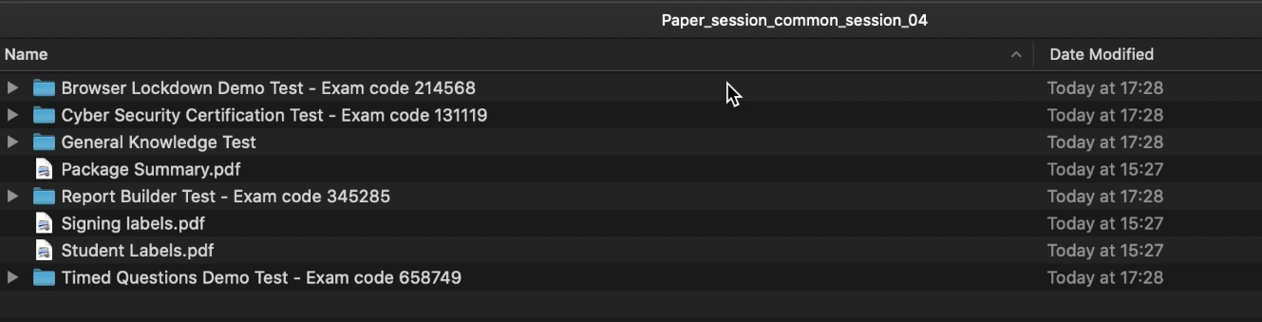

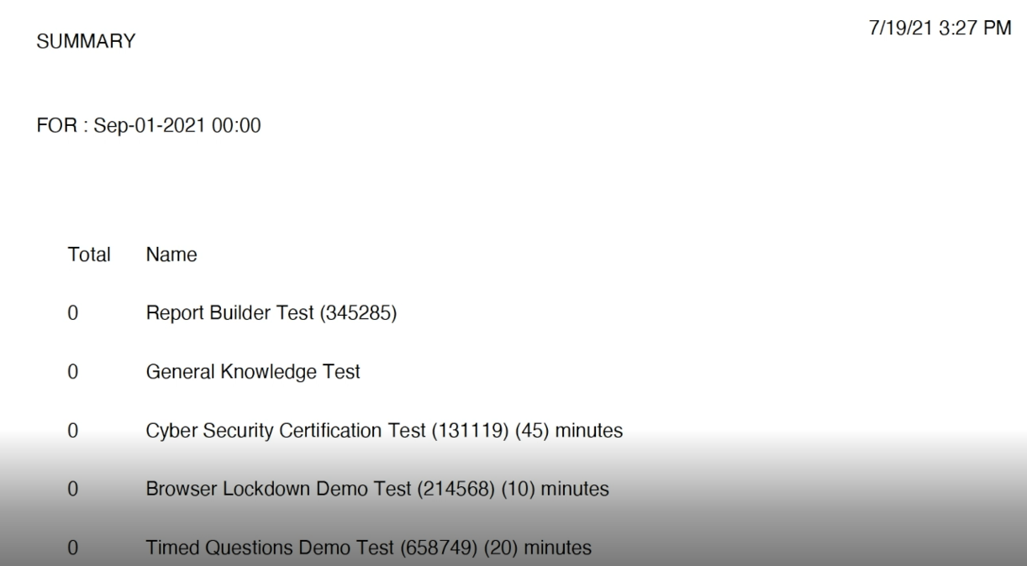

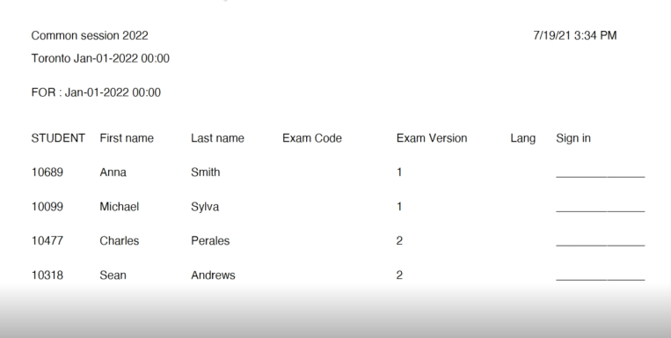

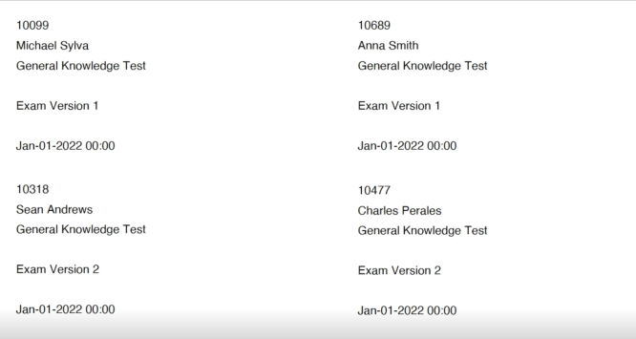

## Example 2

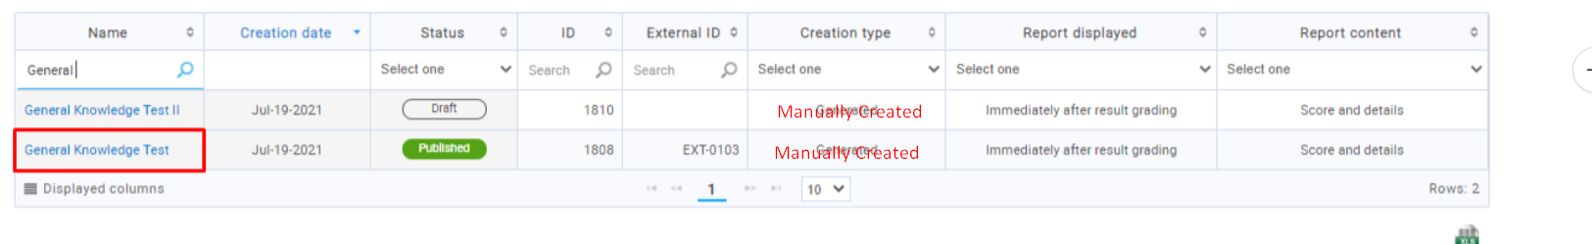

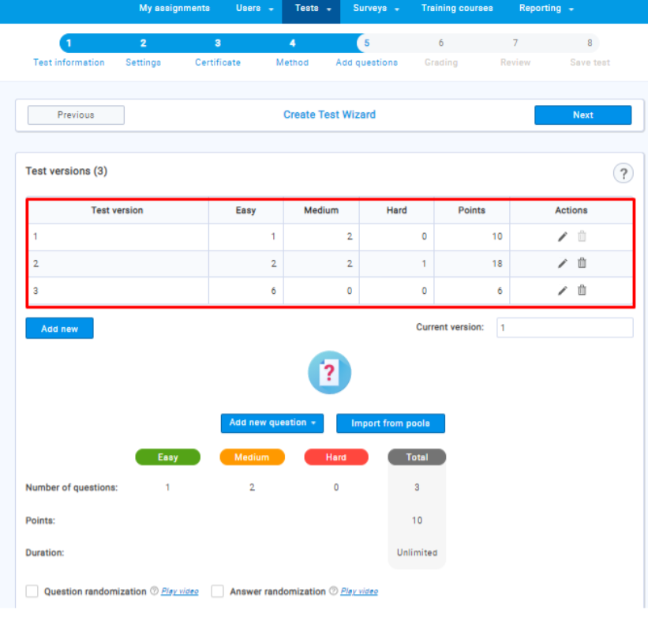

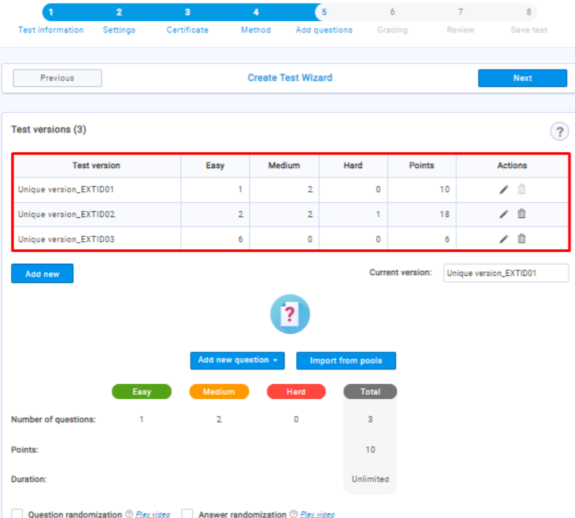

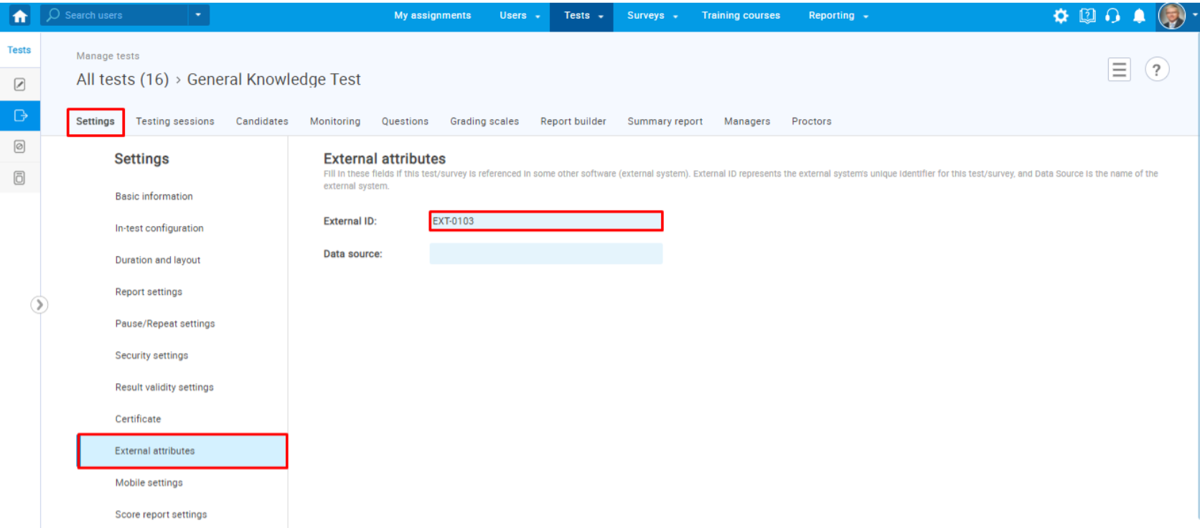

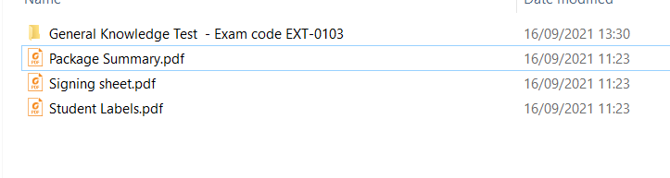

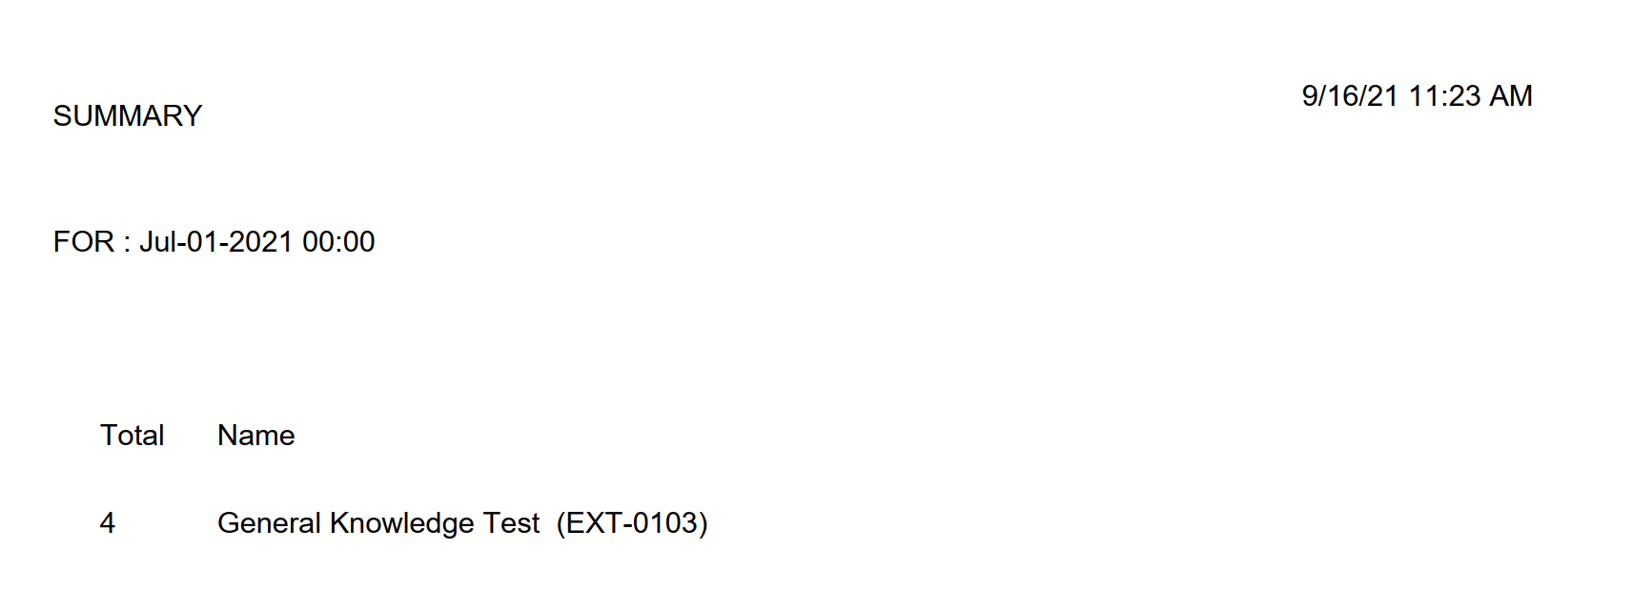

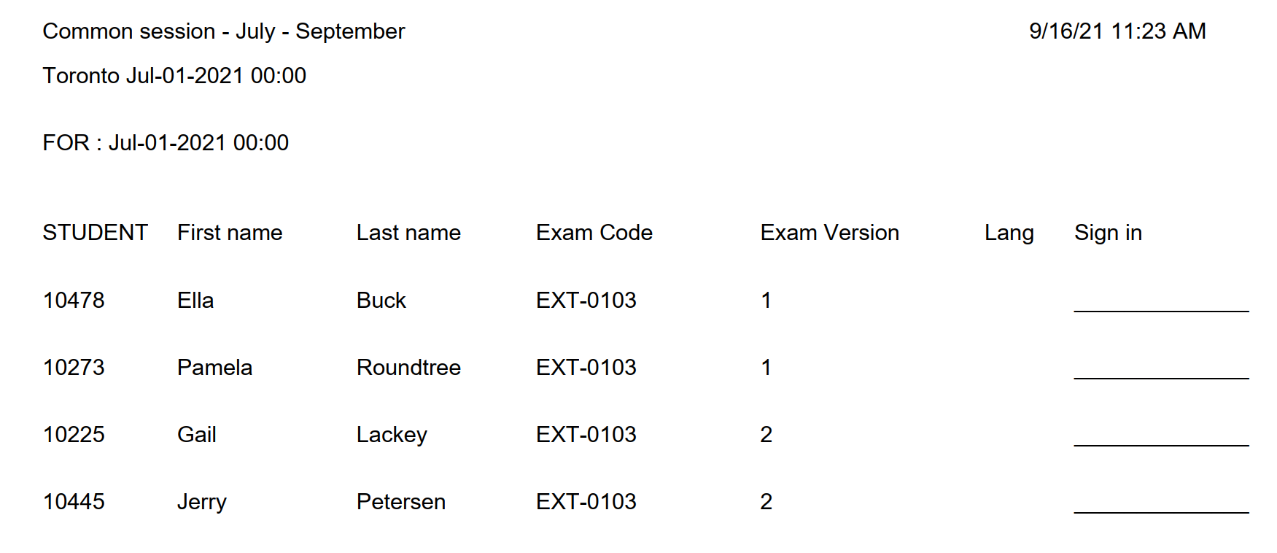

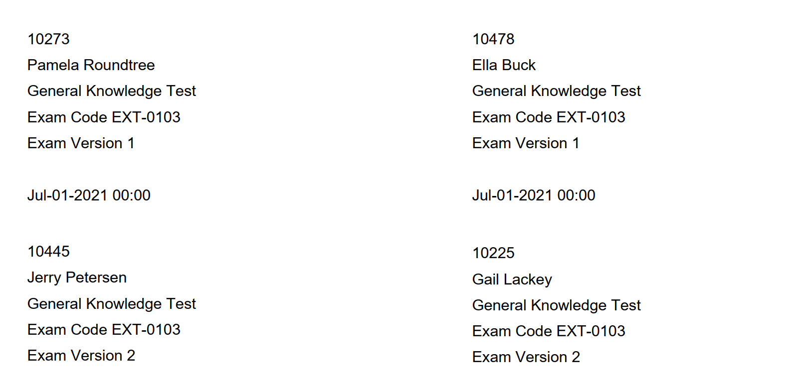

## Example 3

