YouTestMe

Special Accommodations Notifications

Contents
1 Introduction 2
2 Special accommodations workflow 3
2.1 CSR adds special accommodation 3
2.2 Proctor approves added special accommodation 3
2.3 CSR removes special accommodation 5
3 Editing default special accommodation notifications 6

Introduction
Special accommodations notifications provide that the Proctor is informed each time a CSR adds/removes special accommodation for a particular student on a particular test.
There are types of notifications related to the special accommodations feature:
- Accommodation request
- Accommodation request response
- Accommodation removed
This document explains all three types of notifications and how they can be edited.

Special accommodations workflow

CSR adds special accommodation
CSR will add special accommodation to the student. For more information on how to do that, please watch this video.

Once the CSR role adds special accommodation to the student, the system will send the "Accommodation request" notification to the Proctor:
Application:
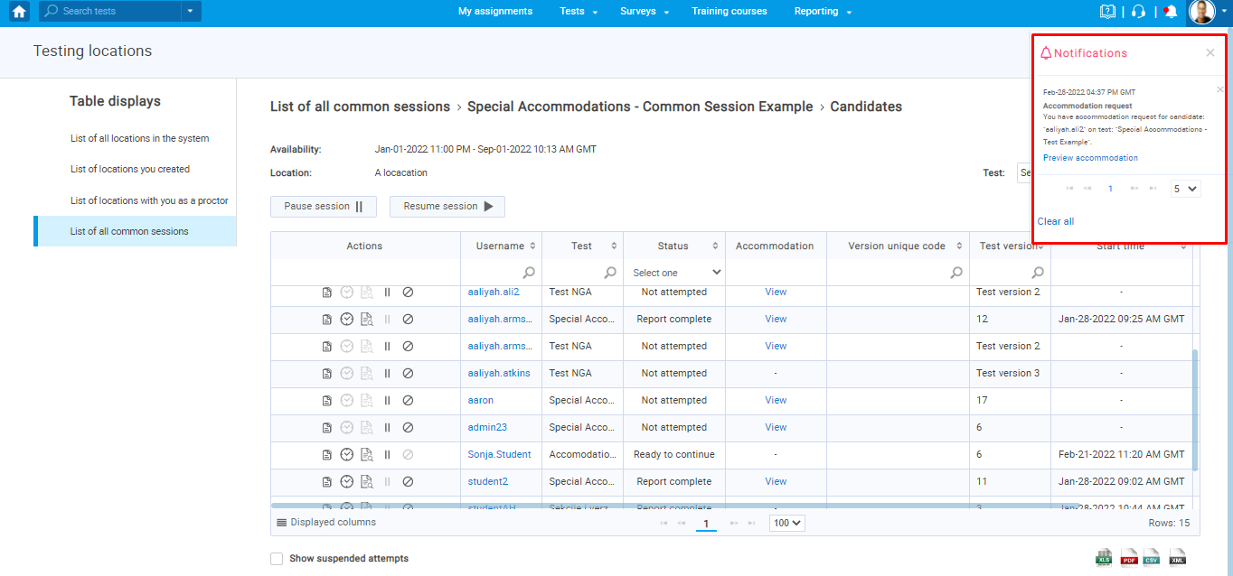
Email:
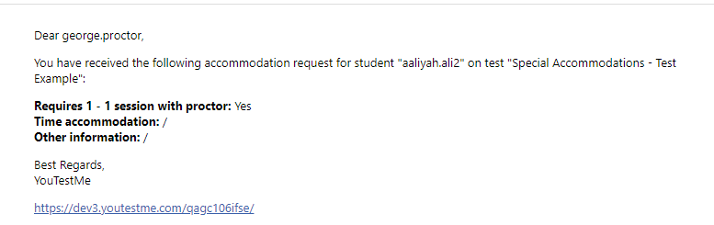

Proctor approves added special accommodation
The status of accommodation added by CSR is "Pending". After receiving the notification, the Proctor will change the accommodation status to "Approved", insert a comment, and confirm it by clicking on the "Respond" button.
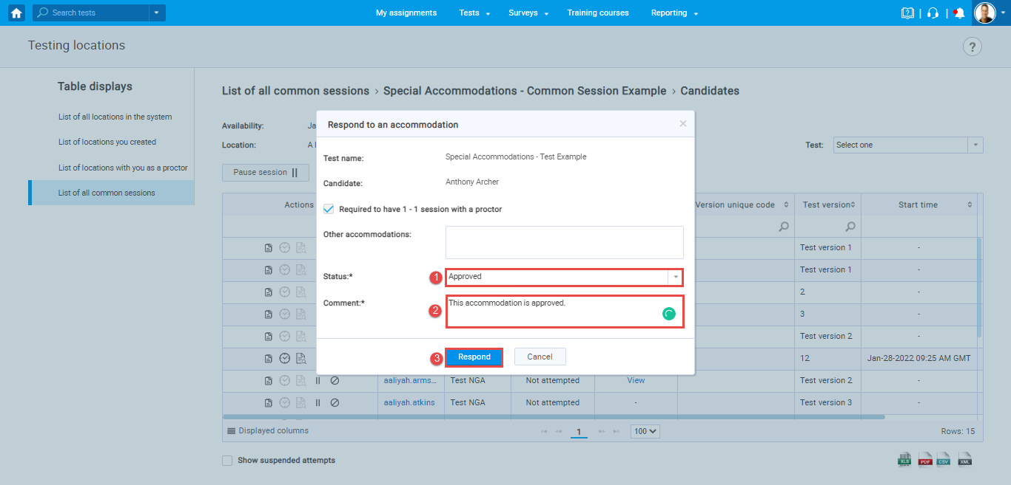
Notification that CSR will receive when the Proctor approves accommodation:
Application:
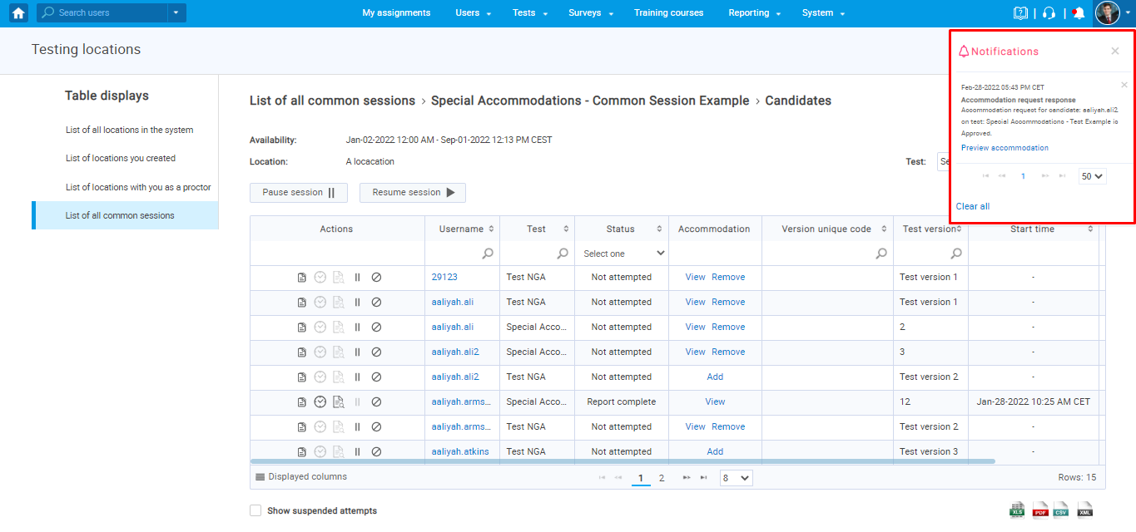

Email:
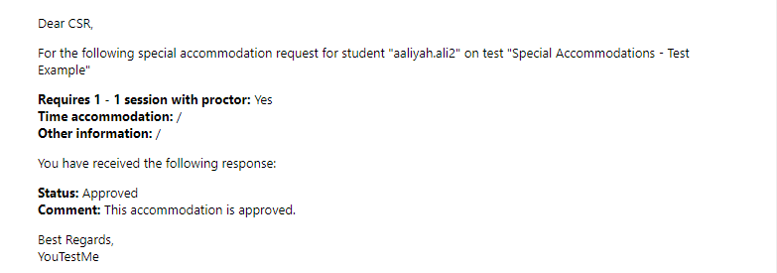

CSR removes special accommodation
If CSR removes previously added accommodation, the Proctor will receive the following notification:
Application:
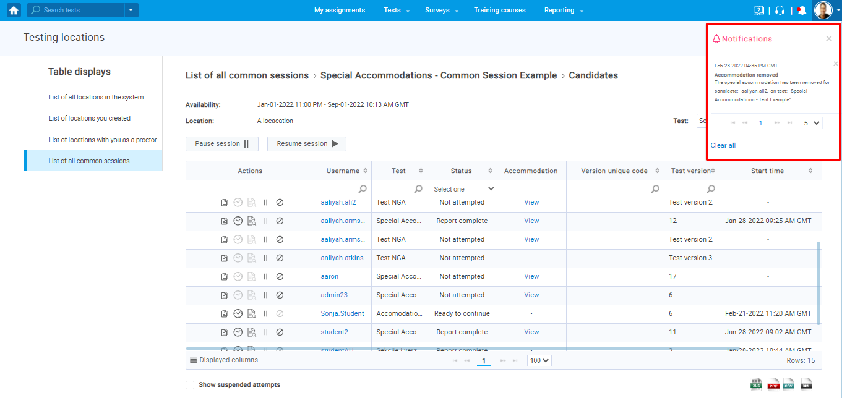
Email:
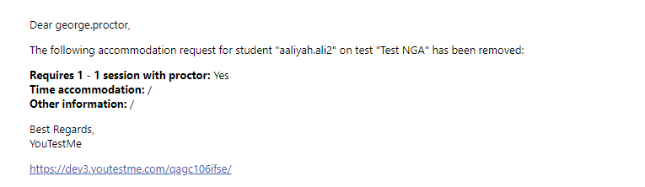

Editing default special accommodation notifications
To edit the content of notifications, navigate to “System” and select “Settings and customization“.
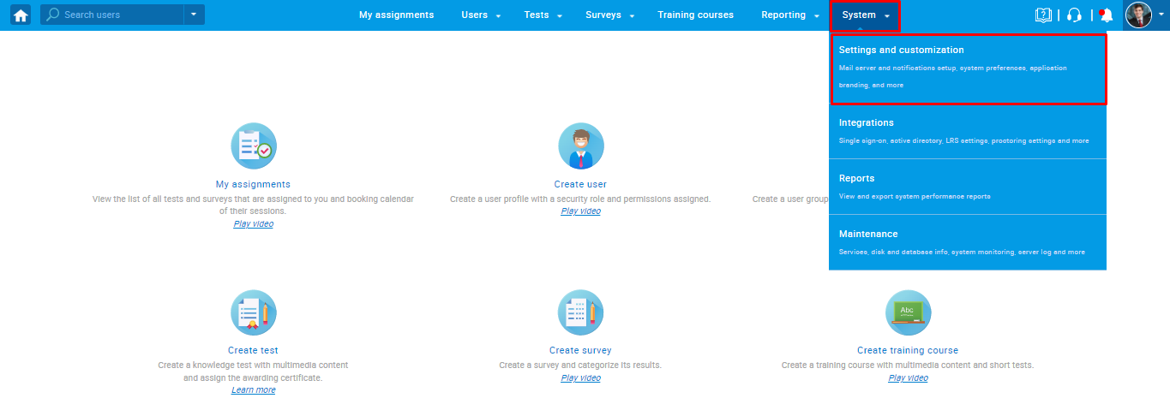
Navigate to the “Notifications” tab, where you can see a list of all notifications, including notifications related to the special accommodation feature:
- Accommodation removed
- Accommodation request
- Accommodation request response
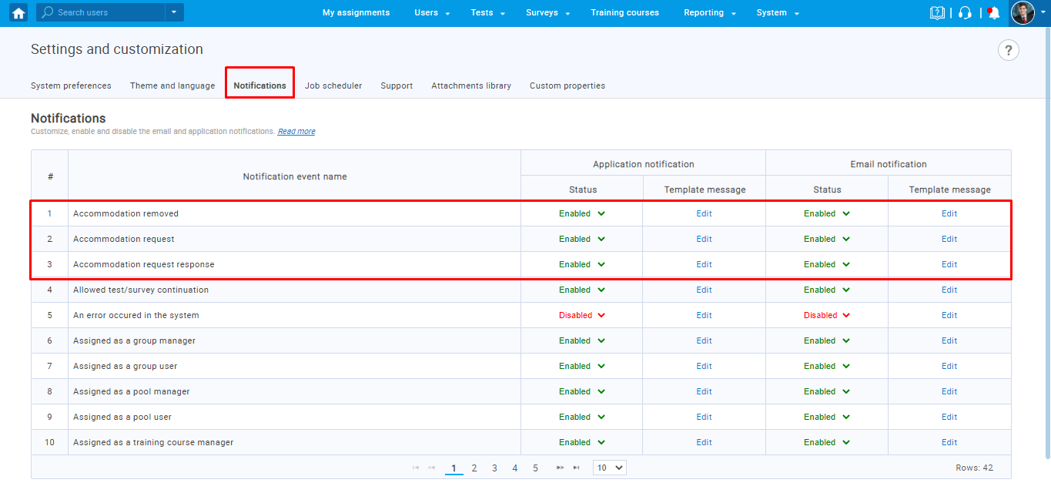

To edit the notification displayed in the application, click “Edit” in the “Application notifications” column.
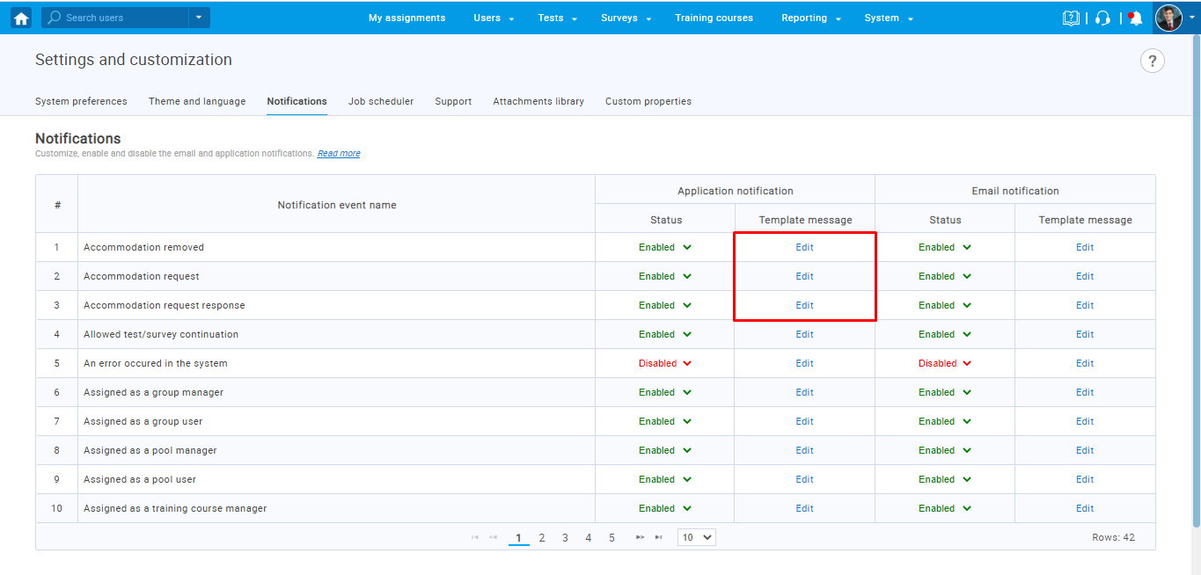
The "Edit application notification template" dialog will appear, where you can enter desired content of the notification using the list of available variables. Once you change the notification, click on the "Save" button.
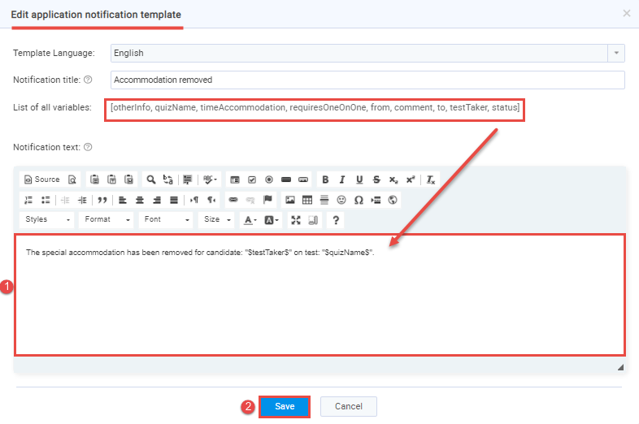

To edit the notification received via email, click “Edit” in the “Email notifications” column.
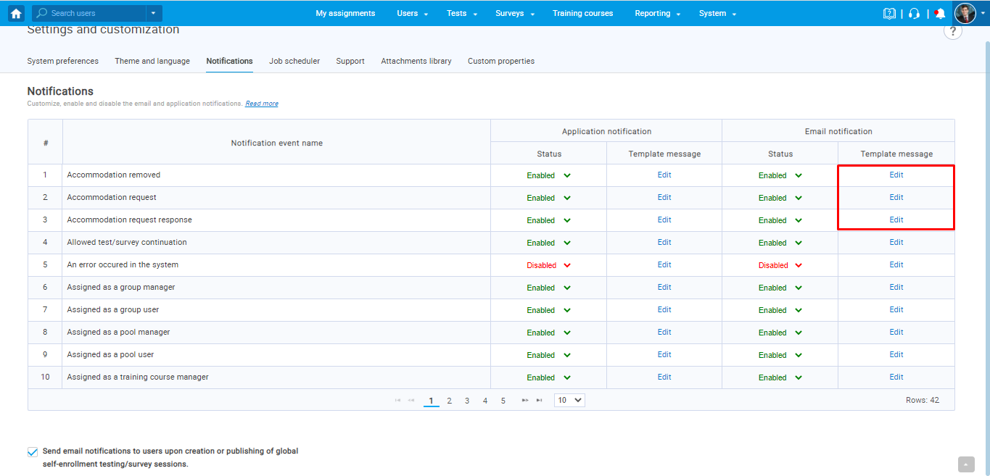
The "Edit email template" dialog will appear, where you can enter desired content of the notification using the list of available variables. Once you change the notification, click on the "Save" button.
