YouTestMe

How to reassign attempt in the private session Guide

Contents
1 Introduction 2
2 Private Individual Session versus Private Common Session 3
2.1 Assigning the student's attempt in the private INDIVIDUAL session 3
2.2 Assigning the student's attempt in the private COMMON session 3
2.2.1 Creating private common session 3
2.2.2 Assigning the student’s attempt into previously created private common session 5

Introduction
When the student account is created on the IFSE system, authorization is sent to YTM.

The conditions that must be met for the student's results to be sent back to the IFSE system are:
- The student's attempt is connected to the authorization
- The student finishes the exam
- The student's results are verified

For the student's attempt to be connected to the authorization, one of the following two actions needs to be performed:
- The student books the exam into the public session.
- The account with CSR role reassigns the student's attempt in the private session using authorization sent to YTM when the student account is created.

This document represents a guide on reassigning attempts in the private session.

Private Individual Session versus Private Common Session
Assigning the student's attempt in the private session using authorization sent to YTM when the student account is created needs to be performed when you do not want to allow the student to choose which session to book the exam.
You can assign the student's attempt into private common or private individual session:
- Assigning the student's attempt in the private INDIVIDUAL session is RECOMMENDED when all students registered for that session take the same exam (example - 1 on 1 session).
- Assigning the student's attempt in the private COMMON session is REQUIRED when students registered for that session take different exams.

Assigning the student's attempt in the private INDIVIDUAL session
Instructions on how to assign the student's attempt in the private individual session using authorization sent to YTM when the student account is created can be found in this video.

Assigning the student's attempt in the private COMMON session

Creating private common session
To create a private common session, navigate to “Tests” in the main menu, and select “Testing locations”.
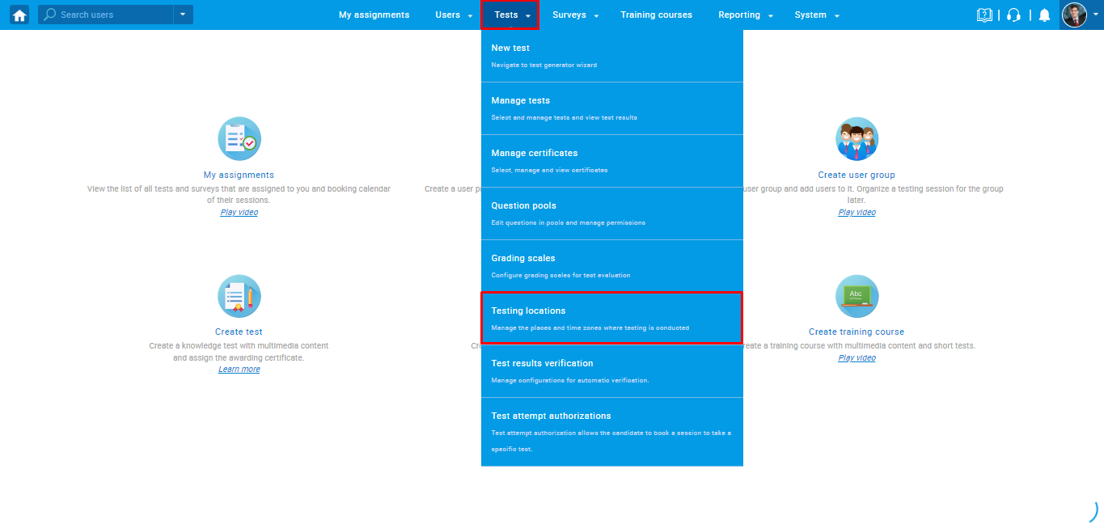

For the desired location, you should click on the third icon on the "Actions" column.
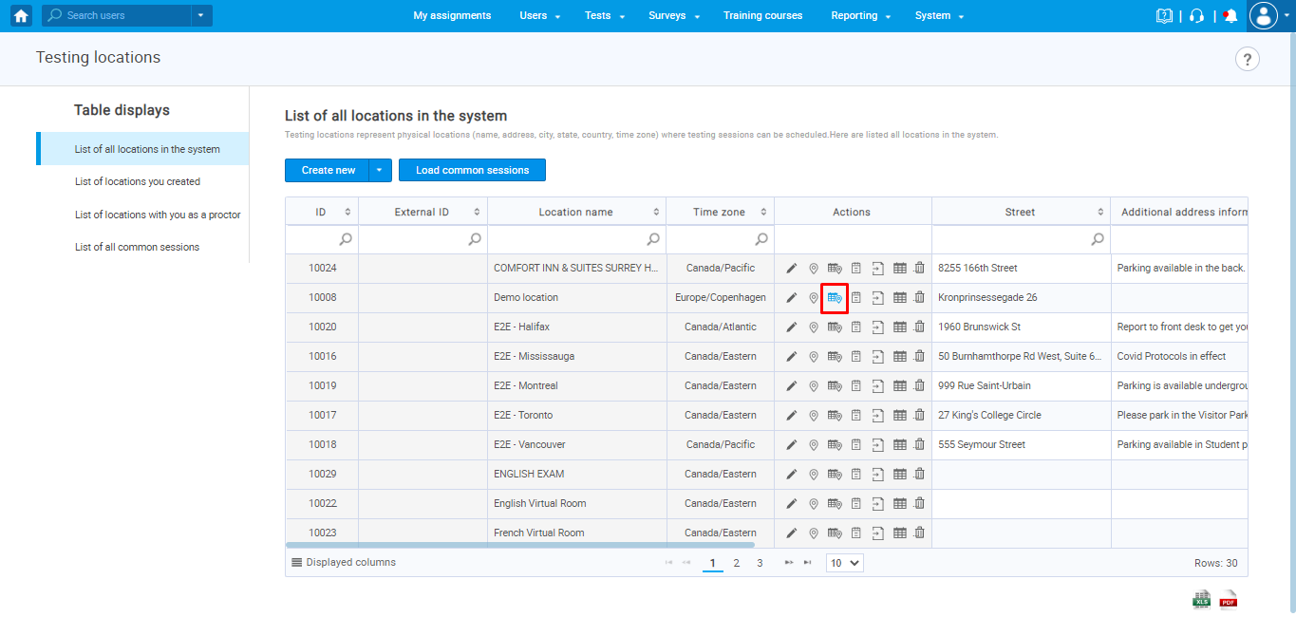
The pop-up window will appear to enter the following information about the private common session you are creating:
- Session name - Enter desired name of the private common session you creating
- Choose room - An optional label for better defining physical or virtual location of the session
- Additional instructions - An optional label for adding additional instructions for the session.
- Delivery preference – Should be set to “Online live-proctored”.
- Availability - Select starting and ending time for this session. Define when the candidates will be able to take the assignment.
- Candidate self enrollment – This option must be disabled in order to be private.
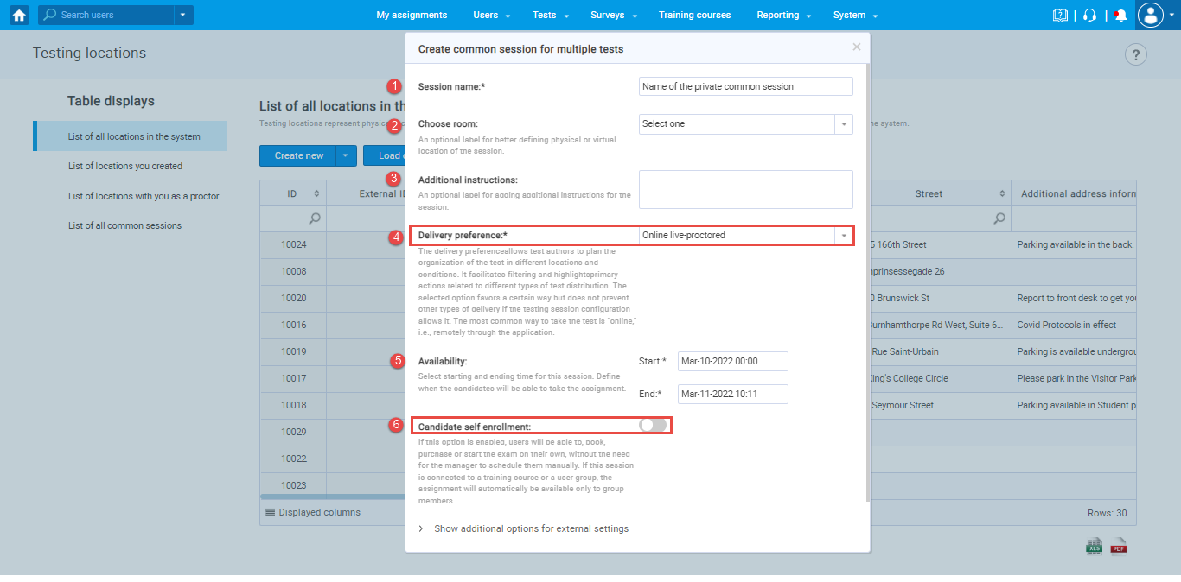

Note: When the self-enrollment option is disabled, the following advanced options are also disabled:
- Booking deadline
- Cancellation deadline
- Capacity
- Authorization required
Even though the "Authorization required" option is disabled, authorization will be connected to the attempt if you follow the steps explained in the chapter below.

Assigning the student’s attempt into previously created private common session
For the user with CSR role to assign the student’s attempt into previously created common session, navigate to “Tests” in the main menu, and select “Test attempt authorizations”.
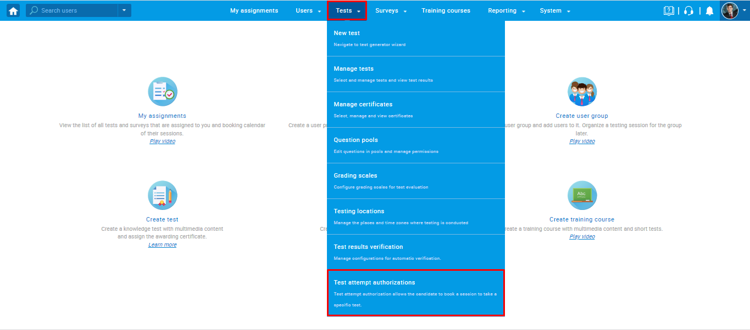
There are different statuses of the authorization:
- When the student purchases the course, authorization is sent to YTM with " Open " status.
- When the authorization connects to the attempt, the status is "Assigned" status.
- The authorization status can also be "Inactive" in case of its deletion.
Note: Only a student's attempt with authorization with the "Open" status, meaning that the student did not book the exam or his authorization is not deactivated, can be assigned to the previously created private session.

To assign an attempt into the private common session, you should click on the third icon in the "Action" column.
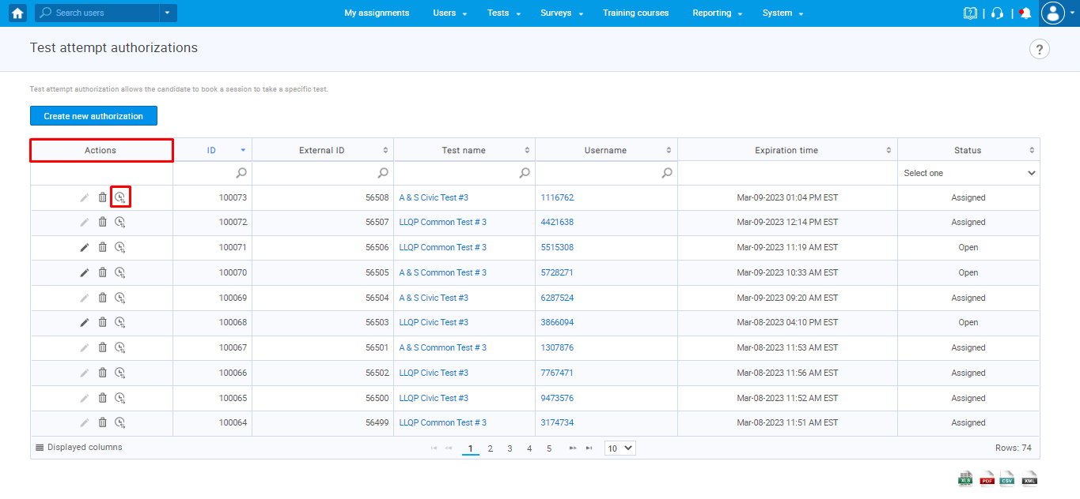
The "Assign attempt to the private testing session" dialog will appear with all previously created PRIVATE COMMON or INDIVIDUAL sessions, where you should:
- Check the checkbox
- Click on the confirm button
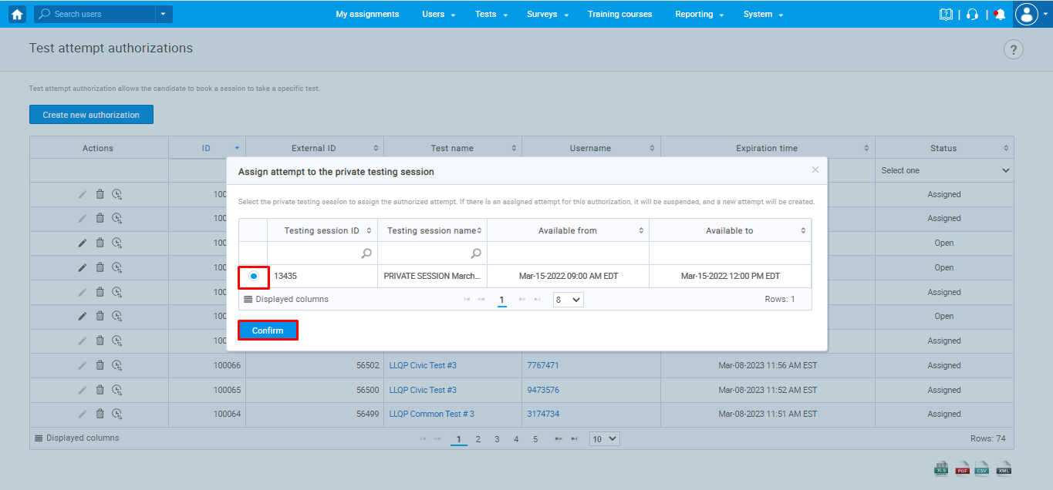
Note: To make sure that the authorization is connected to the attempt, you need to check the following:
- Authorization status is "Assigned".
- The candidate is added to private common session - navigate to the Tests -> Testing locations -> List of all common sessions -> Click on the name of the created private common session -> Candidates

