YouTestMe

Assigning students (authorizations preserved) into a private testing session

Contents
1 Introduction 2
2 Creating private testing session 3
3 Assigning students into a private testing session 5
4 Checking the authorization 7

Introduction
This document explains how IFSE CSR can assign multiple college students to a desired private testing session with preserving their authorization, where the following pre-conditions must be met:
- Once the college student profile is sent from the IFSE to the YTM system, they will automatically become members of the corresponding user group.
- Each user group represents a college.

Creating individual private testing session
Navigate "Tests" in the main menu and choose "Manage tests".
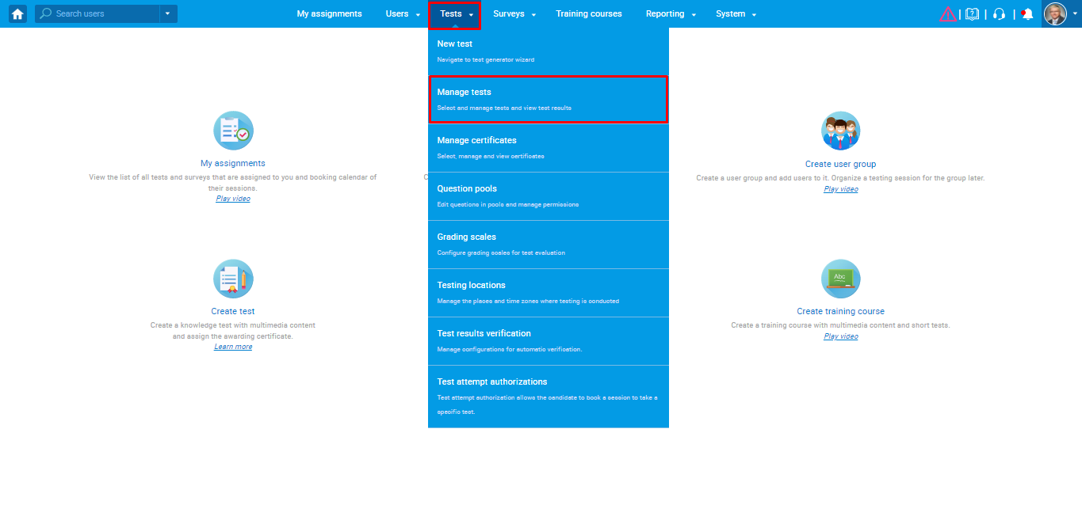
Use the search box to find the test for which you want to create a private testing session, and click on the name of the test to open it.
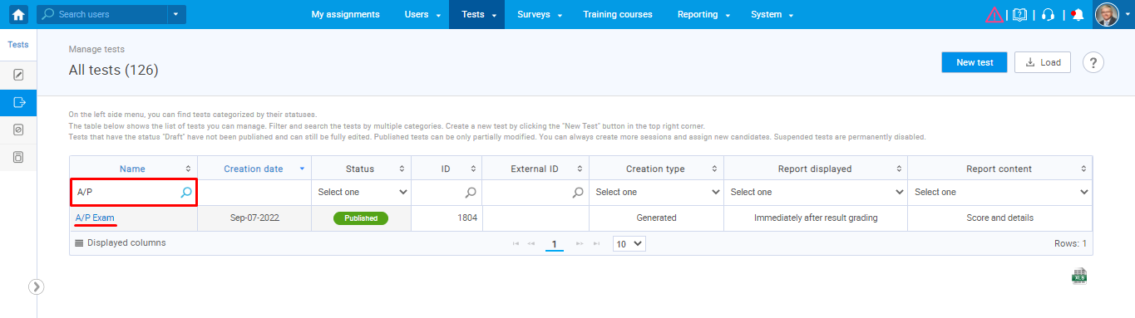
Click on the "Testing session" button on the "New testing session" tab. The pop-up window will appear where you need to enter information about the private testing session you are creating.
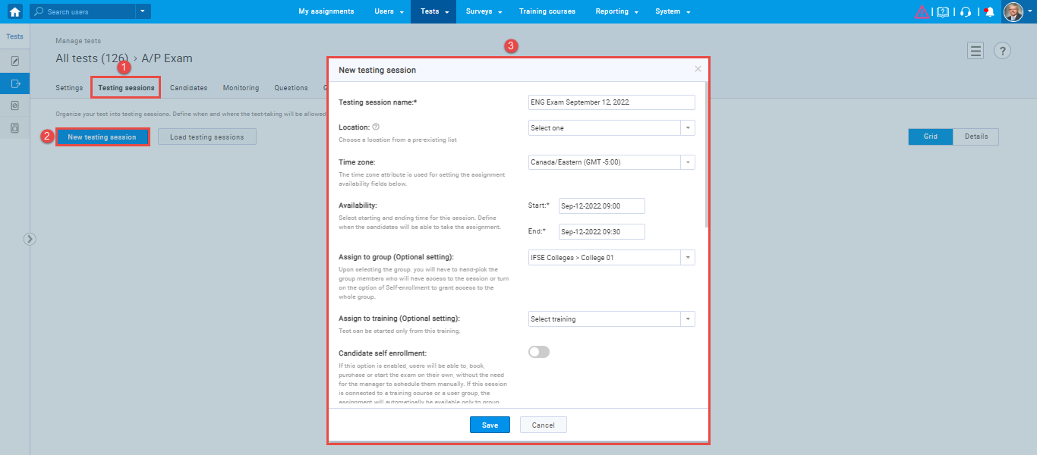
To achieve the desired scenario, the following fields must be configured in the following way:
- Assign to group – Once you assign the user group to the testing session, only its members can assign to it.
- Authorization required – This option should be enabled, and only users with the corresponding authorizations can be assigned to the testing session.
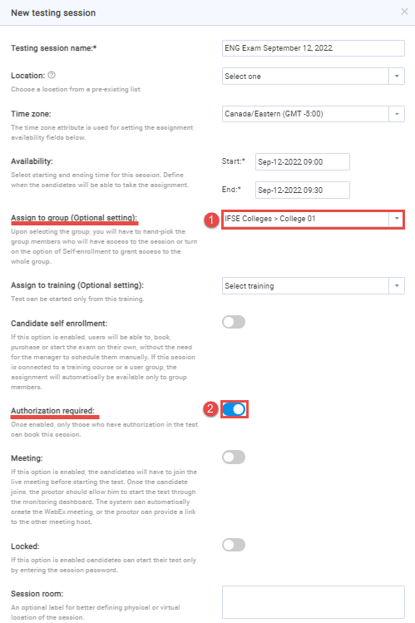
- Set additional instructions template – Select one of the previously created message templates. For more information, please read this article.
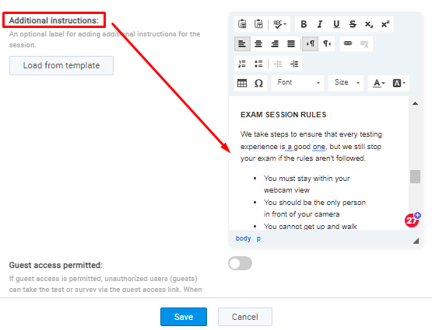
Note: The template that will be set by default is template for private sessions (self-enrollment option disabled). Language of the message will correspond the language that is set in the “Language preference” of that specific test.
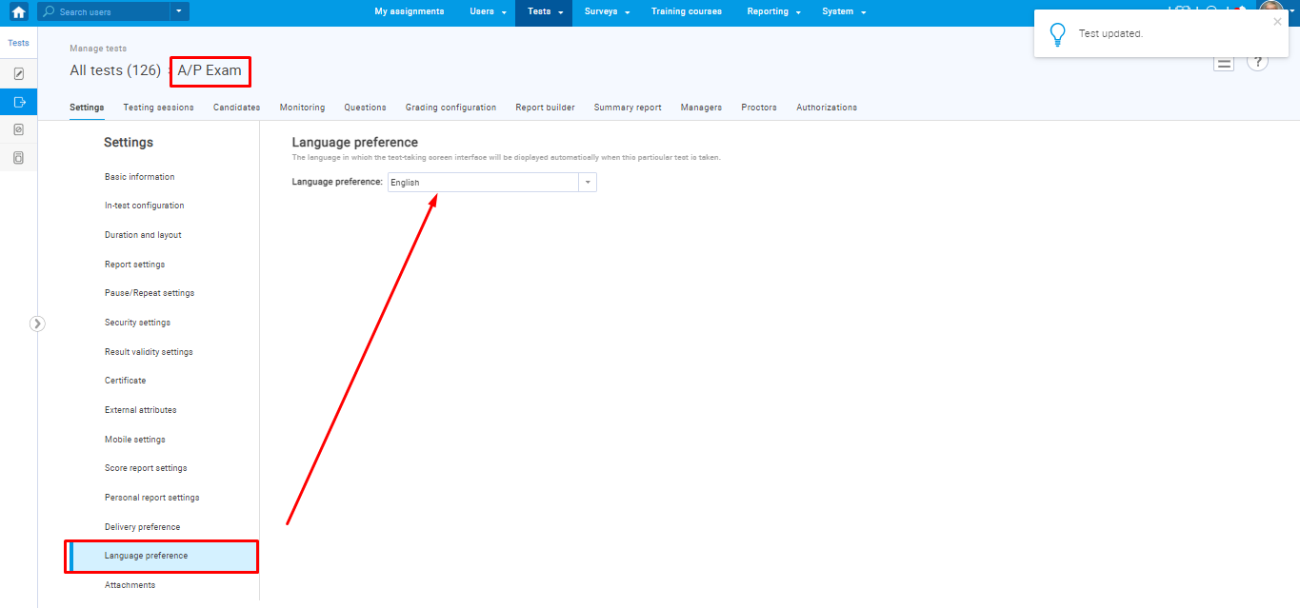

To change the default message template, click on the "Load from template" button and select the desired template and language on which the message should be presented.
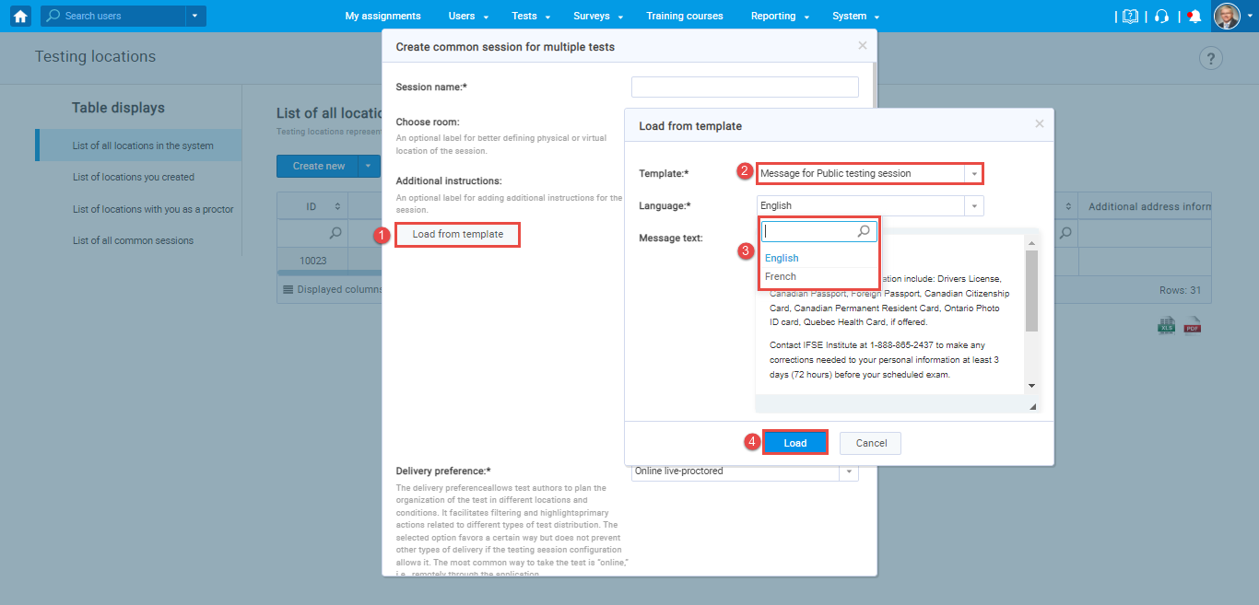

Assigning students into a private testing session
To assign college students to previously created a private testing session, you should follow the next steps:
- Click on the "Add" button.
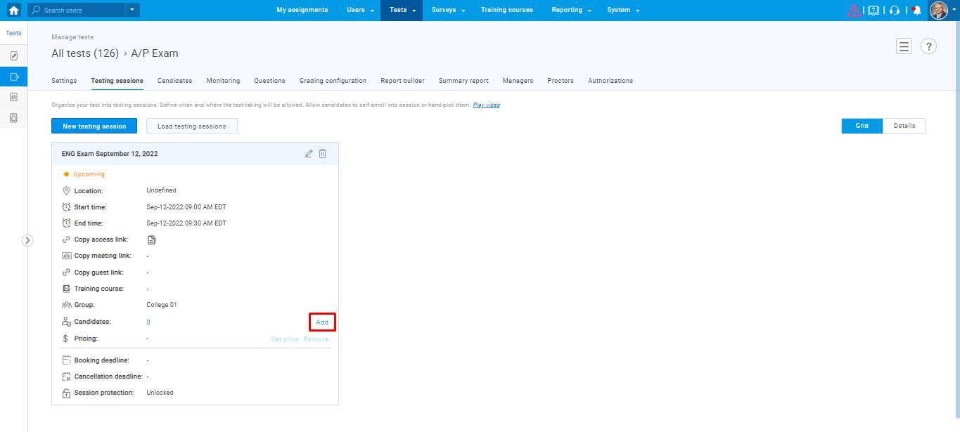
A list of members from the assigned user group with valid authorization will be shown.
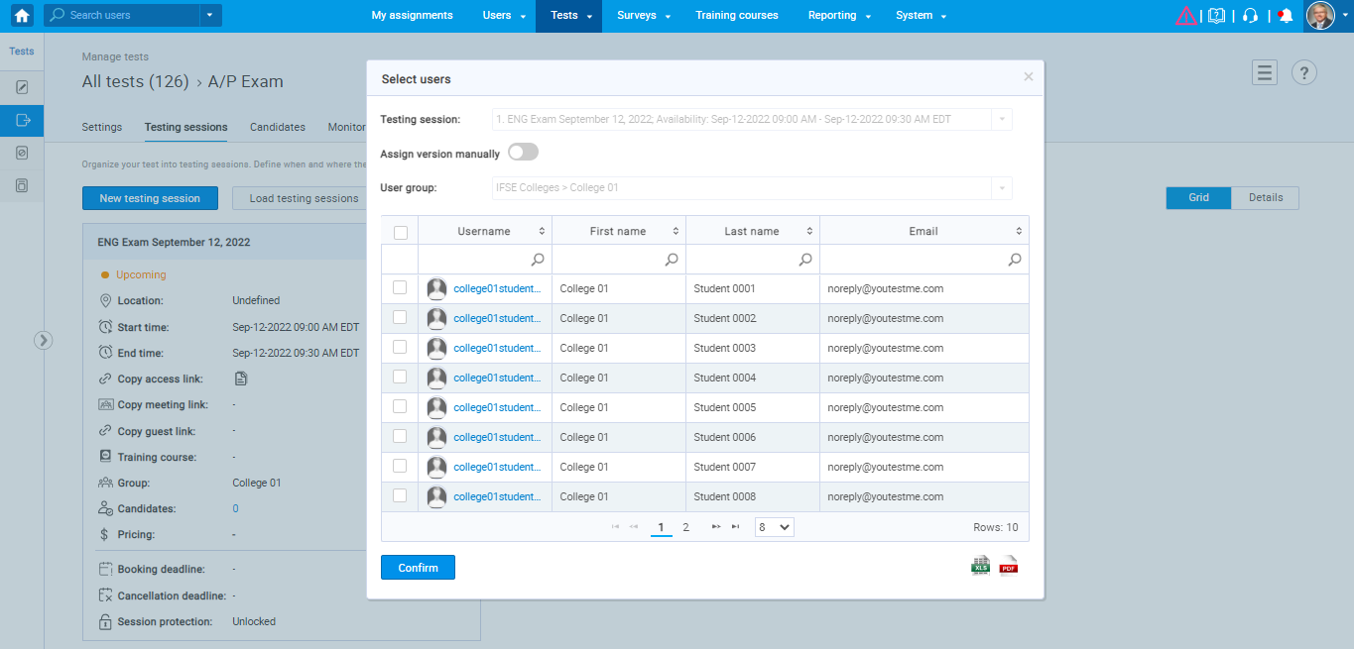
- Select the desired users you want to assign to this testing session by checking the checkbox. After selecting, click on the "Confirm" button.
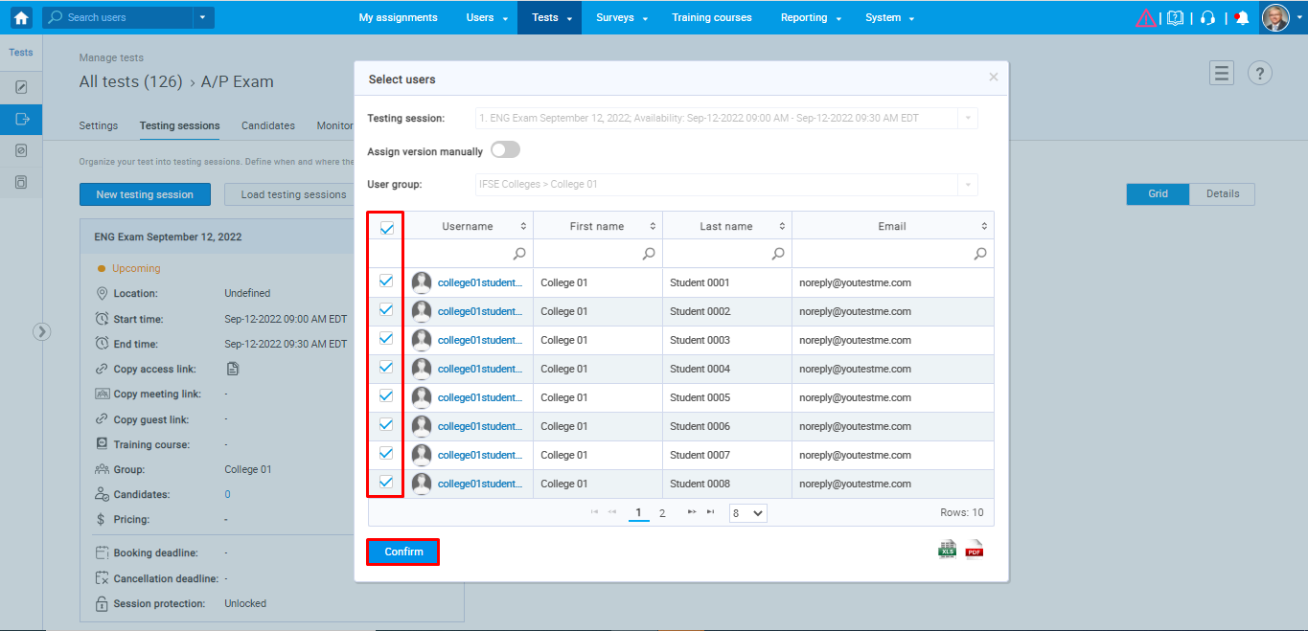
Note: Since the session is non-self-enrollment, there is no automatic way to limit the capacity to 16 users. Therefore, IFSE CSR should add only 16 users to each testing session.
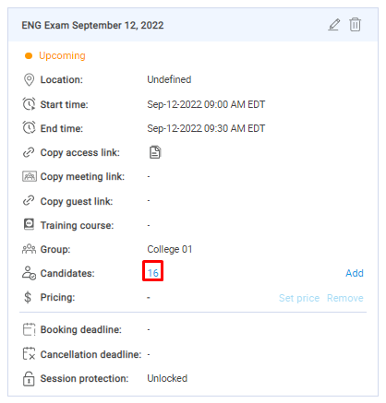

Checking the authorization
Once the users are added to the private testing session, their authorization should be preserved, i.e., connected to their attempt.
You can perform the check by navigating the "Authorization" tab on the student's profile.
