YouTestMe

How to configure message templates

Contents
1 Introduction 2
2 Creating message templates 3
2.1 Adding the "Private testing session - session instructions" template 4
2.2 Adding the "Public testing session - session instructions" template 11

Introduction
This document explains how to configure message templates through the system settings.
To achieve the desired scenario, you should create the following templates:
- Public testing session - session instructions
  - French version
  - English version
- Private testing session - session instructions
  - French version
  - English version
The purpose of message templates is to use them when creating a testing session. Depending on whether the session is individual private, or public and common and language in both cases, you should use the corresponding message template. Data from the set message will be passed to the students within email notifications they will receive (when IFSE CSR book them in the session, remainder, etc.).
For the students to receive this information, the $sessionInstructions$ variable should be used when configuring email notifications. More information can be found in the article explaining the email notifications' configuration.

Creating message templates
To create a message templates, hover over the "System" tab in the main menu and select "Settings and customization".
Note: Only administrator role has permission to access the "System" module.
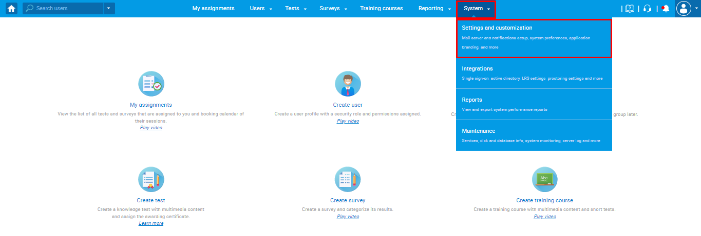
Enter the side-tab "Message templates" from the "System preferences" and click on the "Add new message templates" button.
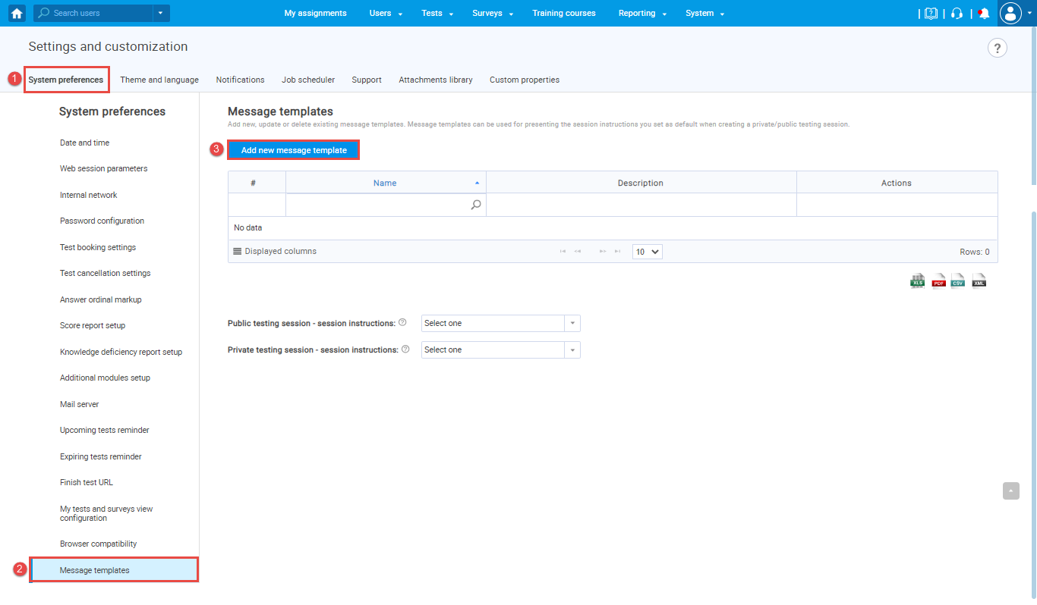

Adding the "Private testing session - session instructions" template
The "Private testing session - session instructions" template will be used for individual private testing sessions. Each time when creating a individual private testing session (this is a session within the test with the self-enrolment option disabled), you will use this template in French or English version.
The "Add new message template" pop-up will appear where you need to configure the message template. To do that, follow the next steps:
- Enter the name of the message template you are creating.
- Optionally add its description.
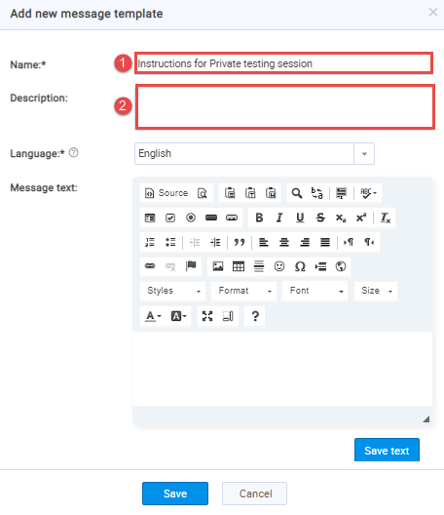

- Select the "English" language and enter the desired message.
Note: This message should contain only information that differs from information non-college students should receive. The common part should remain part of the notification.
For example:
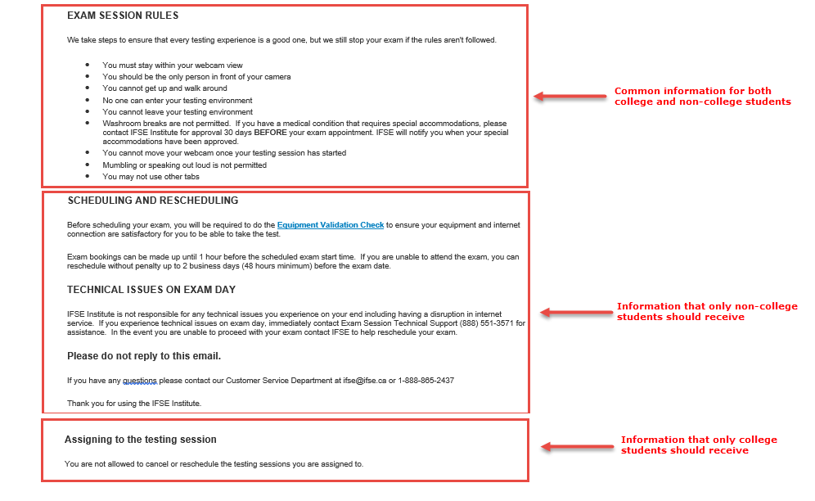

Guided by the example above, we will only enter the common part in the "Message text" field:
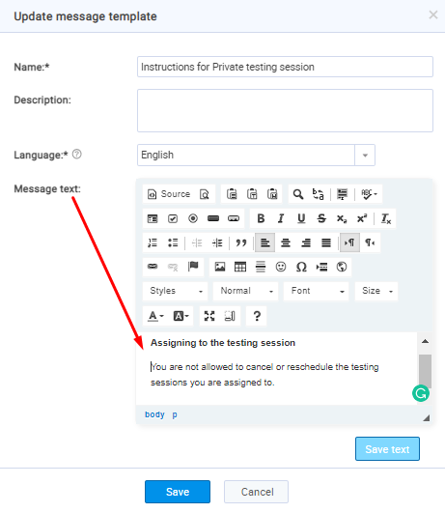

Click on the "Save text" button, and the English version will be saved.
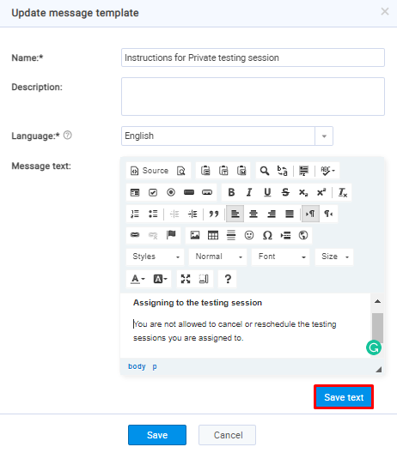

- Select the "French" language on the same window and enter the same message in French.
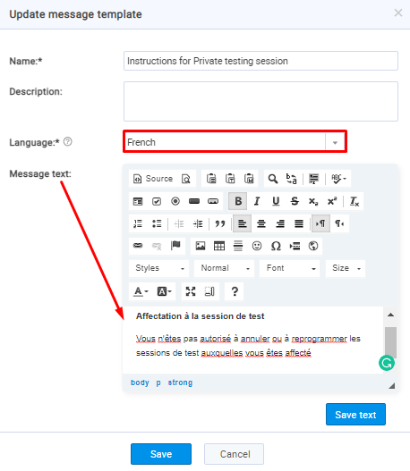

- Click the "Save text" button, and the French version will be saved.
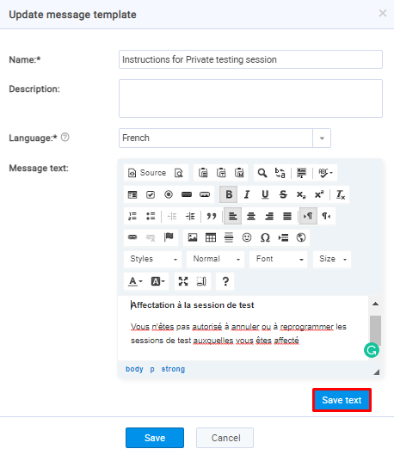

- Click on the "Save" button, and the message template will be saved in both languages and ready to use when creating a testing session.
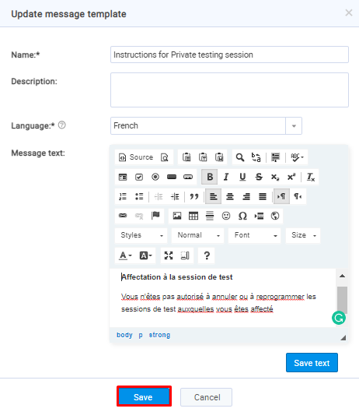

Adding the "Public testing session - session instructions" template
The "Public testing session - session instructions" template will be used for common public testing sessions. Each time when creating an common public testing session, you will use this template in French or English version.
The "Add new message template" pop-up will appear where you need to configure the message template. To do that, follow the next steps:
- Enter the name of the message template you are creating.
- Optionally add its description.
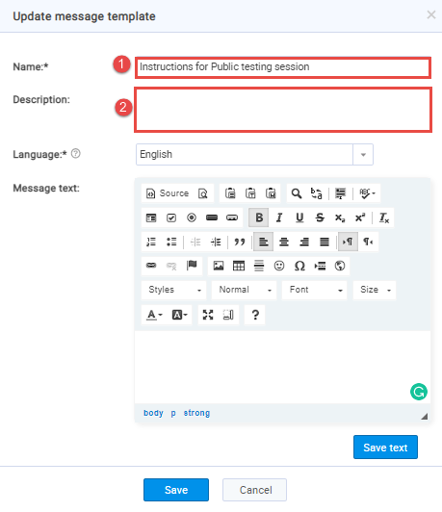

- Select the "English" language and enter the desired message.
Note: This message should contain only information that differs from information non-college students should receive. The common part should remain part of the notification.
For example:

Guided by the example above, we will only enter the part that refers to non-college students in the "Message text" field:
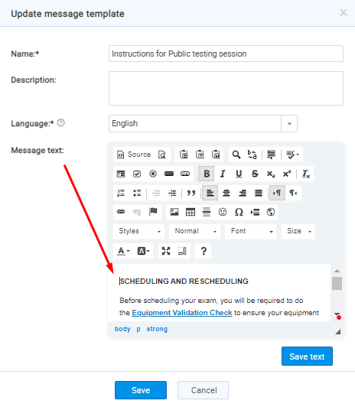

Click on the "Save text" button, and the English version will be saved.
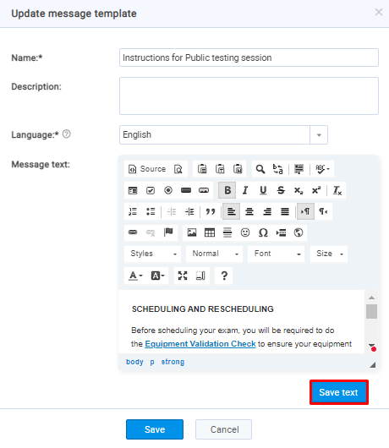

- Select the "French" language on the same window and enter the same message in French.
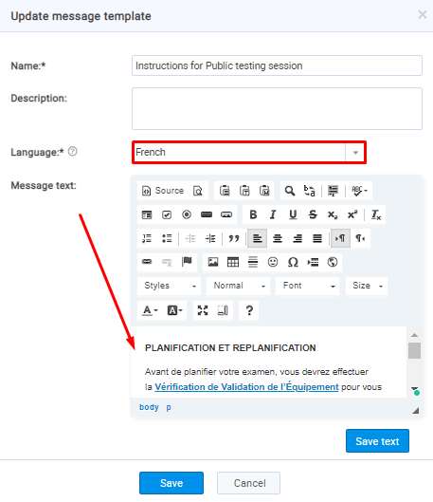

- Click on the "Save text" button, and the French version will be saved.
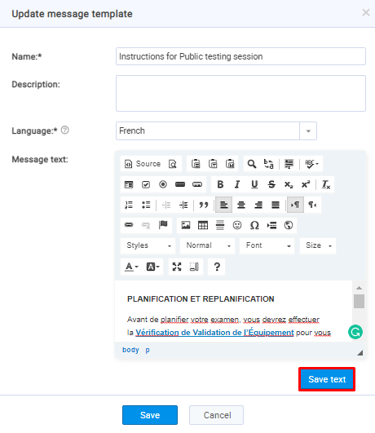

- Click on the "Save" button, and the message template will be saved in both languages and ready to use when creating a testing session.
