YouTestMe

How to create user groups representing colleges

Contents
1 Introduction 2
2 Creating user group 3
3 Assigning users to a group 4

Introduction
This document explains how to manually create a user group through the application, where the following applies:
- Each user group should represent a different college.
- Members of the user groups are students of the specific college.
- This feature allows IFSE CSR to assign the desired group to the individual private testing session and add candidates that are only members of the assigned user group.

Creating user group
To create a user group, hover over the “Users” tab in the main menu and select “User groups”.
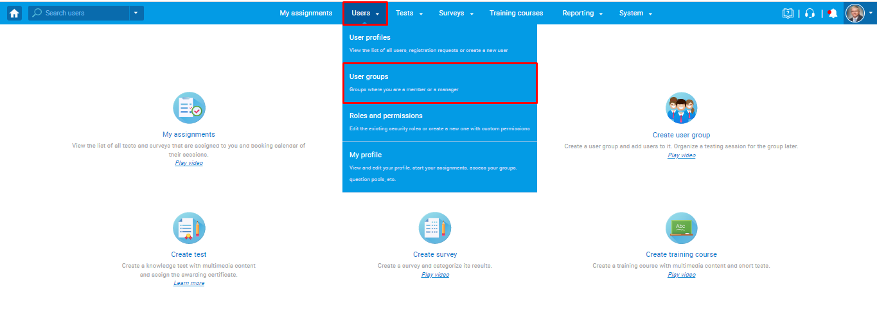
Click the “New” button to create a new user group.
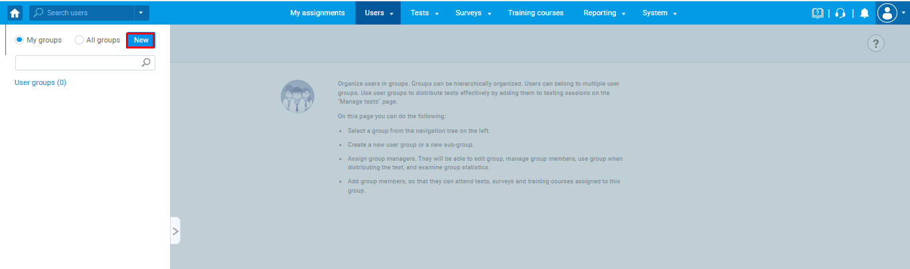
Then:
- Enter the group name.
- Enter a description – The description should represent the contact information of the specific college for which you are creating a group. This information will be passed to the students within email notifications they will receive (when IFSE CSR book them in the session, remainder, etc.). For the students to receive this information, the $ sessionGroupDescription $ variable should be used when configuring email notifications. More information can be found in the article explaining the email notifications' configuration.
- Click the “Save” button to create a user group.
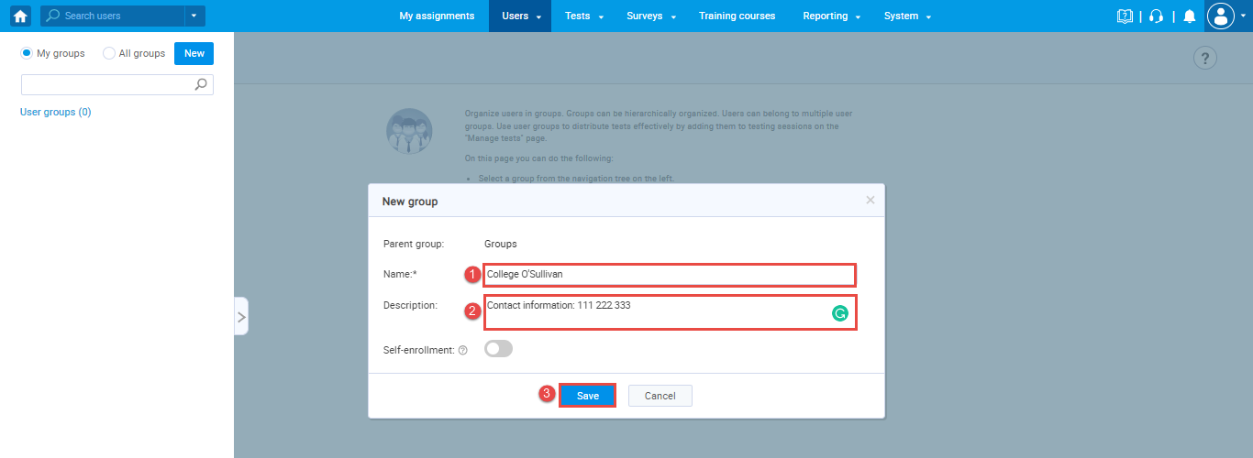

Assigning users to a group
The student will be automatically assigned to the corresponding user group when their profile is sent from the IFSE to the YTM system through the API.

