YouTestMe

Guide for cancelling test attempt by CSR

Contents
1 Introduction 2
2 Cancelling test attempt 2

Introduction
This document explains how CSR can cancel a student's booking.
Note: The student can cancel a booking by the cancellation deadline. On the other hand, CSR can perform booking cancellations even after the cancellation deadline expires.

Cancelling test attempt
To cancel the booking, CSR should navigate to the "Candidates" tab of the desired test.
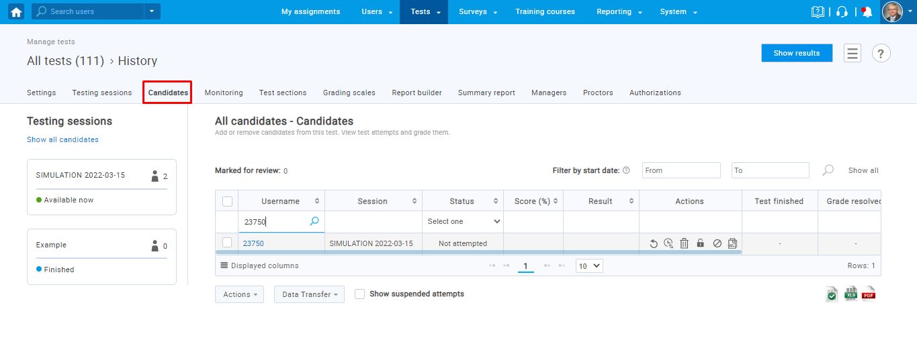
Booking can be canceled only if the status of that attempt is “Not attempted”.
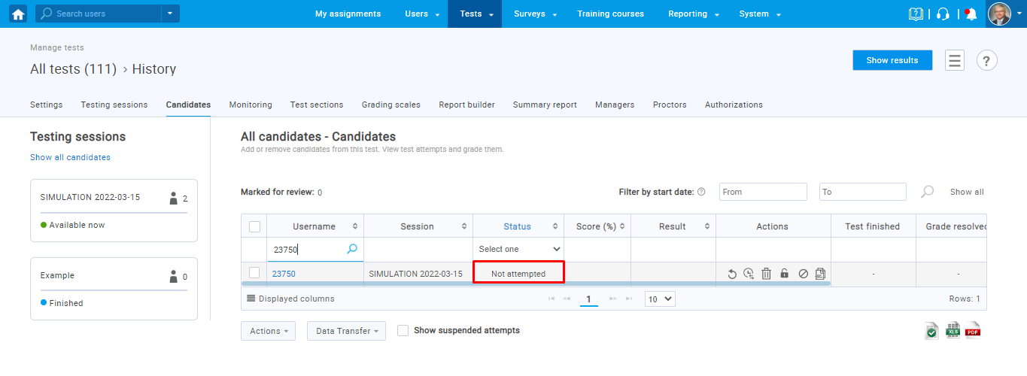
To cancel the booking, CSR needs to perform two actions:
- Remove authorization from the invalid attempt
- Suspend attempt
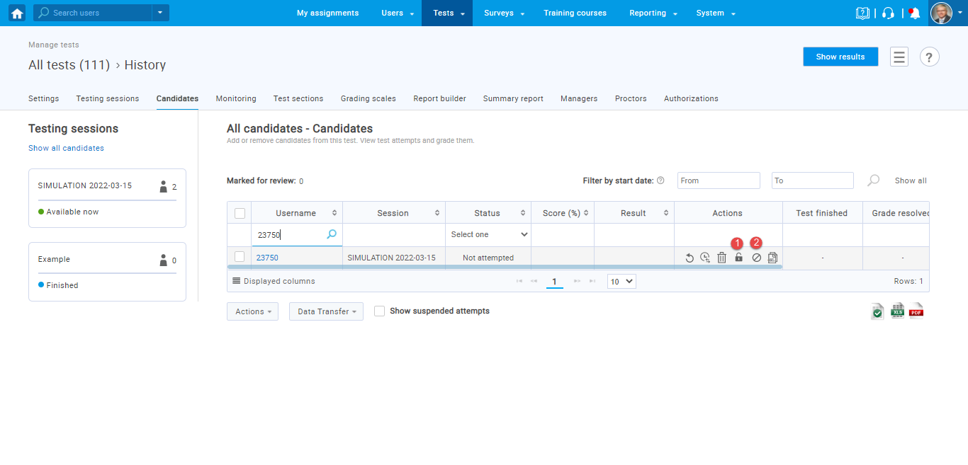
Note: Booking can also be canceled using the "Delete" button. However, this option permanently deletes the attempt without archiving it, while the above-explained option will ensure that the attempt at which the booking was canceled is archived.

