YouTestMe

How CSR can filter all attempts by session end time

Contents
1 Introduction 2
2 Filtering test attempts 2

Introduction
This document explains how CSR can filter test attempts by the session end time, including test attempts with the "Not attempted" status.

Filtering test attempts
Filtering test attempts is enabled at the “Test results verification” page.
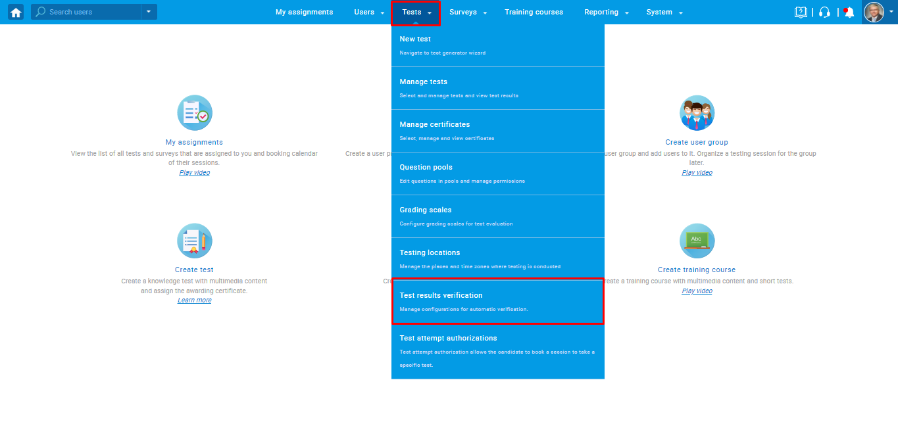

Use the filter by testing session end time by entering "From" and "To", and all test attempts with different statues from the sessions held in that time frame will be displayed.
