YouTestMe

Paper exam bookings migration

Contents
1 Introduction 2
2 Migration 2
2.1 Task list 2
2.2 Import of paper exam bookings in YouTestMe 3
2.2.1 Solution 1 – YTM finds the exam session and creates the attempt 4
2.2.2 Solution 2 – Lambda finds the exam session and creates the attempt 4
2.3 Migration process 4
2.4 Open issues/questions 5

Introduction
This document presents the plan for migrating paper exams bookings from the current IFSE system to Lambda and YouTestMe. The general plan and idea will be presented with workflow and responsibilities and some open questions and options for some parts of the migration.

The reason for this document is to define and optimize the paper exam session migration process.
The idea is to provide an efficient mapping of IFSE PAPER SESSION -> YTM COMMON SESSION.
This will be done by adding common_session_external_id to the common session, which will be mapped to ifse_exam_session_id.
This ID allows for more optimal test attempt creation by eliminating a few steps by creating a simplified API endpoint.

Migration

Task list
ID | Task | Responsible | Depends on | Deadline | Status
1 | Implement option to input the common session external ID (GUI and Import common session template. | YTM | -
2 | Define import file format for importing paper exam bookings into Lambda. Each booking record should include at least ifse_exam_session_id, ifse_exam_code, ifse_student_id, and probably some additional data required by Lambda. Define the batch size. | IFSE, Lambda | -
3 | Test the import paper exam common session into YTM production. It can be done either through GUI or Excel import. For each common session, an external id should be specified, which is the ifse_exam_session_id. | IFSE | 1
4 | Export paper exam bookings from the current IFSE system. | IFSE | 2
5 | Confirm the additional YTM API extension to support paper exam bookings migration. See (2.2) | IFSE, Lambda, YTM
6 | Extend API to support paper exam bookings migration. | YTM | 5
7 | Implement paper exam bookings import. | Lambda | 2, 1, 6
8 | Import paper exam bookings into production. | IFSE | 3, 4, 7

Import of paper exam bookings in YouTestMe
The exported files with the exam bookings records should contain at least ifse_exam_session_id (ytm_common_session_external_id), ifse_exam_code (ytm_test_external_id), ifse_exam_version_id (ytm_version_name), ifse_student_id (ytm_username). The exported files are imported through Lambda. Lambda imports necessary data to their system (for example, user profile, course enrollment, attempt) and creates user if not exists and attempt for the common session in YouTestMe through the API.
The part of the YTM data model representing the common session, child exam session, test, and relations between them:
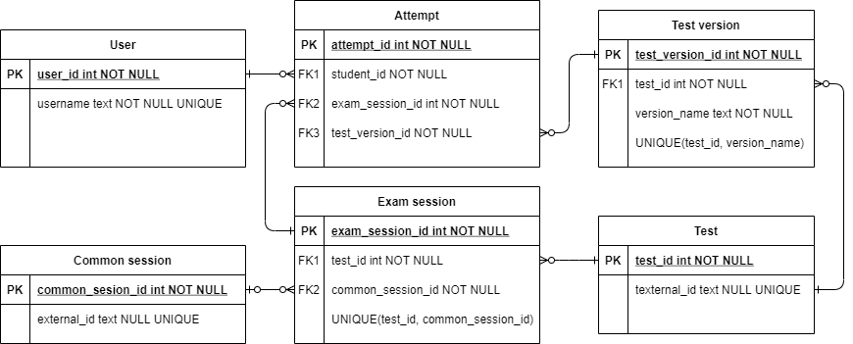
The following rules apply:
- When the common session is created, a child exam session is created for every test.
- For one common session and one test, there can be only one exam session.
- Attempts can only be created for exam sessions.
- If the test_version_id is not specified for the attempt, the system will automatically assign the version based on the uniform distribution algorithm.
For the booking record from the file, the exam session to create an attempt have to be found. For example, if we have the data in YTM tables displayed on the picture below:
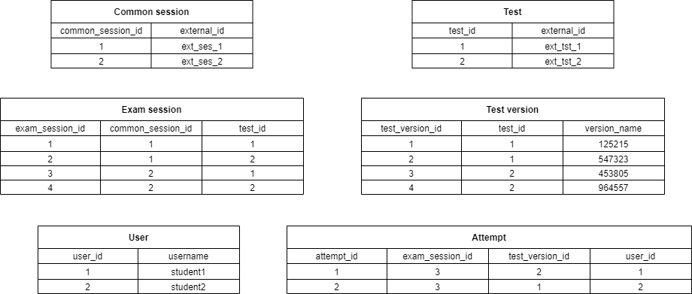

- Case 1 known exam version : If the booking record in the file is (ifse_student_id = student1, ifse_exam_session_id = ext_ses_2, ifse_exam_code = ext_tst_1, ifse_exam_version_id = 5473232), we see from the data that we have to create the attempt in the exam session with exam_session_id = 3 and test_version_id = 2.

- Case 2 unknown exam version If the booking record in the file is (ifse_student_id = student2, ifse_exam_session_id = ext_ses_2, ifse_exam_code = ext_tst_1, ifse_exam_version_id = null), we see from the data that we have to create the attempt in the exam session with exam_session_id = 3 and system will assign test_version_id = 2 to maintain even distribution.

Responsible for finding the proper exam session to create an attempt in can be either YTM or Lambda. So, there are two possible solutions described in 2.2.1 and 2.2.2.

Solution 1 – YTM finds the exam session and creates the attempt
- YTM will implement the new API endpoint – ‘’Create common session attempt” with at least the following parameters:
  - testExternalId (ifse_exam_code)
  - commonSessionExternalId (ifse_exam_session_id)
  - username (ifse_student_id)
  - testVersionName (ifse_exam_vestion_id) * Optional
- Lambda will implement the call of the specified API endpoint for each exam booking record.

Solution 2 – Lambda finds the exam session and creates the attempt
- YTM will add filter by testExternalId and commonSessionExternalId for existing API endpoint “List sessions.”
- YTM will add the field the testVersionName in the “Create attempt” endpoint.
- Lambda will implement the call to “List sessions” endpoint with the filters testExternalId = ifse_exam_code and commonSessionExternalId = ifse_exam_session_id to get the child session for each exam booking record. After that, Lambda will call the existing “Create attempt” endpoint for a returned child session and student.

Migration process
When all implementation tasks are completed and tested, the following migration workflow should be applied:
ID | Task | Responsible | Depends on | Deadline
1 | Import question pools and create paper exam tests in the YTM production environment. | IFSE | -
2 | Create courses in Lambda and connect them to YTM paper exams. | IFSE | 1
3 | Migrate paper exam sessions from the IFSE system to YTM production.  Manually import through the GUI or batch import through Excel file. | IFSE | 1
4 | Export paper exam bookings from the IFSE system to the defined format. | IFSE | -
5 | Import paper exams bookings to Lambda | IFSE | 2, 3, 4

Open issues/questions
ID | Issue/Question | Responsible | Deadline | Resolution
1 | Since already validated bookings are migrated, do session capacity should be validated for each booking? | IFSE
2 | Confirm the final implementation approach. | IFSE, Lambda, YTM

Screenshots and examples
In following chapters you can see screenshots of paper based tests creation and exporting packages for printing.

Export package samples
https://owncloud.youtestme.com/owncloud/s/eZYPSrT4p4Dezbv

Examples

Example 1

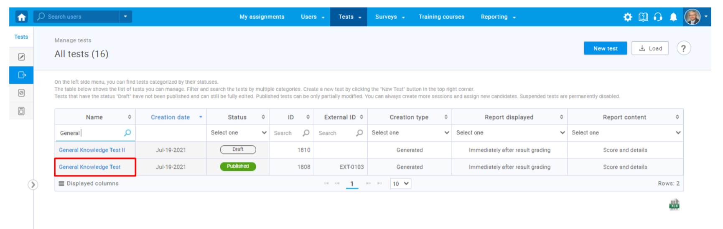
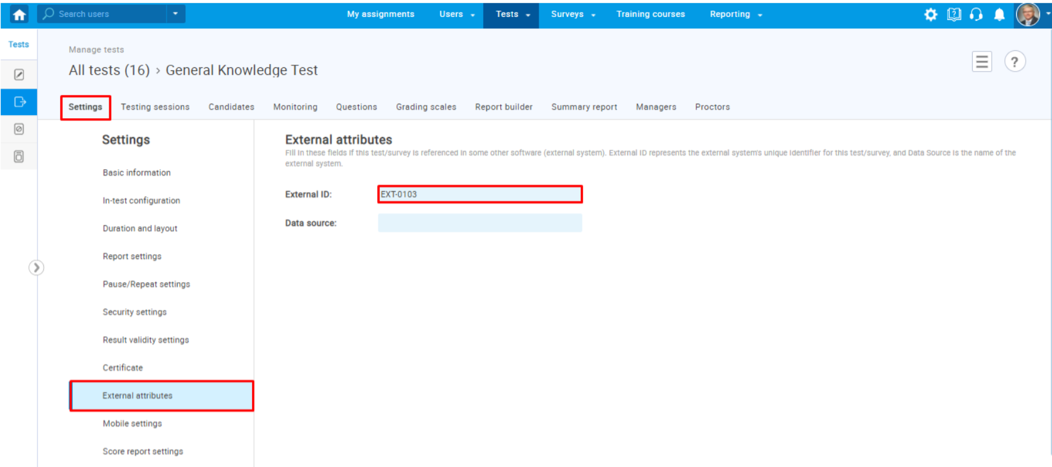

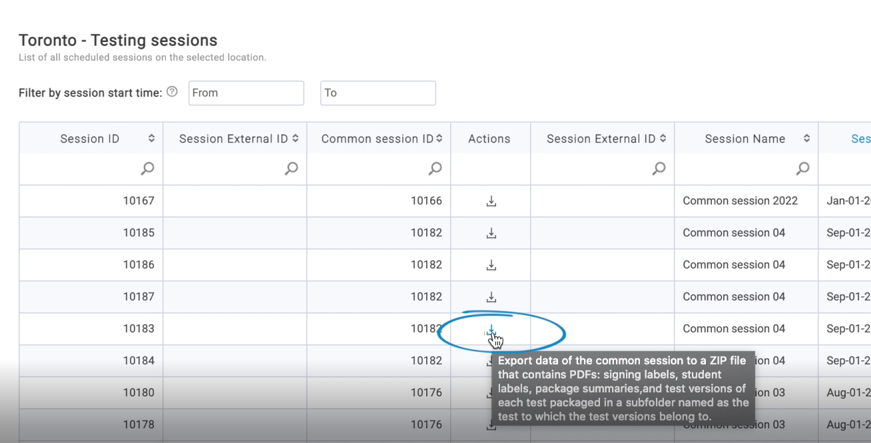

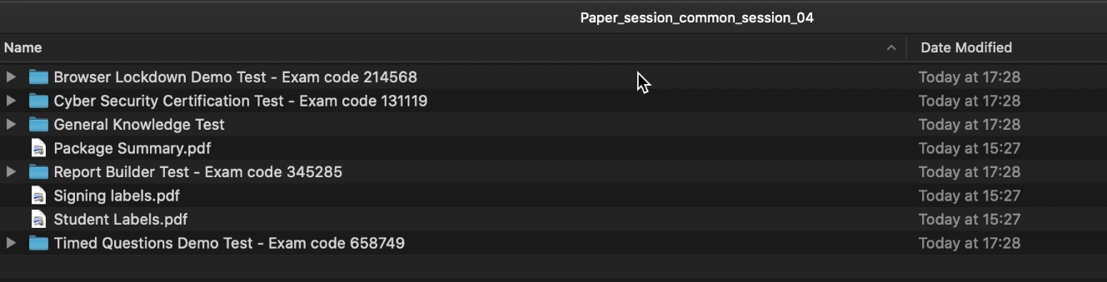

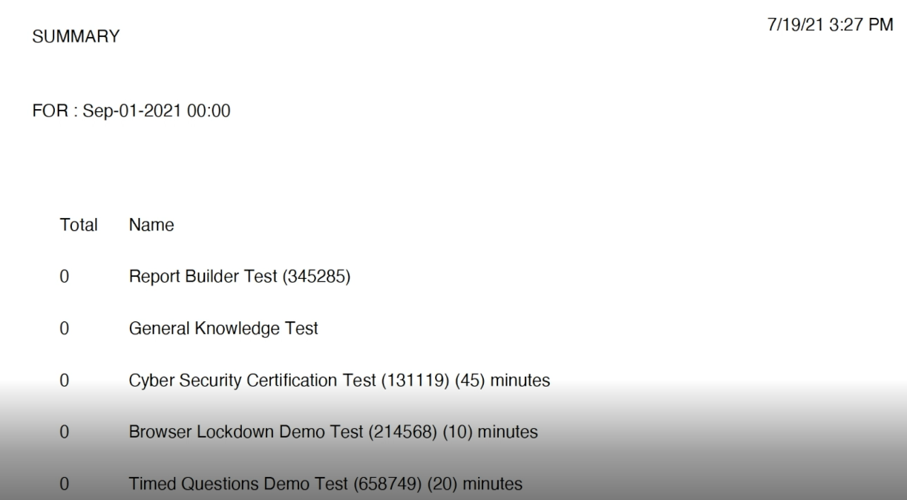

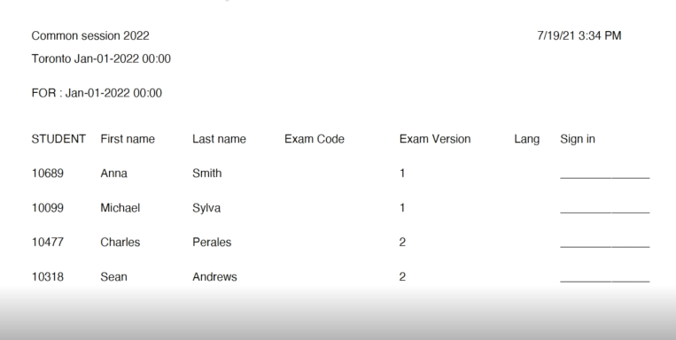
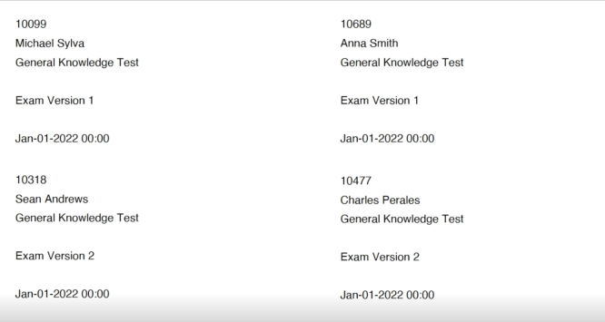

Example 2
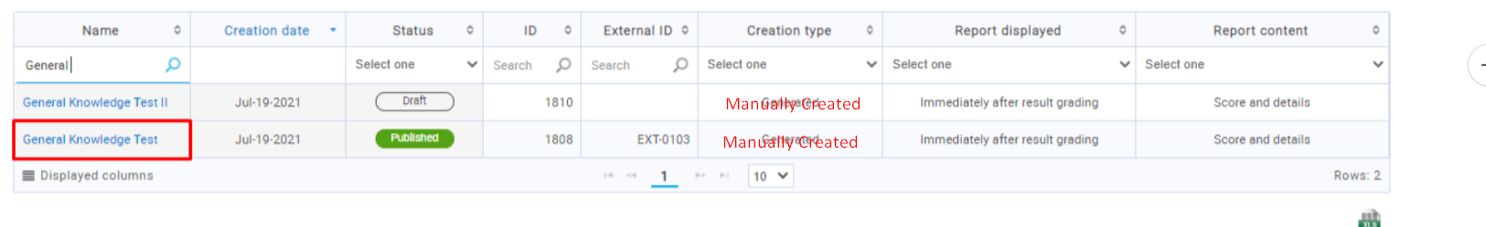
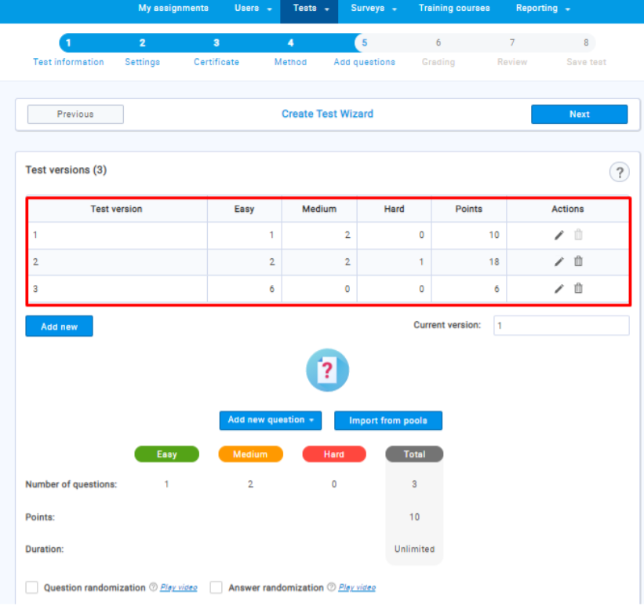
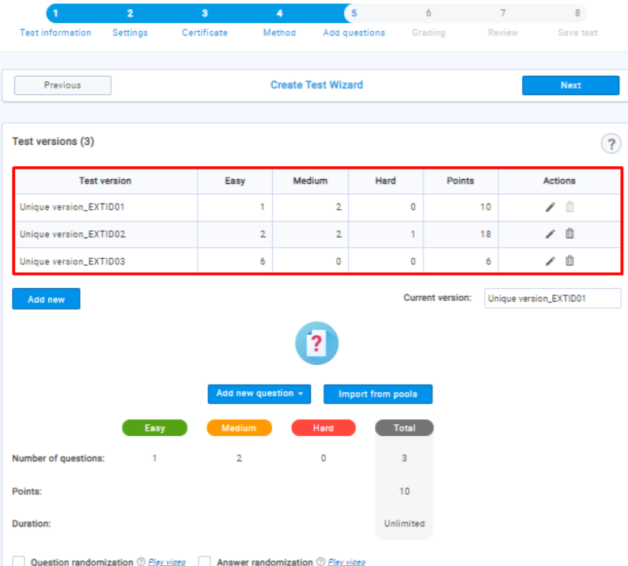

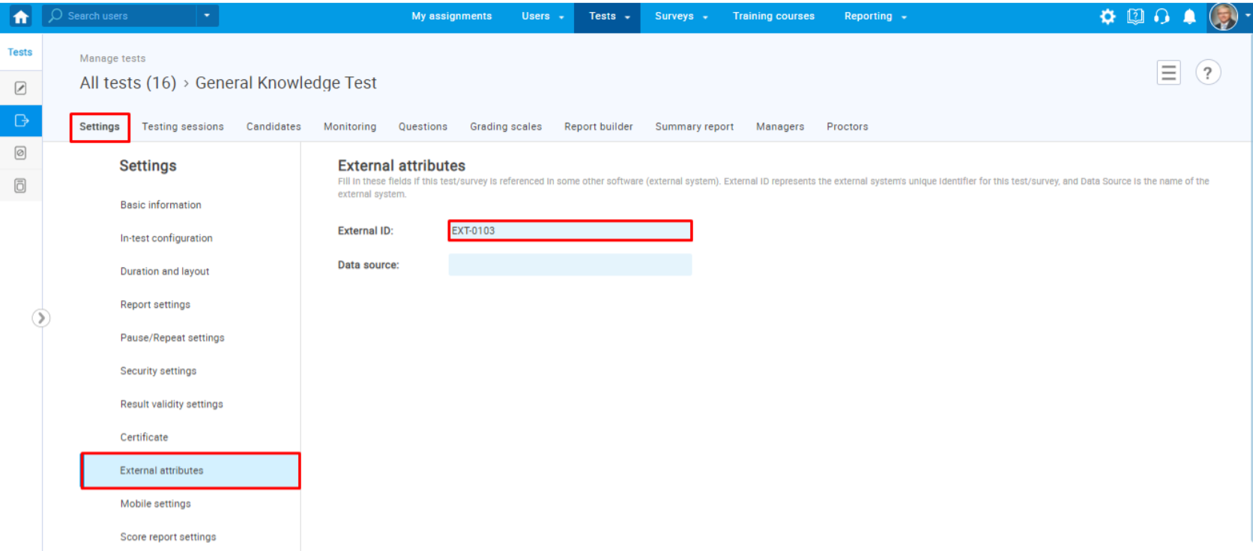

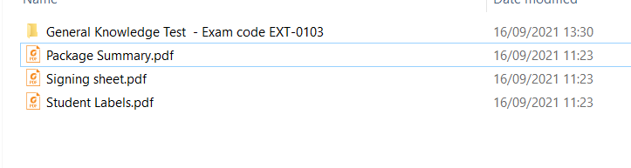
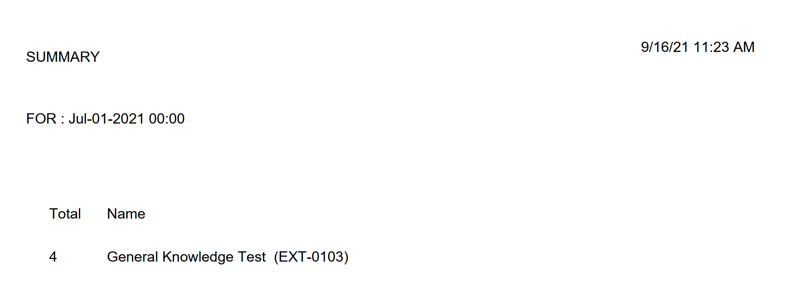
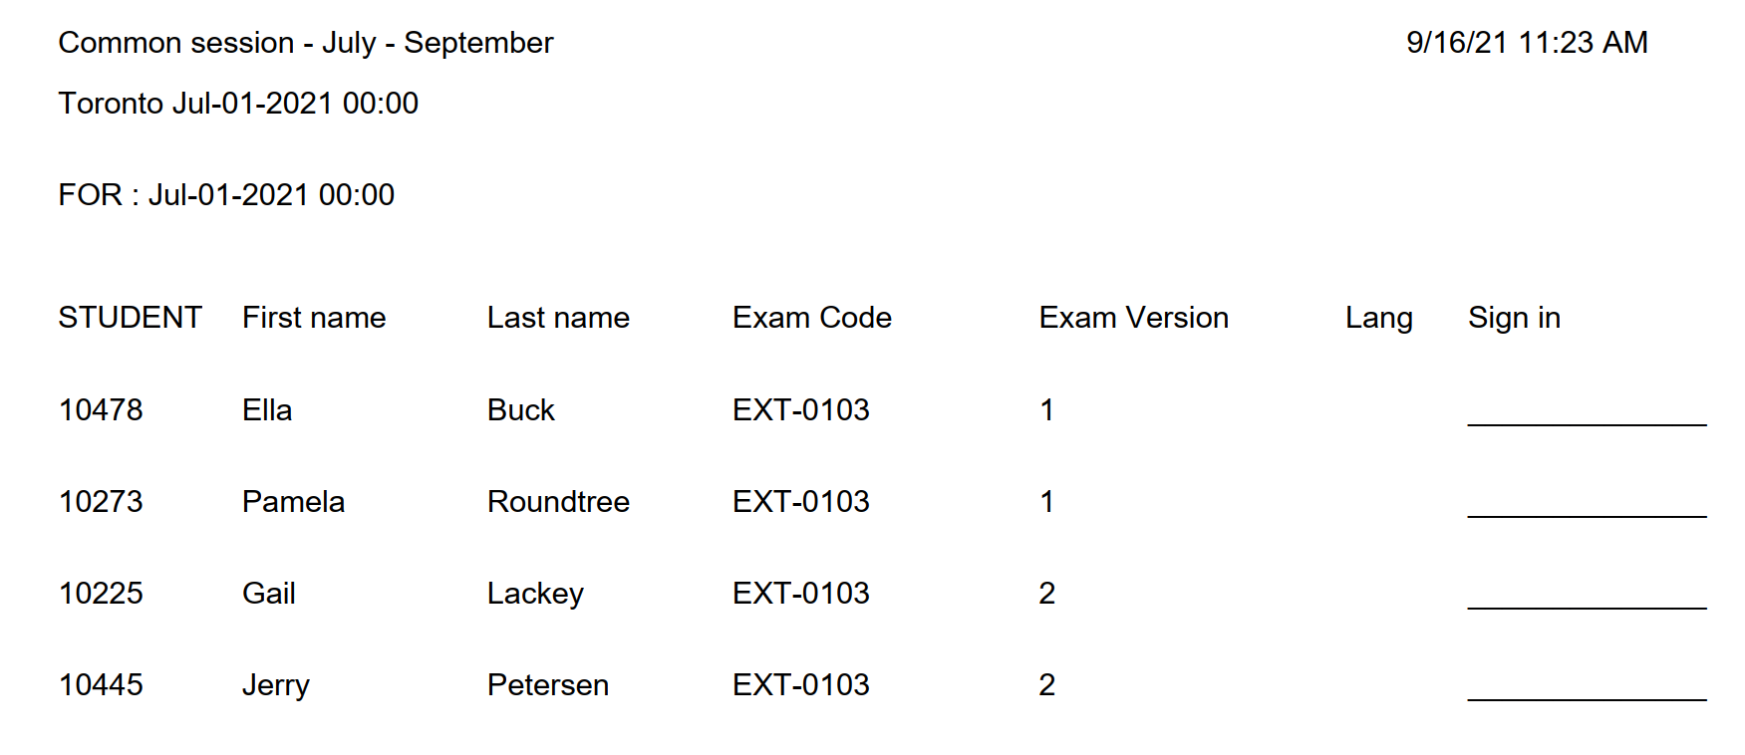
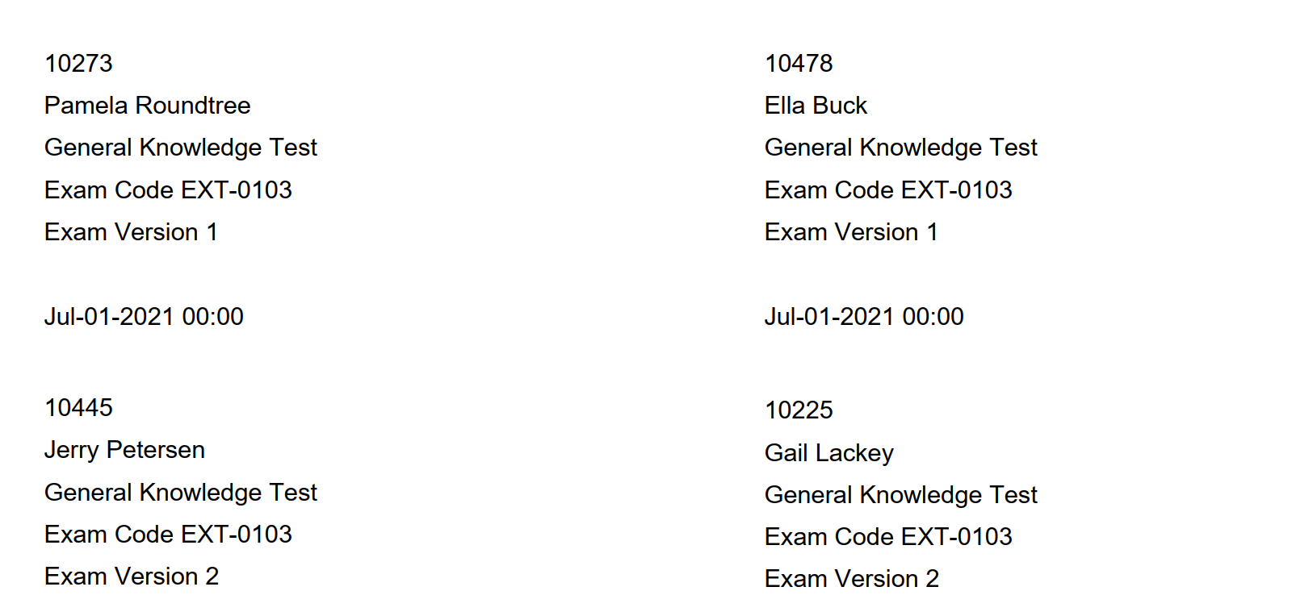

Example 3
